LANDSAT Application and Classification Disaster
Area on Yom River Basin

Vicharn Amarakul¹
Director of Regional Geo-Informatics and Space Technology,
Lower Northern Region, Naresuan University, Muang District, Phisanulok, Thailand
v_amarakul@yahoo.com
Sirirat Sanyong²
Lecturer, Faculty of Agriculture, Natural Resources and Environment
Naresuan University, Muang District, Phisanulok, Thailand
siriratsy@hotmail.com
Abstract
The area of Yom River Basin had 23616 square kilometer which covered 11 provinces consisted of Phayao, Nan, Lumpang, Phrae, Utradit, Tak, Sukhothai, Phitsanulok, Kamphaengphet, Phichit and Nakornsawan provinces. There are eleven sub-basin in Yom River Basin and some areas in this basin was in serious flood in rainy season. LANDSAT images was used for classification the land use, calculation and estimation the direction of water flow and the severity of flooding. The data base for estimation flooding severity or the probability of flooding in each sub-basin were consisted of annual rainfall, slope, the boundary from the main rivers, the density of rivers and canals, area of sub-basin, land covered and soil textures. The result from this study was showed that the highest risk flooding area in Yom River Basin must be occurred on Phitsanulok. The moderate risk had classified in the area of Kampangphet, Sukothai, and Phichit provinces, respectively. The highest sensitive areas on flooding had covered 11,658.22 square kilometer or 60.99% of Yom River Basin. The high, moderate and mildly sensitive areas had covered 3,850.33 ; 1,582.34 and 2,025.11 square kilometer or 20.14% 8.28% and 10.59%, respectively.
Keyword
Yom River Basin, Phayao, Inundate, Nan, Lumpang, Phrae, Utradit, Tak, Sukhothai, Phitsanulok, Kamphaengphet, Phichit, Nakornsawan, Thailand

Introduction
Meteorological condition in Yom river basin is under southwest and northeast monsoons.
For the whole basin, the average annual rainfall, temperature and relative humidity were 1,118 mm, 26.4 º C and 72%, respectively. The maximum rainfall is in August and September. Rainfall is very important weighting factor. Flooding situation in lower northern and middle region of Thailand had caused by over water flow from the northern region. In 2002, Strom had attacked the northern region for many times. Therefore, the disastrous consequence was heavy flooding in lower northern region, 593,118 persons were in trouble, agriculture lands were destroyed 453,101.3 ha. The infectious diseases were epidemic by water. From this reason, the Regional Center of Geo-informatics and Space Technology, lower Northern Region, Naresuan University, had very interesting and concentrate on monitoring the disaster which effecting from flooding.
Objectives
- To draw the boundary of the risk area on flooding in Yom river basin.
- To monitor the flooding direction and severity in the difference height on land
Study area
The study site in Yom river basin is covered 11 provinces, there are Phayao, Nan. Lumpang, Phrae, Uttradit, Tak, Sukothai, Phitsanulok, Kamphaengphet, Phichit and Nakornsawan provinces.
Material
For this task, the area where flooding happening was interpreted from LANDSAT imagery.

Methodology
- Study on the correlation between topography and possibility to flooding
- Analyze opportunity for the occurrence of the flood inundate was done by overlay and weighting
variation data such as rainfall data, terrain mapping unit, main rivers boundary, density and size of water body boundaries in sub-basin, agricultural land use/cover and soil texture (drainage) as table 1 and 2.
- Depicting flood inundation maps at 1:50,000 scale in difference inundation levels and showed the
risking area in each districts which located on Yom river basin.
Density of water bodies in sub-basin
Density of water bodies in sub-basin had direct correlated with drainage, in case of high density of water bodies would be correlated with good drainage. The density of water bodies was calculated by the sum of whole of length of water bodies in each sub-basin divided by size of sub-basin

Size of sub-basin
Sub-basin size could classified the inundate opportunity. The inundate criteria was defined by sub-basin size, the area more than 2,601 km² defines as high opportunity to be inundation and the area less than 1,000 km² defines as no opportunity to be inundation.
Agricultural land use/cover
Yom river basin had a complex topographies, it was hilly in the upper parts and flood plain in the lower parts. Agricultural land use/covers were sorghums, maize, paddy fields, sugarcanes, orchards, forestry and deforest area. The highest risk of inundate for agricultural land use/cover was paddy field.
Soil texture (Drainage)
Soil texture was correlated with drainage. The highest risk of inundate would occurred in the worst drainage soil. In controversy, good drainage would be the least risk of inundate.

Table 1 Grading/Weight values for flooding severity which base on inundate factors.

Items | Severity or Weight value of inundate factors
1. Annual rainfall | 7
2. Boundary from main rivers | 6
3. Slope | 5
4. Density of water bodies in sub-basin | 4
5. Size of sub-basins | 3
6. Agricultural land use/cover | 2
7. Soil Texture (Drainage) | 1

Table 2 Factors weighting varies according to type of data

Factors Variation | Class | Weighting
Factors Variation | Class | factors | Severity ^{1/}
1. Annual rainfall | > 1,200 mm.  1,100 - 1,200 mm.  1,000 - 1,100 mm..  < 1,000 mm. | 7 | 4  3  2  1
2. Boundary from main rivers | 0 – 0.5 km.  0.5 – 1.0 km.  1.0 – 5.0 km.  > 5.0 km. | 6 | 4  3  2  1
3. Slope | 0 – 5%  6 –10%  11 – 15%  > 15% | 5 | 4  3  2  1
4. density of water bodies in sub-basin | 0.1 – 0.35 km./sq.km.  0.36 – 0.71 km./sq.km.  0.71 – 1.00 km./sq.km.  > 1.00 km./sq.km. | 4 | 4  3  2  1
5. Size of sub-basins | > 2,601 sq.km.  1,801 – 2,600 sq.km.  1,001 – 1,800 sq.km.  < 1,000 sq.km. | 3 | 4  3  2  1
6. Agricultural land use/cover | Paddy field  Field crops  Orchards and trees  Forests | 2 | 4  3  2  1
7. Soil Texture (Drainage) | Worse  Bad  Moderate  Good | 1 | 4  3  2  1

Remarks : ^{1/} 1 = Low/Non 2 = moderately 3 = high 4 = very high
Inundate Equation

$$\overline{x}=\frac{\sum_{i=1}^{7}{w_{i}x_{i}}}{\sum{w_{i}}}$$

$\overline{x}$ = average of risk on inundate area
$x_{i}$ = average of risk in each class
$w_{i}$ = weight value of each class
i = class priority from 1, 2, 3, …, 7

Percentage of Inundate Severity Area = $\frac{\left(7\text{Ra}\right)+\left(6\text{Di}\right)+\left(5\text{Sl}\right)+\left(4\text{De}\right)+\left(3\text{Si}\right)+\left(2\text{Ls}\right)+\left(1\text{So}\right)}{7+6+5+4+3+2+1}×\frac{\text{100}}{4}$

$7\text{Ra}$ = Weight value of risk area analyze by average of annual rainfall
$6\text{Di}$ = Weight value of risk area analyze by boundaries from main rivers
$5\text{Sl}$ = Weight value of risk area analyze by from slope
$4\text{De}$ = Weight value of risk area analyze by from Density of water bodies in sub-basin
$3\text{Si}$ = Weight value of risk area analyze by size of sub-basin
$2\text{Ls}$ = Weight value of risk area analyze by agricultural land use/cover
$1\text{So}$ = Weight value of risk area analyze by soil texture (drainage)
Risk severity had been grading as following
0 – 50% low severity / no severity
51 – 60% moderately severity
61 – 70% high severity
>70% very high severity

Result
Inundate Analyze by rainfall
Inundate risk in Yom (Fig. 3) River Basin had been analyzed by rainfall found that the high risk area was only 2.33 percentage or 505.47 km² which area belong to Phayao (in Chiang Khum, Chiang Muan and Pong districts), Nan
(in Tha Wang Pha, Ban Luang and Song Khwae districts), Phrae (in Wang Chin and Den Chai districts) , Uttradit
(in Laplae district) and Sukhothai (Si Satchanalai) provinces. The low or non inundate area was in Lampang, Phrae, Sukhothai (Thung Saliam and Sawankhalok district), Kamphaengphet (Tung Sai, Sai Ngam and Bueng Samakkhi )and Phichit (Sam Ngam, Pho Prathap Chang and Pho Thale ) Provinces.
Inundate Analyze by boundaries from the main river
The highest inundate risk area was 3952.94 km2 which belong to Phrae (Wang Chin district), Sukhothai
(Si Satchanalai, Si Samrong and Mueang Sukhothai districts), Phitsanulok ( Bang Rakam district) Kamphaengphet (Sai Ngam districts) and Phitchit (Sam Ngam and Pho Prathap Chang districts) .
Inundate Analyze by Slope
Their slope was correlated with the runoff velocity , the provinces was very highly opportunity to be inundated were Phrae, Sukhothai, Uttradit, Phitsanulok, Kamphaengphet, Phichit, and some parts of Nakornsawan Province. It could be calculated as 16,123.19 km² (Fig.4 ).
Inundate Analyze by Density of water bodies in sub-basin
High density of water bodies in sub-basin was higher condition for drainage the over flow than the low density of water bodies. This study identified the density of water bodies as the total length of all water bodies divided by size of basin. From this analysis, it showed that the highest inundate risk area was in Phitsanulok, Kamphaengphet and Phichit provinces which covered 2,872.46 km²(Fig.5 ).
Inundate Analyze by Size of Sub-basins
The size of sub-basins was bigger than 2,601 km², had been shown as very highly inundate risk area. In controversy, the size of sub-basin was smaller than 1,000 km², had been shown as non inundate risk area. Phrae, Sukhothai, Phitsanulok, Kamphaengphet, Phichit and some parts of Nakornsawan provinces were shown as the very
highly risk in inundate, which covered 8,350.33 km² (Fig.5 ).
Inundate Analyze by agricultural land use/cover
Paddy field area was weighted as the very highly inundate risk area, which covered 12,567.84 km². The inundate area covered Sukhothai, Phitsanulok, Kamphaengphet, Phichit and some parts of Nakornsawan provinces(Fig.2 ).
Inundate Analyze by Soil Texture (Drainage)
Slow drainage was weighted as the high inundate risk area which covered 118.9 km² and was in Phayao (Chun and Pong districts ), Sukhothai ( Si Satchanalai and Ban Dan Lan Hoi districts) Phitsanulok (Bang Rakam district), Kamphaengphet ( Mueang Kamphaeng Phet and Sai Ngam districts) and Phichit (Sam Ngam and Pho Thale districts) (Fig.4 ). All size and percentage of inundate risk area in Yom River Basin had been shown as Table 3 and 4.
Percentage of inundate severity analyzed by the provinces which located on Yom river basin had showed that Phrae and Sukhothai provinces were 100 percentage risk on inundate. The most area in Phrae province about 3,635.44 km² had effected on inundate from moderately to high severity or 45 percentage of Phrae province. Also the most area in Sukhothai province about 4,358.51 km² had effected on inundate from moderately to high severity or 55.08 percentage of Sukhothai province. Analyze the risk area base on all factors had showed that the area which belong to Nakornsawan, Uttradit, Tak and Nan provinces were only 0.54, 1.35, 3.24 and 11.18 of their provinces, respectively, risk on inundate. (Fig.6) and (Table 6 and 7 )

Table 3 Analyze the size of inundate risk areas in Yom River Basin

Factors | Size of Inundate Risk Area (km²)
Factors | Low / Non | Moderately | High | Very High | Total
Annual Rainfall | 5,893.22 | 10,146.36 | 7,025.95 | 505.47 | 23,616.00
Boundaries from main river | 5,355.93 | 11,130.49 | 3,176.64 | 3,952.94 | 23,616.00
Slope | 4,774.53 | 955.62 | 1,762.65 | 16,123.19 | 23,616.00
Density of water bodies in sub-basin | 0.00 | 15,456.74 | 5,286.80 | 2,872.46 | 23,616.00
Size of sub-basin | 2,025.11 | 1,582.34 | 11,658.22 | 8,350.33 | 23,616.00
agricultural land use/cover | 8,777.57 | 1,732.32 | 538.27 | 12,567.84 | 23,616.00
soil texture (drainage) | 18,711.91 | 306.18 | 4,479.39 | 118.53 | 23,616.00

Table 4 Analyze the percentage of inundate risk areas in Yom River Basin

Factors | Percentage of Inundate Severity in Risk Area
Factors | Low / Non | Moderately | High | Very High | Total
Annual Rainfall | 24.96 | 42.96 | 29.75 | 2.33 | 100.00
Boundaries from main river | 22.68 | 47.13 | 13.45 | 16.74 | 100.00
Slope | 20.22 | 4.05 | 7.46 | 68.27 | 100.00
Density of water bodies in sub-basin | 0.00 | 65.45 | 22.39 | 12.16 | 100.00
Size of sub-basin | 8.58 | 6.7 | 49.36 | 35.36 | 100.00
agricultural land use/cover | 37.17 | 7.34 | 2.28 | 53.22 | 100.00
soil texture (drainage) | 79.23 | 1.3 | 18.97 | 0.50 | 100.00

Table 5 Percentage of Inundate Severity in Risk Area on provinces in Yom river basin

Provinces | Percentage of Inundate Severity in Risk Area
Provinces | Low/non | moderately | high | Very high
Kamphaengphet | 0.53 | 8.81 | 17.28 | 14.6
Tak | 1.82 | 1.42 | 0.00 | 0.00
Nakornsawan | 0.00 | 0.09 | 0.3 | 0.15
Nan | 7.56 | 2.81 | 0.7 | 0.11
Phayao | 11.43 | 13.25 | 7.98 | 4.78
Phichit | 0.02 | 7.2 | 10.05 | 8.81
Phitsanulok | 0.00 | 0.37 | 8.89 | 22.55
Phrae | 37.01 | 24.42 | 21.44 | 11.52
Lumpang | 24.9 | 13.78 | 5.15 | 2.05
Sukhothai | 16.39 | 27 | 28.08 | 35.4
Uttradit | 0.34 | 0.85 | 0.13 | 0.03
Total | 100.00 | 100.00 | 100.00 | 100.00

Table 6 Size of Inundate Risk Areas on provinces in Yom river basin

Provinces | Size of Inundate Risk Areas (km²) |  |  |  | Total
Provinces | Low/non | moderately | high | Very high | Total
Kamphaengphet | 25.37 | 711.21 | 1341.57 | 439.47 | 2517.62
Tak | 87.10 | 114.49 | 0.00 | 0.00 | 201.59
Nakornsawan | 0.00 | 7.61 | 22.91 | 4.66 | 35.18
Nan | 360.72 | 226.48 | 54.45 | 3.28 | 644.93
Phayao | 545.48 | 1069.09 | 619.34 | 144.02 | 2377.93
Phichit | 1.11 | 580.63 | 779.95 | 265.21 | 1626.90
Phitsanulok | 0.01 | 29.82 | 689.58 | 678.91 | 1398.32
Phrae | 1766.52 | 1971.00 | 1664.44 | 346.74 | 5748.70
Lumpang | 1188.52 | 1112.10 | 399.59 | 61.81 | 2762.03
Sukhothai | 782.11 | 2178.81 | 2179.70 | 1066.09 | 6206.72
Uttradit | 16.21 | 68.83 | 10.05 | 0.98 | 96.07
Total | 4773.15 | 8070.07 | 7761.60 | 3011.17 | 23616.00
43

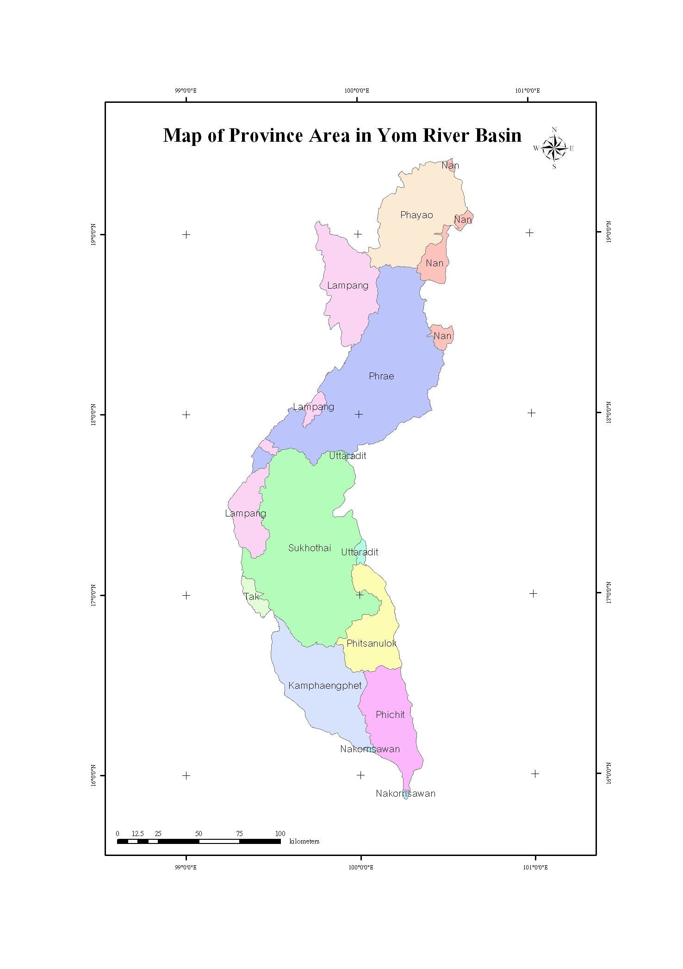
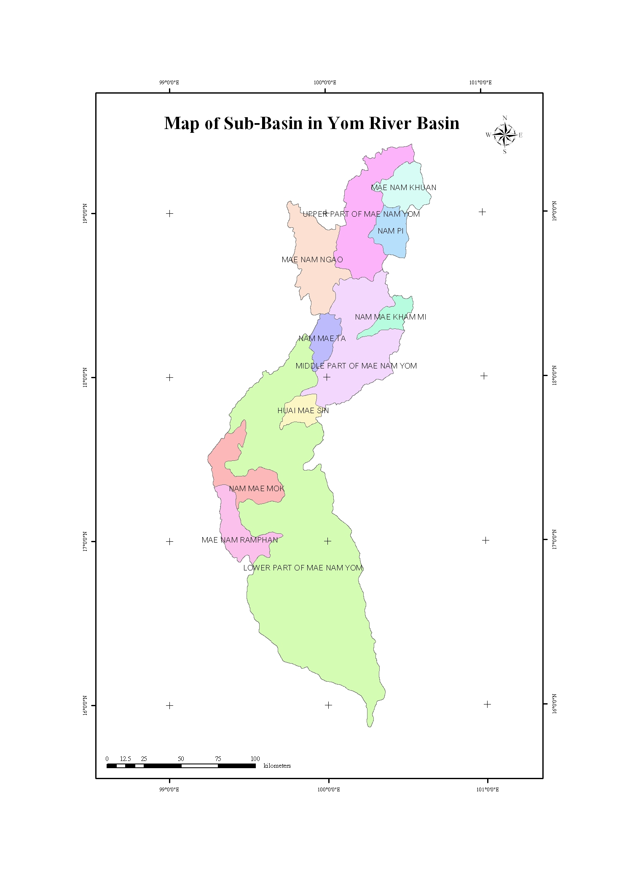

Fig. 1 Provinces and Sub Basin in Yom River Basin

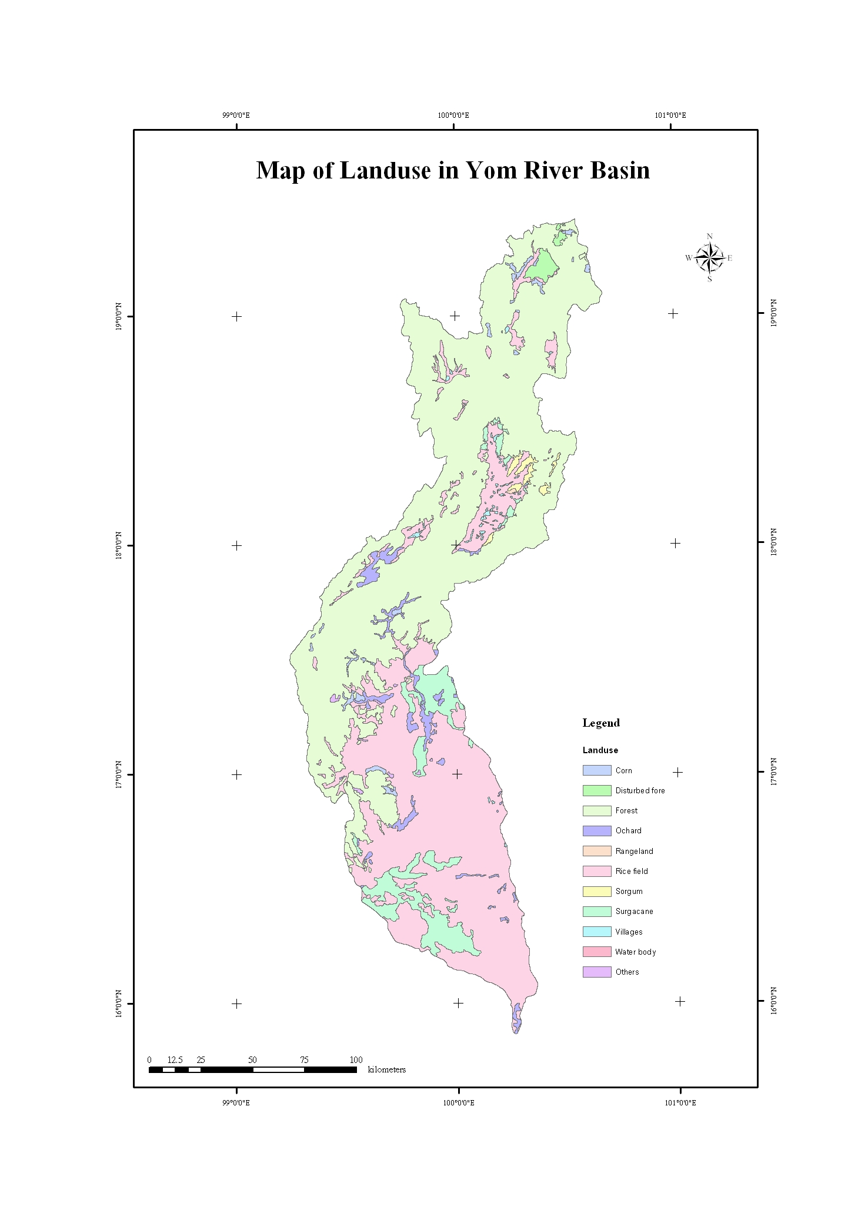
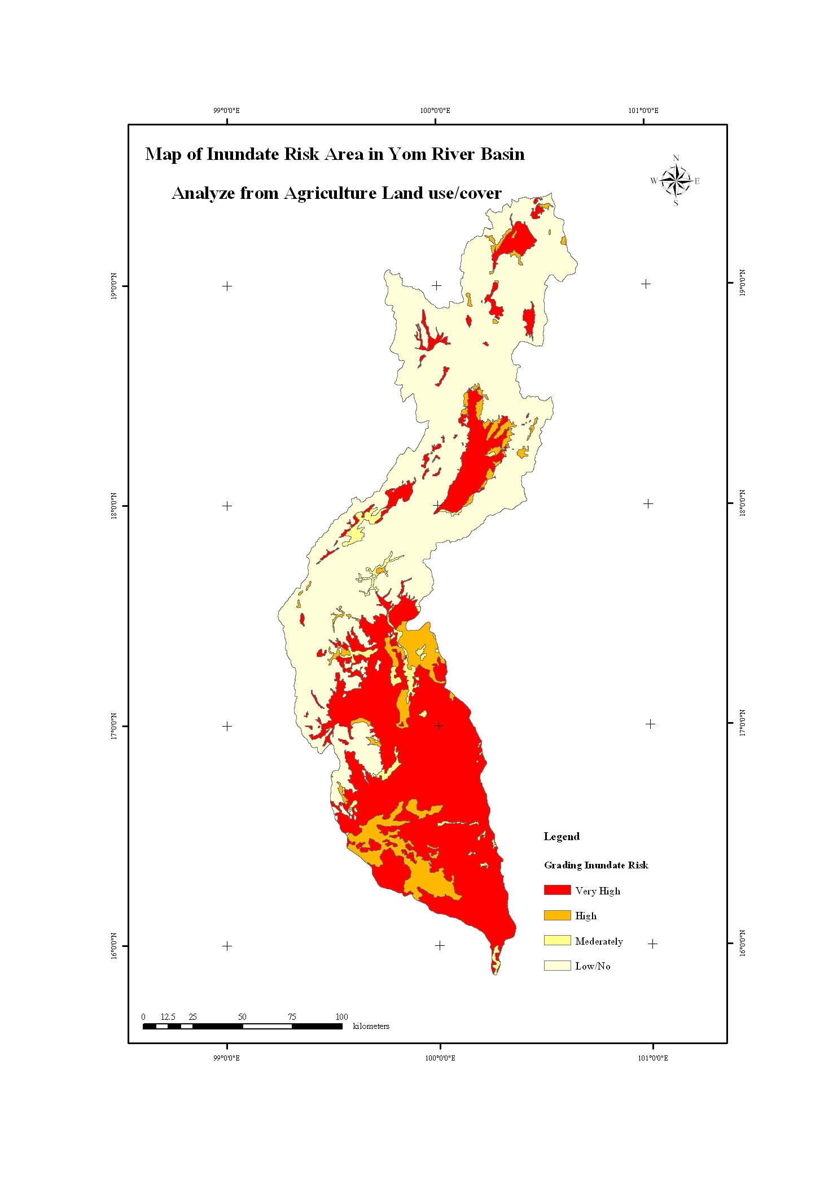

Fig. 2 Landuse and Inundate Risk by agricultural land use/cover
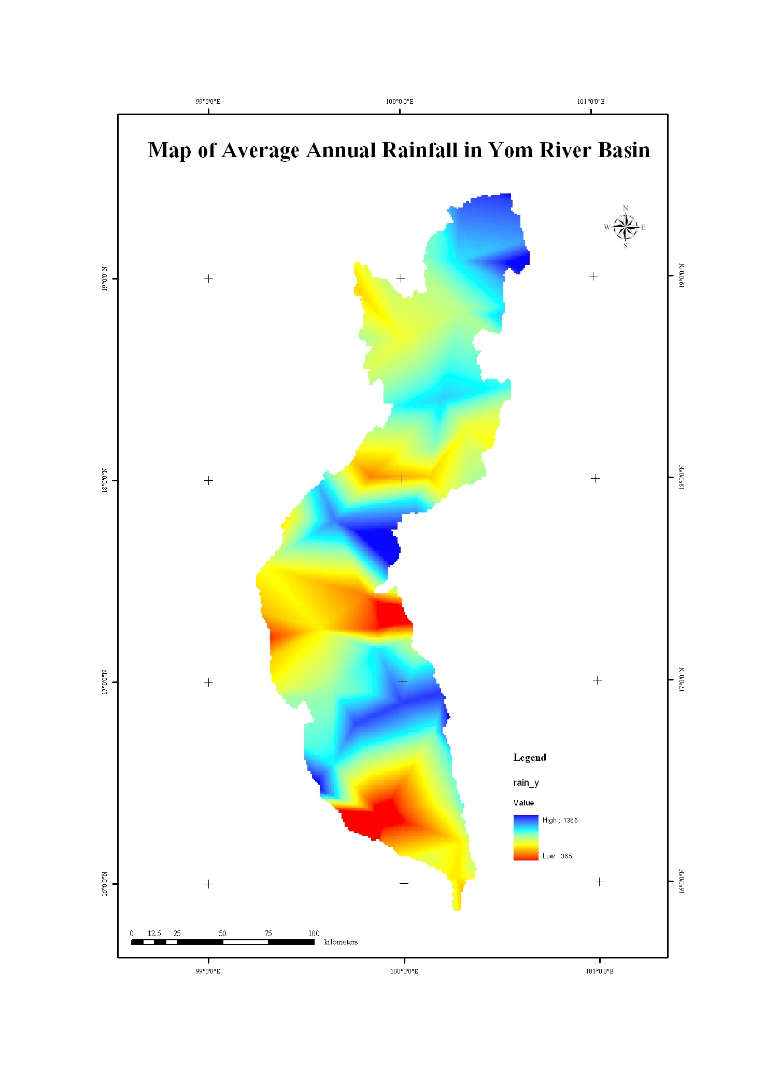
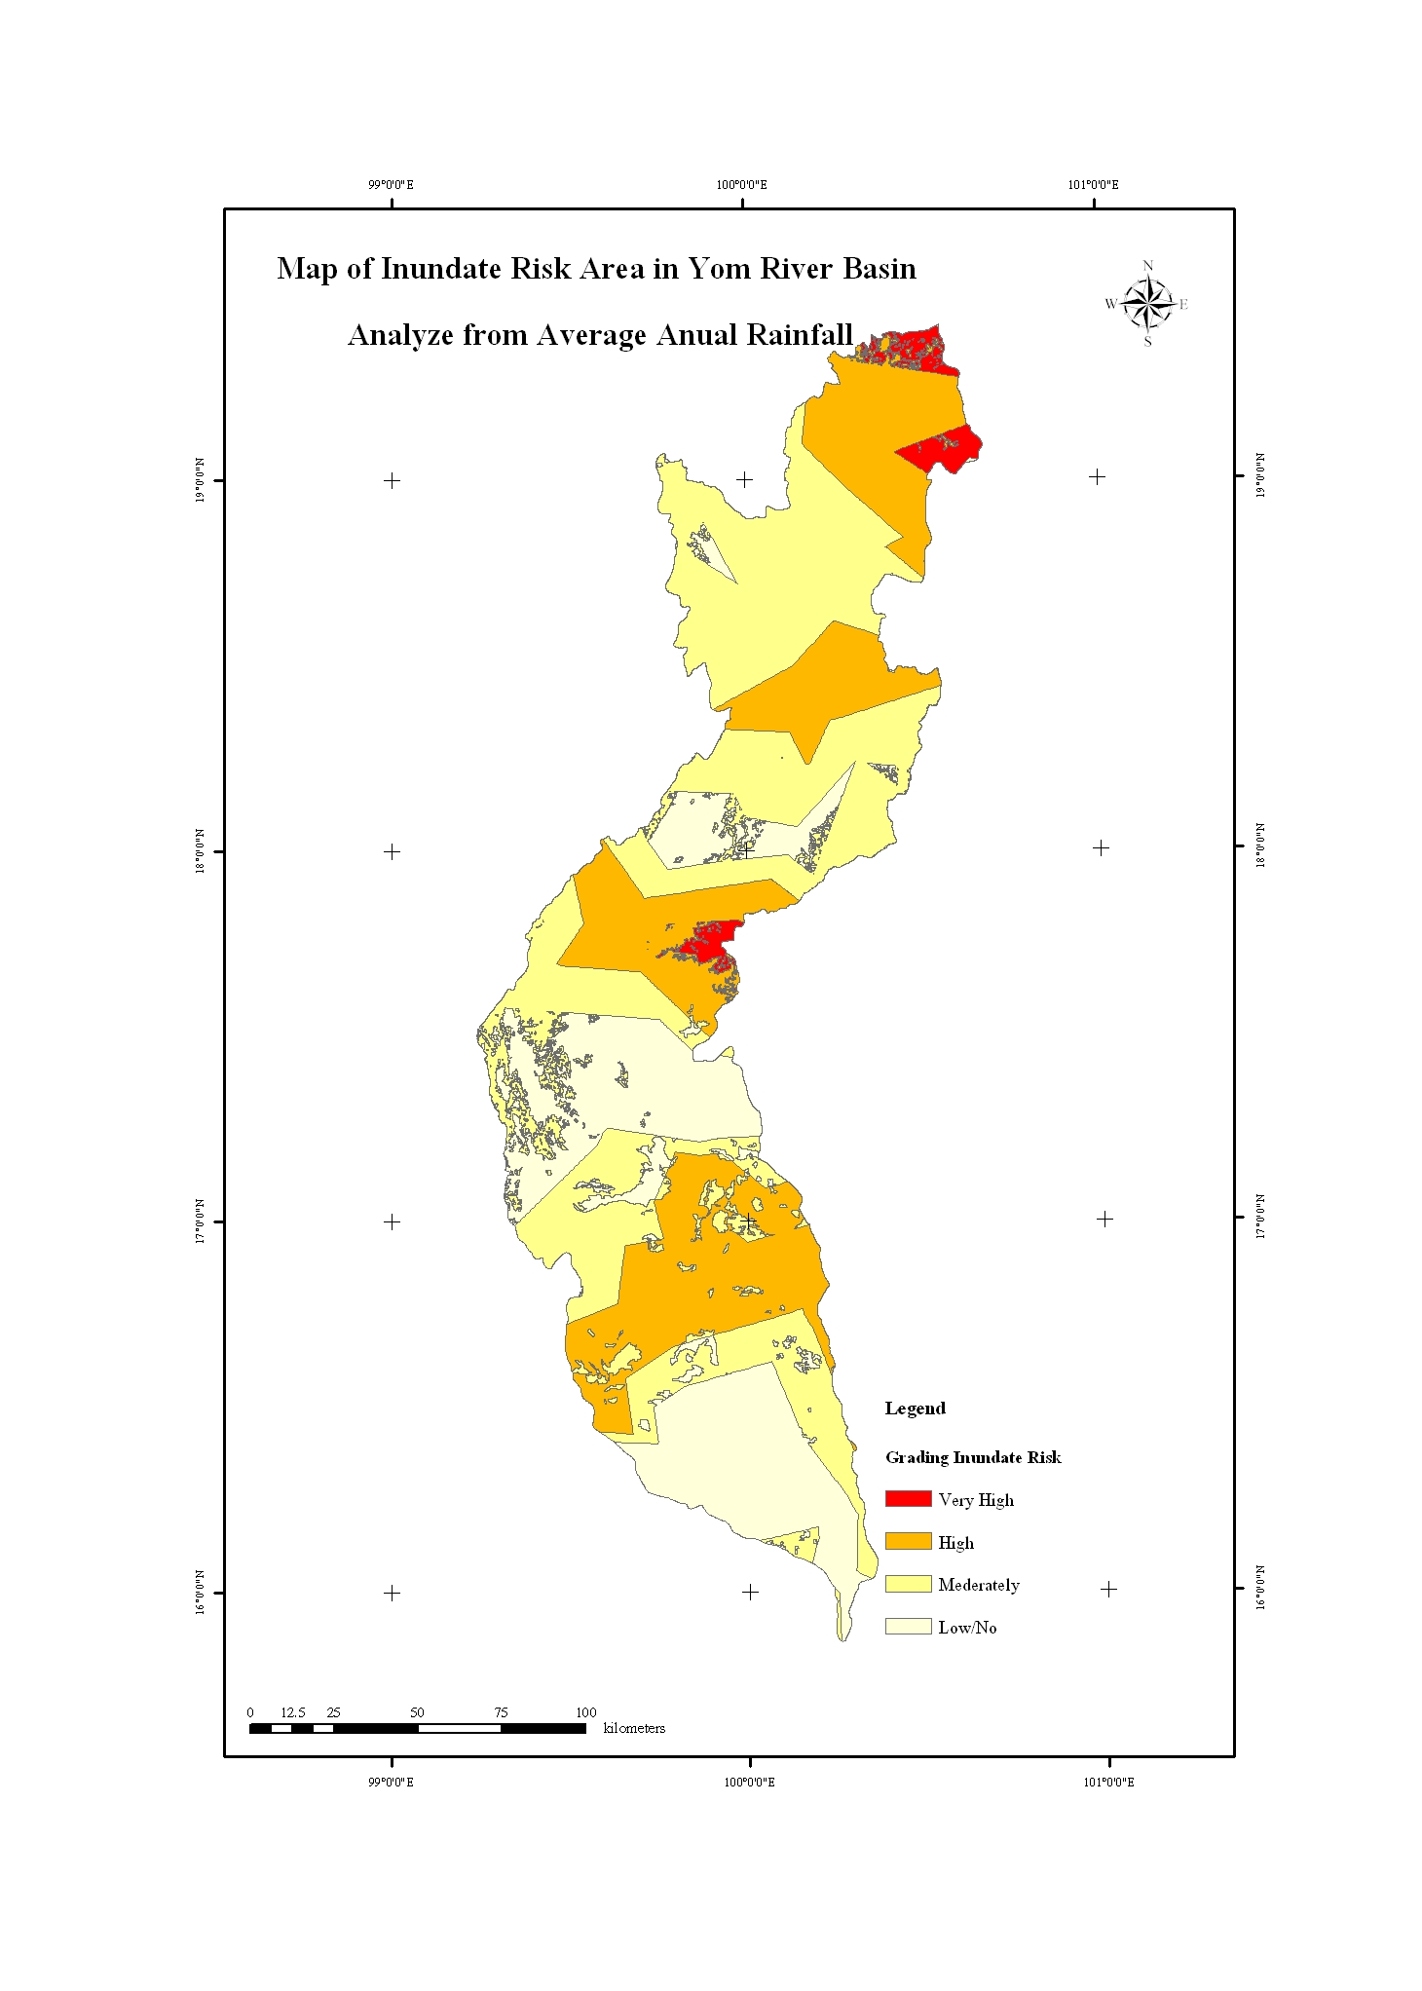

Fig. 3 Annual Rainfall and Inundate Risk by rainfall

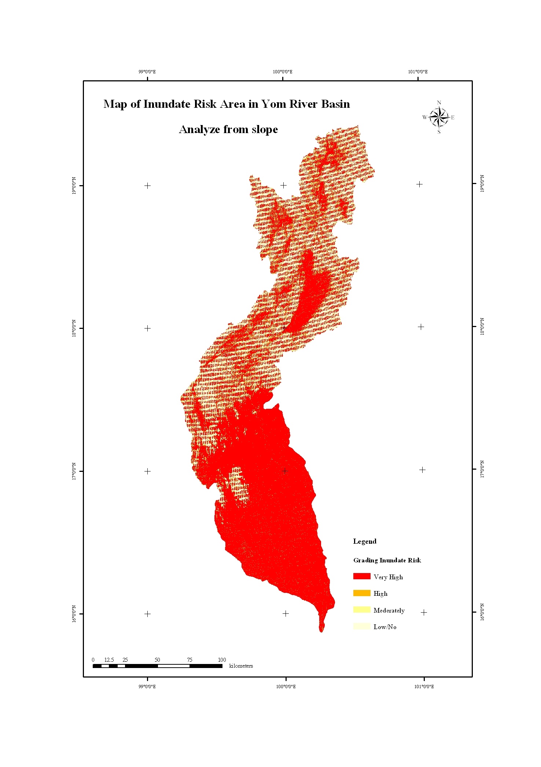
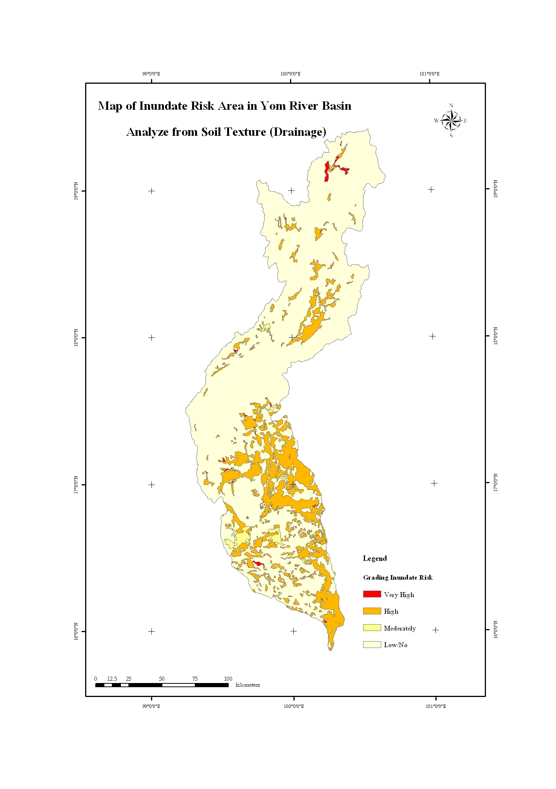

Fig. 4 Inundate Risk by Slope and Soil Texture

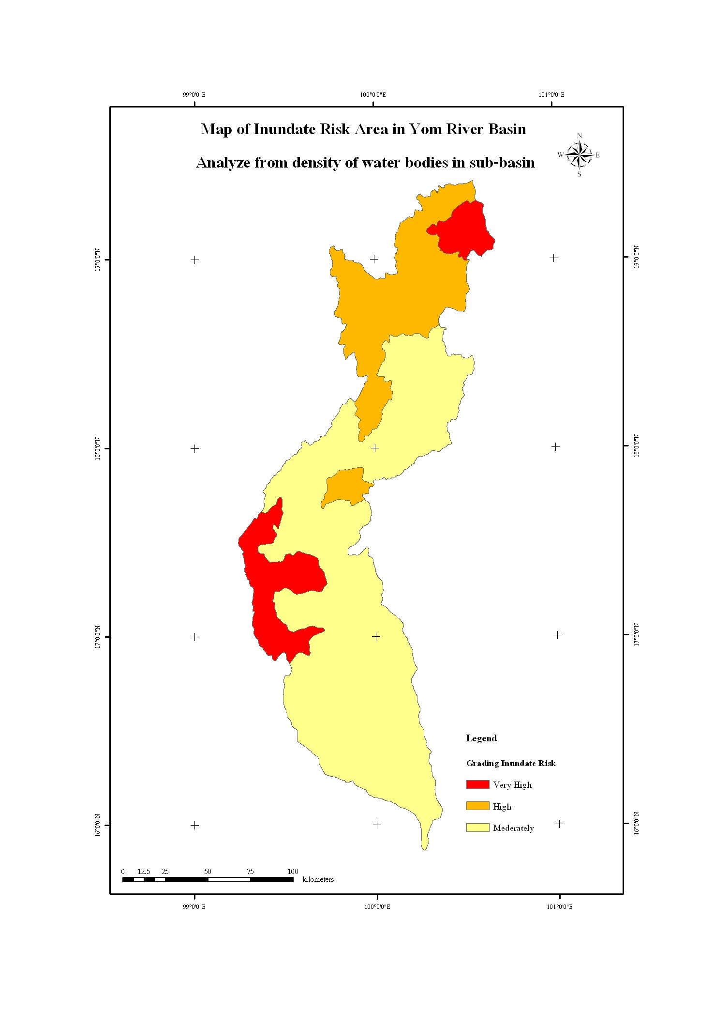
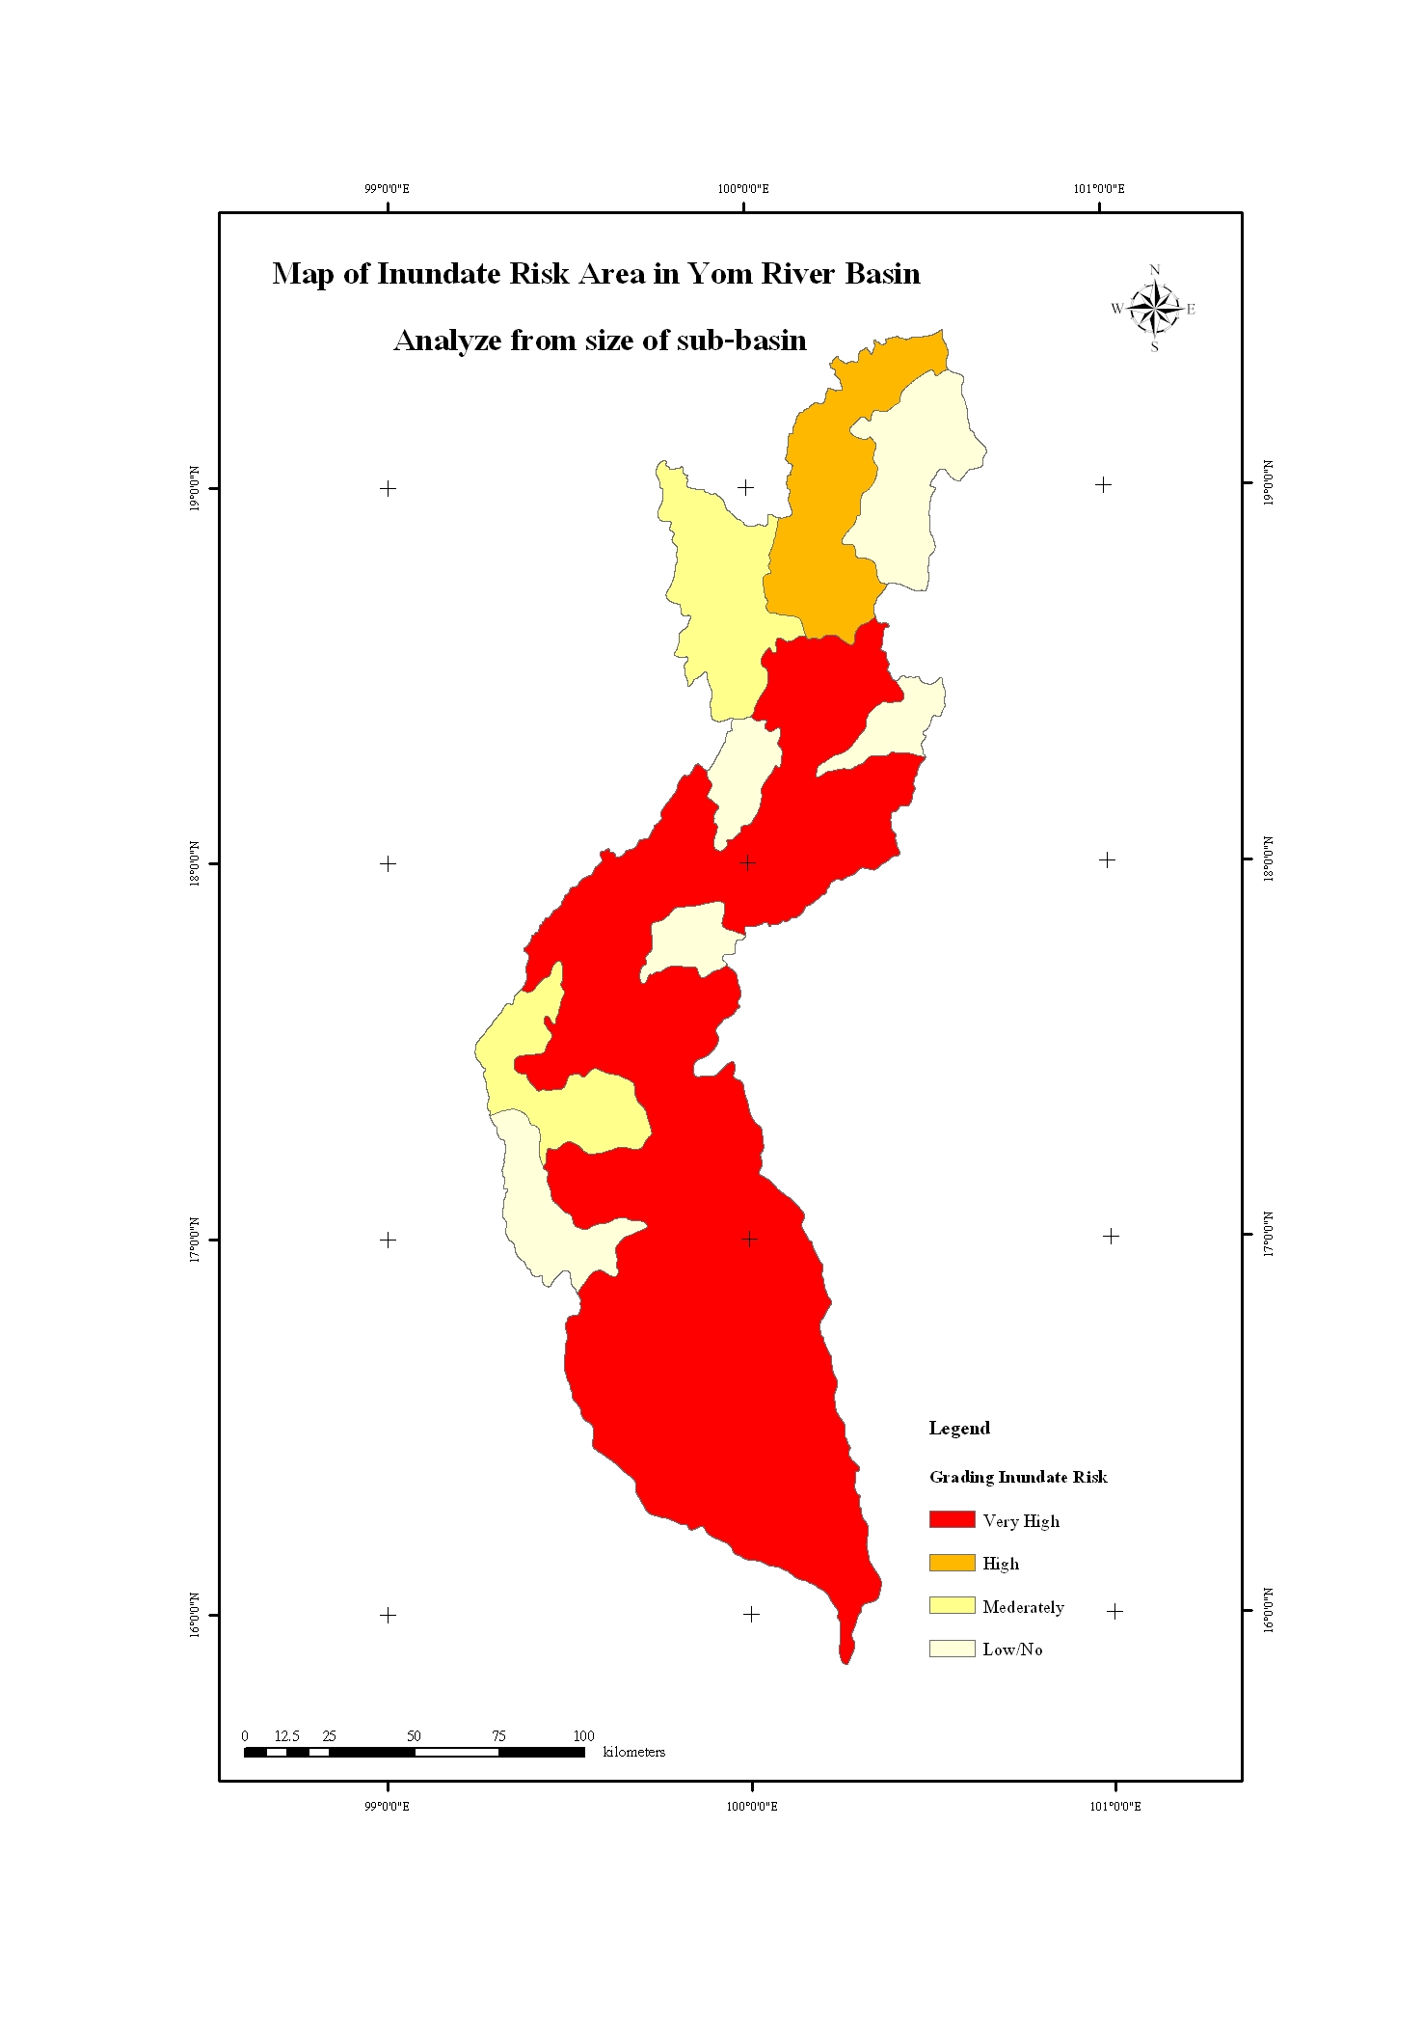

Fig. 5 Inundate Risk by density of water bodies and Size of Sub Basins

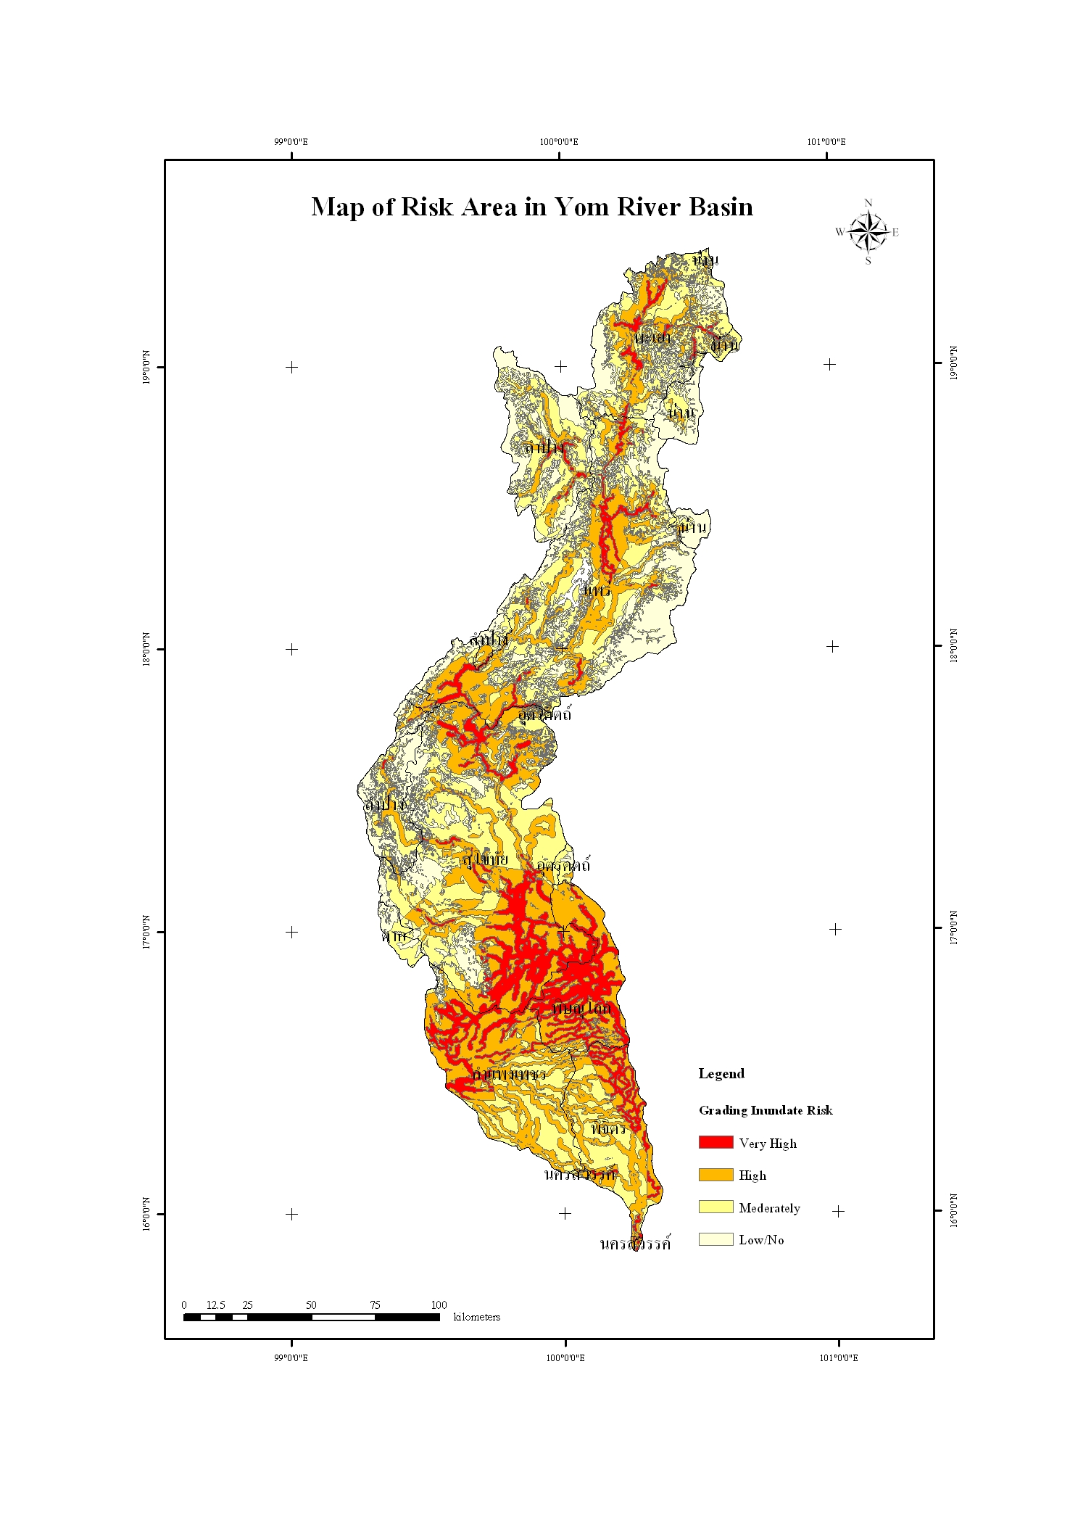

Fig. 6 Inundate Risk in Yom River Basin

Acknowledgement
LANDSAT Application and Classification Disaster Area on Yom River Basin project could not success
if the Regional Geo-Informatics and Space Technology, Lower Northern Region, Naresuan University was not received the very strongly support from Geo-Informatics and Space Technology Development Agency (Public Organization) or GISTDA in term of finance and satellite data. In this occasion, the authors would like to express
the great gratitude to all GISTDA administrative committee and the president of Naresuan University.

Reference
- Chen, G.Y. Chen. 1986. Chronological table of natural Disasters and Man-made Calamities in Various Dynasties of China. Shanghai Publishing House, June 1986.
- ESCAP/UNDP, Proceedings of the Expert Group Meeting on Comprehensive Flood Loss Prevention and Management, Bangkok 17–21 October 1988, United Nations, New York, 1988.
- Jeffrey A. Henderson, Robert W. Molacek, E.I.T., Charles F. Buzzard, and David K. Carlton, P.E. GIS AND THE FLOODPLAIN MANAGEMENT PLANNING PROCESS IN WASHINGTON STATE. Available at : http://gis.esri.com/library/userconf/proc96/ TO150/PAP149/ P149.HTM
- Yan, S.Y., S.X. Wang, C.J. Wei and F. Xu. 1988. Technical Report: Network-based Flood Quick Reporting System Using Remote Sensing, IRSA/CAS and SIC, November 1998.
- Yan, S.Y., C.J. Wei, S.X. Wang, and F. Xu. 1988. Multi-Technical Integrated System for Flood Monitoring in China. In Geoinformatics and Socioinformatics. The Proceedings of Geoinformatic’99 Conference, Li, B., et al., (eds). Amm Arbor, 19-21 June 1999, pp 1-9

