Satellite Based Spatio-temporal Environmental Momentum in Thai Binh Province, Vietnam

Rajesh Bahadur THAPA
Asian Institute of Technology, Thailand
thaparb@yahoo.com

Pham Van CU
Hanoi Agriculture University, Vietnam
phamvancu@hn.vnn.vn

Huy Chu Xuan
VTGEO, Vietnam
chuhuy@gmail.com

Frederic BORNE
CIRAD, France
Frederic.borne@cirad.fr

Vincent PORPHYRE
CIRAD-Vietnam
vincent.porphyre@cirad.fr

Abstract: Thai Binh province from eastern part of Red River Delta has been selected for satellite based environmental change analysis. Much of the land of the province is covered by agriculture activities with the majority of paddy field. Densely populated province (1183 persons/km²) has rapidly changed from conventional agriculture activities to modern integrated agriculture practices. The main objective of the paper was to find the spatial temporal momentum in environment, which would help to develop a geo-spatial based diagnostic methodology for pig production at the province. LANDSAT satellite images taken in 1989 and 2001 and vector layer of administrative boundary were used for environmental changes analysis at commune level. Soil Adjusted Vegetation Index (SAVI) was computed in each image. Mean and standard deviation of SAVI images were calculated at commune level and mapped into GIS. The mean and standard deviation of two dates were evaluated carefully for analyzing the environmental momentum in the province. Agriculture areas were found in decreasing order. Supervised classification method was applied in 2001 image to prepare legends of the land use/cover. Then commune level land use map was prepared within the acceptable accuracy. The land use map and the SAVI results were further compared to understand the relation in between. Very good compromise was observed between the different landscape and corresponding SAVI results. These results will contribute in developing diagnostic methodology of E3P project mission objective of which is to evaluate the relation between land use change and pig production system in Thai Binh and its impact on environment of the study area.
Keywords: SAVI, change detection, land use/cover, spatio-temporal, pig production.

1. Introduction

The Red River Delta (RRD) is second rice bowl of Vietnam after Mekong River delta. The delta alone produces 18% of total paddy production in the country. This densely populated delta is rapidly changing its agriculture activities to urban. A substantial population (exceeding 1000 inhabitants per square kilometer) lives in the delta [1], where their livelihoods depend to same extent on natural resources such as land for food, water and fuel and space for living. Significant population growth is putting an increasing strain on resources, which help to modify the environmental consequences. The environmental change also impinge the livelihood strategies of the people by decreasing or increasing their access to different types of capital assets including access to natural resources such as land, water, energy [2]. Changing environment is degrading natural resources and greeneries, making water pollution and pushing human health into hazard are major concerns in the delta. Pollution due to agriculture practices (crops and livestock) is one of the main issues in the delta. It is very urgent to understand the spatial temporal environmental changing momentum in the delta. Satellite based remote sensing technique is an efficient tool to monitor land-cover changes and analyze the geo-spatial momentum of the past three decades. With time series satellite data we can detect long-term changes that can be managed by GIS [3],[4],[5].

2. Study Area and Objective

Considering the pig production is one of the major official priorities for rural development in Vietnam, the eastern province of the delta namely Thai Binh is selected for satellite based environmental change analysis. About 100km east from the Vietnamese capital, the province covers 1563km² area. It has 284 communes administered by eight districts. Densely populated province (1183 persons/km²) is rapidly changing conventional agriculture activities to modern integrated agriculture practices [6]. The provincial authority prioritized a program for 2010 as the lower areas currently used for rice with very low yields into fish ponds and intensify the production systems by increasing the availability of fish, improving the feeding of fish, manuring of ponds using animal wastes especially from pig. Such intensive agricultural methods may cause environmental degradation in lacking of proper protection measures.
The main objective of the paper is to find the spatial temporal momentum in environment in the province, which helps in developing a geo-spatial based diagnostic methodology for pig production at the province. This work will be a base for a decision making and strengthening tool for the Thai Binh's authorities in order to define urgently suitable technologies for land-use and investment planning, and to enforce the regulation considering environment.

3. Database and Methodology

Efficient integration of temporal, spectral and spatial resolution information is important for analysing and mapping of environmental change analysis [1]. Multi-sensor and multi-temporal data are useful for assessing change dynamics but seasonal variances could affect in images for quantitative analysis [7],[8]. Therefore, we had prepared multi-temporal Landsat images of same month (November) of two different years (1989 and 2001) to avoid the seasonal variances in environmental change analysis in Thai Binh province. Commune level boundary file and field survey data of 2005 were also used in image classification and commune level change analysis.

3.1. Vegetation Analysis

Soil Adjusted Vegetation Index (SAVI, eq. 1) of both images was prepared to identify the greenery patterns in the province. This index computes the ratio between red and near infrared spectral region with some added terms to adjust for different brightness of background soil [9],[10].
$\text{SAVI}=\left[\frac{λ_{\text{NIR}}−λ_{\text{RED}}}{λ_{\text{NIR}}+λ_{\text{RED}}+L}\left(1+L\right)\right]+1$ (1)

Note: $λ=\text{wavelength},L=0\text{.}5$

Originally all the equations produce relative value ranges from –1 to +1. We have added 1 in each equation for avoiding the negative value. Therefore, the entire resulted images will have the value between 0~2 where higher value represents better existences of the vegetation. Mean (eq. 2) and Standard Deviation (eq. 3) were computed from each index at commune level that improves the evaluation procedure of environmental situation.

$\text{Mean}(μ)=\frac{\sum{X}}{n}$ (2)

$\text{Std}\text{.}\text{Dev}(σ)=\sqrt{\frac{\sum_{i=1}^{n}{(X_{i}}−μ)^{2}}{n−1}}$ (3)

$X=$a set of value and $n=$number.

Five relative scales as Very High, High, Medium, Low and Very Low were prepared (eq. 4) in both year indexes for analysing the environmental momentum at commune level.
$\text{RS}=\frac{\text{Max}−\text{Min}}{n}$ (4)

3.2. Legend Preparation for Land Use

The digital image processing techniques required for the land use legend preparation is described in (fig 3.2). Image enhancement, knowledge-based visual interpretation, texture and association analysis [11] and SAVI computation have been done at first. A field survey was conducted to improve the quality of image classification and interpretation.
Field Visit Maps
Supervised Classification
Land Use Map 2001
Accuracy Assessment
RS Image 2001
Image enhancement
Visual Interpretation
SAVI for vegetation
GPS Locations
Photographs
Ground Truth
Classical (Kappa Index)
Band Selection
Training sample selection
Signature evaluation
Maximum Likelihood Classification
RS Image 2001
Fig. 3.2: Land Use Legends Preparation Model.
Legends
Maps, Global Positioning System (GPS) instrument and a handheld digital camera were used while visiting the field. After field visit, supervised classification had been performed on the selected classes scheme employing Bayesian Maximum Likelihood Classifier (MLC). MLC, a parametric decision rule, which is a well-developed method from statistical decision theory, has been applied to problem of classifying image data [12], [13]. Seventy percent of the ground truth data were used for setting the training areas. After obtaining a suitable indication for satisfactory discrimination between the classes during spectral signature evaluation, final classification procedure was run to produce land use legends.
Accuracy assessment in remotely sensed image classification is necessary for validating the obtained results [14]. Remaining thirty percent of the ground truth data were used in setting the training areas for the accuracy assessment. Kohen’s Kappa (eq. 5) index [15] was applied to get overall accuracy as well as error of omission and error of commission for each land use category.
$\text{Kappa Index}κ=\frac{d−q}{N−q}$ (5)
Where, d = total along the major diagonal
q = sum (row total × column total)
N = total number of points

4. Results and Discussions

SAVI was computed in Landsat images of 1989 and 2001 and we have tried to analyze the spatio-temporal environmental momentum in respect of vegetation. The index produced the results based on electromagnetic spectrum recorded in the images. Mean and standard deviation from both indexes are plotted in Fig. 4.1, which describes the distribution patterns of SAVI indexes in different dates. Standard deviation of mean helps to understand the distribution pattern of the objects in land surface. The mean score and coefficient of standard deviation of each index were carefully evaluated at commune level. Uneven distribution pattern of the mean of SAVI were found in some communes. Decreasing order of vegetation was observed in 2001 as compared to 1989. Decreasing patterns in SAVI can expose the avoiding of conventional agriculture practices (i.e. paddy) or adopting new integrated techniques of agriculture practices in some extent. Several farmers are in the way of changing their traditional agriculture land to modern integrated agriculture system such as pig, poultry, fish and other cash crops was observed in the field visit. Furthermore, pig waste is being used as a source of input for aquatic farming fertilization of ponds, nutrient for fishes. Due to high demand of lean pork meat to the growing cities and flexible government policies farmers are attracted to the integrated agriculture practices (pig and fish ponds together). It may be one of the major factors of reducing vegetation properties in 2001 as compared to 1980s.
For understanding spatio-temporal environmental momentum, the SAVI scores of both images further converted into five relative scales as very high, high, medium, low and very low representation of vegetation and mapped into vector GIS (Fig. 4.2 and Fig. 4.3) at commune level. The environmental changing momentum can be easily observed in both maps. As compared to the SAVI result of 1989 with 2001, 177 communes in the province were remained unchanged (Table 4.1). For example, three communes namely Thai Hue, Thai Xuyen, Thai Hoa from Thai Thuy district were in very high class in 1989 remained same in 2001 although there are differences in index scores (Fig. 4.1). The rest of the communes faced different types of environmental changes over the decades, some communes lost their environmental status whereas some communes made significant progress. Thirty-four communes changed their status from very low to low in 2001. Eight communes of 1989 were found moving their status from medium to low category in 2001 where as 9 communes changed their status from medium to high and one commune called Quynh Ngoc commune from Quynh Phu district made significant progress changing its status from medium to very high. Similarly, decreasing pattern is found in seven communes from high to medium class but two communes namely Quynh Lam and Quynh Khe from Quynh Phu district have leaded high to very high class in 2001. The Van Cam commune from Hung Ha district deserved very high class in 1989 but lost the status falling to medium class in 2001. A big number of communes (44) were changed their status from low class (1989) to medium class (2001).

Table 4.1: SAVI Based Spatio-temporal Environmental Momentum (1989-2001, November)
Year | 2001
1989 | Scale | Very Low | Low | Medium | High | Very High | Total
1989 | Very Low | 7 | 34 |  |  |  | 41
1989 | Low | 1 | 98 | 44 |  |  | 143
1989 | Medium |  | 8 | 54 | 9 | 1 | 72
1989 | High |  |  | 7 | 15 | 2 | 24
1989 | Very High |  |  | 1 |  | 3 | 4
1989 | Total | 8 | 140 | 106 | 24 | 6 | 284

Based on field survey 2005, the November 2001 image was classified where six types of land use legend namely, Lowland Agriculture, Upland Agriculture, Integrated Agriculture, Village with Agriculture, Urban Function and Water Bodies were prepared at 82.46% of overall accuracy. The classical Kappa Coefficient (KC) was computed as 0.78. Lowland agriculture legend represents paddy field whereas upland agriculture comprises maize, soybean, mulberry, sugarcane, mustard, banana, citrus, tea, coffee, etc. In some areas, farmers are practicing integrated agriculture such as fishpond linked to poultries and pigs farming surrounded by banana and citrus trees. Such areas are assigned the legend as integrated agriculture. From the legend map (Fig. 4.4), the village with upland agriculture covers 635 km² areas as largest one in the province. Basic agricultural practice is also observed around the home in many villages, which supports daily needs of vegetables and fruits to the householders and earn cash in some extent. Lowland agriculture as paddy field occupies about 40% (622 km²) land of the province. The other legends show nominal representations in the province.
However, the legend map completely reflected the result of SAVI 2001 as mirror. The SAVI map of 2001 shows low to very low class in corresponding legend of low land agriculture areas (paddy field) in the legend map. Paddy fields are often kept as bare in November because of paddy harvested in October and farmers prepare their land for another crops. There is seasonal effect in the image taken in November, especially while computing SAVI. Therefore, the SAVI mean gets lower in the communes with paddy as major agriculture. The upland agriculture remains green in November therefore the SAVI gets higher on those areas. Thus, the SAVI results reflects medium to very high in the upland agriculture and the village with upland agriculture areas. Lowering the SAVI curve is not mean to increasing urban functions or integrated agriculture practice, it may be due to seasonal effects, paddy harvesting period for example. As the legend map shows second largest coverage to the lowland agriculture in the province land but it lowered the SAVI due to harvesting period.

Fig. 4.1: Soil Adjusted Vegetation Index 1989-2001 (Mean & Std. Dev.)
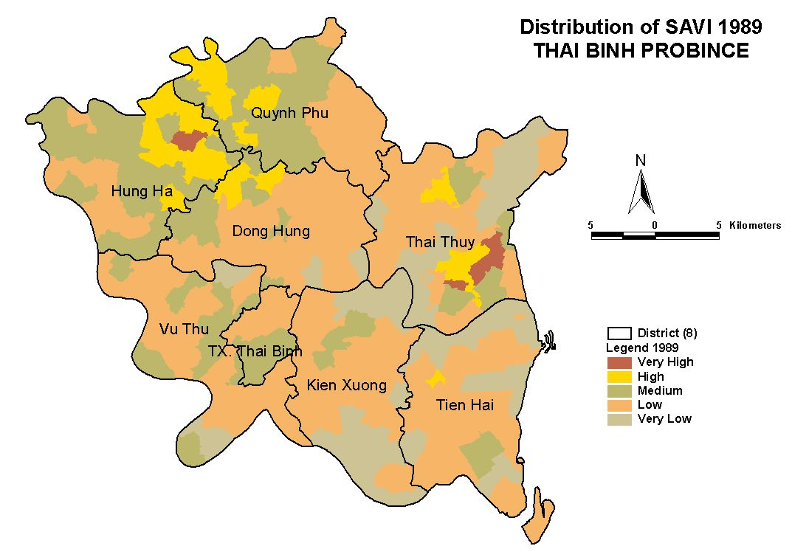
Fig. 4.2 SAVI 1989 Nov.
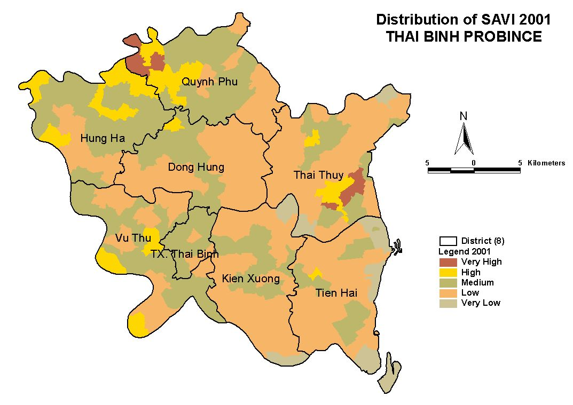
Fig. 4.3: SAVI 2001 Nov.
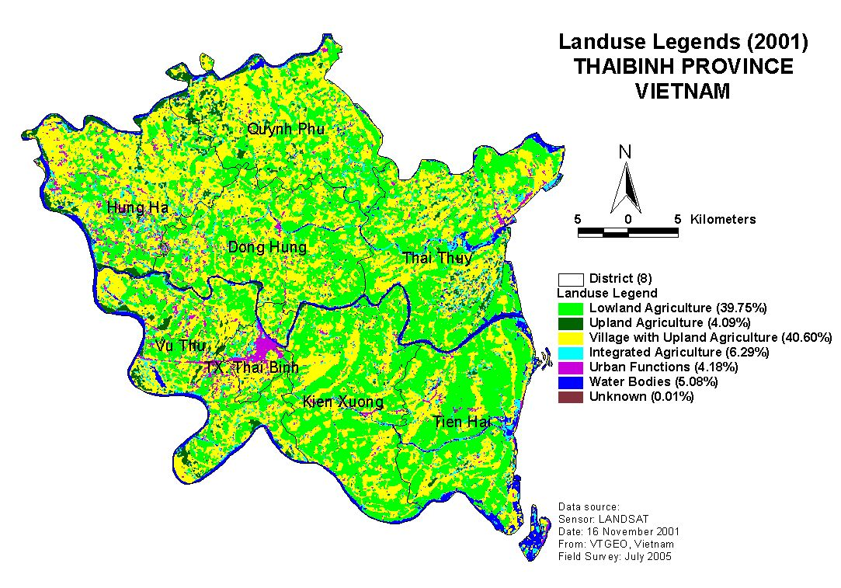

Fig. 4.4: Land Use Legend, Thai Binh Province

5. Conclusion

Landsat satellite imageries are found very useful to understand the spatio-temporal environmental momentum in Thai Binh province. Much of the land in the province is being used for paddy production and upland agriculture. The farmers are adopting integrated type of agriculture practices such as poultry, pig and aquatic farming together. The SAVI maps are able to analyze clearly the environmental momentum during twelve years of period. Similar results are observed from the legend map and the SAVI 2001 map. The legend map is able to validate the SAVI map significantly presenting similarity in the results in diverse landscapes. The degree of evaluation and level of accuracy may be different place to place. However, these results gives clear picture of environmental changing pattern at commune level in the province. This will contribute in developing diagnostic methodology of E3P project mission objectives in evaluating the relation between land use change and pig production system in Thai Binh and its impact on environment of the study area.

Acknowledgement


This study was conducted in the framework of European Commission’s Asia Pro Eco Programme / E3P Diagnostic Project 2005-2006 - “Environment Protection & Pig Production” in Thai Binh Province, Vietnam. More details are available on http://pigtrop.cirad.fr/en. The authors wish to thank all the partners (NIHA, VTGEO, AIT and CIRAD-Vietnam) involved in this programme for their contribution to the field trip, baseline survey, dataset and useful suggestions. We also thank to Global Land Cover Facility (GLCF) and USGS for providing Landsat Image (P126R0467T19891123) freely.

References
[1] Thapa, R.B. (2003). ‘Spatial Decision Support Model for Sustainable Peri-urban Agriculture: Case Study of Hanoi Province, Vietnam’. MSc. Thesis. Asian Institute of Technology, Thailand.
[2] Brook, R.M. and J.D. Davila (2000). ‘The Peri-Urban Interface: A Tale of Two Cities. School of Agricultural and Forest Sciences’. University of Wales and Development Planning Unit, University College London.
[3] Maingi, J. K. and S. E. Marsh (2001). ‘Assessment of Environmental Impacts of River Basin Development on the Riverine Forests of Eastern Kenya Using Multi – Temporal Satellite Data’. International Journal of Remote Sensing, 22: 2701–2729.
[4] Burrough, P.A. and R.A. Mcdonnel (1998). ‘Principal of Geographical Information System’. Oxford University Press, USA.
[5] Moran, M. S., R. D. Jackson, P. N. Slater and P. M. Teillet (1992). ‘Evaluation of Simplified Procedures for Retrieval of Land Surface Reflectance Factors from Satellite Sensor Output’. Remote Sensing of Environment, 41:169–184.
[6] Thapa, R.B., F. Borne, P.V. Cu and V. Porphyre (2005). ‘Environmental change analysis using satellite imageries: case study of Thai Binh province, Vietnam’. Available online: http://pigtrop.cirad.fr/en/worldwide/asie_VN_Asiaproeco_SATELLITE_MapAsia.htm
[7] Doung, N.D., L.K. Thoa, N.T. Hoan, T.A. Taun, H.L. Thu and K.C. Seto (2003). ‘A Study on Urban Growth of Hanoi using Multi-temporal and Multi-sensor Remote Sensing Data’. Asian Journal of Geoinformatics, 3 (3).
[8] Xiuwan, C., H. Heping, R. Tateishi and C. H. Ahn (1999). ‘A Method on Land Cover Classification by Combining Unsupervised Algorithm and Training Data’. Geocarto International, 14 (4).
[9] Huete, A. R. (1988). ‘A soil-adjusted vegetation index (SAVI)’. Remote Sensing of Environment, 25: 295-309.
[10] Millington, A. C. and R. W. Alexander (2000). ‘Vegetation Mapping in the Last Three Decades of the Twentieth Century’. Vegetation Mapping: From Patch to Planet. John Wiley & Sons Ltd.
[11] Lillesand, T. M. and R. W. Kiefer (2000). ‘Remote Sensing and Image Interpretation (4th Ed.)’. John Wiley & Sons, Inc. New York.
[12] Shrestha, R.P. (1999). ‘Developing Sustainable Land Use Systems through Water Conservation in the Sakae Krang Watershed, Center Thailand’. PhD Desertion, Asian Institute of Technology, Thailand.
[13] Turker, M. and E. Derenyi (2000). ‘GIS Assisted Change Detection Using Remote Sensing’. Geocarto International, 15 (1).
[14] Stehman, S.V. (1997). ‘Selecting and interpreting measures of thematic classification accuracy’. Remote Sensing of Environment, 62:77–89.
[15] Richards, J.A. and X. Jia (1999). ‘Remote Sensing Digital Image Analysis’. Springer- Berlin, Germany.

