Tsunami Disaster Assessment of Ports in India
by using QuickBird Images

K.Kozai, E.Kobayashi, M.Kubo
Kobe University Faculty of Maritime Sciences
5-1-1, Fukaeminami, Higashinada, Kobe, Japan
kouzai@maritime.kobe-u.ac.jp

K.Morita
Mitsui O.S.K. Lines, Ltd.
2-1-1, Toranomon, Minatoku, Tokyo, Japan

Abstract: Tsunami damage to the breakwaters in Chennai and Ennore ports along the eastern coast of India is assessed by using pre and post Tsunami QuickBird panchromatic images with 60cm spatial resolution and field survey after the Tsunami. Since there are no absolute ground control points available for geometric correction of images, ground control point matching between pre and post Tsunami images is performed to evaluate the displacement of breakwaters at two ports 24km apart. Displacements of breakwaters in Chennai port between pre and post images indicate the magnitude of 2 to 3 meters with the direction of northwest and southeast, while the displacements of breakwaters in Ennore port indicate the magnitude of 1 to 2 meters with the direction of southeast. The different direction and magnitude of displacement in breakwaters between these two ports may imply the different influences of Tsunami on breakwaters with openings of different directions. That is, the direction of opening in Ennore port is favorable for the direction of Tsunami with the northwest propagation, while the direction of opening in Chennai port is toward the northeast, which is normal to the Tsunami propagating direction. Hypothesis is made on the different impact of Tsunami on breakwaters in Chennai and Ennore ports.
Keywords: Tsunami Damage, Displacement of Breakwaters, GCP Matching, QuickBird Panchromatic Images.

1. Introduction
The Tsunami triggered by the Off-Sumatra Earthquake on Dec.26, 2004 caused devastating damages in the coastal areas around the Indian Ocean. It is reported that the size of the earthquake is second only to the 1960 Chilean earthquake [1] and the Tsunami propagated across the Indian Ocean at a speed of more than 800km/h. Ports and harbors along the eastern coast of India and Sri Lanka are among the hardest hits by the Tsunami. Although numerous scientific reports on the Tsunami damages have been released [2][3][4], the damages of ports and harbors are not well clarified because of the restricted admission to major ports just after the Tsunami.
Investigations of tsunami damage on ports and ships have been carried out by the research group of Kobe University Faculty of Maritime Sciences since 2002. In response to the Off-Sumatra Earthquake Tsunami, a member of the research group (K.M.) was dispatched for investigating the damages of ports and ships at Chennai in India and Colombo, Galle in Sri Lanka during the period from Jan.16 to 24, 2005.
The purpose of the study is to assess the Tsunami damages on breakwaters of Chennai and Ennore in India by using high spatial resolution QuickBird images with reference to the field survey and thereby contribute to the Tsunami countermeasures of ports and ships.

2. Satellite Data and Field Survey
A field survey was conducted during the period from January 16 to 24, 2005 at Chennai in India and Colombo, Galle in Sri Lanka with the staffs from Chennai Port Authority and Sri Lanka Port Authority.
The port of Chennai has a history of more than 100 years as a hub port in the eastern coast of India. In 1983 new container and passenger ship berths were built and now the bulk cargo such as coal, iron ore, automobiles are handled. On the other hand the port of Ennore was originally conceived as a satellite port to the Chennai Port,
Table 1. Specifications of QuickBird.

Fig.1 QuickBird standard panchromatic image of Chennai (left, Nov.15, 2004) and Ennore (right, Nov.20, 2004) ©2004DigitalGlobe.

primarily to handle coal to meet the requirement of Tamil Nadu Electricity Board. The scope of the port is now expanded taking into account subsequent developments such as a LNG power project, a petrochemical park [5].
The detailed field survey concerning the purpose of this study is summarized as follows.
(1) The first Tsunami was observed at the height of 6m at 09h05min local time. Subsequent Tsunamis were also observed at the height of 2~3m.
(2) A strong backrush just after the first Tsunami created muddy stream within the port, which caused cutting the mooring cables of 6 ships, one of them drifting and destroyed the breakwater.
(3) Because of the strong muddy stream within the port a part of the breakwater was tilted eastward about 20 degrees.
These are only parts of damages reported for ships and breakwaters. Port facilities like dolphins and container cranes were also damaged.
QuickBird standard panchromatic images with 60cm spatial resolution are used for detecting changes made on the breakwaters at Chennai and Ennore ports before and after the Tsunami. Standard images before the Tsunami are illustrated in Fig.1 and specifications of QuickBird are shown in Table 1. Standard image is one of the QuickBird satellite products distributed by DigitalGlobe, Inc. and processed based on the specific map projection (UTM) ,the spheroid (WGS84) and resampling method (cubic convolution).

3. Assessment Method

In order to assess changes made on the breakwaters at Chennai and Ennore ports before and after the Tsunami, QuickBird Standard images must be precisely corrected geometrically. Ground Control Points (GCPs) such as road intersections are usually chosen for geometric correction of the images. Since there are no absolute ground control points available for geometric correction of images, which is generally the case in the disaster areas, and the accuracies of Standard Imagery products have an average absolute location accuracy of 23m [7], Ground Control Point matching between pre and post Tsunami images is employed for the precise geometric correction. GCP matching is defined as a method finding a sub-pixel position in the corresponding image with the highest correlation coefficient, and creating a GCP at that position [8]. Fig.2 shows the flowchart to derive displacement vectors of breakwaters. Displacement vectors are defined as the post minus pre-image locations of GCP and of the specific points (called Check Point (CP)) on the breakwaters. The distribution of the location of Ground Control Points and Check Points are illustrated in Fig. 3. 7 GCPs and 9 CPs at Chennai and 6 GCPs and 8 CPs are acquired at Ennore respectively.
Table 1. Specifications of QuickBird [6].

Orbit altitude 450km
Inclination 98°
(Sun-synchronous Polar orbit)
Weight 950kg
Mean repeat period 1～3.5 days
Sensor Push-broom
Pointing Forward, backward, right, left ±30°
Panchromatic resolution 0.61m（at nadir）
Panchromatic bandwidth 450～900nm
Multi-spectral resolution 2.44m（at nadir）
Multi-spectral bandwidth Blue 450～520nm
Green 520～600nm
Red 630～690nm
Near IR 760～900nm
Swath Snapshot：16.5Km×16.5Km

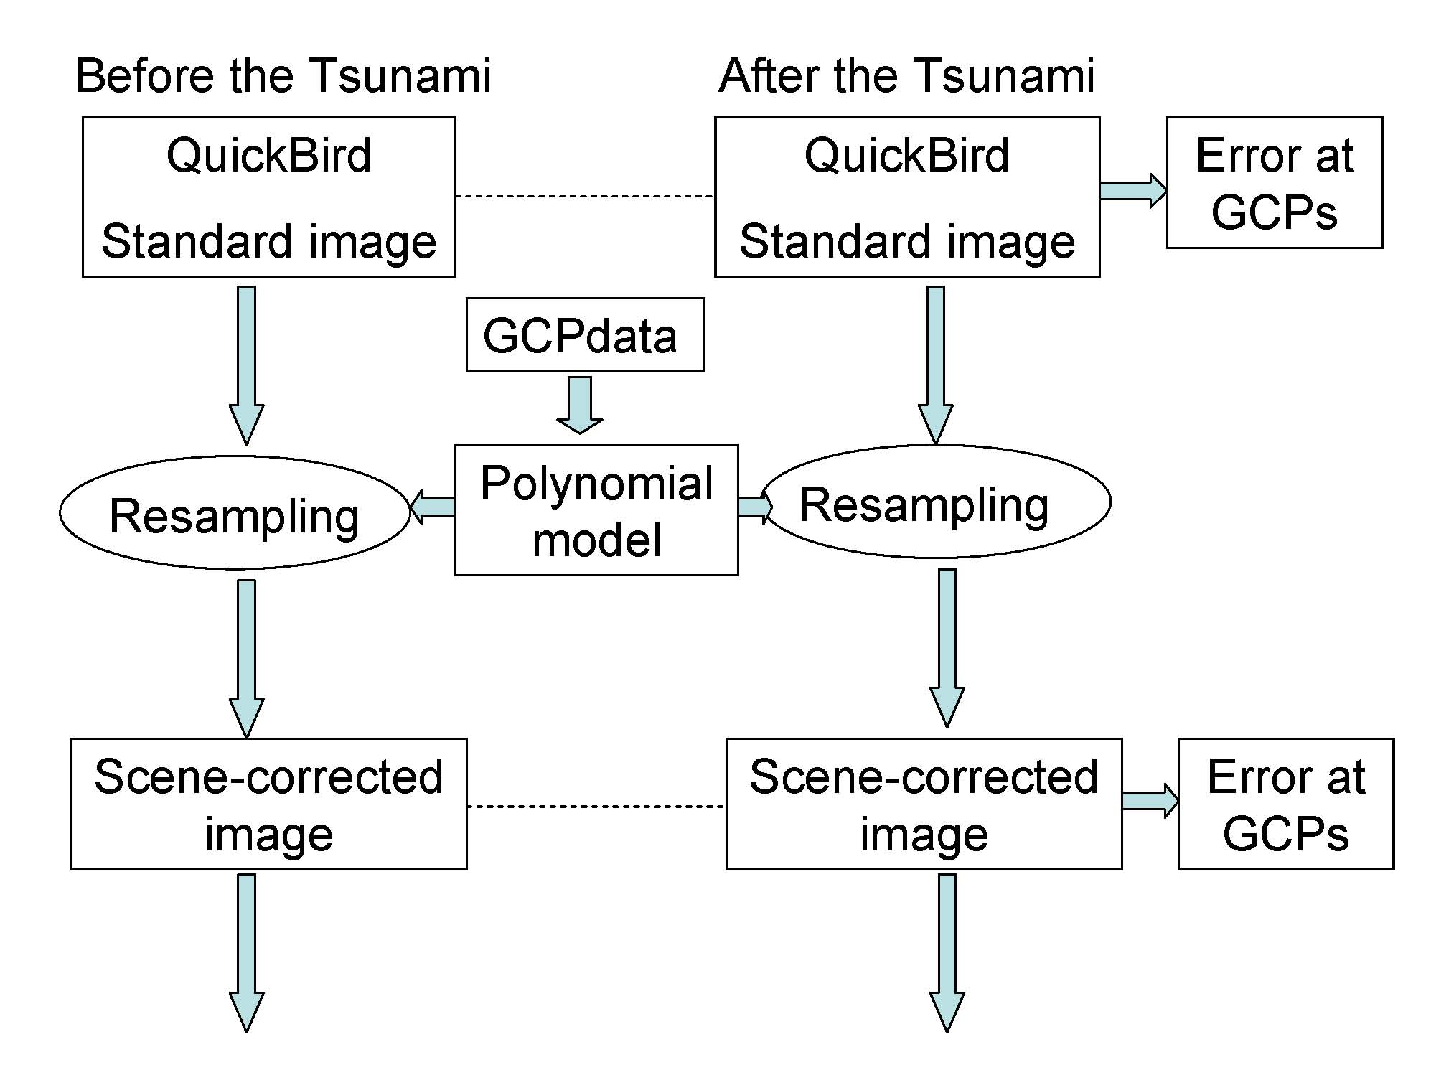

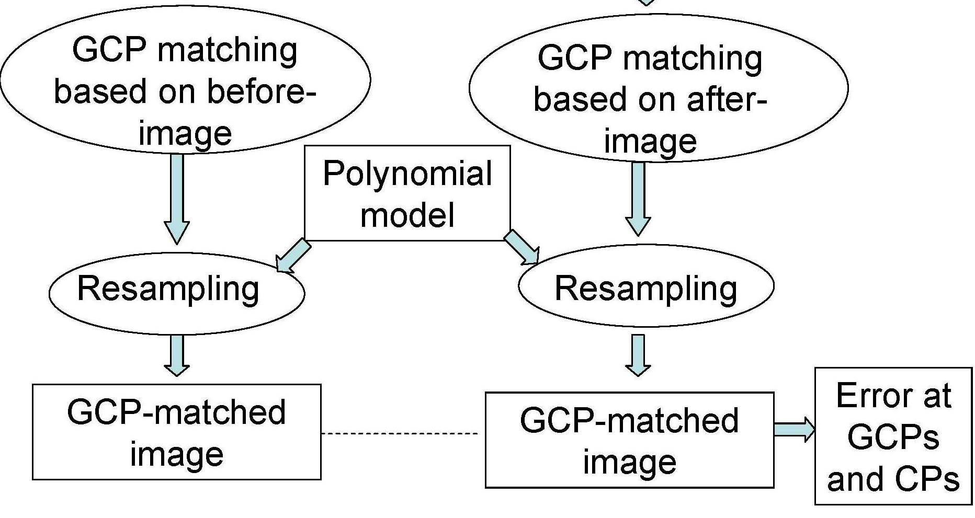

Fig.2 Flowchart to derive displacement vectors.

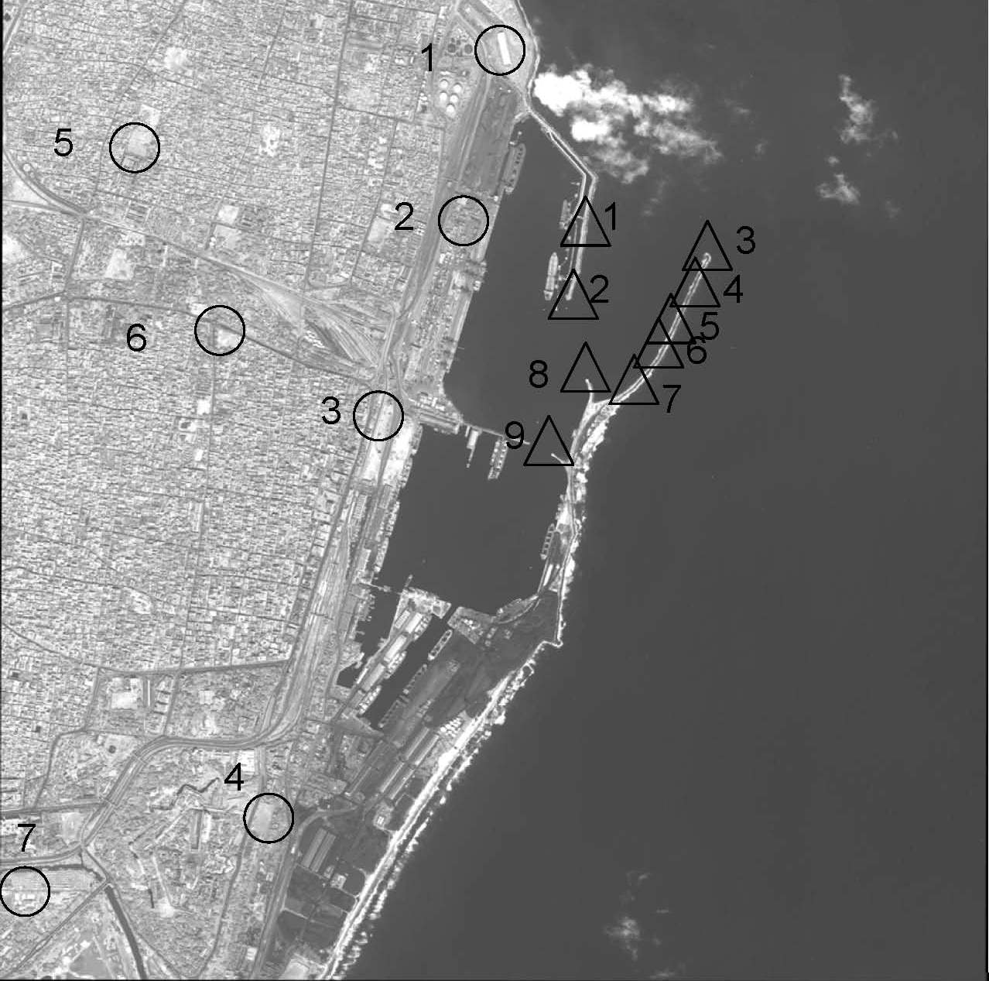
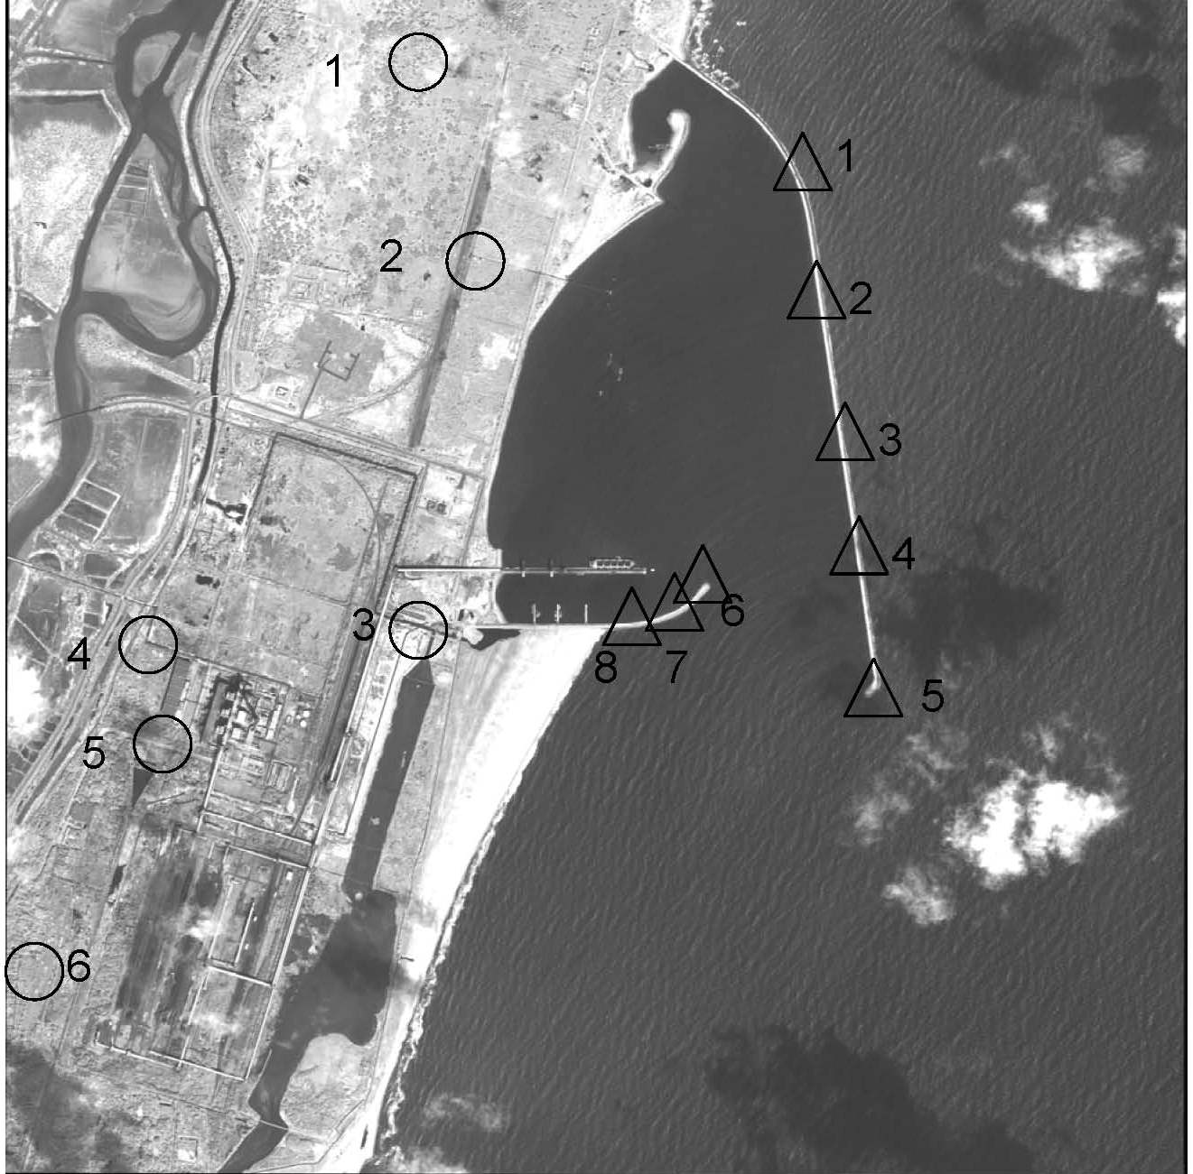
Distribution of displacement vectors at GCPs are shown in Fig.4 for uncorrected Standard image pairs. Magnitudes of displacement vector range from 40cm to 14m in Chennai, while the magnitudes range from 14 to 15m in Ennore, respectively. These differences make it possible to use geometric model such as polynomial model with different order. That is, the polynomial model with the 1st order will be appropriate for Ennore, while the polynomial with the 2nd order will be suitable for Chennai. The 1st and 2nd order polynomial models are shown in Eq.(1) and Eq.(2) below [9].

Fig.3 Location of 7Ground Control Points（○）and 9Check Points（△）at Chennai (left) and 6Ground Control Points and 8Check Points at Ennore (right). (○: Ground Control Point, △: Check Point) ©2004DigitalGlobe.

1st order (for Ennore)
x=a00+a10xref+a01yref (1)
y=b00+b10xref+b01yref

2nd order (for Chennai)
x=a00+a10xref+a01yref+a11xrefyref+a20xref²+a02yref² (2)
y=b00+b10xref+b01yref+b11xrefyref+b20xref²+b02yref²

where x,y are distorted image coordinates, and xref,yref are corresponding GCP coordinates.

4. Results and Hypotheses
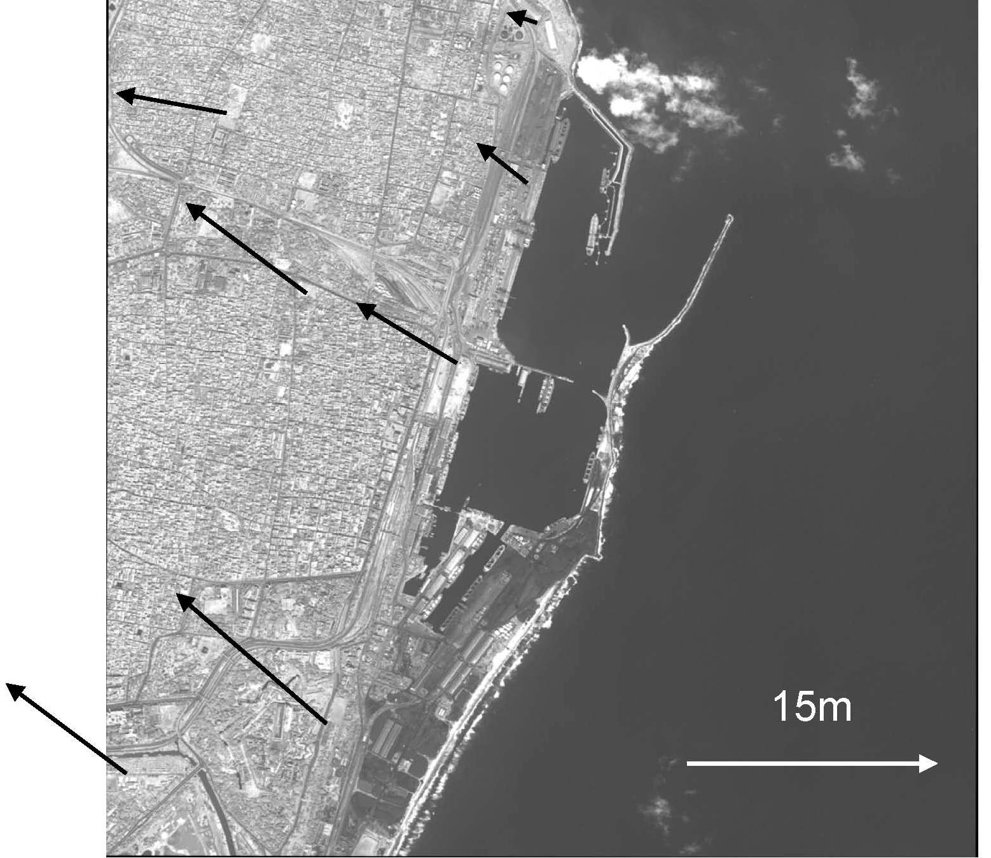
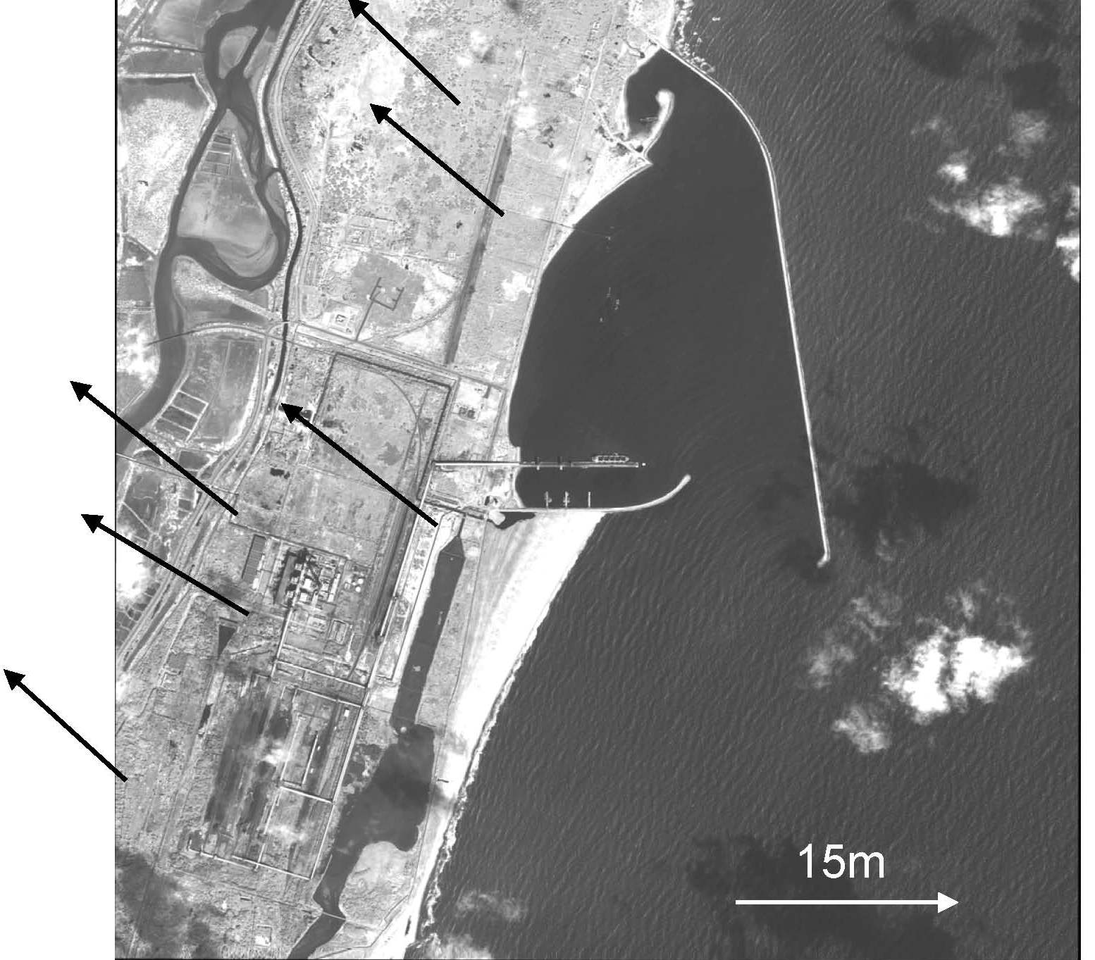

Table 2 indicates the magnitude of displacement at Chennai and Ennore based on the two methods, that is, scene-corrected (GCP only) and GCP matching. We chosen the smallest RMS errors of 59cm at Chennai and 44cm at Ennore derived from GCP matching based on the pre-image correction. It is noted that these errors are shown within the spatial resolution of QuickBird panchromatic image. Fig.5 shows the distribution of displacement vectors at the Check Points in Chennai and Ennore based on the GCP matching. Displacements of breakwaters in Chennai port between pre and post images indicate the magnitude of 2 to 3 meters with the direction of northwest and southeast, while the displacements of breakwaters in Ennore port indicate the magnitude of 1 to 2 meters with the direction of southeast.
Hypotheses are made on the different impact of Tsunami on breakwaters in Chennai and Ennore ports as follows. The different direction and magnitude of displacement in breakwaters between these two ports may imply the different influences of Tsunami on breakwaters with openings of different directions. That is, the direction of opening in Ennore port is favorable for the direction of Tsunami with the northwest propagation, while the direction of opening in Chennai port is toward the northeast, which is normal to the Tsunami propagating direction.

Fig.4 Distribution of displacement vectors at GCPs in Chennai (left) and Ennore (right) ©2004DigitalGlobe.
GG

Table.2 Magnitude of displacement at GCPs in Chennai (upper) and Ennore (lower).

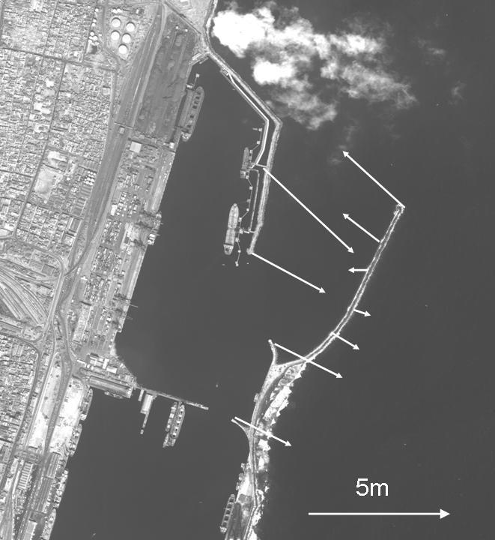
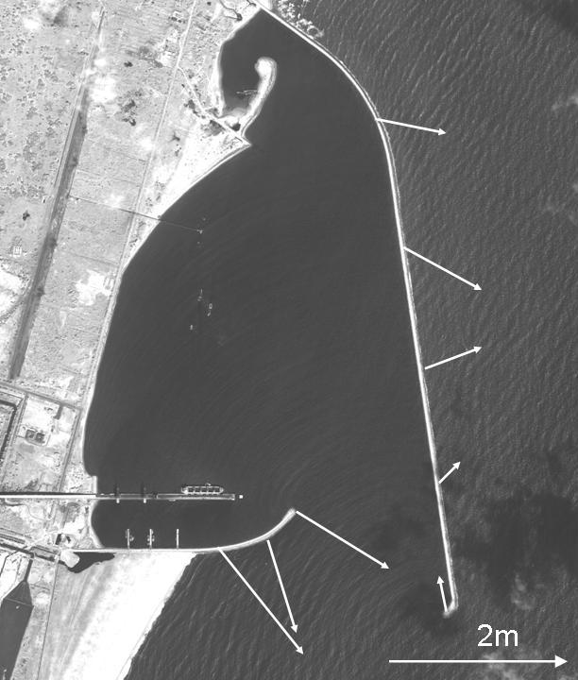

Thus it is highly likely that the impact of the Tsunami on breakwater in Chennai is higher than the one in Ennore.
Fig.6 illustrates the extensive debris inside the portion of breakwaters after the Tsunami in Chennai and Ennore, which did not exist before the Tsunami. Although the origins of debris are unknown, the careful examination of the images indicates that the hinterland characteristics may be attributable to the origin of debris. The hinterland of Chennai Port includes coal, container yards and fully developed urban area, while the hinterland of Ennore Port is mostly bare land and vegetation. Since there are some signatures of the Tsunami on land in Ennore image, it is expected that the Tsunami energy is easily dissipated on land. However in the urban environment like Chennai it is highly likely that the return water after the Tsunami will be trapped within the port and subsequently creates a muddy stream. Complex port structure in Chennai is also helpful to trigger the muddy stream. The field survey in Chennai reports the existence of strong muddy stream just after the Tsunami. It is the strong muddy stream which probably makes the breakwater displace. Fig.7 illustrates the hypotheses above for Chennai and Ennore and Table 3 summarizes the hypotheses based on the displacement vectors of breakwaters from three perspectives, that is, the relative direction of opening to the direction of the Tsunami propagation, the hinterland characteristics and the port structure.

Fig.5 Distribution of displacement vectors at CPs in Chennai (left) and Ennore (right) ©2004DigitalGlobe.

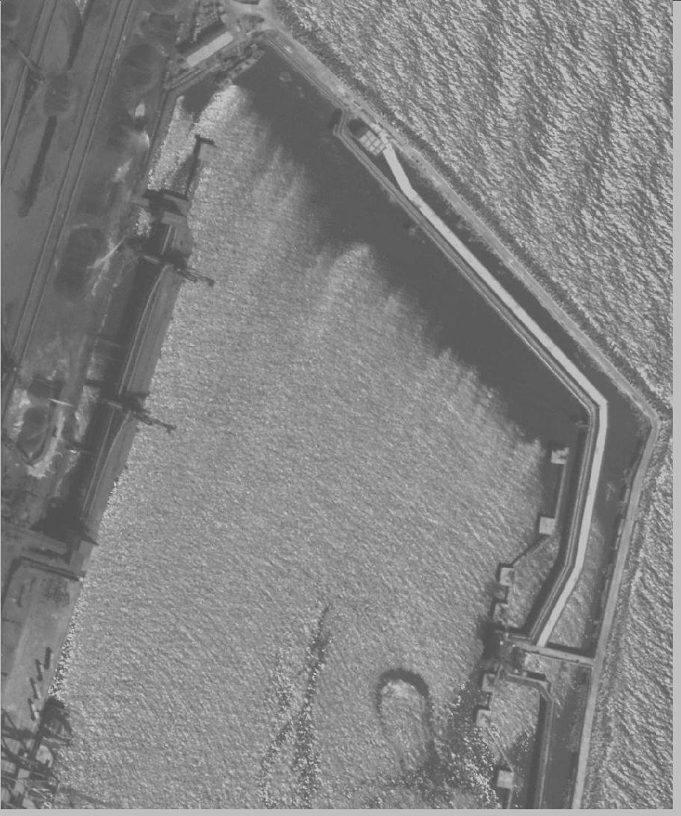
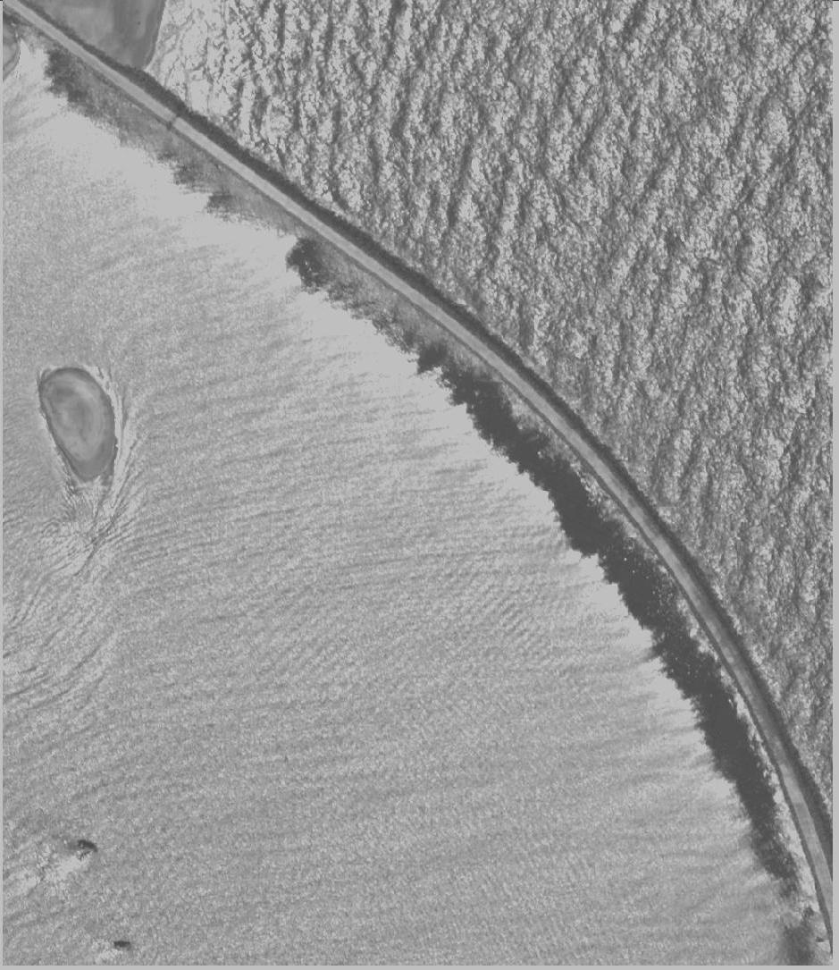

Fig.6 Distribution of debris along the breakwater in Chennai (left, Jan.5, 2005) and Ennore (right, Dec.31, 2004) ©2004DigitalGlobe.

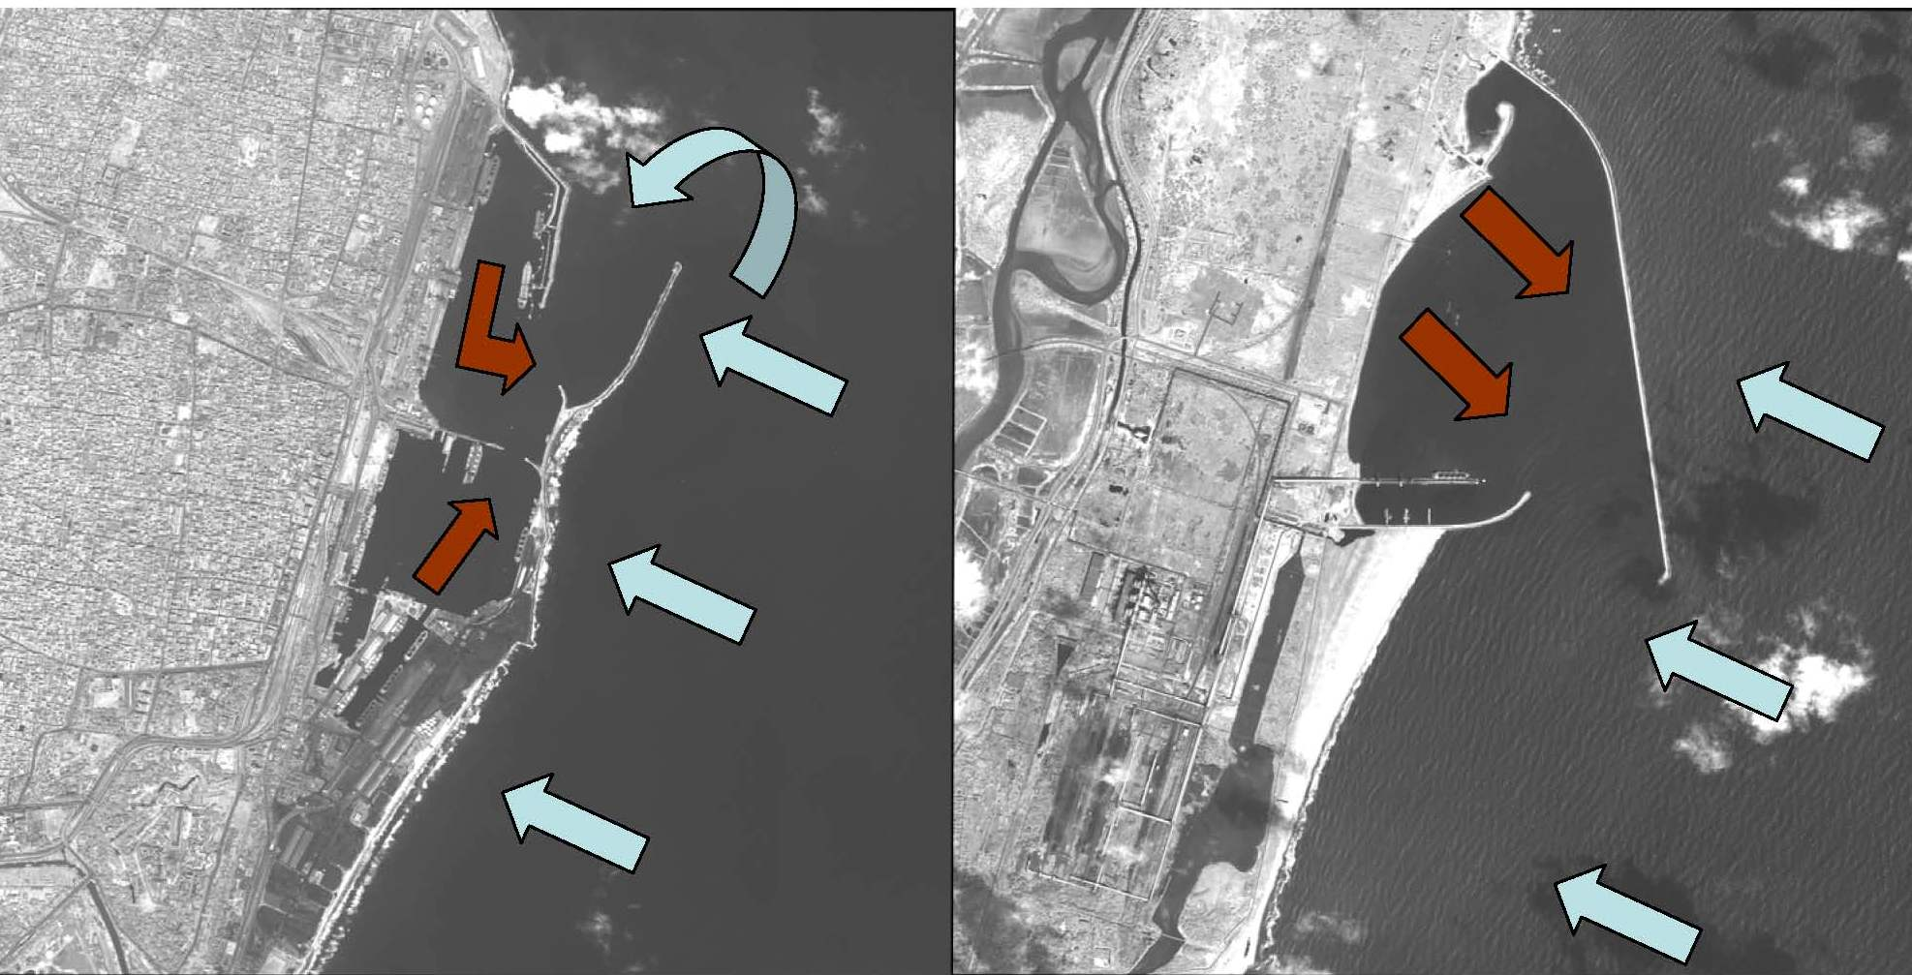
Table 3. Hypotheses based on the displacement vectors of breakwater from three perspectives.

Chennai Ennore Hypotheses
Relative direction Normal Oblique More impact
of opening on Chennai
Hinterland Urban Bare land More energy
characteristics dissipated in Ennore
Port structure Complex Simple Muddy stream likely in
Chennai

Fig.7 Hypotheses based on the displacement vectors along the breakwaters in Chennai (left) and Ennore (right) (Blue and red arrows indicate the Tsunami and the return water with mud respectively) ©2004DigitalGlobe.

5. Conclusions

Based on the results of the displacement vectors three hypotheses are made as follows.
(1) The relative direction of opening to the Tsunami propagating direction will determine the different impact of Tsunami on breakwaters. Since the direction of opening in Chennai Port is normal to the Tsunami propagating direction, it is expected that the higher impact on breakwater in Chennai is likely compared with the one in Ennore.
(2) Based on the hinterland characteristics more energy of the Tsunami is dissipated in Ennore than in Chennai before the first Tsunami water returns. The hinterland of Chennai is the fully developed urban area, while the one of Ennore is the bare land and vegetation.
(3) It is highly likely that the muddy stream occurs in Chennai because of the complex port structure and the hinterland characteristics. It is the strong muddy stream which probably makes the breakwater displace.
Last of all the proposals to the Port Authorities of Chennai and Ennore are as follows.
- to verify the displacement vectors of the breakwater through field surveys as soon as possible.
(2) to develop new design parameters of breakwater for the Tsunami countermeasures.
(3) to deploy Tsunami early warning system for minimizing risks of ships and ports.

Acknowledgements

Acknowledgements are given to the Port Authorities and MOL representatives in Chennai and Sri Lanka for helping the author (K.M.) in the field survey, which was partially supported by the Ministry of Education, Culture, Sports, Science and Technology, Japan. This study is supported by the University strategic research project “Investigation of Tsunami damages on ports and ships” in 2004.

References

[1] Stein, S. and E. A. Okal, 2005. Speed and size of the Sumatra earthquake, NATURE, 434: 581-582.
[2] Bhattacharjee, Y., 2005. In Wake of Disaster, Scientists Seek Out Clues to Prevention, SCIENCE, 307: 22-23.
[3] Kamataki, T. and Y. Nishimura, 2005. Field Survey of the 2004 Off-Sumatra Earthquake Tsunami around the Banda Aceh,
Northern Sumatra, Indonesia, Journal of Geography, 114(1): 78-82. (original in Japanese)
[4] URL: American Society of Civil Engineers’ tsunami damage assessment. Available at http://www.asce.org
[5] URL: Tamil Nadu infrastructure and the introduction to Ennore Port. Available at http://www.tidco.com/tn_policies/tn_infra_structure/ennore1.asp
[6] URL: Home page of DigitalGlobe, Inc., a provider of QuickBird image. Available at http://www.digitalglobe.com
[7] DigitalGlobe, 2005. QuickBird Imagery Products, Product Guide, Revision 4.6.1, 68p.
[8] Leica Geosystems GIS & Mapping LLC, 2003. ERDAS Field Guide, 7th Edition, 671p.
[9] Schowengerdt, R.A., 1997. Remote Sensing Models and Methods for Image Processing, Second Edition, 522p.

