A COMPARISON OF VEGETATION SPECTRAL INDICES DERIVED FROM LANDSAT 8 AND PREVIOUS LANDSAT GENERATIONS
Nguyen Thi Thuy Hang, Pham Xuan Canh
Faculty of Geography, VNU University of Science,
Vietnam National University Hanoi, 334 Nguyen Trai Str. Thanh Xuan, Hanoi, Vietnam
Phone: +84 438581420; Fax: +84 4 38589739,
Email: nguyenthuyhang@vnu.edu.vn, phamxuancanh@hus.edu.vn

KEY WORDS: Landsat imagery, Landsat 8, vegetation index, Hai Phong.

ABSTRACT: The Landsat system has contributed significantly to the understanding of the Earth observation for over forty years. Since May 2013, data from Landsat 8 has been available online for download, with substantial differences from its ancestors, having an extended number of spectral bands and narrower bandwidths. This paper aims to examine how well Landsat 8 sensor perform its ancestors’ vegetation observations, and more significantly, the differences between those of Landsat 8 and Landsat 5/7, hoping to optimize vegetation index continuity across different Landsat sensors. The paper investigates the quantitative relationship using regression analysis on the scatter plots of three indices derived from these sensors including the Normalized Difference Vegetation Index (NDVI), the Soil Adjusted Vegetation Index (SAVI), and the Urban Index (UI). Three scenes of Landsat 5, 7, and 8 images covering Hai Phong city, Vietnam was used. Comparisons indicate vague differences of vegetation indices derived from the sensors and their strong positive linear relationship, which supports the continuity of Landsat imagery use. Few notices are given as the NDVI and SAVI values in Landsat 8 ​​appear to be higher than those of its ancestors, while the UI has relatively high correlation among the sensors despite in the water area.

1. INTRODUCTION

The Landsat family satellites have contributed significantly to the understanding of the Earth observation for over forty years. Since May, 2013, data from Landsat - 8 (Landsat Data Continuity Mission (LDCM)) has been available online for download, with substantial differences from its ancestors such as Landsat - 5 Thematic Mapper (TM), Landsat- 7 Enhanced Thematic Mapper Plus (ETM+), having an extended number of spectral bands and narrower bandwidths (Table 1). As the application of multi-sensored data is growing importantly and effectively in this era of global environment changes (Li et al., 2014), comparison research on the differences between multiple sensors could confirm whether those data are highly related or not; therefore, contributing to the use of various sensors. This is especially helpful particularly in the case of the Landsat system when Landsat 5 was officially retired in January 2013 (Holm, 2013) and Landsat 7 has experienced the scan line corrector failure since 2003 with an estimated 22 percent of data missing per scene (U.S. Geological Survey, 2014).

Recent literature has shown an impressive number of studies on evaluating spectral indices based on their sensitivity to vegetation biophysical parameters (Abuzar et al., 2014; Agapiou et al., 2012; Anderson et al., 2011; Fadaei et al., 2012; Li et al., 2014) with more than fifty different remote sensing vegetation indices (VIs) used since 1995. In general, researchers have combined visible and near infrared bands to compute VIs, and among the most notably indices are the normalized difference VI (NDVI) (Equation 1) and its modification, soil adjusted VI (SAVI) (Equation 2) (Huete, 1988; Jackson and Huete, 1991; Lyon et al., 1998):

$\text{NDVI}=\frac{\text{NIR}−\text{RED}}{\text{NIR}+\text{RED}}$ (1); $\text{SAVI}=\frac{\text{NIR}−\text{RED}}{\text{NIR}−\text{RED}+L}(1+L)$ (2)

In which, NIR is the reflectance value of the near infrared (NIR) band, RED is reflectance of the red band, and L is the soil brightness correction factor. The value of L varies by the amount or cover of green vegetation: in very high vegetation regions, L=0; and in areas with no green vegetation, L=1, and in most situations, L =0.5 (Huete, 1988; Lyon et al., 1998).

Based on the typical response of urban built-up in spectrum regions of shortwave infrared (SWIR) (2.08 - 2.35 µm) and near infrared - NIR (0.76 to 0.90 µm), Kawamura et al. (1997) suggested Urban Index (UI) was applied in Landsat 5 images for detecting the urban built-up area. The UI was calculated as:

$\text{UI}=(\frac{\text{SWIR}−\text{NIR}}{\text{SWIR}+\text{NIR}}+1\text{.}0)\text{100}$ (3)
This equation produced gray scale images that appears brighter in area with dense urban built-up whereas darker in agriculture and water area.

Landsat – 8 has seven of the spectral bands narrowed and refined from the Landsat -7 ETM+ and Landsat – 5 TM bands; a coastal/aerosol and a cirrus detection band have been added. All bands are acquired at 12-bit radiometric resolution; 8 first bands are 30 meters, the panchromatic (pan) band are 15 meters, and two thermal bands are collected at 100 meters (Table 1). Therefore, to compute UI, in Landsat 8, band 7 is selected as SWIR, and band 5 as NIR, while in Landsat 5 and Landsat 7, band 4 is NIR. In addition, the narrower bandwidth in the NIR and SWIR portion of the spectrum region may also add to variability in the vegetation indices derived from these sensors.

The overall objective of this paper is to evaluate the effects of waveband selection on NDVI, SAVI and UI therefore, the paper could contribute to the determination of the relationships between the spectral indices computed from the wavebands included on different Landsat satellite generations.

2. MATERIALS AND METHODS

2.1 Remotely Sensed Data

In this paper, we use three scenes of Landsat -5 , Landsat -7 and Landsat- 8 covering Hai Phong city, Vietnam at path 126, row 046, acquired on January 30, 2009, December 19, 2013, and December 27, 2013 respectively. Specifications of those data are illustrated in Table 1. An additional scene of Landsat- 7 on December 3, 2013 (previous orbital cycle) was used to fill gaps in the December 19, 2013 image due to the SLR off. All satellite images were captured within the same season so the seasonal variations of vegetation on the ground could be considered insignificantly.

Table 1: Specifications of the Landsat images
Landsat 8 |  | Landsat 7 |  | Landsat 5 |  | Spatial resolution (m)
Band | Wavelength (µm) | Band | Wavelength (µm) | Band | Wavelength (µm) | Spatial resolution (m)
Band 1 –  Coastal/ Aerosol | 0.433 - 0.453 |  |  |  |  | 30
Band 2 - Blue | 0.450 - 0.515 | Band 1 - Blue | 0.45 - 0.515 | Band 1 - Blue | 0.45 - 052 | 30
Band 3 - Green | 0.525 - 0.600 | Band 2 - Green | 0.525 - 0.605 | Band 2 - Green | 0.52 - 0.6 | 30
Band 4 - Red | 0.630 - 0.680 | Band 3 - Red | 0.63 - 0.69 | Band 3 - Red | 0.63 - 0.69 | 30
Band 5 - NIR | 0.845 - 0.885 | Band 4 - NIR | 0.75 - 0.90 | Band 4 - NIR | 0.76 - 0.9 | 30
Band 6 - SWIR1 | 1.560 - 1.660 | Band 5- SWIR1 | 1.55 - 1.75 | Band 5 - SWIR1 | 1.55 - 1.75 | 30
Band 7 – SWIR2 | 2.100 - 2.300 | Band 7 – SWIR2 | 2.09 - 2.35 | Band 7 – SWIR2 | 2.08 - 2.35 | 30
Band 8 - Pan | 0.500 - 0.680 | Band 8 – Pan | 0.52 – 0.90 |  |  | 15
Band 9 - Cirrus | 1.360 - 1.390 |  |  |  |  | 30
Band 10 - TIRS | 10.30 - 11.30 | Band 6 - Thermal-IR | 10.40 - 12.5 | Band 6 - Thermal-IR | 10.4 - 12.5 | 100  (ETM+/TM: 60)
Band 11 - TIRS | 11.50 - 12.50 |  |  |  |  | 100
Source: U.S.Geological Survey

2.2 Methods

Landsat data acquired from the U.S.Geological Survey (USGS) has been radiometrically-, and geographically corrected, but has been formatted to fit in an 8-bit (Landsat – 5 and 7) or a 12-bit number (Landsat-8). As the data in such a format is referred to as “digital number,” or DN data, we applied atmospheric correction to each Landsat image to convert the DN values into surface reflectance so that they can be used to calculate vegetation indices. The Environment for Visualizing Images software (ENVI, Version 4.7, Exelis Visual Information Solutions, Boulder, CO, USA) has been employed to perform the computation.
In this study, six sample plots (polygons) covering main land cover types of Hai Phong city were randomly selected within three scenes of Landsat imagery, which are captured within the same season (Figure 1).
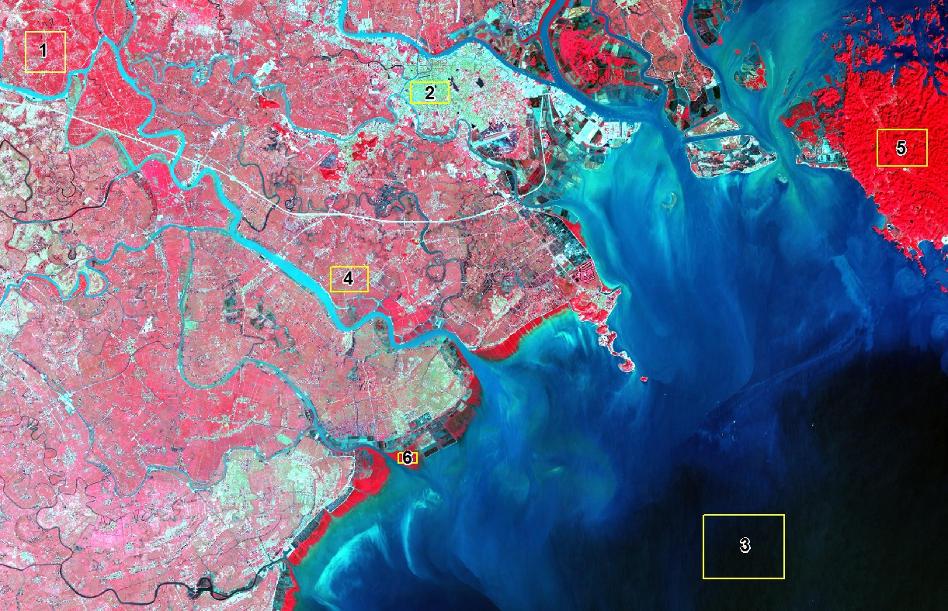 | Sample Plot No. | Land cover | Perimeter (km) | Area (km²) | No. of Pixels
 | 1 | Agricultural area | 10.92 | 7.46 | 8286
 | 2 | Urban area | 8.06 | 3.72 | 4128
 | 3 | Water area | 19.59 | 23.66 | 26228
 | 4 | Rural area | 8.54 | 4.38 | 4902
 | 5 | Forest land | 11.74 | 8.42 | 9398
 | 6 | Mangrove forest | 4.00 | 0.92 | 1008
Figure 1: Distribution of land cover samples on background of RGB-543 Landsat-8 LDCM image of the study area

3. RESULTS AND DISCUSSION

3.1 Results

Table 2: Mean values of NDVI, SAVI and UI derived from Landsat-5 TM, Landsat-7 ETM+,
and Landsat-8 LDCM images
Sample plot No | Land cover | NDVI MEAN VALUES |  |  | SAVI MEAN VALUES |  |  | UI MEAN VALUES
Sample plot No | Land cover | TM | ETM + | LDCM | TM | ETM + | OLI | TM | ETM + | LDCM
1 | Agricultural area | 0.306 | 0.095 | 0.363 | 0.457 | 0.142 | 0.545 | 0.570 | 0.767 | 0.671
2 | Urban area | -0.168 | -0.260 | 0.115 | -0.250 | -0.339 | 0.172 | 0.983 | 1.242 | 0.999
3 | Water area | -0.284 | -0.496 | -0.057 | -0.420 | -0.737 | -0.585 | 0.564 | 0.896 | 0.932
4 | Rural area | 0.017 | -0.161 | 0.295 | 0.025 | -0.241 | 0.443 | 0.658 | 0.942 | 0.714
5 | Forest land | 0.412 | 0.236 | 0.453 | 0.614 | 0.352 | 0.679 | 0.462 | 0.602 | 0.568
6 | Mangrove forest | 0.309 | 0.086 | 0.377 | 0.062 | 0.129 | 0.565 | 0.649 | 0.559 | 0.551
VI values of six sample plots derived from Landsat-8 image were used to compare with those derived from Landsat-7 image; and similarly, with those gained from Landsat-5 (Table 2). Pair comparative analysis of vegetation indices (NDVI, SAVI and UI) for each sample plot demonstrates the slight variation between the Landsat-8 and its previous sensors (Figure 2, Figure 3).
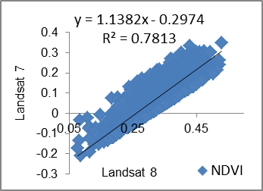  Sample plot 1: agricultural area | 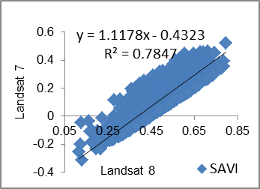 | 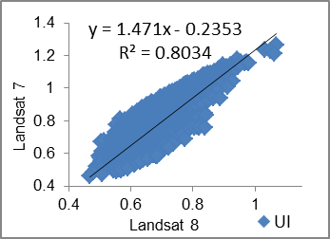
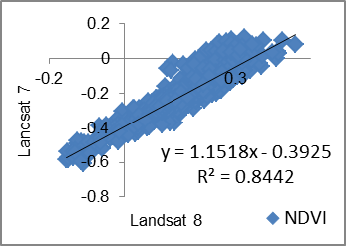  Sample plot 2: urban area | 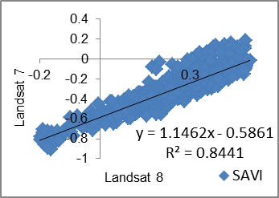 | 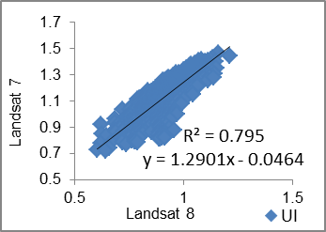
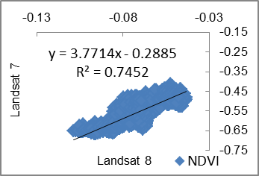  Sample plot 3: water area | 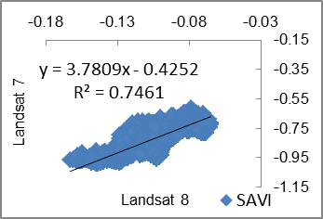
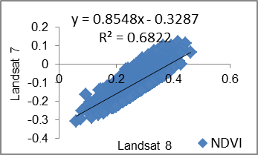  Sample plot 4: rural area | 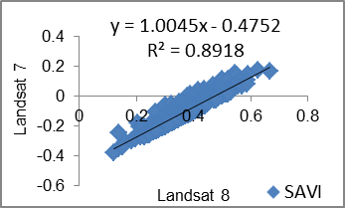 | 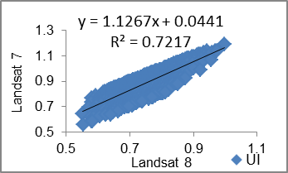
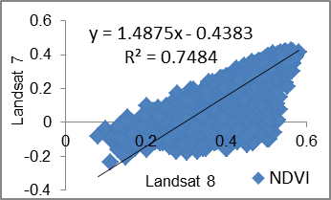  Sample plot 5: forest area | 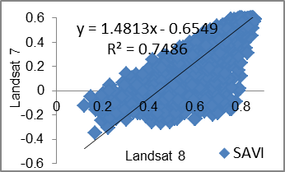 | 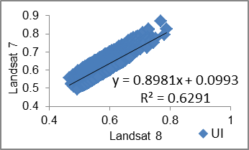
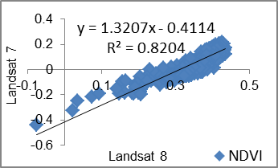  Sample plot 6: mangrove forest | 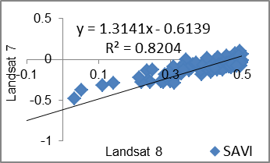 | 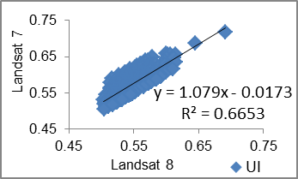
Figure 2: Statistical charts of NDVI, SAVI, UI showing the correlation between Landsat 8 and Landsat 7
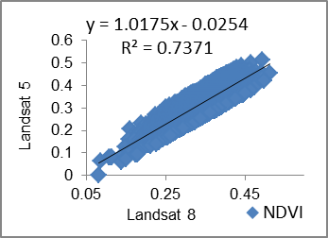  Sample plot 1: agricultural area | 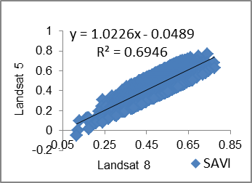 | 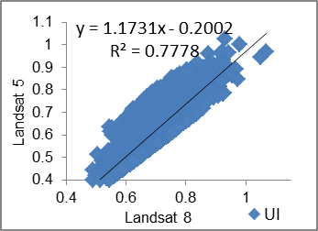
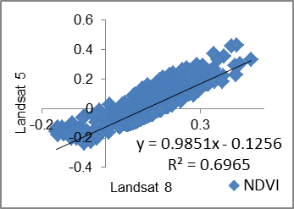  Sample plot 2: urban area | 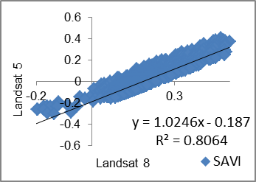 | 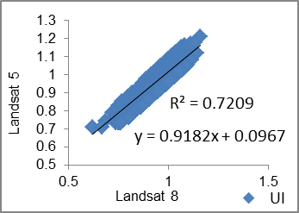
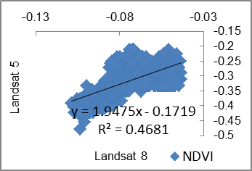  Sample plot 3: water area | 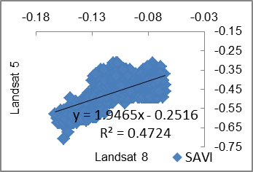
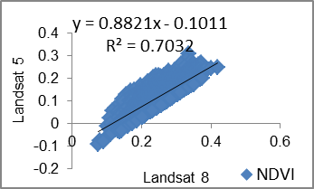  Sample plot 4: rural area | 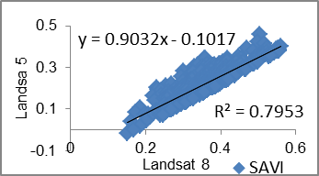 | 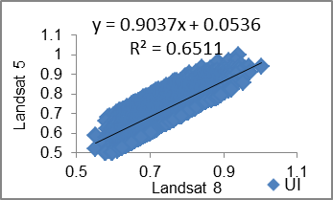
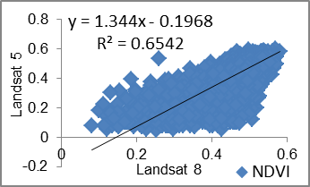  Sample plot 5: forest area | 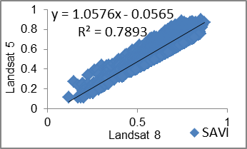 | 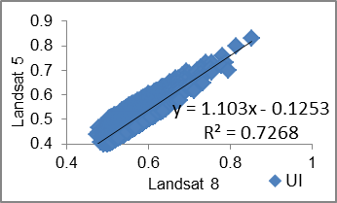
Sample plot 6: mangrove forest | 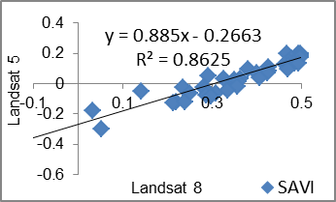 | 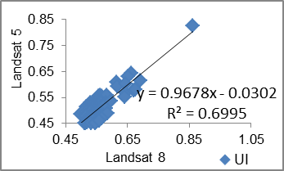
Figure 3: Statistical charts of NDVI, SAVI, UI showing the correlation between Landsat 8 and Landsat 5

3.2 Discussion

In this paper, comparative analyses of two pairs of images, Landsat-8/Landsat-7; and Landsat-8/Landsat 5 were carried out from VIs comparison with sample plots. We used Landsat imagery acquired in the same season, which helps to reduce the impacts of phenology and weather fluctuations. The difference of VIs (Table 2) comparison showed that there were subtle differences between Landsat 8 and its ancestors. NDVI has mean difference values higher than Landsat 5 (0.159) and Landsat 7 (0.34) while SAVI have average difference values higher than 0.22 (Landsat 5) and 0.42 (Landsat 8). However, UI performed relatively well, because the average difference values reached up to 0.09 (Landsat 5) and -0.09 (Landsat 7).

Additionally, correlation analysis of the vegetation indices indicated that Landsat-8 has a high linear correlation coefficient with its previous generation, with R² greater than 0.74 within the vegetative land cover types. Correlation of NDVI and SAVI between Landsat 8 and 5 is relatively low within sample plot of water with R² less than 0.462 could be explained by the different image date (Landsat 8 in 2013 and Landsat 5 in 2009). However, despite the low correlation of NDVI between Landsat 8 and 5 with forest area (R² less than 0.66), the soil-adjusted factor does help when we see the relatively high correlation between SAVI Landsat 8 and 5 (R² ~ 0.79). In an exceptional case, we could not perform the comparative analyses of UI within the sample plot of water area as the UI values derived from Landsat-7 and Landsat-5 in this sample is infinite which could be explained due to the different bandwidth in SWIR and NIR band. In other sample plots, the NIR and SWIR bands-calculated vegetation indices (UI) performed better than NDVI and SAVI for cross-comparison analysis of satellite sensors, due to the spectral band difference effects. The subtle differences and high correlation of vegetation indices demonstrated that Landsat 8 and Landsat 7/Landsat 5 could be used as complementary data. .

Recommendations for future studies include continued assessment of the effects of these other characteristics of sensor systems on vegetation indices in isolated and combined analyses.

Acknowledgements

We would like to thank VNU University of Science (VNU-HUS), Vietnam National University, Hanoi for providing partial financial assistance to us for attending the 35th Asian Conference on Remote Sensing 2014. We also want to express our thanks to the U.S. Geological Survey for providing the Landsat-5/7/8 imagery for the accomplishment of the work. Particularly thanks are due to the Faculty of Geography, VNU-HUS for their assistance during our study.

References

