Simulation of Three-dimensional of Wave Refraction Pattern Using ENVISAT ASAR Data

Maged Marghany

Institute of Geospatial Science and Technology (INSTeG),Universiti Teknologi Malaysia,81310 UTM, Malaysia,
Email:maged@utm.my, magedupm@hotmail.com

KEY WORDS: ENVISAT ASAR, Wave refraction, first order Partial Differential Equation (PDEs).

ABSTRACT: Synthetic Aperture Radar (SAR) has been recognized as a powerful tool for modeling ocean waves and forecasting over an area of 300 km x 300 km. The quantitative descriptors of the ocean surface wave properties such as wave height and wave slope spectra can retrieve from several satellite SAR missions, such as ENVISAT ASAR data.The retrieving techniques of sea surface quantitative descriptors involve linear and nonlinear techniques. In linear technique, Modulation Transfer Function (MTF) used to relate SAR spectra image with real sea surface spectra. This study has demonstrated a new approach for the simulation of wave refraction pattern in airborne radar data. In doing so, the quasi-linear algorithm used to model significant wave height based on the new approach of the azimuth cutoff algorithm. The study shows that wave refraction pattern can simulate from ENVISAT ASAR data with convergence and divergence spectra energy of 0.84 and 0.4 m² sec, respectively. In conclusion, modification of the conventional azimuth cutoff algorithm can be used to retrieve significant wave height in C_{vv}- band data under circumstances of wave transformation using first order Partial Differential Equation (PDEs).

- INTRODUCTION

Synthetic Aperture Radar (SAR) has been recognized as a powerful tool for modeling ocean waves and forecasting over an area of 300 km x 300 km. Hence, the sediment transport could be modeled by the wave spectra information extracted from a SAR image (Forget et al., 1995 and Li et al., 2010) . Currently, a number of investigations have been carried out on the assimilation of SAR wave mode data into wave forecasting models. This is because the SAR image spectrum has turned out to be far removed from the actual wave spectrum and rather complicated post-processing is necessary for extracting quantitative wave information In this regards, previous studies were carried out by Hasselmann and Hasselmann, (1991), and Li et al., (2010) by developing an inversion algorithm to map SAR wave spectra into ocean wave spectra.

Hasselmann and Hesselman (1991) introduced a non-linear algorithm which was developed by Vachon et al.,(1994) to model the significant wave height based on the azimuth cutoff. Vachon et al. (1995) defined the azimuth cutoff as the degree to which the SAR image spectrum is constrained in the azimuth direction. The azimuth cutoff is affected by the wind and wave condition in a quasi-linear forward-mapping model (Vachon et al. 1995). Marghany (2003 and 2004) utilized the azimuth cutoff model which was developed by Vachon et al. (1994) to estimate the significant wave height. This study is aimed to retrieve the wave refraction pattern from ENVISAT ASAR data using the velocity bunching algorithm along the east coast of Malaysia.

The question can be raised as to how an integration of the velocity bunching algorithm with a first order Partial Differential Equation (PDEs) could use to develop a new approach to observe coastal wave refraction from ENVISAT ASAR data. The main objective is to modify the conventional azimuth algorithm to model significant wave height in coastal water of Malaysia. The sub-objectives are :(i) to model the physical properties of wave spectra such as wavelength, significant wave height and spectra energy in azimuth direction using C_{vv}-band data; (ii) to simulate wave refection pattern using first order Partial Differential Equation (PDEs); and to model spectra energy variation of wave refraction patterns.

- Velocity Bunching Algorithm
2.1 Wave Spectra Model
According to Pierson and Moskowitz (1964) the significant wave height spectrum $H_{s}$ can be related to the one sided directional wave number spectra density $S(\vec{K},φ)$ by the following formula
$H_{s}=4[\int{\int{S(\vec{k},φ){\text{dk}}_{i}}}{\text{dk}}_{j}]^{0\text{.}5}$ (1)
where are the wave numbers in the azimuth and range directions, respectively, and $\vec{K}$ is the wave-number magnitude of in the azimuth and the range directions, respectively

2.2 Wave Spectra from SAR Data

In this study, a single ENVISAT ASAR image frame comprising of 512 x 512 pixels and lines was extracted. The ENVISAT ASAR images are a two dimensional sampling of the ocean wave field and thus a two-dimensional (2-D) Fourier transfer has to be utilized (Populus et al., 1991;Forget et al., 1995;Marghany 2001;Marghany 2003; Marghany 2004; Marghany 2014a) .When the Fourier transfer was selected, the output domain is the two-dimensional frequency spectrum of the input image (Marghany 2014a). To map observed SAR spectra into the ocean wave spectra, a nonlinear model was applied. The nonlinear theory is explained below: According to the Gaussian linear theory, the relation between ocean wave spectra $S(\vec{K},φ)$ and ENVISAT ASAR image spectra $S_{Q}(\vec{K})$could be described by tilt and hydrodynamic modulation (real aperture radar (RAR) modulation) and velocity bunching modulation. The tilt modulation is linear to the local surface slope in the range direction, i.e. In the plane of radar illumination. The tilt modulation in general is a function of wind stress and wind direction for ocean waves and ENVISAT ASAR. According to Vachon et al.,(1994) the tilt modulation is the largest for HH polarization. The hydrodynamic interaction between the scattering waves (ripples) and longer gravity waves produced a concentration of the scatterer on the up wind face of the swell. Following Vachon et al., (1995) ENVISAT ASAR image spectra can map into ocean wave spectra under the assumption of the quasi-linear modulation transfer function $S_{Q}(\vec{k})$ which is given by

$S_{Q}(\vec{K})=R(K)H(k_{i};K_{c})\text{.}\left[\frac{S(\vec{K},φ)}{2}{\left|T_{\text{lin}}(k_{i,j})\right|}^{2}+\frac{S(−\vec{K},φ)}{2}{\left|T_{\text{lin}}(−k_{i,j})\right|}^{2}\right]$ (2)
where $H(k_{i};K_{c})$ is an azimuth cutoff function that depends upon the azimuth wave number $k_{i}$ and range wave number $k_{j}$, the the cut-off azimuth wave number $K_{c}$ and R ($\vec{K}$) is the ENVISAT ASAR point spread function. ENVISAT ASAR point spread function is a function of the azimuth and the range resolutions (Li et al., 2010). According to Vachon et al., (1995) $T_{\text{lin}}$ is a linear modulation transfer function which is composed of the RAR (the tilt modulation and hydrodynamic modulation), and the velocity bunching modulation.

2.3 Significant Wave Height
In order to estimate the significant wave height from the quasi-linear transforms, we adopted the algorithm that was given by Vachon et al., (1995) and modified by Marghany (2003) to be appropriate for the geophysical conditions of tropical coastal waters:
$λ_{c}=β(\int_{H_{s_{0}}}^{H_{s_{n}}}{}\sqrt{H_{s}}{\text{dH}}_{s}+\int_{U_{0}}^{U_{n}}{\sqrt{U}}\text{dU})$ (3)
where is cut-off, H_{s} and U are the in situ data of significant wave height and wind speed. The measured wind speed was estimated at 10 m height above the sea surface. $β$ is an empirical value which results of R/V multiplied by the intercept of azimuth cut-off C when the significant wave height and the wind speed equal zero. A least squares fit was used to find the correlation coefficient between cut-off wavelength and the one calculated directly from the ENVISAT ASAR spectra image by equation (3). Then, the following equation was adopted by Marghany (2014) to estimate the significant wave height (H_{sT}) from the ENVISAT ASAR images

$H_{\text{sT}}=β^{−2}\int_{λ_{c_{0}}}^{λ_{c_{n}}}{{\left(λ_{c}\right)}^{2}}{dλ}_{c}$ ( 4)

where $β$is the value of ${\left(c\frac{R}{V}\right)}^{−1}$ and $H_{\text{sT}}$ is the significant wave height simulated from ENVISAT ASAR images. The significant wave height is estimated by using the velocity-bunching model. Finally, the in situ wave spectra measurements have been collected using AWAC wave rider buoy during the ENVISAT ASAR overpass on 28 December 2010.

2.4 Wave Refraction Pattern

Following, Marghany (2014a) the explicit finite difference scheme, centered in x, proposed for the solution of wave refraction equation:
(1) Wave angle equation: solved for $φ_{\text{ij}+1}$

$\begin{aligned}φ_{\text{ij}+1}=\text{arccos}\begin{aligned}\left[(\frac{{Δy}_{j}}{2}((\frac{\text{sin}φ_{i+1j}}{c_{i+1j}}−\frac{\text{sin}φ_{\text{ij}}}{c_{\text{ij}}}){Δx}^{−1}+ | \right] \\ \end{aligned} \\ \end{aligned}$. (5)
(2) Significant wave height equation: solved for ${\text{Hs}}_{\text{ij}+1}$( Herbers et al.,1999)

$H_{{s_{\text{ij}+1}}^{2}}=\frac{1}{c_{\text{gij}+1}\text{sin}φ_{\text{ij}+1}}\begin{aligned}\left[(H^{2_{s}}c_{g}\text{sin}φ)_{\text{ij}}−0\text{.}5Δy(\frac{(H^{2_{s}}c_{g}\text{cos}φ)_{i+1j}}{{Δx}_{i}}−\frac{(H^{2_{s}}c_{g}\text{cos}φ)_{\text{ij}}}{{Δx}_{i}} | \right] \\ \end{aligned}$. (6)

- Results and Discussion

Figure 1 shows the ENVISAT ASAR satellite data along the coastal waters off Johor which are acquired on 28 December 2010 (Figure 1). The study area is located along the coast of Johor in the southern, eastern part of Peninsular Malaysia. The area is approximately 20 km of Johor (Figure 1), located in the South China Sea, between 1° 57´ N to 2° 15´ N and 103° 51´ E to 104° 15´ E. Further, the coastline is bordered with varying widths of alluvial plains. Consistent with Marghany et al., (2010) and Zelina et al., (2001), this area is located in an equatorial region dominated by two seasonal monsoons and two transition monsoon. The southwest monsoon lasts from May to September while the northeast monsoon lasts from November to March. The transition monsoon periods involve April which is between end of northeast monsoon and the beginning of the southwest monsoon periods. Further, the second transition monsoon is October which is between the end of the southwest monsoon and beginning of northeast monsoon periods (Marghany 2014).
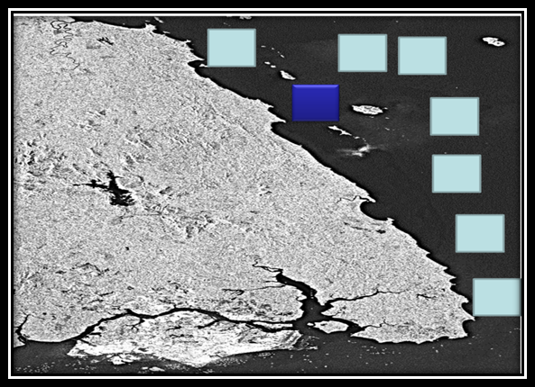
Figure 1. ENVISAT ASAR data with selected kernel windows of 512 x 512 pixels and lines
and blue windows indicates the location of in situ measurements.

Figure 2 shows the simulated wave spectra that derived from AWAC wave rider buoy, ENVISAT ASAR data, and modeled by using the velocity bunching model. Clearly, the wavelength is varied from 100 m to 200 m. The main direction of the wave spectra is the northeast. The monsoon winds affect the direction and magnitude of the waves. Further, Marghany [8] stated that strong waves are prevalent during the northeast monsoon when the prevailing wave direction is from the north (November to March), while during the southwest monsoon (May to September), the wave directions are propagated from the south. According to Marghany et al., (2004) the maximum wave height during the northeast monsoon season is 4 m. The minimum wave height is found during the southwest monsoon which is less than 1 m (Marghany et al., 2009 and Marghany 2013).

- (b) (c)
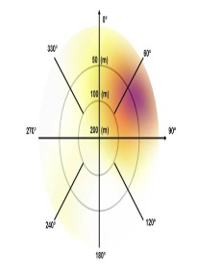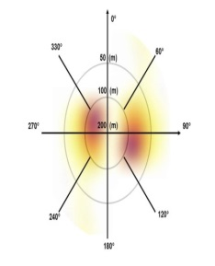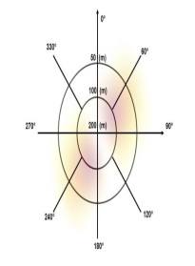
Figure 2. Ocean wave spectra derived from (a) AWAC, (b) ENVISAT ASAR and (c) velocity bunching model.

According to Marghany (2004), velocity bunching model produces precisely the information of wave spectra. Indeed, it is able to solve the matter of non-linearity between SAR observed spectra and ocean wave spectra. In other words, it can be used to map SAR observed spectra into real ocean spectra. This result confirms that studies of Vachon et al., (1995); Marghany (2004) and Marghany (2014a). Figure 3 shows the wave refraction spectra energy because of convergence and divergence. The convergence spectrum has the sharper peak compared to divergence spectra. The sharp peak of the convergence spectrum is 1.0 m² sec while the divergence spectrum peak is 0.2 m² sec. This study confirms the studies of Marghany (2014b).

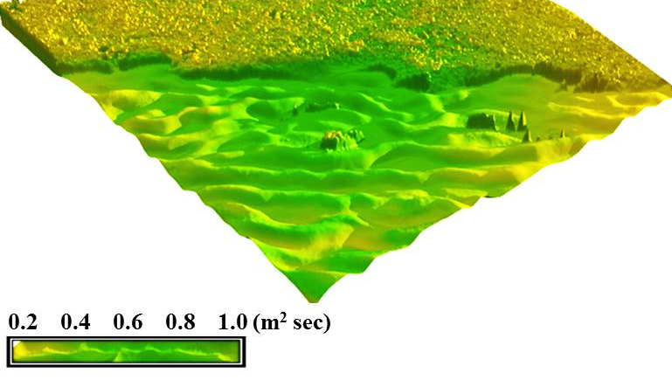
Figure 3. 3-D wave refraction simulated from ENVISAT ASAR data.

4 Conclusions
This study has demonstrated a new approach for the simulation of wave refraction pattern in airborne radar data. In doing so, the quasi-linear algorithm used to model significant wave height based on the new approach of the azimuth cut-off algorithm. The study shows that wave refraction pattern can simulate from ENVISAT ASAR data with convergence and divergence spectra energy of 1.0 and 0.2 m² sec, respectively. In conclusion, the integration between velocity bunching algorithm and wave transformation using first order Partial Differential Equation (PDEs) can be used to retrieve wave refraction pattern from ENVISAT ASAR data.

References

Forget, F., Broche, P., Cuq, F. 1995. Principles of Swell Measurement by SAR with Application to ERS-1 Observations off the Mauritanian Coast. Int J Rem. Sen. 16,2403- 2422 .

Herbers, T. H., Elgar, C., Guza, R.T. 1999. Directional Spreading of Waves in the Nearshore. J. Geophys. Res. 104, 7683-7693.

Hasselmann, K., Hasselmann, S.1991. On the Nonlinear Mapping of An Ocean Spectrum and Its Inversion. J. Geophys. Res. 96,10,713-10,799.

Li,X., Lehner,S. and Rosenthal,W. 2010. Investigation of Ocean Surface Wave Refraction Using TerraSAR-X Data. IEEE Tran Geos Remote Sens. 48,830-840.

Marghany, M.M, Cracknell, A., Hashim, M.2010. 3-D Visualizations of Coastal Bathymetry by Utilization
of Airborne TOPSAR Polarized Data. Int. J. Dig. Ear. 3, 1753 -8955.

Marghany, M., Hashim, M., Cracknell. A., 2009. 3D Reconstruction of Coastal Bathymetry from AIRSAR/POLSAR
data. Chin. J. Ocean. and Lim. 27, 117-123.

Marghany, M. 2004. Velocity Bunching Model for Modelling Wave Spectra along East Coast of Malaysia. J. Ind. Soc. Rem. Sens. 32,185-198.

Marghany,M. 2001. TOPSAR Wave Spectra Model and Coastal Erosion Detection. Int. J. App. Ear. Obs. and Geo. 3,357- -365.
Marghany M. 2003. ERS-1 Modulation Transfer Function Impact on Shoreline Change. Int. J. App. Ear. Obs. and Geo. 4,279—294.
Marghany M., 2014a. Modelling Wave Refraction Pattern Using AIRSAR And POLSAR C-Band Data. 14th International Conference, Guimarães, Portugal, June 30 – July 3, 2014, Proceedings, Part VI. pp 518-531.

Marghany M. 2013. DInSAR technique for three-dimensional coastal spit simulation from radarsat-1 fine mode data. Acta Geophysica .61,2, 478-493.
Marghany M. 2014b. Simulation of three-dimensional of coastal erosion using differential interferometric synthetic aperture radar, Global NEST Journal, Vol 16, No 1, pp 80-86.

Person, W.J., and Moskowitz, L. 1964. A Proposed Spectral From Fully Developed Wind Seas Based on the Similarity Theory of S.A. Kitaigorodskii. J. Geo. Res. 69, 5181- 5190.

Populus, J., Aristaghes, C., Jonsson, L., Augustin, J.M., Pouliquen, E.1991. The Use of SPOT Data For Wave Analysis. Rem. Sen. Env. 36, 55-65.

Vachon, P.W., Harold, K.E., Scott, J.1994. Airborne and Space-borne Synthetic Aperture Radar Observations of Ocean Waves. J. Atm. Oce. 32, 83-112 .

Vachon, P.W., Liu, A.K., Jackson, F.C.1995. Near-shore Wave Evolution Observed by Airborne SAR during SWADE. J Atm Oce. 2, 363- -381.

Zelina, Z.I., Arshad, A., Lee, S.C., Japar, S., Law, A., Nik Mustapha, R.A., Maged, M.M., 2000. East coast of peninsular Malaysia. Sea at The Millennium: An Environmental Evaluation. In (Ed.) Sheppard C, II, 345-359. Oxford.

