Developing Genetic Algorithm for Survying of MH370 Flight in Indian Ocean Using Altimetry Satellite Data

Maged Marghany

Institute of Geospatial Science and Technology (INSTeG),Universiti Teknologi Malaysia,81310 UTM, Malaysia,
Email:maged@utm.my, magedupm@hotmail.com

KEY WORDS: Genetic algorithm, MH370 flight,Object detection, Remote sensing data, Altimetry data

ABSTRACT: This study utilized Genetic Algorithm for automatic detection and simulation of location of MH370 flight and its debris. Multi-remote sensing data based object detection are also used. The altimeter data provided information regarding the water circulation in Indian ocean. The study shows that the The significant wave height in this Indian ocean during surveying MH370 flight is around 3.5 m with a northeast direction of 25°. The wavelength is around 80 m. Further, the sea surface current is 0.5 m/s. This current generates a large anticlockwise gyre over the water depth of 8000 m. The Genetic Algorithm suggested that objects are existed on satellite data are not MH370 flight. In addition, Genetic Algorithm suggested that the difficulties to acquire the exact location of MH370 flight in Indian ocean due to complicated hydrodynamic movements.

- INTRODUCTION

In spite of twelve countries joined in for the search-and rescue efforts of missing flight of MH370 on last March 8th, 2014, it is so difficult to find a plane like MH370. By the way, China deployed 10 high-resolution satellites to scurry the South China Sea, Digital Globe opened its crowdsourcing platform Tomnod and Airbus Defense and Space mobilized its five satellites to find some leads (Asia News 2014). We live in an age and era where technology tracks our every little movement. Why then it is so difficult to find a plane like MH370? The Malaysian Airlines flight went missing on March 8, 2014 and every new piece of information seems to shroud the flight’s disappearance in more mystery. Theories ranged from hijacking to sabotage to a possible suicide by one of the pilots. Finally, citing satellite-data analysis by British firm Inmarsat, has concluded that the flight, which vanished while flying to Beijing from Kuala Lumpur, had crashed thousands of miles away in the southern Indian Ocean (Figure 1) and none of the passengers or crew on board survived (Asia News 2014).

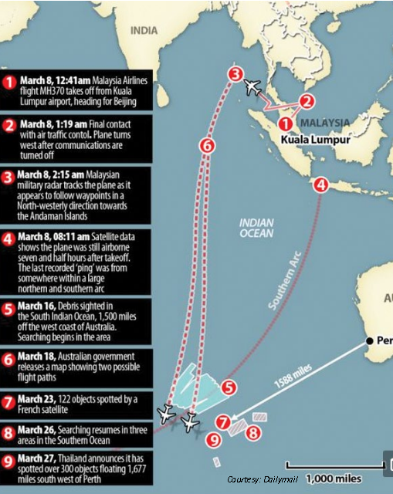
Figure 1. MH370 suspected location in the southern Indian Ocean.

The main question can be raised up what appropriate sensors can be used to monitor and detect MH370 debris? The high resolution sensors either on board of satellite or airborne. Even HF ground radar can detect any foreign objects moving in the coastal zone. This also required standard methods of object detections by using advanced remote sensing technology such use RADARSAT-2 satellite data. The Satellite has a Synthetic Aperture Radar (SAR) with multiple polarization modes, including a fully polarimetric mode in which HH, HV, VV and VH polarized data are acquired. Its highest resolution is 1 m in Spotlight mode (3 m in Ultra Fine mode) with 100 m positional accuracy requirement. In addition, RADARDSAT-2 SAR Scan Narrow SCNB beam is its and a high revisit period of 7 days. Further, has nominal near and far resolutions of 7 m. If the length of the flight is 24 m, means it will be detect clearly in RADARDSAT-2 SAR Scan Narrow. I suggest that, as this zone is dominated by high cloud covers. I also suggested to use Airborne SAR sensors like Uninhabited Aerial Vehicle Synthetic Aperture Radar (UAVSAR, by JPL, L-band) with a 22-km-wide ground swath at 22° to 65°. However, if there are other optical sensors with high resolution are available such as IKNOS and QUICKBIRD without heavy cloud covers also can be used. According to Grady (2014), leveraging a combination of satellite and terrestrial assets, news networks continue to dig-deep into their portfolio of communications options. Among those options are their pre-existing full time, loss of satellite capacity, or contribution feeds. Nearly all major news networks leverage these contribution feeds to help deliver studio-to the studio feeds, move content from one corner of the globe to another, or supplement other terrestrial-based pathways.

Aireon will enable airlines and ANSPs to more accurately track the location of aircraft, something that, as evidenced by the recent MH370 disappearance, is very much needed. By providing near real-time data transmission via satellite, aircraft can be tracked to within a few miles of its location at any time, no matter where it is on earth. In light of the disappearance of flight MH370, technological advancements in flight tracking have come under some serious scrutiny. How will Aireon play a role in flight tracking of commercial aircraft? How is it different from the current tracking technologies available. The hunt for the aircraft has been a sobering reminder of the vastness and uncharted mystery of our planet’s oceans. But the race against the clock to find the airliner’s black box has also provided something of a showcase for the technologies that are enhancing our ability to operate in an environment often considered to be every bit as challenging as outer space Excell (2014).

Clearly, the lack of remote sensing and in situ data made the search for MH370 all the more sophisticated. Satellite altimeter measurements could provide accurate data of bathymetry, sea level, ocean wave and ocean current movements. In this regard, the main objective of this work is to utilize the capability of Genetic algorithm to investigate the existing of MH370 debris in the southern Indian ocean under the impact of ocean surface current.

- STUDY AREA

Seafloor topography in the Malaysia Airlines flight MH370 search area. Dashed lines approximate the search zone for sonar pings emitted by the flight data recorder and cockpit voice recorder popularly called black boxes. The first sonar contact (black circle) was reportedly made by a Chinese vessel on the east flank of Batavia Plateau (B), where the shallowest point in the area (S) is at an estimated depth of 1637 meters. The next reported sonar contact (red circle) was made by an Australian vessel on the north flank of Zenith Plateau (Z) (Figure 2). The deepest point in the area (D) lies in the Wallaby- Zenith Fracture Zone at an estimated depth of 7883 meters. The Wallaby Plateau (W) lies to the east of the Zenith Plateau. The shallowest point in the entire area shown here is on Broken Ridge (BR). Deep Sea Drilling Project (DSDP) site 256 is marked by a gray dot. The inset in the top left shows the area’s location to the west of Australia. Seafloor depths are from the General Bathymetric Chart of the Oceans [2010].

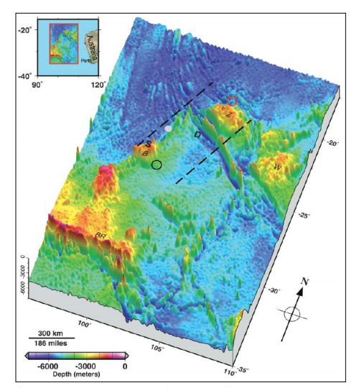
Figure 2. Bathymetry of Indian Ocean Zweck (2014a).

- The Publicly Available Data

According to Zweck (2014b) ,the only publicly available reliable data are (1) the location of the INMARSAT 3-F1 satellite in a geostationary orbit at an elevation of 35,800 km over the point on the earth at 1.5°N, 64.5° E; (2) the data released by the AAIB on March 25th which includes the times at which the satellite pinged the aircraft, together with the measured burst frequency offsets (i.e, the Doppler-shift frequencies) at those times; and (3) a map released by the Malaysian government which shows that the angle between the 8:11am arc and the satellite position was about 40°. The initial search area is accurately shown on a March 17th map on the web site of the Washington Post newspaper. This map also includes the approximate location of the satellite and four red arcs marked with the times 5:11am, 6:11am, 7:11am, and 8:11am. Although this map is qualitatively correct, the data it seeks to represent does not agree quantitatively with the three reliable data sets described above [6]. Since the methodology the Inmarsat team is using to deduce possible flight paths depends on accurate knowledge of the locations of the arcs, it is not currently possible for their calculations.
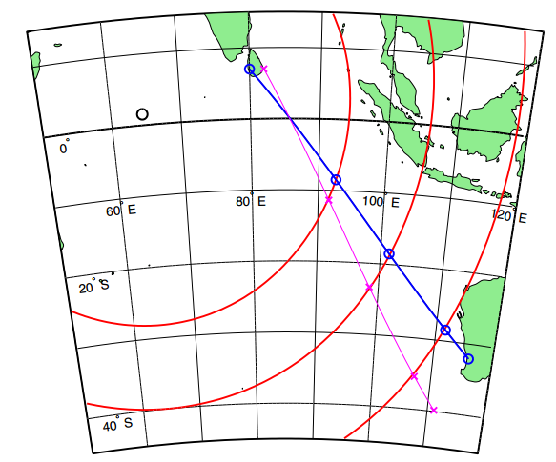
Figure 3. Map of the path of a fictitious flight, XX123, from Colombo, Sri Lanka towards Perth, Australia, departing at 12 noon and arriving in Perth at 7:48 pm (Zweck 2014b).

In addition, in Figure 3, the three red arcs show the location of the plane at 3 pm, 5 pm, and 7 pm. Using only this information, the blue curve shows the 400 knot flight path deduced using the methods described in this article. The magenta curve shows how the flight path that is deduced would change if the starting location were assumed to be 220 km due east of Colombo. A plane traveling along the magenta path would have a speed of 416 knots and be 970 km from Perth at 7:48 pm (Zweck 2014b).

- Genetic Algorithm and Debris of MH370
The Genetic Algorithm (GA) can work in two ways: (i) if a piece of debris is located in the southern Indian ocean, GA can hindcast’, or backtrack, to the original location, or the possible crash site; and (ii)if a piece of debris is located by satellite, GA can decide either the debris belong to MH370 or not The simulation of MH370 debris is done using Genetic algorithm. Following Anderson (2014), Genetic algorithms encode the parameter values associated with each candidate solution as a string, usually in binary format. For each parameter, the number of bits provided must be sufficient to encode the full range of possible values associated with that parameter. The string representing a solution is simply the concatenation of the sub-strings corresponding to the individual parameters; by analogy with biology, this string is referred to as a chromosome. Starting with an initial population of candidate solutions (ie, chromosomes) constructed by means of a random number generator, a genetic algorithm iteratively applies three basic steps : (i) rank the members of the current population according to fitness, (ii) select superior members which will be used to breed the next generation, and (iii) apply operators on randomly-selected pairs of these members to mimic the transfer of genetic material to offspring that occurs during biological reproduction, thereby producing a new generation with statistically superior characteristics.

  - Multi-objective optimization via Pareto dominance
Following Anderson (2013), the definition of the problem given above is in one sense incomplete – it does not specify the choice of norm for the space Y. In a single objective optimization problem, the objective space is usually a subset of the real numbers and a solution is better than another solution if where and. In the case of a vector-valued objective function mapping, comparing solutions is more complex and one must endeavour to capture the essential priorities of the problem in the choice of norm. Herein lies the crucial distinction between single objective and multi-objective problems - whereas the former afford simple scalar measures of fitness that can be used to rank individual members of the design space, the latter is characterised by conflicts of interest among the competing objectives as measured by (Anderson S.J. 2003 and Anderson et al., 2013).
There are several ways to deal with this complication. Perhaps the simplest is to create a scalar figure of merit as a weighted sum of the separate objective measures,
(i) minimise (1)
Another approach is to convert all but one of the objectives into constraints,
(ii) minimise subject to (2)
While convenient, these methods shed little light on the nature of the trade-offs made. As there may be subtle, non-quantifiable considerations involved in site selection, such as risks to personnel or to equipment, a better approach is to map the trade-off surface so that the decision maker can execute judgment in making a final selection. To perform this mapping, it is not necessary to run (i) or (ii) above for a large number of parameter selections and to inspect the outcomes. Instead, we can use an evolutionary stochastic optimization algorithm to reveal the Pareto front, as described below.
Pareto optimality is based on the binary relation of dominance. A solution is said to be dominated by another solution , written , if is at least as good on all counts (objectives) and better on at least one, that is,
and for some j. (3)
With this relation, the Pareto set of optimization (non-dominated) solutions will usually have multiple entries, associated with different trade-offs between the objectives. The image of the Pareto set is referred to as the Pareto front and knowledge of its shape greatly assists in choosing the best compromise solution (Anderson 2014). The Genetic algorithm has implemented on the data of the Jason-2/Ocean Surface Topography Mission (OSTM), and QuikSCAT.

- Results and Discussion

Figure 4, shows the possible MH370 debris which acquired by Chinese satellite in 44° 57’S 90° 13’E in the southern Indian ocean with the length of 24 m. Further, Figure 5a, shows the corrected image generated by using a Genetic Algorithm. Figure 5 shows the segmented image generated by Genetic Algorithm which indicates that the bright object which claimed by Chinese satellite as MH370 debris is wave crest. This wave crest was generated because of wave group propagations. The significant wave height in this area is approximately 3.5 m with a northeast direction of 25°. The wavelength is 80 m. This can be confirmed an absence of 24 m object(Figure 4) during operational searches in the South Indian Ocean.
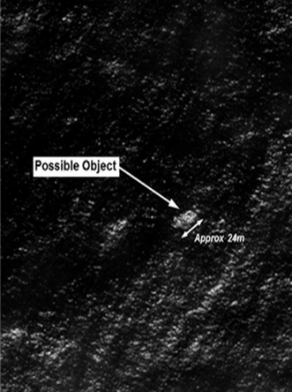
Figure 4. Chinese Satellite of MH370 debris.
(a) (b)
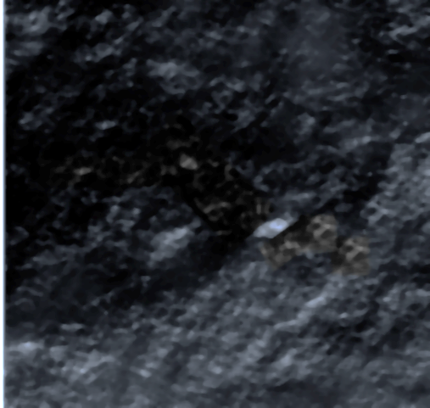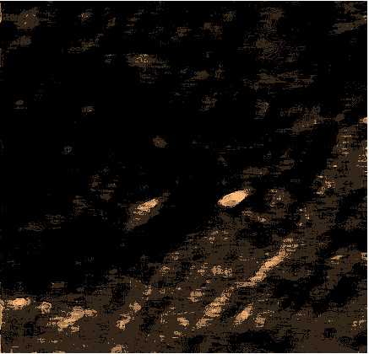
Figure 5. Genetic algorithm results of (a) image generation and (b) image segmentation

The Genetic algorithm shows the large-scale instability gyre flow in the month of March-April 2014. (Figure 6). This eastward current flow is known as Antarctic Circumpolar Current (ACC) (Figure 6) which cause flow instabilities. In this regard, the MH370 debris could transport westward and spin in a large scale counterclockwise eddies rotation and drifted westward to the African east coast. In fact, ocean current during the northeast monsoon late in (March - April) in South Indian ocean dominated a great gyre now moving anti-clockwise. It means any debris will be existed within this gyre and could move towards South Africa.
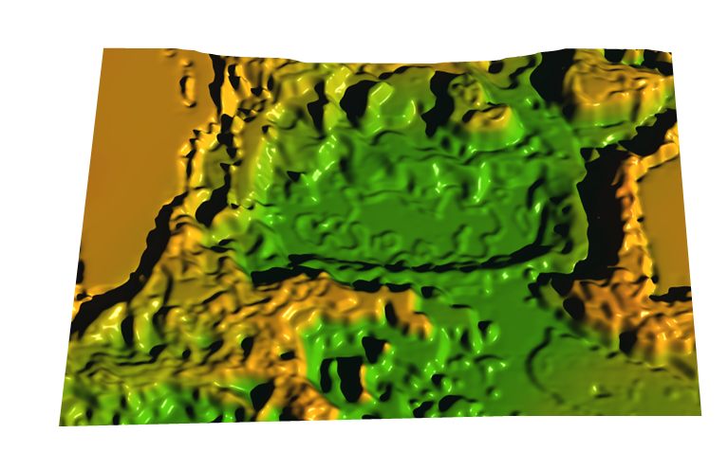
Figure 6. 3D ocean surface current simulated using Genetic algorithm on March-April 2014.

The ocean is vast and conditions are continuously changing. This area is known for strong winds, large waves and turbulent eddies. Debris can potentially travel up to 50 km/day with large eddies of width of 100 km wide. The water is moving around these at about 0.5 m/s. in addition,the geology features are very complicated as the existence of mid Indian ocean ridge , and other ridges such as Carlsberg Ridge, Southwest Indian Ridge (SWIR) , Southeast Indian Ridge (SEIR), Central Indian Ridge (CIR), Ninety East Ridge, and Chagos-Laccadive Ridge. Therefore, the average water depth is 3,890 m. In the area where MH370 was claimed to be crushed, the water depth is around 2000 m. Due the complicated current system which includes gyres in the northern and southern of the Indian ocean, the ship operational search routes can not continue searching for more than two months. MH370 paths must be existed above the land not above the ocean because of strong monsoon winds which caused eddies in northern and southern parts of the Indian ocean. In this regard, any professional pilot cannot fly away from the west coast of Australia due to greater risk of monsoon wind impact, deep water of 2000 m and large eddy flows.

- ConclusionS
This study has used optimization techniques of Genetic algorithm to investigate the impact of ocean surface current on MH370 debris. The southern Indian ocean during the months of March-April has dominated by anticlockwise large gyre moving with maximum velocity of 0.5 m/s and slowly drift westward. It means that MH370 debris can potentially travel up to 50 km/day with large eddies of a width of 100 km wide. The Genetic algorithm segmentation of claimed debris objects in Chinese satellite confirmed this object is just a wave crest. In conclusion, it is difficult to determine the MH370 debris in the South Indian ocean because of sophisticated and turbulent current which could drift the debris away to westward that required large scale search areas.

References

Anderson S.J., Edwards P.J., Marrone P., and Abramovich Y.A. 2003. Investigations with SECAR - a bistatic HF surface wave radar, Proceedings of IEEE International Conference on Radar, RADAR 2003, Adelaide.

Anderson S.J., Darces M., Helier M., and Payet N. 2013 . Accelerated convergence of Genetic algorithms for application to real-time inverse problems, Proceedings of the 4th Inverse Problems, Design and Optimization Syposium, IPDO-2013, Albi, France, 149-152.

Anderson S.J., 2013. Optimizing HF Radar Siting for Surveillance and Remote Sensing in the Strait of Malacca IEEE Tran. on Geosc. and Rem. Sens., 51, 1805-1816.

Anderson S.J., 2014. HF radar network design for remote sensing of the South China Sea: In Marghany M.(ed.), Advanced Geoscience Remote Sensing. Intech, Retrieved August 10, 2014, from http://cdn.intechopen.com/pdfs-wm/46613.pdf.

Asia News 2014. Missing Malaysian flight MH370: Is satellite data not enough? 2014 Geospatial World, 9:13.

Grady B. 2014 NSR Analysis: OU Or Contribution The Business of Pre-Planning For Breaking News. Sat magazine, June , 2014 p.60.

Excell J. 2014. Down deep. The Engineer, 296 3.

Walter H.F. and Karenm M.M 2014. Seafloor in the Malaysia Airlines Flight MH370 Search Area EOS, 95,21, 173-174.

Zweck J. 2014a. How Satellite Engineers are Using Math to Deduce the Flight Path of the Missing Malaysian Airliner. Retrieved August 10, 2014, from www.utdallas.edu/~zweck/MH370.pdf.

Zweck J. 2014b. How Did Inmarsat Deduce Possible Flight Paths for MH370? SIAM News. Retrieved August 10, 2014, from http://www.siam.org/news/news.php?id=2151.

