A smart and enhanced multi-temporal SAR interferometry platform: SkySENSE-InSAR, development and applications
Hu Xianzhi¹, Lin Hui^{1*}, Chen Fulong ²
¹ Institute of Space and Earth Information Science, The Chinese University of Hong Kong, Shatin, N.T., Hong Kong, China; E-mail: huilin@cuhk.edu.hk;
² Institute of Remote Sensing and Digital Earth, Chinese Academy of Sciences, Beijing, China; E-mail:chenfulong@ceode.ac.cn

Key Words: multi-temporal SAR interferometry; application-oriented; process-designed; surface deformation

Abstract: Nowadays, the advance of Differential SAR Interferometry (DInSAR), so-called Multi-Temporal SAR Interferometry (MT-InSAR) has been proved to be an effective tool for surface displacement monitoring with millimeters accuracy using time series SAR images over the same area. However, the extension of current software is constrained due to the rigorous requirement of expertise in radar signal processing, electromagnetism, DInSAR/MT-InSAR, etc. Furthermore, when specialized applications are involved, current DInSAR/MT-InSAR software tools confront with challenges. In this study, an application-oriented and process-designed MT-InSAR software— SkySense-InSAR is developed. Three MT-InSAR models have been further investigated and then integrated into the platform, including 1) Large-scale oriented Stanford Method for Persistent Scatterers (L-StaMPS), 2) High-resolution oriented Least Square Persistent Scatterer (H-LSPS), and 3) Slope instability-oriented Small Baseline Subsets (S-SBAS). Experimental results demonstrate that promising MT-InSAR products (velocity rates, historical deformations, refined height) can be derived through case studies of Hong Kong, China.

- Introduction
Differential SAR Interferometry (DInSAR), an advanced quantitative remote sensing technology, has been proved effectively and accurately for subtle ground deformation monitoring. In this study, a smart and enhanced SAR interferometry platform, so-called SkySENSE-InSAR was developed. Firstly, the work-flow designing was introduced to minimize the expertise requirement. Second, thematic data were seamlessly embedded into the platform, providing users with a friendly interface for the study site selection and then sub-region data processing. Last but not least, application-oriented MT-InSAR models were further exploited and then integrated into the system. In Sect. 2, we describe the work-flow framework and its implementation. After that, several key issues related to DInSAR/MT-InSAR procedures are further developed. In Sect.4 three MT-InSAR models were described, including Large-scale oriented Stanford Method for Persistent Scatterers (L-StaMPS), High-resolution oriented Least Square Persistent Scatterers (H-LSPS) and Slope instability-oriented Small Baseline Subsets (S-SBAS). Finally, summaries and conclusions are drawn for this study.
- System designing and development
From the operation aspect, generally, conventional DInSAR/MT-InSAR software tools have some evident deficiencies. Firstly, apart from exorbitant price of commercial services, they are hardly understandable, requiring professional knowledge or course training, particularly for a beginning user. Second, the Graphic User Interface (GUI) of current tools is poor. Users have to remember a mass of programming commands due to the sophisticated procedures of MT-InSAR; in addition, any wrong or disorder commands lead to incorrect results.
In this study, the idea of flow-process framework is proposed and applied, and thus customized tasks can be managed as an integrated project, implemented step by step to derive quantitative results, as illustrated in Fig.1. This design mitigates software training as well as expertise in InSAR research background. In other words, users are released from confused functions as well as the sequence of data processing triggered by command lines or menu commands. However, the operation of the platform is based on the realization of main functions and packages, including project management, data input and output, interest region selection, InSAR/DInSAR data processing, MT-InSAR parameters inversion and time series analysis, results visualization and evaluation, as illustrated in Fig. 2. Merits and advances of those packages are summarized as follows:
- Project management. In our development platform, tasks submitted by users will be managed as a project, and thus the procedures can be tracked step by step. The corresponding log file records the progress of procedures, supporting redo and undo when it is necessary.
- Data input and output. Different from other InSAR software tools, apart from general satellite SAR data, the SkySENCE-InSAR platform supports GIS thematic maps or other layers, facilitating the selection of interested regions as well as the synergy analysis of multi-source data.
- Interest region selection. This operation is absolutely useful to enhance the computation efficiency. In our system, the focused interesting regions can be not only cropped by a rectangle in the image coordinate system, but also in geocoding maps using thematic layers or KML files.
- InSAR/DInSAR data processing. This package is the foundation of the platform. General InSAR/DInSAR functions, including the interferogram generation, orbit estimation and orbit error phase mitigation, flat and topographic phase estimation, interferogram filtering and phase unwrapping, topography-related atmospheric delay estimation and removal, have been seamlessly integrated into the system.
- MT-InSAR parameters inversion and time series analysis. In this component, the application-oriented MT-InSAR models are in-depth investigated to satisfy user-specialized applications from different industry sectors.
- Results visualization and evaluation. In this study, a KML generation method based on a self-adaptive quad-tree was developed to export InSAR products. Millions of target points can be loaded simultaneously into Google Earth without time delay and hardware limitation, and thus MT-InSAR derived results can be superimposed on high-resolution optical imagery for further interpretation. For the InSAR results validation, the combination of internal assessment and cross comparison is applied depending on the availability of ground-based and other measurements.
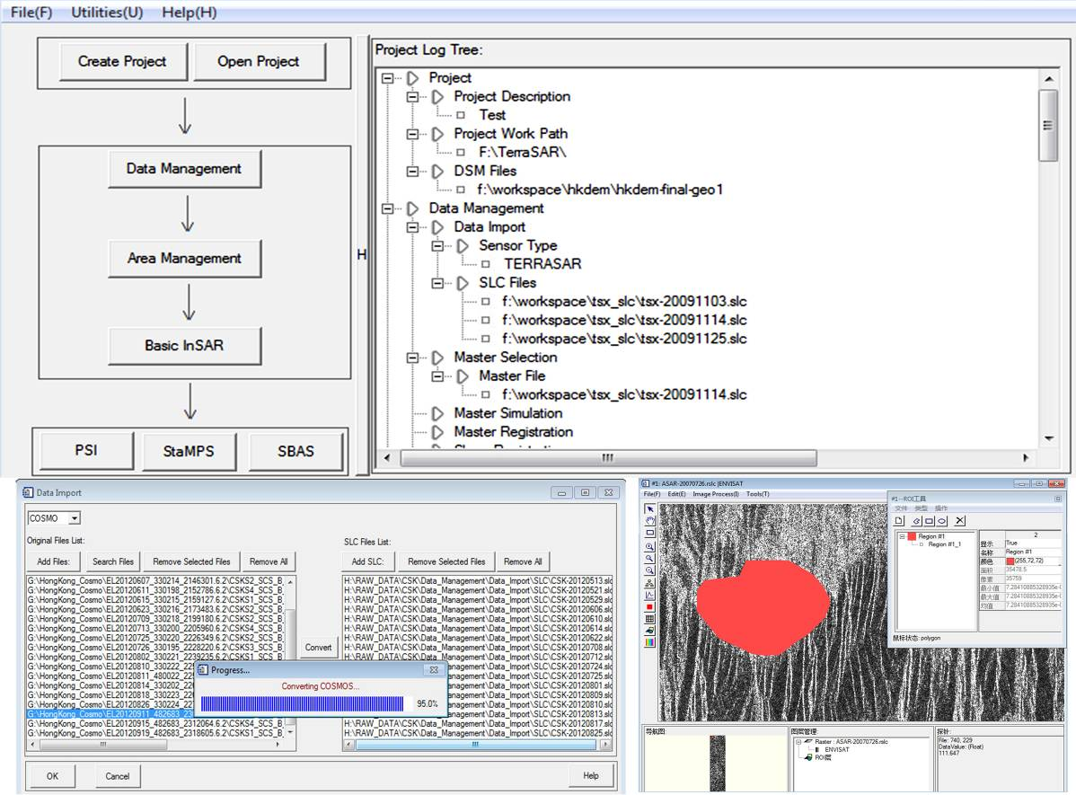

Fig.1. Flow-process framework of SkySENCE-InSAR platform.

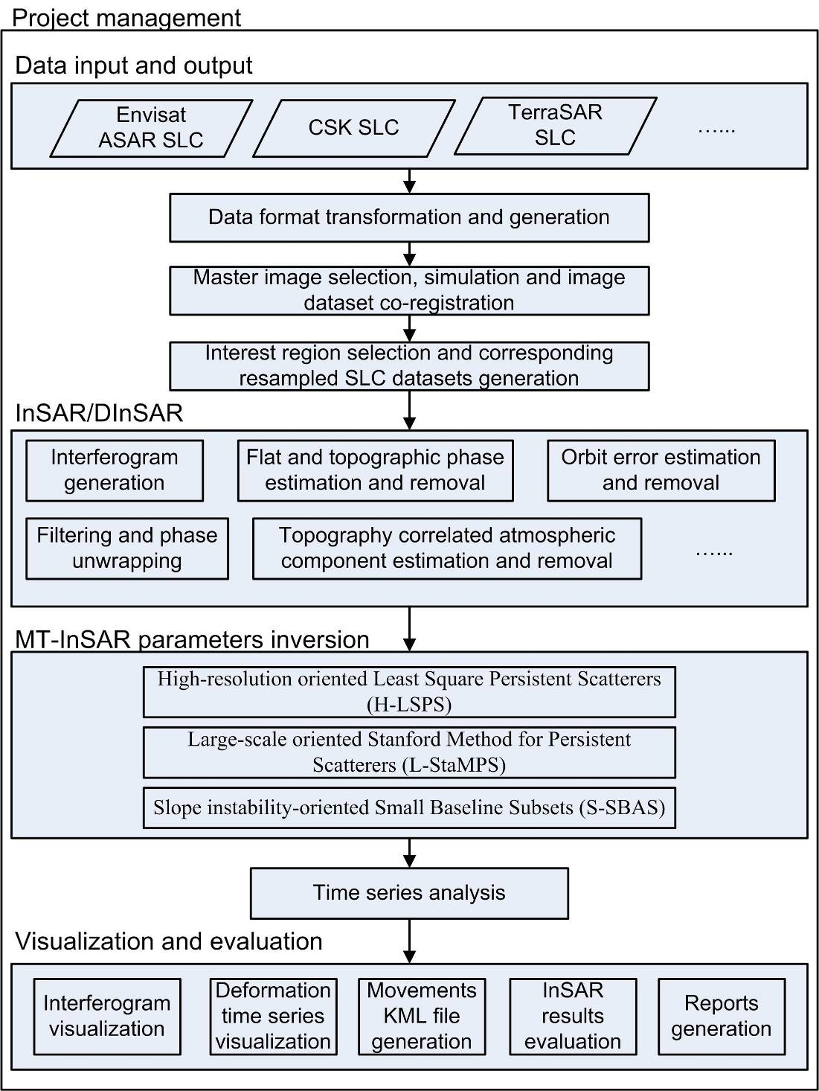

Fig. 2 Main functions and packages embedded into the SkySENCE-InSAR system.

- Methodology exploitation and integration
From the methodology aspect, when specialized applications are involved, we are confronted with new challenges because algorithms in current software sometimes cannot satisfy the industry demand. In our developed platform, several of key technologies have been further investigated.

3.1 High-resolution LiDAR Digital Surface Model (DSM) simulation
When fine DSM data are available, such as high-resolution LiDAR data, the infrastructure height-related phases can be simulated by an enhanced method. In such a way, parameters related to backscatter characteristics, incidence angles, 3D geometry position, imaging geometry (e.g. shadow, layover, foreshorting) can be simulated accurately, demonstrating resemble outputs compared with real SAR data, as illustrated in Fig. 3.
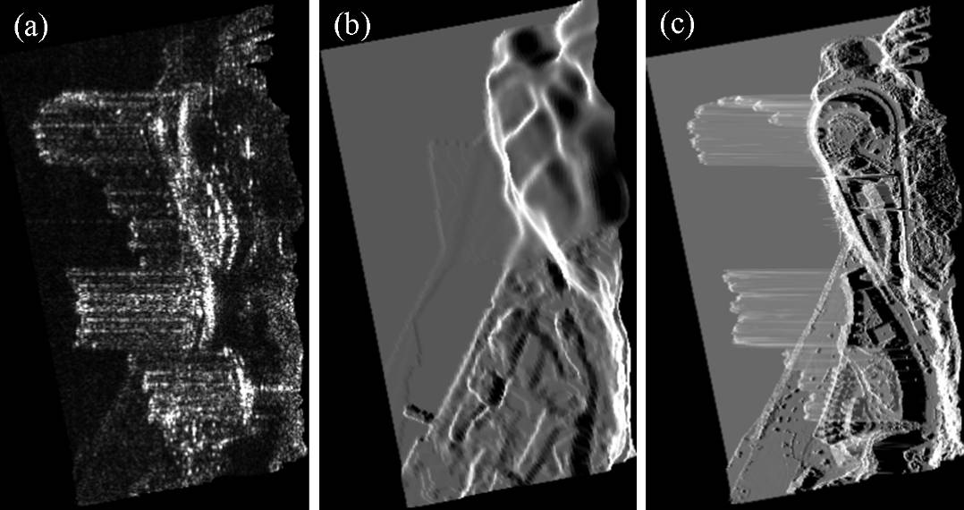
Fig. 3. SAR image simulation. (a) Real TerraSAR-X image, (b) simulated SAR image using DEM data (5 m resolution in vertical direction), (c) simulated SAR image using LiDAR DSM data (0.3 m resolution in vertical direction).

3.2 Self-adaptive quad-tree KML generation
When a large amount of target points are encountered, data loading and visualization in Google Earth become a problem. Thus, in our platform, a self-adaptive quad-tree KML generation algorithm was proposed.
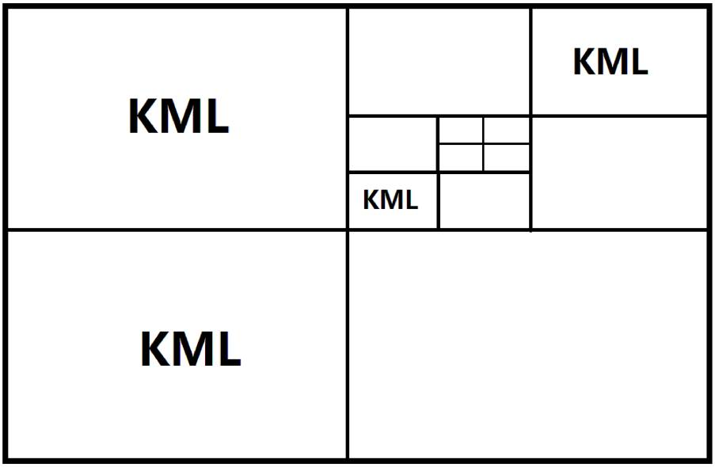

Fig. 4.Diagram of KML files generation using the proposed self-adaptive quad-tree method.

3.3 Large-scale oriented Stanford Method for Persistent Scatterers (L-StaMPS)
Several challenges (e.g. phase errors and sparse target candidates) arise when a large-scale natural region monitoring is encountered. Potential phase errors could be from orbit, atmospheric delay and long-distance parameter integration. The sparse spatial candidates are caused by the lack of persistent scatterers or coherent targets in natural scenarios. In order to conquer above two deficiencies, the L-StaMPS model was developed.

3.4 High-resolution oriented Least Square Persistent Scatterers (H-LSPS)
Owing to the development of spaceborne platforms, the spatial resolution of SAR data has increased by an order of magnitude from tens of meters to a meter.High resolution is beneficial for detail information detection. Compared with the current persistent scatterer method (Colesanti et al., 2003; Ferretti et al., 2000), the proposed H-LSPS model is more feasible for urban area monitoring using high-resolution SAR data.

3.5 Slope instability-oriented Small Baseline Subsets (S-SBAS)
Landslides or slope vulnerability monitoring is one of the important applications of DInSAR/MT-InSAR. Different from urban regions, distributed scatterers are prevalent in natural scenarios instead of persistent scatterers, and thus determines the feasibility of SBAS (Berardino et al., 2002) taking advantage of its capability for DS targets extraction.
- Case study: Ground deformation monitoring in Kowloon, Hong Kong
TerraSAR-X data are applied to monitor deformation velocity in Kowloon which is one of the most prosperous and bustling districts in Hong Kong, China. The area of interest is about 15 km², encompassing most of Kowloon (see Fig. 5). The pixel spacing of TerraSAR data is 0.9 m in the range and 2.0 m in the azimuth direction. In our proposed H-LSPS model, the differential phases from adjacent persistent scatterers are analyzed in order to eliminate spatially correlated terms after the removal of orbital and topographic components. Totally, 47 scenes of TerraSAR-X data are used for H-LSPS analysis, ranging from 13 May, 2008 to 26 Dec., 2010. The SRTM DEM is used for the topographic phase mitigation. Analogical to the classical persistent scatterer method (Colesanti et al., 2003; Ferretti et al., 2000), the calculated motion and residual heights can be further improved by iterations. The final deformation velocity rate of Kowloon is illustrated in Fig. 6, including 223,502 detected points, that is 8,278 p/km2. It is clear that the mean linear deformation velocities are not evident, primarily in the range of -5.9 mm/yr to 6.1 mm/yr. Because of the unavailable of leveling data, the standard deviation of the linear deformation velocity is also used for the preliminary evaluation. The averaged standard deviation of all points is 2.56 mm/yr, indicating the reliability of derived results. There is a main deformation fields marked by ellipses in Fig.10. The specific area spreads along the W Kowloon Highway with values higher than -2 mm/yr, probably caused by the construction (around 2003) hysteresis effect of Nancang station of Tung Chung Line.

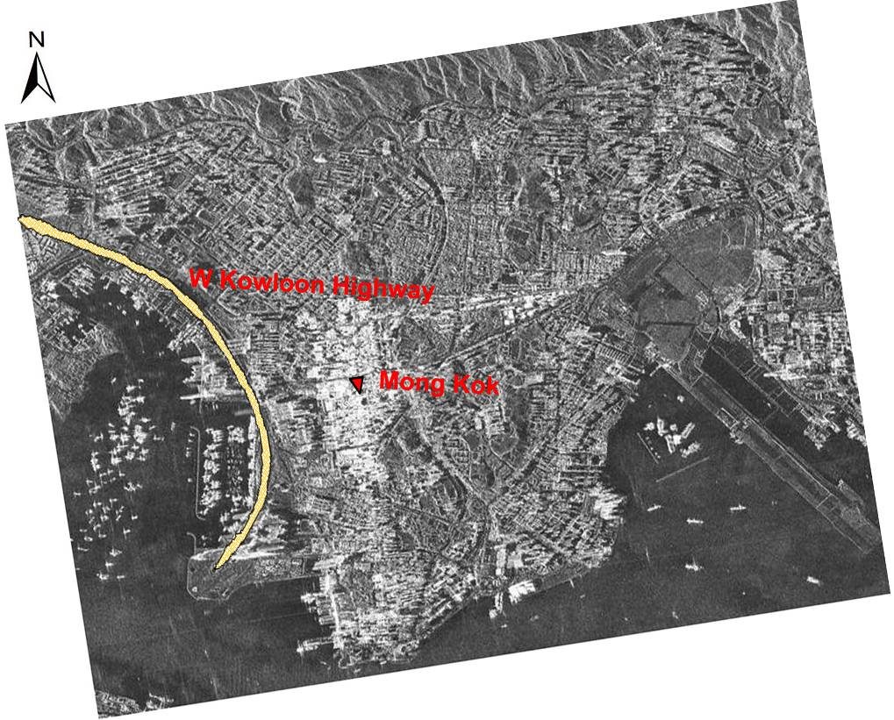
Fig. 5. Study area of Kowloon using TerraSAR-X data.
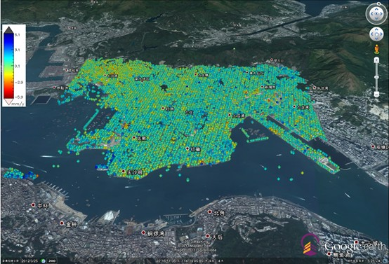
Fig. 6. Linear deformation velocity of Kowloon derived by the H-LSPS model using TerraSAR-X data spanning from 13 May, 2008 to 26 Dec., 2010.

- Summary and conclusion
In this study, a smart and enhanced multi-temporal SAR interferometry platform, so-called SkySENCE-InSAR, was developed by the InSAR group of Institute of Space and Earth Information Science, The Chinese University of Hong Kong. The system overcomes limitations (e.g. training experience and SAR interferometry background for end-users) of current DInSAR/MT-InSAR tools (e.g. ROI_PAC, Doris, StaMPS), primarily owing to the flow-process data processing and friendly user interfaces. In order to deal with high resolution LiDAR DSM data, an enhanced DSM simulation method was developed, a KML file generation algorithm based on a self-adaptive quad-tree was proposed, facilitating the visualization and interpretation of InSAR products taking advantage of high-resolution optical remote sensing images in Google Earth.
For the InSAR technology promotion, three typical application-oriented MT-InSAR models were proposed before the system integration, including H-LSPS, L-StaMPS and S-SBAS. Taking Hong Kong, China as study sites, the performance of those models w.r.t. the high-density urban ere further investigated, demonstrating the potential of SkySENCE-InSAR for customized applications from different industry sectors.

Acknowledgement: This study has been supported by funding from the Innovation and Technology Support Programme of HKSAR, China (ITS/152/11FP), the Research Grants Council of the HKSAR, China (450210), the National Natural Science Foundation of China (41201455), and Hundred Talents Program of the Institute of Remote Sensing and Digital Earth, Chinese Academy of Sciences (Y2ZZ27101B). We thank anonymous reviewers for their constructive and insightful comments. The LiDAR data covering Hong Kong are provided by Geotechnical Engineering Office, Civil Engineering and Development Department, HKSAR, China. The Envisat ASAR data in Tibet Plateau was provided by ESA under the ESA-MOST Dragon 3 Cooperation Programme (10674).

References:
Berardino, P., Fornaro, G., Lanari R., Sansosti E. (2002). A new algorithm for surface deforamtion monitoring based on small baseline differential SAR interferograms. IEEE Transactions on Geoscience and Remote Sensing, 40(11), 2375-2383.
Calderhead, A. L., Therrien, R., Rivera, A., Martel, R., and Garfias, J. (2011). Simulating pumping-induced regional land subsidence with the use of InSAR and field data in the Toluca Valley, Mexico. Advances in Water Resources, 34(1), 83-97.
Chen, F. and Lin, H. (2011). Multi-baseline differential SAR interferometry analysis of Lantau Highway, Hong Kong, using Envisat ASAR data. Remote Sensing Letters, 2(2), 167-173.
Chen, F., Lin, H., Yeung, K. and Cheng, S. (2010). Detection of slope instability in Hong Kong based on multi-baseline differential SAR interferometry using ALOS PALSAR data. GIScience and Remote Sensing, 47, 208-220.
Chen, F., Lin, H., Li, Z., Chen, Q. and Zhou, J. (2012). Interaction between permafrost and infrastructure along the Qinghai-Tibet Railway detected via jointly analysis of C- and L-band small baseline SAR interferometry. Remote Sensing of Environment,123,532-540.
Colesanti, C., Ferretti, A., Novali, F., Rocca, F. (2003). SAR monitoring of progressive and seasonal ground deformation using the permanent scatterers technique. IEEE Transactions on Geoscience and Remote Sensing, 41(7), 1685-1701.
Colesanti, C., Wasowski, J. (2006). Investigating landslides with space-borne synthetic aperture radar (SAR) interferometry. Engineering Geology, 88, 173-199.
Ferretti, A., Prati, C., & Rocca, F. (2000). Nonlinear subsidence rate estimation using persistent scatterers indifferential SAR interferometry. IEEE Transactions on Geoscience and Remote Sensing, 38, 2202-2212.
Ferretti, A., Fumagalli, A., Novali, F., Prati, C., Rocca, F. and Rucci, A. (2011). A New Algorithm for Processing Interferometric Data-Stacks:SqueeSAR. IEEE Transactions on Geoscience and Remote Sensing, 49, 3460-3470.
Guzzetti, F., Manunta, M., Ardizzone, F., Pepe, A., Cardinali, M., Zeni, G., Reichenbach, P., Lanari, R. (2009). Analysis of ground deformation detected using the SBAS-DInSAR technique in Umbria, Central Italy. Pure and Applied Geophysics,166,1425-1459, doi:10.1007/s00024-009-0491-4.
Hooper, A. (2008). A multi-temporal InSAR method incorporating both persistent scatterer and small baseline approaches. Geophysical Research Letters, 35, 1-5.
Hooper, A., Bekaert, D., Spaans, K., Arkan, M. (2012). Recent advances in SAR interferometry time series analysis for measuring crustal deformation. Tectonophysics, 514-517, 1-13.
Hooper, A., Zebker, H., Segall, P., Kampes, B. (2004). A new method for measuring deformation on volcanoes and other natural terrains using InSAR persistent scatterers. Geophysical Research Letters, 31, L23611, doi:10.1029/2004GL021737.
Jiang, L., Lin, H., Ma J., Kong B., and Wang Y. (2011). Potential of small-base SAR interferometry for monitoring land subsidence related to underground coal fires: Wuda (Northern China) case study. Remote Sensing of Environment, 115, 257-268.
Lanari, R., Mora, O., Manunta, M. (2004). A small-baseline approach for investigating deformations on full-resolution differential SAR interferograms. IEEE Transactions on Geoscience and Remote Sensing, 42, 1377-1386.
Liu, G., Jia, H., Zhang, R. et al., (2011). Exploitation of subsidence estimation by persistent scatterer InSAR on time series of high resolution TerraSAR-X images. IEEE Journal of Selected Topics in Applied Earth Observations and Remote Sensing, 4(1), 159-170.
Liu, L., Zhang, T., Wahr, J. (2010). InSAR measurements of surface deformation over permafrost on the North Slope of Alaska. Journal of Geophysical Research, Earth Surface, 115, F03023, doi: 10.1029/2009JF001547.
Mora, O., Mallorqui, J. J., Broquetas A. Linear and nonlinear terrain deformation maps from a reduced set of interferometric SAR images. IEEE Transactions on Geosciences and Remote Sensing, 41(10), 2243-2253.
Ng, A.H-M., Ge, L., Zhang, K. and Li, X. (2012). Estimating horizontal and vertical movements due to underground mining using ALOS PALSAR. Engineering Geology, 143-144, 18-27.
Perissin, D., Wang, Z. and Lin, H. (2012). Shanghai subway tunnels and highways monitoring through Cosmo-SkyMed Persistent Scatterers. ISPRS Journal of Photogrammetry and Remote Sensing, 73, 58-67.
Usai, S.(2003). A least squares database approach for SAR interferometric data. IEEE Transactions on Geoscience and Remote Sensing, 41(4), 753-760.
Werner, C., Wegmuller, U., Strozzi, T., and Wiesmann, A. (2003). Interferometric point target analysis for deformation mapping. Proceeding of IEEE Geoscience and Remote Sensing Symposium (IGARSS’03), July 2003, Toulouse, France, 4362-4364.
Zhang, L., Ding, X., Lu, Z. (2011). Modeling PSInSAR time series without phase unwrapping. IEEE Transactions on Geoscience and Remote Sensing, 49(1), 547-556.

