Pareto optimality for modelling Tsunami Effects on Sea Surface Salinity From MODIS Satellite Data

Maged Marghany

Institute of Geospatial Science and Technology (INSTeG),Universiti Teknologi Malaysia,81310 UTM, Malaysia,
Email:maged@utm.my, magedupm@hotmail.com

KEY WORDS: Pareto Optimality, least square algorithm, Tsunami, Sea Surface Salinity.

ABSTRACT: Remote sensing technology has been recognized as a powerful tool for environmental disaster studies. Ocean surface salinity is considered as a major element in the marine environment. In this study, we simulated the tsunami 2004 impacts on the Sea Surface Salinity along Banda Aceh using the least square algorithm. This study is implemented the Pareto optimality with least square algorithm for retrieving sea surface salinity during and post tsunami day. This study shows significant variations in the values of SSS pro, during and post the tsunami event. The maximum salinity was observed post tsunami event was 38 psu as compared to pre and during tsunami event. The results also show a good correlation between in situ SSS measurements and the SSS that is retrieved from MODIS satellite data with high r² of 0.99 and RMSE of bias value of ±0.82 psu. Clearly, the tsunami 2004 has significant impacts on the SSS because of high sediment deposit concentrations which added more salts and minerals to the coastal waters of Banda Aceh. It can be said that Pareto Optimality produced accurate mapping of sea surface salinity.

- INTRODUCTION

The study of tsunami effects on the physical properties of coastal water body is required, standard procedures and optimal computing methods. This is because of the Christmas tsunami was so powerful it actually sped up the rotation of the Earth, reducing the length of its sidereal day. The earthquake that spawned also caused the Earth to vibrate all over by as much as 1 cm. In this regard, one critical question that may be raised is what the optimal method can investigate the tsunami effects on the ocean physical properties such as temperature and salinity? In fact, there are not many studies which have been conducted to answer this question. Temperature and salinity are the main parameters used to understand ocean circulation. Both parameters can produce vertical current movement because of their gradient changes. In addition, water density changes are a function of gradual changes of temperature and salinity. Also, climate change, marine pollution and coastal hazards are basically controlled by the dramatic changes in sea surface salinity (SSS) (Marghany 2014).

System identification techniques are applied in coastal hydrodynamics in order to model and predict the behaviors of unknown and/or very complex hydrodynamic systems based on given huge input-output physical oceanography data. The study of tsunami effects on coastal parameters has been studied by Marghany (2014) by using a least square algorithm. However, this method is required to be optimized to acquire accurate results. One of the significant optimized technique can be achieved by using Genetic algorithm (GA). For all the objective functions, there is no an excellent single optimum solution. As an alternative, there is a set of optimum solutions, well known as Pareto optimal solutions or Pareto front, which discriminates expressively the intrinsic natures amongst single-objective and multi-objective optimization dilemmas.

The notion of Pareto efficiency is also beneficial in complex system study such as a coastal hydrodynamic system. Given a set of choices and a way of valuing them, the Pareto frontier or Pareto set or Pareto front is the set of choices that are Pareto efficient. By restricting attention to the set of choices that are Pareto-efficient, a designer can make tradeoffs within this set, rather than considering the full range of every parameter (Tomoiagă et al., 2013). The concept of Pareto front or set of optimal solutions in the space of objective functions in multi-objective optimization problems (MOPs) tolerates for a set of solutions which are non-dominated to each other but are superior to the rest of solutions in the search space. Even though the first Pareto front is the most important and will be the ultimate solution, it must does occur in changed levels, developing dissimilar ranked Pareto fronts (Srinivas and Deb 1994).

Concern with above prospective, we address the question of the optimization of tsunami ‘s impact on Sea Surface Salinity (SSS) pattern changes pro and post tsunami event of 2004. This is demonstrated with Moderate-resolution Imaging Spectrometer (MODIS) i.e. the Aqua/MODIS data level IB reflectance satellite data using the Pareto optimality with a least square algorithm for retrieving sea surface salinity during and post tsunami day.

- STUDY AREA
The study area is located along the western coastal zone of Aceh with boundaries of latitudes 3° 30´ N to 6° 30´ N and longitudes of 93° 30´ E to 99° 30´E (Figure 1). The Sunda trench is running north-south along the coastal waters of Aceh towards the Andaman Sea. Running in a rough north-south line on the seabed of the Andaman Sea is the boundary between two tectonic plates, the Burma plate and the Sunda Plate. These plates (or microplates) are believed to have formerly been part of the larger Eurasian Plate, but were formed when transform fault activity intensified as the Indian Plate began its substantive collision with the Eurasiancontinent. As a result, a back-arc basin center was created, which began to form the marginalbasin which would become the Andaman Sea, the current stages of which commenced approximately 3–4 million years ago. On December 26, 2004, a large portion of the boundary between the Burma Plate and the Indo-Australian Plate slipped, causing the 2004 Indian Ocean earthquake. This megathrust earthquake had a magnitude of 9.3. Between 1300 and 1600 kilometers of the boundary underwent thrust faulting and shifted by about 20 meters, with the sea floor being uplifted several meters. This rise in the sea floor generated a massive tsunami with an estimated height of 28 meters (30 ft) (Marghany 2014).
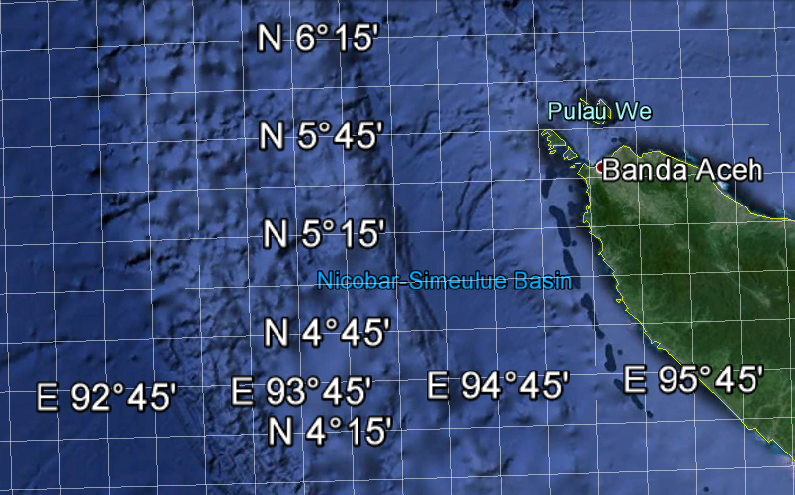
Figure 1. Location of study area.

- LEAST SQUARE METHOD

Following Marghany (2014), the theoretical model of the split window method that relates to MODIS sea surface salinity with in situ salinity measured by thermal infrared sensors, these include multi-channel methods. We assume the MODIS image radiance $I$ within multi-channels $i$ have a linear relationship with measured sea surface salinity (). According to Marghany (2009) and Marghany et al, (2010), a useful extension of linear function of N channels as in eq. (1)

I =1,2,….,n (1)

where the retrieval Sea Surface Salinity ( S)_{i} in Scalar notation, from MODIS data, the least squares estimators of the regression coefficients are and k is a number of selected MODIS radiance bands which equals 7 bands. Therefore, the fitted regression model to retrieve the Sea Surface Salinity from MODIS data ( S) is
S=I β (2)

where β is the ordinary least squares estimator of b to distinguish it from other estimators based on the least squares idea. According to Marghany (2014) β is given by

β =( I′ I)⁻¹ I′ S (3)

In general, S is an (n x 1) vector of the Sea Surface Salinity (S) observations from MODIS radiance data I which is and (n x p) matrix of the levels of independent variables. In addition, I′ S is a (p x 1) column vector [3]. In this form it is easy to see that I′ I is a (p x p) symmetric matrix (2014). The model, written in terms of the observations, is

, i=1,2,3,…………,n (4)

It is simpler to solve the normal equations if they are expressed in matrix notation. We now give a matrix development of the normal equations that parallels the development of equation (4).

- Multi-objective optimization via Pareto dominance
Following Atashkari et al., (2004), the Multi-objective optimization (MOB) which is also termed the multi-criteria optimization or vector optimization. In this regard, it has been defined as finding a vector of decision variables satisfying constraints to give acceptable values to all objective functions. Generally, it can be mathematically defined as: find the vector to optimize
, (5)
subject to m inequality constraints

, (6)

and p equality constraints
, (7)
where is the vector of decision or design variables, and is the vector of objective functions which each of them be either minimized or maximized. However, without loss of generality, it is assumed that all objective functions are to be minimized.

A point ( $Ω$ is a feasible region in $ℜ^{n}$ satisfying equations (5) and (7)) is said to be Pareto optimal (minimal) with respect to the all if and only if . Alternatively, it can be readily restated as
$∀i∈\left\{1,2,\text{.}\text{.}\text{.},\left.k\right\}\right.$, ∧ $∃j∈\left\{1,2,\text{.}\text{.}\text{.},\left.k\right\}\right.$ : . In other words, the solution is said to be Pareto optimal (minimal) of salinity if no other solution can be found to dominate using the definition of Pareto dominance. For a given MOP, the Pareto front ƤŦ٭ is a set of vector of objective functions which are obtained using the vectors of decision variables in the Pareto set Ƥ٭, that is ƤŦ٭Ƥ٭}. In other words, the Pareto front ƤŦ٭ is a set of the vectors of objective functions mapped from Ƥ٭ (Atashkari et al., 2004).

- Results and Discussion

The tsunami impact on sea surface salinity has been investigated on three MODIS satellite data along Aceh coastal waters. These MODIS data are acquired on 23rd ,26th and 27th 2004 which represent pro, and post tsunami event, respectively (Figure 2). According to Marghany et al., (2014), Moderate Resolution Imaging Spectroradiometer (MODIS) has 1 km spatial resolution and having 36 bands which are ranged from 0.405 to 14.285µm . The MODIS satellite takes 1 to 2 days to capture all the scenes in the entire world, acquiring data in 36 spectral bands over a 2330 km swath.
(a) (b) (c)
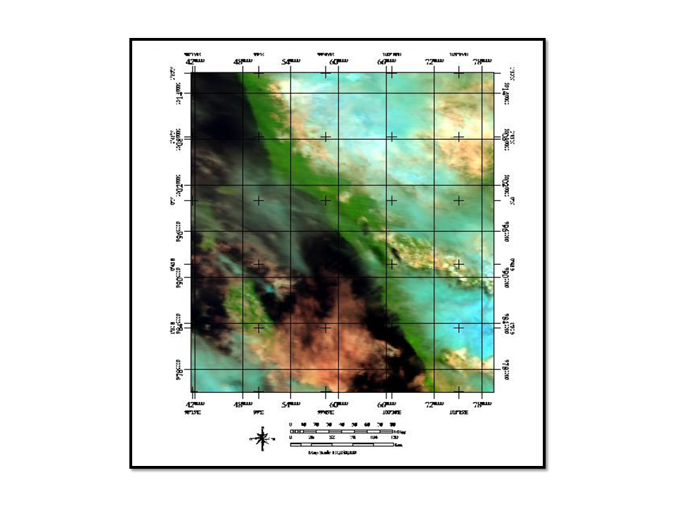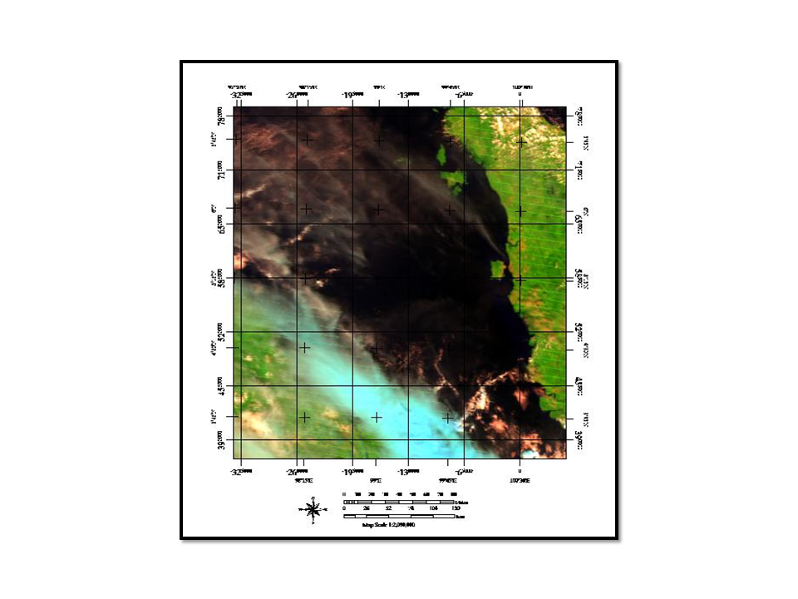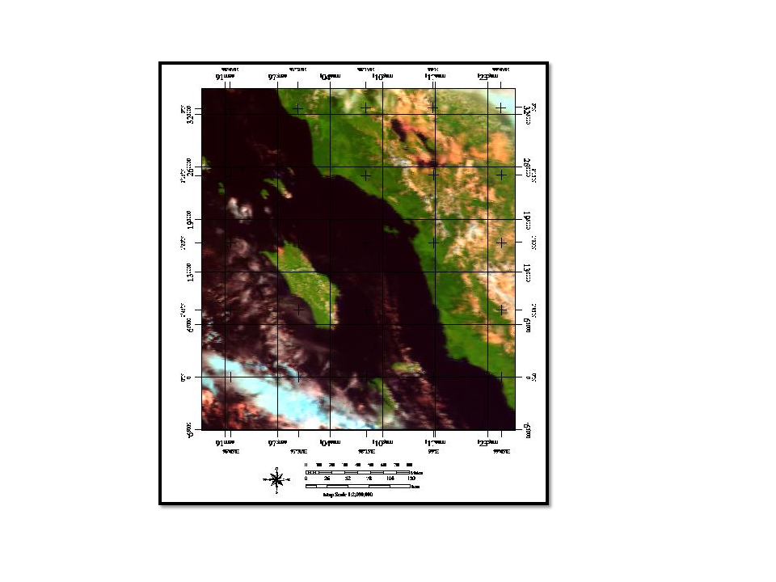
Figure 2. MODIS satellite data (a) pro tsunami event, (b) during tsunami event and (c) post tsunami event.

Figure 3 shows the spatial variation of the salinity distribution along Aceh, which are derived using the multi-objective optimization via Parto Dominance. On December 23th 2004, the sea surface salinity ranged between 28 psu to 31 psu. Nevertheless, during the tsunami event 25th 2004, the sea surface salinity dramatically increased and ranged between 34 psu to 36 psu. The sea surface salinity was continued to increase post tsunami event of December 27th 2004 and ranged between 37 psu to 38 psu.

- (b)
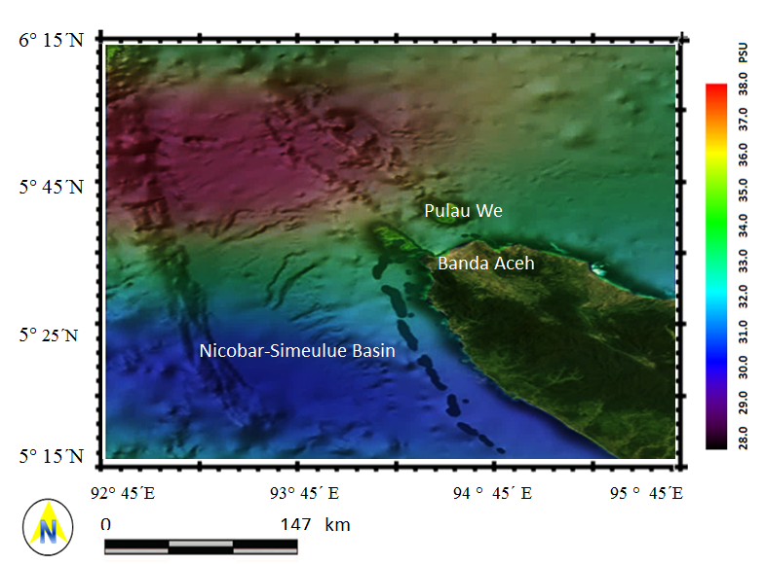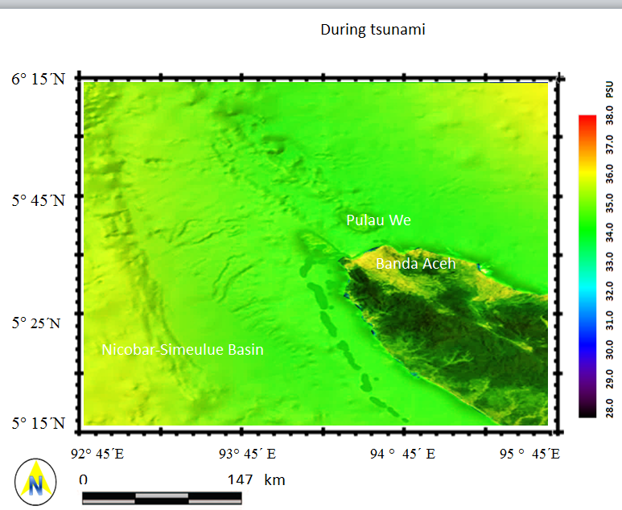
(c)
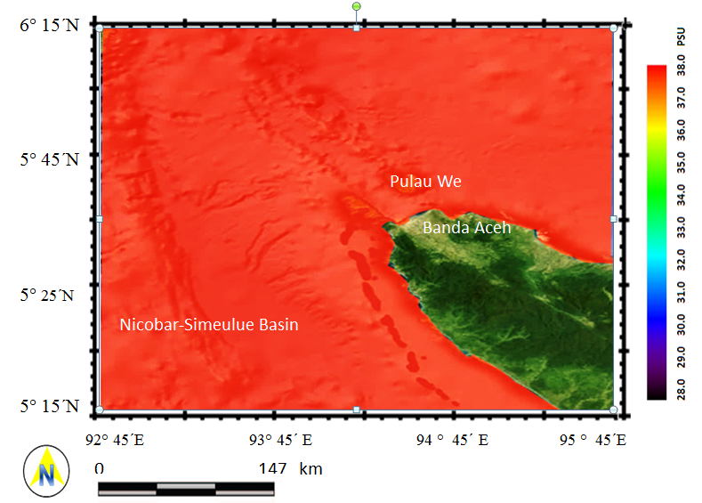
Figure 3. Retrieved Sea Surface Salinity from MODIS (a) pro (b) during and (c) post tsunami event using multi-objective optimization via Parto Dominance.

Table 1 shows the accuracy of the retrieved S from MODIS data using multi-objective optimization via Parto dominance compared to the in situ measurements obtained from the NOAA web site. Clearly, using multi-objective optimization via Parto Dominance performs the highest accuracy with r² of 0.82 and root mean square errors of 0.9. This indicates that the using multi-objective optimization via Parto Dominance can be considered to be a accurate technique for retrieving SSS from MODIS data.
Table 1: Statistical summary of accuracy assessments
Periods r² RMSE

Pro tsunami 0.97 0.92
During tsunami 0.98 0.87
Post tsunami 0.99 0.82

These results are dissimilar to studies of Wong et al. (2007); Marghany et al., (2010); Marghany (2014). In fact, Multi-objective optimization has been stated as finding a vector of decision variables satisfying constraints to give accurate values to all objective functions. Furthermore, using the multi-objective optimization via Parto dominance derives a curve that minimizes the discrepancy between the estimated salinity from MODIS data and in situ data. This means that using the new approach based on the multi-objective optimization via Parto Dominance, can minimize the sum of the residual errors for the estimating salinity from MODIS data and provides an accurate salinity spatial variation map. This study confirms the work done by Atashkari et al., (2014).

- ConclusionS

This study has been demonstrated an optimal method which is based on the multi-objective optimization via Parto dominance to retrieve sea surface salinity from MODIS satellite. It was during the tsunami 2004 boxing day.
This study presents substantial variations in the values of sea surface salinity pro, during and post the tsunami 2004 event. The maximum salinity was observed during the post tsunami event which was 38 psu as compared to pre and during tsunami 2004 disaster. The results also show that the multi-objective optimization via Parto dominance has an accurate performance with high r² of 0.99 and RMSE of bias value of ±0.82 psu. In conclusion, the multi-objective optimization via Parto dominance can be used as an optimized algorithm to acquire accurate results for sea surface salinity retrieving from MODIS satellite data.

References

Atashkari, K., Nariman-Zadeh, N., Darvizeh, A., Yao, X., Jamali, A., & Pilechi, A. (2004). Genetic design of GMDH-type neural networks for modelling of thermodynamically pareto optimized turbojet engines. WSEAS Transactions on Computers, 3(3), 719-724.

Marghany M., 2010, Examining the Least Square Method to Retrieve Sea Surface Salinity from MODIS Satellite Data. Eur. J. of Sci. Res. (40) 377-386.

Marghany M., Hashim M., and Cracknell A.P., 2010, Modelling Sea Surface Salinity from MODIS Satellite Data. Lecture Notes in Computer Science, Computational Science and Its applications- ICCSA, (6016): 545-556.

Marghany M., and Hashim M., 2010, MODIS satellite data for modeling chlorophyll-a concentrations in
Malaysian coastal waters. Int. J. of Phys. Sci., (5) 1489-1495.

Marghany M. 2009. Linear algorithm for salinity distribution modelling from MODIS data, Geoscience and Remote Sensing Symposium,2009 IEEE International, IGARSS 2009, 12-17 July 2009, Cape Town, South Africa, 2009 (3) III-365 - III-368.

Maged M. (2014). Simulation of Tsunami Impact on Sea Surface Salinity along Banda Aceh Coastal Waters, Indonesia, Advanced Geoscience Remote Sensing, Prof. Maged Marghany (Ed.), InTech, Retrieved August 10, 2014, fromhttp://www.intechopen.com/books/advanced-geoscience-remote-sensing/simulation-of-tsunami-impact-on-sea-surface-salinity-along-banda-aceh-coastal-waters-indonesia

Srinivas, N. and Deb, K., 1994. Multiobjective optimization Using Nondominated Sorting in Genetic Algorithms, Evolutionary Computation, Vol. 2, No. 3, pp 221-248.

Tomoiagă, B.; Chindriş, M.; Sumper, A.; Sudria-Andreu, A.; Villafafila-Robles, R. 2013. Pareto Optimal Reconfiguration of Power Distribution Systems Using a Genetic Algorithm Based on NSGA-II. Energies, 6, 1439-1455.

Wong M. S., Kwan L., Young J. K., Nichol J., Zhangging L., Emerson N., 2007, Modelling of Suspendid Solids and Sea Surface Salinity in Hong Kong using Aqua/ MODIS Satellite Images. Kor. J. of Rem. Sens. , (23) 161-169.

