Particle swarm optimization for Geological feature Detection from PALSAR DATA

Maged Marghany

Institute of Geospatial Science and Technology (INSTeG),Universiti Teknologi Malaysia,81310 UTM, Malaysia,
Email:maged@utm.my, magedupm@hotmail.com

KEY WORDS: Particle Swarm Optimization, Linear geological features, Automatic detection, PALSAR satellite data.

ABSTRACT: Synthetic aperture radar (SAR) has been recognized as a powerful tool for geological feature detection. This work introduces a new approach using Particle Swarm Optimization automatically detected geological features from PALSAR SAR data. The result shows that the new formula based on Particle Swarm Optimization can be delineated lineament features in PALSAR data. The new approach using Particle Swarm Optimization has a small standard deviation of 3.54. The result shows a clear appearance of morpholineament, urban, and infrastructure features due to speckle reduction. This confirms a low error standard deviation value of 2.32. In conclusion, Particle Swarm Optimization has improved distinction of morpholineaments, urban features, infrastructure features such as roads and bridges from the surrounding environment features. This new approach can be used as an automatic tool to extract linear features from SAR data.

- INTRODUCTION

Geological feature detections and identifications in SAR images are required standard procedures and accurate algorithms. In fact, the main disadvantage of SAR images is speckles. The speckles do not allow any accurate retrieving information from SAR data. According to Marghany (2010), the high speckle noise in SAR images, has posed great difficulties in inverting SAR images for geological features detection and mapping. A speckle pattern, consequently, is a random intensity pattern fashioned by the mutual interference of a set of wavefronts having different phases. Under this circumstance, they add together to give a resultant wave whose amplitude, and therefore intensity, varies randomly. In this context, Lopes et al., (1990) stated that if each wave is modelled by a vector, then it can be seen that if a number of vectors with random angles are added together. The length of the resulting vector, therefore, can be anything from zero to the sum of the individual vector lengths—a 2-dimensional random walk, sometimes known as a drunkard's walk. Further, when a surface is illuminated by a microwave, spectra according to diffraction theory, each point on an illuminated surface acts as a source of secondary spherical waves. The microwave spectra at any point in the scattered microwave field is made up of waves which have been scattered from each point on the illuminated surface. If the surface is rough enough to create path-length differences exceeding one wavelength, giving rise to phase changes greater than 2π, the amplitude, and hence the intensity, of the resultant backscatter microwave varies randomly ((Touzi,2002; Yu and Scott 2002; Hondt et al., 2006; Helmy and El-Taweel, 2010; Marghany 2010 ).

This work has hypothesized that linear features such as morphological features i.e. faults and lineaments; urban; infrastructures and their surrounding backscattered environmental signals in the SAR data can be automatically detected by Particle Swarm Optimization. In this context, approach of Particle Swarm Optimization algorithm can be used as an automatic tool to extract morphological features from SAR data.

- Particle Swarm Optimization for sar data

Most of the target detection problems in SAR data are characterized by multiple objectives, which often oppose and contend with one another. Such complications arise in SAR applications, where more objective functions have to be minimized or maximized concurrently. Due to the multi criteria nature of SAR speckles, optimality of a solution has to be redefined, giving rise to the concept of Pareto optimality (Marghany 2014). Evolutionary algorithms are appropriate to multi-objective problems because of their proficiency to synchronously exploration for multiple Pareto optimal solutions. Also, evolutionary algorithms do not rely on the precise features of the objective function to accurately perform, for instance, continuity, convexity and concavity. Therefore, Particle Swarm Optimization (PSO), Shuffled Complex Evolution Metropolis (SCEM), and Complex Evolution Metropolis (CEM)there are major evolutionary algorithms. In this regard, Particle Swarm Optimization has been implemented in many different research fields because of its accurate performance in solving numerous single and multi objective optimization problems such as despeckles (Riccardo et al., 2007 and Jin et al., 2008).

PSO is a population-based randomly searching process. It is assumed that there are N “particles” i.e., lineaments, faults, topographic breaks, bedding, depressions, lithologies, which are presented in SAR data. These geological features invasive contacts randomly seem in a “solution space”. Thus the optimization problem can be solved for data clustering, there is always a criteria (for example, the squared error function) for every single particle at their position in the solution space. The N particles will keep moving and calculating the criteria in every position the stay which is named as fitness in PSO pending the criteria reaches satisfied threshold. Therefore, each geological feature (particle) maintains its coordinates in the solution space of SAR images which are combined with the finest fitness that has extremely accomplished by requested geological feature i.e. particle. In fact, the pixel of each feature i.e. particle (i,j) denotes a probable solution to the optimization problem. Following Kennedy and Eberhart (1995), each agent moves the particle with a direction and velocity $v_{\text{ij}}$
$p_{\text{ij}}=p_{\text{ij}}+v_{\text{ij}},$ (1)
where $p_{\text{ij}}$ represent the $\text{jth}$ particle in the $\text{ith}$ agent and $v_{\text{ij}}$ is the velocity of the $\text{jth}$ particle in the $\text{ith}$ agent.
$v_{\text{ij}}=v_{\text{ij}}+c_{1}r_{1}({\text{lbest}}_{\text{ij}}−p_{\text{ij}})+c_{2}r_{2}({\text{gbest}}_{\text{ij}}−p_{\text{ij}})$ (2)
where ${\text{lbest}}_{\text{ij}}$ is the local best particle, ${\text{gbest}}_{\text{ij}}$ is the global best particle, $r_{1}$ and $r_{2}$ are random variables and $c_{1}$ and $c_{2}$ are the swarm system variables. After each iteration the global best $g_{\text{best}}$ particle and the agent local best $l_{\text{best}}$ particle are evaluated based on the maximum fitness functions of all particles in the solution space. Then equations 1 and 2 can be expressed as follows

(3)
(4)
where is the current position of the particle, is the current velocity of the particle. The velocity is regulated by a set of rules that influence the dynamics of the swarm. Further, there are several parameters must be considered such as initial population, representation of position and velocity strategies, fitness function identification and the limitation. These parameters are for PSO performances. Following Ibrahim et al., (2010) the initial swarm particles proposed PSO is initialized to contain 1000 points of particles with random position and velocity . The points had been randomly selected in the azimuth and range directions in SAR data.

After reaching a precise number of iteration or an accurate, error threshold is performed,the optimal solution is obatined. is the personal best position of the particle, w, c, are all constant factors, and r is the random numbers uniform distributed within the interval [0,1]. Thus the general swarm algorithm can be changed into binary particle (Discrete Particle Swarm Algorithm DPSO) which handles particle values of either $0$ or $1$ by a given equation (Kennedy and Eberhart 1997 and El Meseery et al., 2009).
$P(i)⇐\left\{\begin{matrix}1 \text{if} r_{3}>p_{i} \\ 0 \text{if} r_{3}<p_{i}\end{matrix}\right\}$ (5)
where $p_{\text{ij}}$ is the numerical values of the particle and $r_{3}$ is a random variable.

According to El Meseery et al., (2009) the PSO can segment the geological features in SAR data. In this regard,
The input SAR data $S$ with $N$ points can be represented by set $S=\left\{x_{1},x_{2}…x_{N}\right\}$ where $x_{i}$ is the location of geological feature on the point $i$. The swarm algorithms consist of $M$ agents which are represented by the set $A=\left\{P_{i}|i\text{=1,2}⋯M\right\}$ where $P_{i}$ is a single solution particle from the solution space. Each particle decodes the problem using a binary array with the same length $N$ as the input SAR data. Consequently, the system denotes each particle $P_{i}$ by $P_{i}=\left\{p_{\text{ij}}|j\text{=1,2}⋯N\right\}$ where $p_{\text{ij}}$ has only two values a)1 ($p_{\text{ij}}\text{=1}$); means that this point ($j$) is a dominate point, or b) 0($p_{\text{ij}}\text{=0}$)which means that means this point ($j$) is not a dominate point (El Meseery et al., 2009). The fitness is computed using the given equation

where $N$ is the number of points in the SAR data, $D$ is the number of points in the solution that was previously labeled as a possible dominant point ($P_{\text{pd}}$), $E$ is the computed error and $ε$ is the error threshold. According to El Meseery et al., 2009 It should be noticed that when the error is larger than the threshold $ε$ the fitness is given a -ve value to lower the fitness value of the solution. Otherwise the system favors the lower number of vertices.

- Results and Discussion

The PALSAR SAR is distinctive in that it has a characteristic speckled effect similar to other SAR sensors which looks like ‘salt and pepper’ noise (Figure 1). According to Marghany et al., (2011) the resulting grainy appearance can be seen in Figure 1. This speckle noise is caused by random interferences when the signals arrived to the roughness of the studied areas and objects and that result in high spatial-frequency wave front deformations (Lopes et al., 1990). The speckle pattern super-imposed on the images makes it very difficult to be used in many applications (Lopes et al., 1993; Marghany 2001a; Touzi 2002; Marghany and Hashim 2010). Therefore, the morphological features such as morpholineaments are existed PALSAR data cannot be extracted and interpreted due to the speckle impacts (Figure 1).
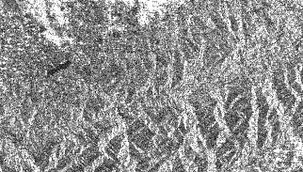
Figure 1. PALSAR SAR data with high speckles.

Figure 2 shows the result of PSO algorithm. It is obvious the clear appearance of the lineament features in PALSAR data. In fact, the PSO circumvents a decreasing resolution by making a weighted combination of running average with the neighbor surrounding pixels. This reduced the noise in the feature s’ edge areas without losing edge sharpness.

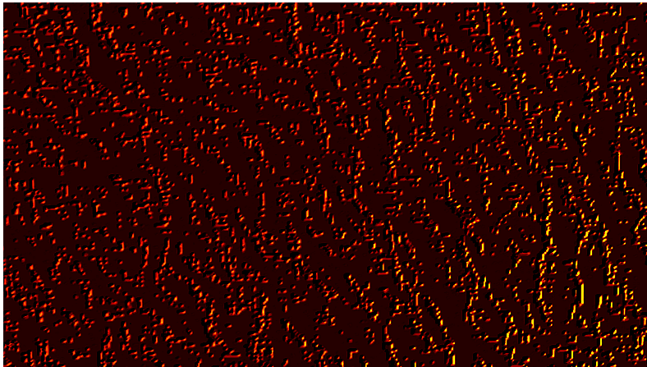

Figure 2. Lineament automatic detection using Particle Swarm Optimization.

The linear features in Figure 2 are clearly visualized PSO compared to amplitude raw data of PALSAR SAR. It is interesting to find that PSO produced a automatically detect lineament features in PALSAR SAR data (Figure 2). This indicates that the implementation of PSO is able to separate the lineament features from the surrounding pixels on the background in SAR image. This can be confirmed by the lower error standard deviation value of PSO i.e. 2.32 as compared to SAR raw data (Figure 3).

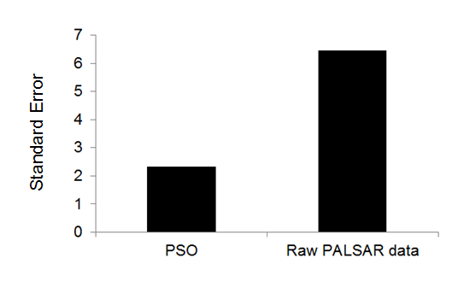
Figure 3. Standard error of Particle Swarm Optimization compared to PALSAR data

In fact, PSO provides the optimal line or curve length n that satisfies the figure-of-merit (FOM) function that embodies a nation of best curvature (Figure 2). This technique is useful in the case of high intensity line or curve of fixed length and locally low curvature boundary is known to exist between edge elements and high noise levels in the SAR data. It could be used for filling in gaps left between an edge detecting-thresholding-thinning operation. Finally, multistage optimization procedures have performed better use of PSO is due to its abilities to search to actual edge pixels lie on the boundary of lineament features being segmented. This can explain that the evolution of PSO is accomplished by using the multistage process is robust and accurate, and that all edge points fall on the boundary of lineament features in SAR image. Finally, this work agreed with Ibrahim et al., (2010) that PSO provides accurate segmentation for feature detections in coherence data such as SAR.

4 ConclusionS

This work has demonstrated a new approach using Particle Swarm Optimization for automatically geological feature detections in PALSAR SAR data. The study shows that high level of speckles in PALSAR data which effect the visual interpretation of any object in PALSAR data. Particle Swarm Optimization shows high performance in geological feature detection with low a low error standard deviation value of 2.32. In conclusion, Particle Swarm Optimization has improved distinction of geological features from the surrounding environment in PALSAR data. It can be said that Particle Swarm Optimization can be implemented as an excellent automatic tool for geological feature detections and mappings in SAR data.

References

El Meseery, M. El Din, M.F. ; Mashali, S. ; Fayek, M. ; Darwish, N 2009. Sketch recognition using particle swarm algorithm, 16th IEEE International Conference on Image Processing. 7-10 Nov. 2009, Cairo,Egypt. 2017 – 2020.

Ibrahim, S., Abdul Khalid, N.E., Manaf,M. 2010. Computer aided system for brain abnormalities segmentation. Malaysian Journal of Computing (MJOC) 1(1): 22-39.

Jin Yisu, Joshua Knowles, Lu Hongmei, Liang Yizeng and Douglas B. Kell (2008),” The landscape adaptive particle swarm optimizer”, Applied Soft Computing, Vol.8, pp. 295–304.

Kennedy, J. and Eberhart, R. C. 1997. A discrete binary version of the particle swarm algorithm. Systems, Man, and Cybernetics, 1997.'Computational Cybernetics and Simulation'., 1997 IEEE International Conference on,

Kennedy, J. and Eberhart, R. (1995) Particle Swarm Optimization. pages 1942--1948 vol.4, 1995.

Helmy, A.K., and G.S., El-Taweel (2010). Speckle Suppression of Radar Images Using Normalized Convolution. Journal of Computer Science. 6 (10): 1125-1129.

Hondt, O.D’, L. Ferro-Famil, and E. Pottier, (2006) Nonstationary spatial texture estimation applied t adaptive speckle reduction of SAR data. IEEE Transactions on Geosciences and Remote Sensing Letter, 3 (4), pp. 476–480.

Lee, J.S., D. Schuler, T. L. Ainsworth, E. Krogager, D. Kasilingam, M.A. and W.M. Boerner, (2002) On the estimation of radar polarization orientation shifts induced by terrain slopes. IEEE Transactions on Geosciences and Remote Sensing,40, 30–41.

Lopes, A. Touzi, R. and E. Nezry, (1990) Adaptive speckle filters and scene Heterogeneity. IEEE Transactions on
Geosciences and Remote Sensing, 28(6): 765-778.

Marghany M., 2014. Multi-Objective Evolutionary Algorithm for Oil Spill Detection from COSMO-SkeyMed Satellite. In Beniamino M., Sanjay Misra, Maurizio Carlini, Carmelo M. Torre, Hong-Quang Nguyen, David Taniar, Bernady O. Apduhan, and Osvaldo Gervasi(Eds.,) ICCSA 2014. Part VI, pp 355-371.

Maged Marghany (2012). Three-Dimensional Lineament Visualization Using Fuzzy B-Spline Algorithm from Multispectral Satellite Data. In Escalante-Ramirez B. (ed.) "Remote Sensing - Advanced Techniques and Platforms". InTech - Open Access Publisher, Croatia. pp.213-232.

Marghany,M. and Hashim,M. and Moradi F., (2011). Object recognitions in RADARSAT-1 SAR data using fuzzy classification. International Journal of the Physical Sciences. Vol. 6(16) pp. 3933 – 3938.

Marghany M., and Hashim M., (2010). Developing adaptive algorithm for automatic detection of geological linear features using RADARSAT-1 SAR data. International Journal of the Physical Sciences.Vol. 5(14), pp. 2223-2229.

Riccardo Poli, James Kennedy and Tim Blackwell (2007),” Particle swarm optimization -An overview”, Swarm Intell, Vol.1, pp.33–57.

Touzi,R., (2002) A review of speckle filtering in the context of estimation theory. IEEE Transactions on Geosciences and Remote Sensing. p. 2392–2404.

Yu, Y., and T. A., Scott, (2002). Speckle reducing anisotropic diffusion. IEEE Transactions on Geoscience and Remote Sensing. p.1260-1270.

