HOLOGRAM INTERFEROMETRIC SAR AND OPTICAL DATA FOR
FOURTH-DIMENSIONAL URBAN SLUM RECONSTRUCTION

Maged Marghany

Institute of Geospatial Science and Technology (INSTeG),Universiti Teknologi Malaysia,81310 UTM, Malaysia,
Email:maged@utm.my, magedupm@hotmail.com

KEY WORDS: Hologram Interferometric, LANDSAT-8, ENVISAT ASAR,Urban Slum, Fourth-dimensional.
ABSTRACT: In this study, hologram interferometric with 3D phase unwrapping is used to reconstruct fourth-dimensional urban slum in Cairo city,Egypt. The data are used that involved two ENVISAT ASAR data, and two optical LANDSAT-8 data . The results show that the hologram Interferometric an excellent tool for chaotic urban slum as it can discriminate between them from its surrounding environment. The combination of hologram Interferometric, DEM, time changes, then used to reconstruct 4-D of urban slum. Hologram interferometric shows a great overlapping between high class area with urban slum with every and less than 4 m. The results show that urban slums, road network, and infrastructures are perfectly discriminated. In conclusion, that the hologram Interferometric is an appropriate algorithm for chaotic 4-D urban slum automatic detection in ENVSIAT ASAR and LANDSAT-8 data.

- INTRODUCTION

The United Nations Human Settlements Programme (UN-HABITAT, 2012) defines urban slums as a household that cannot afford one of the following elementary living physical appearances: (i) adequate, living space, which means not more than three people sharing the same room (Figure 1); (ii) easy access to safe water in necessary amounts at the reasonable price (Figure 2); (iii) access to passable hygiene in the form of a private or public toilet shared by a sensible number of people; (iv) security of tenure that prevents forced evictions. In general. Urban slums are settlements, neighborhoods, or city regions that cannot afford the elementary living circumstances required for its inhabitants, or slum dwellers, to live in a safe and healthy environment.
- (b)
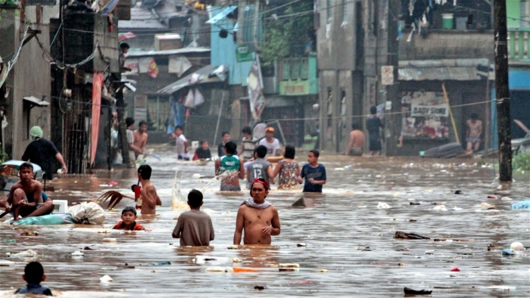
Figure 1: physical characteristics of urban slums (a) people sharing the same room in urban slums, (b) unsafe water

Many hypothesizes suggested that a mainstream of slum growth is owing to express urbanization within a developing country (Figure 2). This concept has implication because a population boom, correlated to urbanization, generates a greater request for housing than the urbanized area can provide or deliver. This population boom regularly involves rural inhabitants who migrate to urban areas where jobs are abundant and where wages are steadied. The issue, conversely, is impaired by the absence of federal and city-government guidance, control, and organization (Jordan 2014, and Marghany 2013).


Figure 2. Rapid growth of urban slums

Remote sensing technology plays termoundous roles to understand the mechanisms of urban slums. In fact, remote sensing technology has shown excellent promising for identification, mapping, and monitoring slums (Kohli et al., 2012; Ismail et al., 2013 and Jordan 2014). These studies have implemented automated or semi-automatic detection algorithms for identifying slums in low resolution satellite images such as LANDSAT TM, ENVISAT ASAR data. Further, Ismail et al., (2013) proposed a new method to identify urban slum which is based on Coexistent Urbanism approach. They proposed approach that is considered three groups of factors to differentiate between slums. These involve basic and socioeconomic factors, urban analysis factors and fabric morphological factors. Finally they applied space Syntax to slums network, then slums can be classified By a devised normalized index called Coexistence Potential index which measures effectiveness and neediness for intervention.

Recently, Marghany (2013) implemented fuzzy B-spline with ENVISAT ASAR data to reconstruct 3-D of Cairo’s urban slums. According to Dekker (2006), SAR data are suitable for monitoring urban land use. In fact, various bands of L, C, or X bands; with a wide range of incidence angles between 35º and 50º; and HH and HV polarization (HV interesting to investigate urban land use or quad pol monitoring urban environments). However, Dekker (2006) stated that ENVISAT ASAR satellite data with 30 m resolution cannot detect small objects. On the contrary, the same system can be used in combination with higher resolution satellites such as RADARSAT-2 SAR, TerraSAR X and airborne SAR systems for monitoring land use. Amarsaikhan et al. (2010) and Brook et al. (2013) have also shown how the combined use of optical and SAR data sets can enhance urban feature detections and enhancements.

Therefore, the advanced remote sensing technique of fourth-dimensional (4D) view will be appreciated if it provides excellent reconstruction of urban slums in satellite images with a combination of hologram interferometry for both optical and microwave data. The overall objective of this work is to reconstruct 4D of urban slums using hologram interferometry for ENVISAT ASAR and LANDSAT TM satellite data.

- Fourth-dimensional using hologram interferometry

Holography is an application of the interference property of the beam. By superimposing two sets of monochromatic and coherent wave fronts on a photographic plate, a microscopic interference pattern is produced. The developed plate, called a hologram, contains a permanent record of the interference pattern, i.e., it stores both amplitude and phase information. When the hologram is placed in a beam of the same coherent, monochromatic beam, the beam is diffracted through the fringes recorded on the hologram to produce a set of wavefronts identical to those originally reflected from the object. Consequently, when viewed, the diffracted wavefronts give a remarkably realistic, three-dimensional picture of the object.

$\begin{aligned}E_{\text{out}}=t\left(x,y\right)E_{1}=\left(t_{0}+βI\right)E_{1} \\ \left(t_{0}+{\text{βε}}_{0}c\left|E_{1^{2}}+E_{2^{2}}\right|\right)E_{1}+{\text{βε}}_{0}{cE}_{1}E_{2^{}}E_{1}+{\text{βε}}_{0}{cE}_{1^{}}E_{2}E_{1} \\ \left(t_{0}+{\text{βε}}_{0}c\left|E_{1^{2}}+E_{2^{2}}\right|\right)E_{10}e^{i(k_{1}x−ω_{1}t)}+{\text{βε}}_{0}{cE}_{{10}^{2}}E_{2^{}}e^{i2(k_{1}x−ω_{1}t)}+{\text{βε}}_{0}{cE}_{{10}^{2}}E_{2} \\ ={AE}_{10}e^{i(k_{1}x−ω_{1}t)}+{BE}_{2^{}}e^{i2(k_{1}x−ω_{1}t)}+{CE}_{2}\end{aligned}$A plane wave of light has an amplitude which varies in space and time, and moves in a particular direction. The simplest dependence to discuss is a sinusoidal oscillation, so that the intensity goes through peaks and troughs with time. The transverse electric field is given by
(1)
and will give an instantaneous intensity (the amount of energy flowing per unit area per unit time) given by
$I_{\text{inst}}=ε_{0}c\left|E^{2}\right|=ε_{0}{\text{cE}}_{0^{2}}{\text{cos}}^{2}(k⋅r−ωt)$ | (2)
where E_{o} is the wave amplitude, k is the wave vector and  is the radial frequency. The time average of this intensity over a period of oscillation is also known as irradiance, or
$I=ε_{0}c\left\langle E^{2}\right\rangle =ε_{0}c\left\langle E_{0^{2}}{\text{cos}}^{2}(k⋅r−ωt)\right\rangle =\frac{ε_{0}{\text{cE}}_{0^{2}}}{2}$ | (3)
If we have two waves, E₁ and E₂, then at any point in space or time their amplitudes will add vectorially. If one of these is a plane wave pointing in the z direction and the other is a spherical wave, then we get

$\begin{aligned}I_{\text{inst}}\left(x,y,z,t\right)=ε_{0}c\left|E^{2}\right|=ε_{0}c\left|{\left(E_{1}+E_{2}\right)}^{2}\right|=ε_{0}c\left|E_{1^{2}}+E_{2^{2}}+2E_{1}⋅E_{2}\right| \\ ε_{0}c\left(E_{1^{2}}+E_{2^{2}}+2E_{1}E_{2}\text{cos}ϑ_{\text{12}}\right) \\ ε_{0}c\left[E_{{01}^{2}}{\text{cos}}^{2}(\text{kz}−ω_{1}t)+\frac{E_{{02}^{2}}}{r^{2}}{\text{cos}}^{2}(\text{kr}−ω_{2}t)+\frac{2E_{01}E_{\text{02}}}{r}\text{cos}(\text{kz}−ω_{1}t)\text{cos}(\text{kr}−ω_{2}t)\text{cos}(ϑ_{\text{12}})\right]\end{aligned}$
(4)

This expression contains a part which only depends on one wave or the other, plus an interferometery term involving the cosine of the angle ϑ₁₂ between the two vector amplitudes (which may be a function of position x,y,z).

Space involves of three dimensions which is x,y,z. Further, time (t), is also a dimension. Therefore,space and time are not concepts that can be considered independently of one another when we are looking for change detection from satellite data. In addition to 3D space our model needs TIME as one of its geometric dimensions. Starting from the center, it is an integer count of layers outward. The spherical layers (3D slices through the 4D Hypersphere) are the spatial dimensions, each representing a particular moment in time (Figure 3). They are separated one Planck-time from each other. Based on the universe theory, we assumed that Whereas, any object is all of Space as it exists in a single moment, the single 3D wavefront expanding within this 4D spherical Space~Time context.

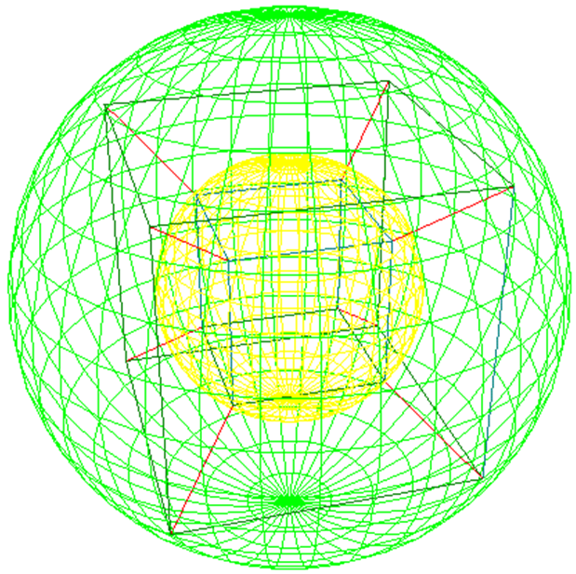
Figure 3. Example of 4D reconstruction.
To help envision a sphere expanding inside a hypercube, consider the yellow inner sphere, being the object at half its current size; expanding to the outer green sphere, representing the object at its current size/time. Defining the moment called “Now”, and established the direction that time flows.

- Results and Discussion

This multi-coloured composite ENVISAT Advanced Synthetic Aperture Radar (ASAR) wide swath mode image over Egypt's capital city of Cairo. Clearly ENVISAT ASAR image shows the Nile River is running from south to north. Radar images measure surface roughness rather than reflected light. The colour in the image was produced by a combination of the three acquisitions of ENVISAT ASAR. A colour is assigned to each date of acquisition: red for 7 June 2004, green for 20 November 2003 and blue for 8 April 2004, with a spatial resolution of 12.5 metres (Figure 4). Further, two images LANDSAT images were acquired by in 1987 and 2014. During this time period, Cairo's population has increased from an estimated 6 million in 1986 to over 15 million in 2014 (Figure 4b).
- (b) (c)
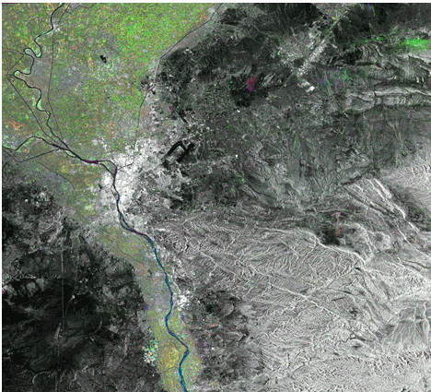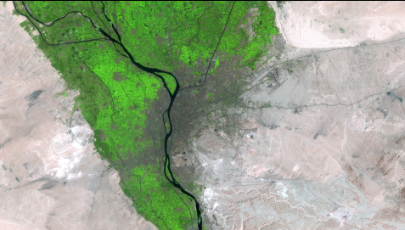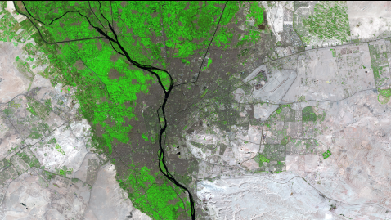

Figure 4. Data used on (a) Composite colour image of ENVISAT ASAR; (b) LANDSAT images acquired in 1987 and (c) LANDSAT image acquire in (2014) over Cairo, Egypt.

Figure 5 shows the hologram interferometry for both ENVISAT and LANDSAT TM pairs. Cleary, both hologram interferometry fringes shows great changes in land uses since 1987 to 2014. The maximum rate of changes is 20 m/yr which is obvious in LANDSAT 8 hologram. This could be due to the rapid development and increment in ratio of population in Cairo. This area is dominated by heavy density of urban slum. According to Marghany (2013), the main criteria of urban slum in Cairo low quality building, poor infrastructures, overlapping between high quality and low quality buildings, high building density, hazardous location, poor environmental condition, durability. This confirms the study of Ismail et al., (2013).
- (b)
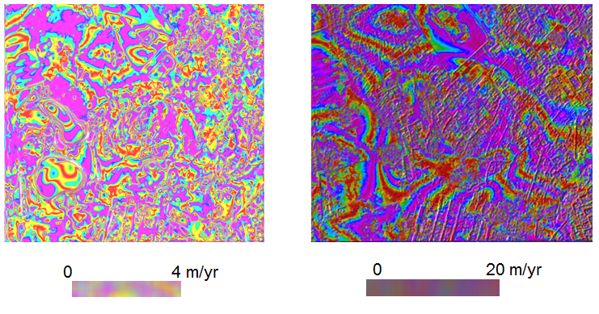
Figure 5. Hologram interferometry for (a) ENVISAT ASAR and LANDSAT 8.

Figure 6 shows the 4D visualization derived from hologram interferometry. It is clear that the 4-D visualization discriminates between infrastructures and buildings. Roads, buildings and infrastructures are clearly displayed in both ENVISAT ASAR and LANDSAT TM (Figure 6). This is due to the fact that the hologram interferometry, is considered as a deterministic algorithm, which is described here to optimize a triangulation only locally between two different points. This corresponds to the feature of deterministic strategies of finding only sub-optimal solutions usually. The visualization of the infrastructures of urban slums is sharp with the ENVISAT ASAR and LANDSAT TM. This study is showing excellent promising for 4D visualization that is derived from hologram interferometry.

- (b)
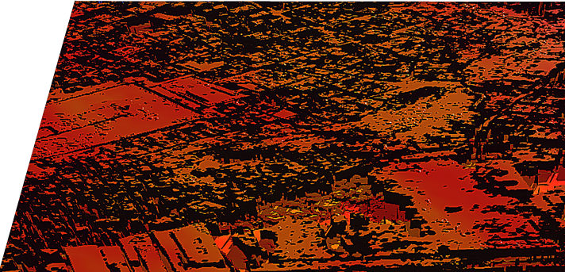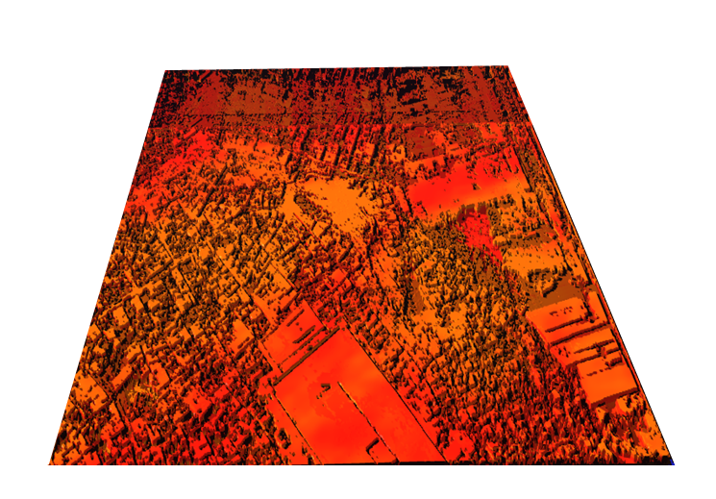

Figure 6. 4D visualization produced by hologram interferometry from ENVISAT ASAR data with different angle of view (a) 90° and (b) 180°.

- CONCLUSIONS

This study has demonstrated a method to visualize 4-D of urban slums using ENVISAT ASAR and LANDSAT TM imagery. Some urban slums in Cairo city were selected as test area. Then, the hologram interferometry implemented to reconstruct a 4-D visualization of the urban slums. The results show that the high density of housing spatial distributions, inherent in many dense slum areas, together with the high level of infrastructure, can be clearly observed. In conclusions, hologram interferometry shows an excellent tool for 4-D visualization and discrimination between infrastructures and housing features in remotely sensed data specially with SAR satellite and optical data. With the current operational status of 4D hologram interferometry, the proposed technique described in this paper can be very useful for urban slum studies.

References

Amarsaikhan, D., Blotevogel, H.H., Genderen, J.L. van, Ganzorig,M., Nergui,B., 2010. Fusing high-resolution SAR and optical imagery for improved urban land cover study and classification. International Journal of Image and Data Fusion, 1, 83-97.

Brook, A., Ben-Dor, E. And Richter, R., 2013, Modelling and monitoring urban built environment via multi-source
integrated and fused remote sensing data. International Journal of Image and Data Fusion, 4, 2-32.

Dekker R 2006. Monitoring urban development using ENVISAT ASAR 1st EARSeL Workshop of the SIG
Urban Remote Sensing Humboldt-Universität zu Berlin, 2-3 March 2006, Retrieved May 13, 2005, from
http://www.earsel.org/workshops/SIG-URS-2006/PDF/Session3_Dekker.pdf.

Ismail,A., Bakr H., Anas S., 2013. Ahybrid GIS space syntax methodology for prioritizing slums. Coordinates, IX,44-50.

Jordan R. F, (2014) Urban Slum: Massive urban slum in developing countries.Geography intern. Retrieved August 10, 2014, from http://geography.about.com/od/urbaneconomicgeography/a/Urban-Slums.htm

Kit O., Lüdeke,M.,and Reckien D., 2012, Texture-based identification of urban slums in Hyderabad, India
using remote sensing data. Applied Geography. 32, 660-667

Kohli D, Richard S, Norman K, Stein A, 2012. An ontology of slums for image-based classification. Computers, Environment and Urban Systems. 36 (2), 154–163.

Maged Marghany (2013). Urban Slum Three-Dimensional Reconstruction from Envisat Satellite Data in Egypt. Proceedings of the 34th Asian Conference on Remote Sensing 2013. Bali – Indonesia, October 20 -24, 2013. pp. SC06-54-SC06-60.

Smith, J., 2010. Optimizing Remote Sensing for Disaster Monitoring, Retrieved May 13, 2005, from http://www.remotesening.net/index.htm.

UN-HABITAT (2012). Retrieved August 10, 2014, from http://www.unhabitat.org/pmss/listItemDetails.aspx?publicationID=2917.

