COSMO-SkyMed FOR AUTOMATIC DETECTION OF OIL SPILL USING ON MULTI-OBJECTIVE EVOLUTIONARY ALGORITHM ALONG GULF OF THAILAND

Maged Marghany

Institute of Geospatial Science and Technology (INSTeG),Universiti Teknologi Malaysia,81310 UTM, Malaysia,
Email:maged@utm.my, magedupm@hotmail.com

KEY WORDS: Multi-Objective Evolutionary Algorithm, COSMO-SkyMed, oil spill, Pareto optimal solutions, Automatic detection
ABSTRACT: Oil spill pollution has a substantial role in damaging the marine ecosystem. Oil spill that floats on top of water, as well as decreasing the fauna populations, affects the food chain in the ecosystem. In fact, oil spill is reducing the sunlight penetrates the water, limiting the photosynthesis of marine plants and phytoplankton. Moreover, marine mammals for instance, disclosed to oil spills their insulating capacities are reduced, and so making them more vulnerable to temperature variations and much less buoyant in the seawater. Objective: This study has demonstrated a design tool for oil spill detection in COSMO-SkyMed satellite data using Methods: Multi-Objective Evolutionary Algorithm which based on Pareto optimal solutions. The COSMO-SkyMed along the Gulf of Thailand is involved in this study. Results: The study also shows that Multi-Objective Evolutionary Algorithm provides an accurate pattern of oil slick in COSMO-SkyMed data. This shown by 96% for oil spill, 1% look–alike and 3% for sea roughness using the receiver –operational characteristics (ROC) curve. The MOGA also shows excellent performance in COSMO-SkyMed data. Conclusion: In conclusion, Multi-Objective Evolutionary Algorithm can be used as an automatic detection tool for oil spill in COSMO-SkyMed satellite data.

- INTRODUCTION

Recently, there has been an explosive increments in marine oil spill pollutions. Deepwater Horizon oil spill in 2010, for instance, is the most serious marine pollution disaster has occurred in the history of the petroleum industry. This disaster has dominated by three months of oil flows in coastal waters of the Gulf of Mexico. Incidentally, the Deepwater Hoizon oil spill has serious effects on feeble maritime, wildlife habitats, Gulf's fishing, coastal ecologies and tourism industries. Therefore, the resulting oil slicks are difficult to control, as their evolution be influenced by weather, currents, tides, and many chemical and physical factors (Marghany 2001; Marghany 2004; Brekke and Solberg 2005; Topouzelis et al., 2009; Marghany 2013a; Marghany 2013b). Further, oil sources are challenging to verify and be subject to the type of oil, its volume, location and duration of the seepage, and surrounding environmental conditions (Migliaccio et al., 2007; Marghany et al., 2009; Zhang et al., 2011) Consistent with Marghany (2001), Synthetic aperture radar (SAR) is a precious foundation of oil spill detection, surveying and monitoring that improves oil spill detection by various approaches (Brekke and Solberg 2005). The different SAR tools to detect and observe oil spills are vessels, airplanes, and satellites (Migliaccio et al., 2007; Marghany et al., 2009; Zhang et al., 2011). Vessels can detect oil spills at sea, covering restricted areas, say for example, (2500 m x 2500 m), when they are equipped with the navigation radars [8]. On the other hand, airplanes and satellites are the main tools that are used to record sea-based oil pollution (Marghany and Hashim 2011; Shirvany et al., 2012 and Zhang et al., 2012).

Recently, Skrunes et al., (2012), nevertheless, reported that there are several disadvantages are associated with Current SAR based oil spill detection and monitoring. They stated that, SAR sensors are not able to detect thickness distribution, volume, the oil-water emulsion ratio and chemical properties of the SAR data. In this regard, they recommended to utilize multi-polarization acquisition, data such as RADARSAT-2 and TerraSAR-X satellites. They concluded that the multi-polarization data show a prospective for prejudice between mineral oil slicks and biogenic slicks. Finally Marghany (2013a) used Genetic algorithm for oil spill detection in ENVISAT ASAR data along Singapore Straits. Marghany (2013b) found that crossover process, and the fitness function generated accurate pattern of oil slick in SAR data. He used the receiver –operational characteristics (ROC) curve to verify oil spill detection in SAR data. He stated that ROC verified 85% for oil spill, 5% look–alike and 10% for sea roughness. The objective of this work can divide into two sub-objectives: (i) To examine MOEA for oil spill automatic detection in COSMO-SkyMed satellite data; and (ii) To design the multi-objective optimization algorithm based on Pareto optimal solutions for oil spill automatic detection.

- Study Area

According to Marghany (2014), approximately 50 tons of crude oil spilled into the sea of Rayong province, Thailand, on Saturday morning, July 27, 2013 after a leak occurred in a pipeline (Figure1a). The oil spill has moved away from the mainland and has started to disperse to an extent. However, what is worrying now is that it seems to have reached a group of islands dominated by Koh Kudee. The stag-horn and giant clam coral reef is dominated natural features of Koh Samet island (Figure 1b) with water depth less than 20 m depth.
- (b)
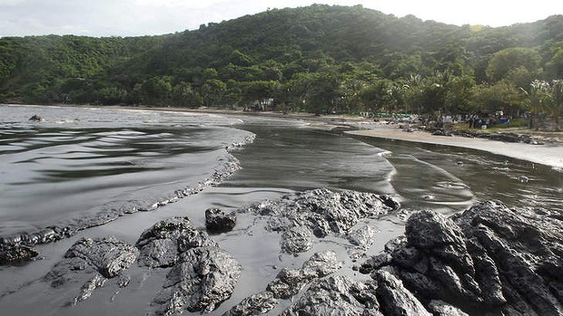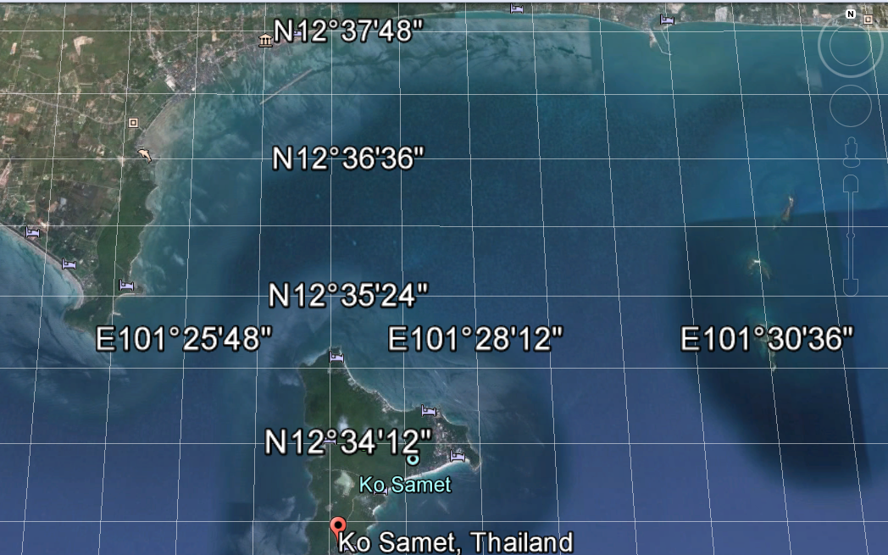
Figure 1. Oil spill covers beach on (a) Koh Samet Island and (b) Google map of Koh Samet Island.

- Data Acquisition

The COSMO-SkyMed-2 imagery was acquired on August 1st , 2013 at 06:09 a.m. shows oil spill at Rayong. COSMO-SkyMed is a 4-spacecraft constellation for Earth observation, funded by ASI and the Italian Ministry of Defense. Each of the four satellites is equipped with SAR instruments (Marghany 2014). All the space crafts of the SAR constellation are to be positioned in the same orbital plane with a defined phasing. Thenominal repeat cycle is 16 days. However, each single satellite is believed to have a near revisit time of 5 days. The nominal full constellation should have a revisit time of a few hours on a global scale. The first constellation satellite is designed to observe in X-band (9.6 GHz with a wavelength of 3.1 cm). Multi-band scenarios (X-, C- L- and P bands) are planned. The X-band instrument has a swath between 10 and 200km (depending on support mode); a total FOR (Field of Regard) of 1300 km in the cross-track direction (Marghany 2014).

- Multi-Objective Evolutionary Algorithm (MOEA)
  - Data organization

Following Marghany (2013a), entire backscatter of dark patches in COSMO-SkyMed data are where K is the total number backscatter of dark patches in the SAR data. Therefore, K is made up from genes which is representing the backscatter of dark patches and its surrounding environment and genetic algorithms is started with the population initializing step.

  - Pareto optimal solution
In this research, two objectives are considered. One is oil spill backscatter and the other is sea surface, ship, lookalikes, and land backscatters. The definitions of oil spill pixels and non- oil spill pixels are given as follows:
1. Oil Spill pixels (): the variation of maximum pixels which contain oil spill pixels i.e. =. Where denotes the oil spill pixel$j , ∀j=1,2,\text{.}\text{.}\text{.},k$.
2. total SAR pixels (): the sum of pixels surrounding oil spill pixels of each row and column in SAR data.
Pareto optimal solutions are applied to retain the discrimination of oil spills
backscatter diversity and surrounding backscatter environment.

To optimize the oil spill automatic detection from SAR data using MOEA, the oil spill backscatter must be coded into a Genetic Algorithm syntax form. In this context, the oil spill must backscatter is coded into the chromosome form. In this problem, the chromosome consists of a number of genes where every gene corresponds to a coefficient in the n^{th}-order surface fitting polynomial as given by
(1)
where [0,1…..m] are the backscatter parameter coefficients that will be estimated by the genetic algorithm to approximate the minimum error for oil spill backscatter discrimination from surrounding environment. i and j are indices of the pixel location in the image respectively, m is the number of coefficients (Figure 2).

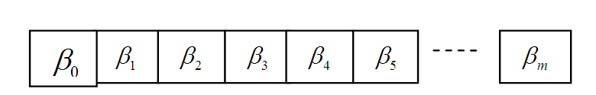
Figure 2. Coding scheme of the coefficients of the n^{th}-order surface fitting polynomial into the chromosome syntax form.

Then the weighted sum to combine multiple objectives into single objective is given by
(2)
where are the objective functions and $w_{1},w_{2},\text{.}\text{.}\text{.},w_{n}$ are the weights of corresponding objectives that satisfy the following conditions.
$\begin{aligned}w_{i}≥0 ∀i=1,2,\text{.}\text{.}\text{.},n \\ w_{1}+w_{2}+\text{.}\text{.}\text{.}\text{.}\text{.}\text{.}+w_{n}=1\end{aligned}$ (3)
Once the weights are determined, the searching direction is fixed. To search Pareto optimal solutions as much as possible, the searching directions should be changed again and again to sweep over the whole solution space. Therefore the weights have to be changed again and again Marghany (2014).

- Results and Discussion

In this study, COSMO-SkyMed data Spotlight 2 mode on July 29, 2013 at 11:23:33 UTC is implemented for oil spill detection in the Koh Samet island, Thailand. This data covered 12° 31´48" N to 12° 37´ 48" N latitude and 101° 2´24" E to 101 33 37" E longitude (Figure 3) The Satellite has a Synthetic Aperture Radar (SAR) with multiple polarization modes, including a fully polarimetric mode in which HH, HV, VV and VH polarized data are acquired. Its highest resolution is 1 m in Spotlight mode 2 with the maximum coverage is ≤20 x 20 km², geometric resolution is 1.0 m², pixel spacing is 0.5 m x 0.5 m, and the incident angle is between 20° to 59°. Fig. 6 shows the Spotlight 2 data where the oil spill is heading by 16.5° towards inland within 6.59 km length of the island to inland (Figure 3).
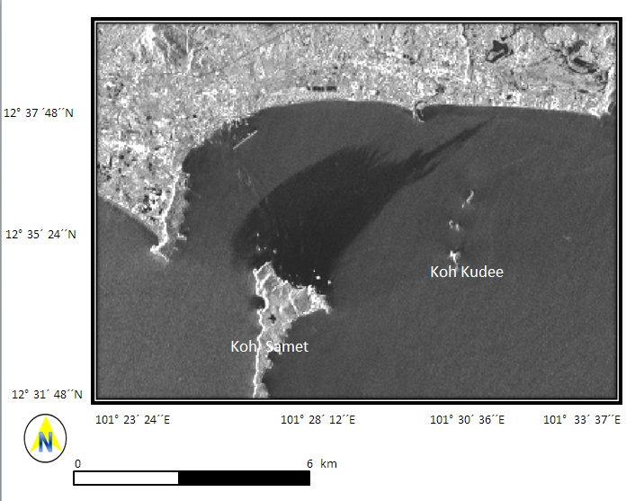
Figure 3. COSMO-SkyMed data along Koh Samet island, Thailand.

Figure 4 shows the result of Pareto optimal solutions for oil spill discriminating in COSMO-SkyMed data. It is clear that the Pareto optimal provides excellent decision of oil spill pixels in COSMO-SkyMed data. In fact, the Multi-Objective Evolutionary Algorithm (MOEA) provide a set of compromised solutions called Pareto optimal solution since no single solution can optimize each of the objectives separately. The decision maker is provided with the set of Pareto optimal solutions in order to choose a solution based on the decision maker’s criteria.

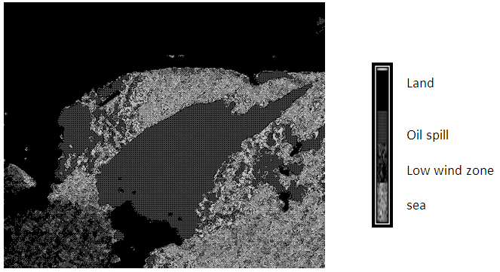

Figure 4. Pareto optimal solution for oil spill discrimination in COSMO-SkyMed

This sort of MOEA solution technique is called a posteriori method since the decision is taken after searching is finished. In this context, the Pareto-optimal approach does not require any a priori preference decision between the conflicting of oil spill pixel, look-alike pixels, land pixels, and surrounding sea pixels. Further, Pareto-optimal points have formed Pareto-front as shown in Figure 4 in the multi pixel objectives function the COSMO-SkyMed data space (Shirvany et al., 2012 and Zhang et al., 2012;Marghany 2014). Multi-Objectives Evaluation Algorithm (MOEA) which based on the Pareto optimal solutions provides excellent discrimination of oil spill pixels. This can be confirmed by the receiver–operator characteristics (ROC) curve (Figure 5). In this regard, the existing of weighted sum of objective function converts a conflicting multiobjective problem of oil spill and surrounding sea features objective one.
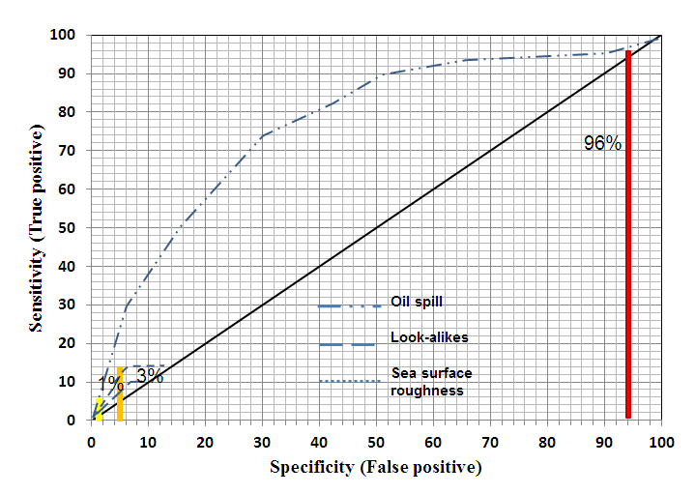
Figure 5. ROC for oil spill discrimination using MOEA.

This can be seen in ROC curve where oil spill has an area difference of 96%, which is larger than look-alike and sea surface areas. Further, p probability of 0.0005 another proof for excellent of MOEA for oil spill detection. This study shows a great performance as compared to previous work done by Marghany (2013a). This because of Pareto-front contains the Pareto-optimal solutions and in case of continuous front, it divides the pixels objective function space into two parts, which are non-optimal solutions and infeasible solutions. In this regard, it improved the robustness of pattern search and improved the convergence speed of MOEA. This confirms the work of Yudong et al., (2013).

- Conclusions

The study demonstrated the Pareto optimal solution and weight sum in MOEA which are generated accurate pattern of oil slick in SAR satellite data such as COSMO-SkyMed. This is approved by using the receiver –operational characteristics (ROC) curve. The ROC curve confirmed the oil spill occurrence along the Koh Samet island, Thailand with 96 %, which is larger than other surrounding environment features. In conclusion, MOEA which is based on Pareto optimal solution can be used as an automatic detection tool for oil spill in COSMO-SkyMed satellite data. In conclusion COSMO-SkyMed data are an excellent sensor for oil spill detection and monitoring.

Acknowledgement
The author would like to thank Geo-informatics and Space Technology Development Agency (GISTDA) of Thailand for providing COSMO-SkyMed data.

References

Brekke, C. and Solberg, A. 2005. Oil Spill Detection by Satellite Remote Sensing. Remote Sensing of Environment. 95,1-13.

Marghany,M. and Hashim M., 2011. Comparative algorithms for oil spill detection from multi mode RADARSAT-1 SAR satellite data. Lecture Notes in Computer Science. D. Taniar et al. (Eds.). Computational Science and Its Applications – ICCSA 2011, 6783: 318-329.

Marghany, M. 2001. RADARSAT Automatic Algorithms for Detecting Coastal Oil Spill Pollution. Int. J. of App. Ear. Obs. and Geo. 3: 191-196.

Marghany, M. 2004. RADARSAT for Oil spill Trajectory Model. Env. Mod. and Sof. 19, 473-483.

Marghany, M., Cracknell, A. P. and Hashim, M. 2009. Modification of Fractal Algorithm for Oil Spill Detection from RADARSAT-1 SAR Data. Int. J. of App. Ear. Obs. and Geo. 11: 96-102.

Marghany M. 2013a. Genetic Algorithm for Oil Spill Automatic Detection from Envisat Satellite Data. In Beniamino Murgante, Sanjay Misra, Maurizio Carlini, Carmelo M. Torre, Hong-Quang Nguyen, David Taniar, Bernady O. Apduhan, and Osvaldo Gervasi. Computational Science and Its Applications – ICCSA 2013, 7972, pp 587-598.

Marghany M.2013b. Genetic Algorithm for Oil Spill Automatic Detection from Multisar Satellite Data. Proceedings
of the 34th Asian Conference on Remote Sensing 2013. Bali – Indonesia, October 20 -24, 2013. pp. SC03-671-SC0-
3677.

Marghany M., 2014. Multi-Objective Evolutionary Algorithm for Oil Spill Detection from COSMO-SkeyMed Satellite. In Beniamino Murgante, Sanjay Misra, Maurizio Carlini, Carmelo M. Torre, Hong-Quang Nguyen, David Taniar, Bernady O. Apduhan, and Osvaldo Gervasi. ICCSA 2014. Part VI, pp 355-371.

Migliaccio, M., Gambardella, A. and Tranfaglia, M., 2007. SAR Polarimetry to Observe Oil Spills. IEEE Tran. on Geos. and Rem. Sen. 45: 506-511.

Skrunes, S., C. Brekke, and T. Eltoft, 2012.An Experimental Study on Oil Spill Characterization by Multi-
Polarization SAR,” in Proc. European Conference on Synthetic Aperture Radar, Nuremberg, Germany (2012) 139-
142.

Topouzelis, K., Karathanassi, V., Pavlakis, P. and Rokos, D. 2009. Potentiality of Feed-Forward Neural Networks for
Classifying Dark Formations to Oil Spills and Look-alikes. Geo. Int. 24,179-19.

Zhang B., W. Perrie,X. Li and W. Pichel 2011. Mapping sea surface oil slicks using RADARSAT-2 quad-
polarization SAR image, Geophys. Res. Lett., 38: L10602.

Zhang Y., H. Lin, Q.Liu, J. Hu, X. Li and K.Yeung 2012. Oil-spill monitoring in the coastal waters of Hong Kong
and vicinity, Marine Geodesy, 35: 93-106.

Shirvany, R., M. Chabert, J-Y. Tourneret 2012. Ship and Oil-Spill Detection Using the Degree of Polarization in
Linear and Hybrid/Compact Dual-Pol SAR, Selected Topics in Applied Earth Observations and Remote Sensing,
IEEE Journal of, 5:885-892

Yudong Z, Shuihua W., Genlin J. and Zhengchao D., 2013. Genetic Pattern Search and Its Application to Brain
Image Classification. Math. Prob. in Eng., 1-8.

