A Geographical Model for Prediction of Malaria Index

on Ayeyarwady Region

Aye Aye Khine

Lecturer, Department of Geography, Dagon University

aak13366@gmail.com

ABSTRACT

Ayeyarwady Region located within the low risk to moderate risk area of Malaria in Myanmar. This research is intended to depict the spatial patterns of malaria situations of the Region by using geospatial technologies. Some statistical procedures are adopted to make better conclusion. The climatic conditions of Ayeyarwady Region enhance the breeding of mosquitoes, particularly in Kyangin, Pathein, Thabaung, Ngapudaw, Ingapu, Eainemae, Kyaiklat townships covering the western part of the township which is high in Normalized Different Vegetation Index (NDVI). The malaria morbidity and mortality rates are relatively high in these townships. Generally the morbidity rate is high in townships with low and moderate population density. The above-mentioned factors would be helpful in predicting the morbidity rates in Ayeyarwady Region and in locating the areas for preventive measures. Among the environmental factors related to malaria, six are chosen as dependent variables to build a model which can be used for the prediction of morbidity rate. Furthermore, using Multiple Linear Regressions (Stepwise Method), malaria morbidity index is equal to 20.889- 0.252RH - 0.004Population Density is worked out, that can be used for prediction of malaria morbidity in any area within Ayeyarwady Region. For the effective reduction of the morbidity and mortality rates, such socio-economic factors as education level, the use of drinking water, health education and accessibility and status of health centres in the remote areas are examined and the necessary measures are recommended. If the discussions and suggestions presented in this paper could be solved by the responsible persons, the malaria morbidity and mortality rates in Ayeyarwady Region would be reduced notably.

INTRODUCTION

Research Problems
To find out the major influencing factors upon the distribution of malaria morbidity and mortality which are the problems of Ayeyarwady Region.

Aim

The aim of this study is to identify the influencing factors that cause malaria morbidity and mortality in Ayeyarwady Region and to investigate the relationship between the prevalence of certain diseases and specific geographic features so as to be able to focus the treated area and provide necessary preventive measures, which will eventually lead to the reduction of malaria incidence to the Millennium Development Goals (MDG) level in Ayeyarwady Region.

Sources of Data and Methodology
The spatial technologies-Geographic Information Systems and Remote Sensing are applied throughout the research work. The advantage of using geospatial technology is that GIS database of Ayeyarwady Region will become available for future research works and monitoring of spatial patterns of malaria Risk Areas.
Some mathematical models are constructed by using interpolation methods (IDW) and zonal statistical procedures are employed to figure out township level data concerning climatic conditions. The Normalized Difference Vegetation Index (NDVI) values for the Region and township level are worked out by using satellite imagery Landsat 8 ETM+ 2013 (Spatial Resolution 30m). Groups resulted are normal and above normal from using Residual Method.

PHYSICAL FACTORS OF AYEYARWADY REGION

Location, Size, and Boundaries
It is located south western part of Myanmar within the low risk to moderate risk area of Malaria in Myanmar. It lies between latitudes 15˙ 40’and 18˙ 30’north and longitudes 94˙ 15’ an 96˙ 05’ east. The region has an area of 3567sq.
Miles or 35138.37sq.kilometres. There are six districts with a total of 26 townships in Ayeyarwady Region.

Climatic Condition
There are only 8 weather stations in Ayeyarwady Region, but for the analysis of climatic conditions of the study area, data recorded in and around the study area from 14 other weather stations are used, to present the climatic maps by interpolation method (IDW).

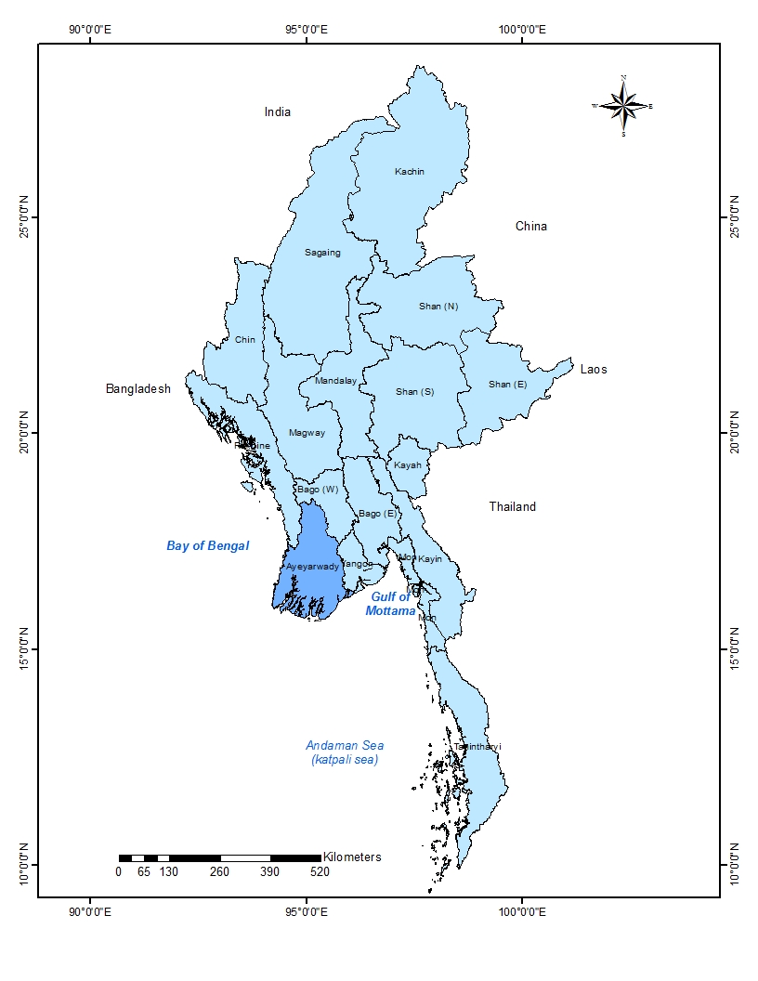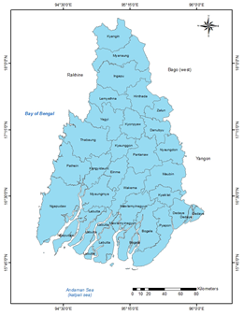
Figure 1States and Regions of Myanmar Figure 2 Locations of Township in Ayeyarwady Region
Source: Survey Department, Yangon Source: Survey Department, Yangon

According to mean monthly temperature and rainfall data of Ayeyarwady Region (1981-10) have undertaken, the climatic type is said to be Am in the south and Aw in the north of the study area. The annual mean temperature within the study area is 24˙C (75.2˙F) and 28˙C (82,4˙F), it rarely drops below 25˙C (77˙F) or rarely exceeds above 32˙C (89.6˙F). Thus the temperature conditions for the entire Ayeyarwady Region are within the limit where malaria-parasite bearing mosquitoes can survive. Figure 3 shows the condition of Rainfall. The average annual rainfall ranges between 2128 mm (83.78 inches) and 3608 mm (142.05 inches) and relative humidity between 72 per cent and 84 per cent for the entire Ayeyarwady Region. Figure 4 shows the condition of temperature. Figure 5 shows the condition of relative humidity. Hence, no place in Ayeyarwady Region experiences a relative humidity of less than 60 per cent. In the rainy season it is over 80 per cent. Generally the percentage of relative humidity is higher in the townships of whole Ayeyarwady Region. The density of malaria bearing mosquitoes increases with the rising relative humidity above 60 per cent and enhances the rate of the proliferation of malaria.

Natural Vegetation and Forest
In Ayeyarwady Region, most areas are thick forest and swampy. The NDVI values are in the range of (-1.0 to 1.0). The values of (-1 to 0.2) indicate bare soils (with scanty vegetation), (0.2 to 0.7) different categories of green vegetation and (0.7 to 1) indicate the denser vegetation (Dutta, 2006).
NDVI output image is also based on pixels of original landsat 8 ETM + 2013 image. Output values can be used as indicator of greenness. Since areas with NDVI index between 0.2 and 1 are considered to be covered with natural vegetation or forests help develop the growth and provide the resting places for the infected mosquitoes. That is why NDVI index is employed here to study the relationship between the values of NDVI index and malaria morbidity rate within the study area. The NDVI values for the region and township level are worked out by using zonal statistics based on NDVI image.
The resultant values are notably high in Pathein, Thabaung, Ngapudaw, Kyangin, Ingapu, Myaungmya, Eainemae and Kyaiklat. The townships with high NDVI value are nearly the same with the areas of high relative humidity. Thus, the ability to foresee the spreading of mosquito habitats by using remote sensing has been identified to have importance on developing strategies for mosquito control and disease prevention. Table 1 represents the NDVI values with township level. Figure 6 shows the NDVI image of Ayeyarwady Region.

Factors Responsible for the Occurrence of Malaria
The climatic conditions have a profound effect on the life cycle and longevity of vector mosquito and also on the development of the malaria parasite. The important climatic factors are: The optimum temperature for development of malaria parasite is between 25˙C (77˙F) to 30˙C (86˙F), and average relative humidity at least 60 percent. If relative humidity is less than 60 percent, it is unfavorable for malaria. These temperature and relative humidity conditions increase the longevity of mosquitoes and thus aid malaria transmission. If the temperature is more than 32˙C (89.6˙F), malaria parasite could not be able to survive.
Increased rainfall especially rainy days result in mosquitogenic conditions and the rainy season (June to October) which maintains temperatures between 25 - 30˙C and relative humidity around 80 percent for longer duration, lead to increase vector density and longevity to initiate malaria transmission, if parasite load exists in the community.

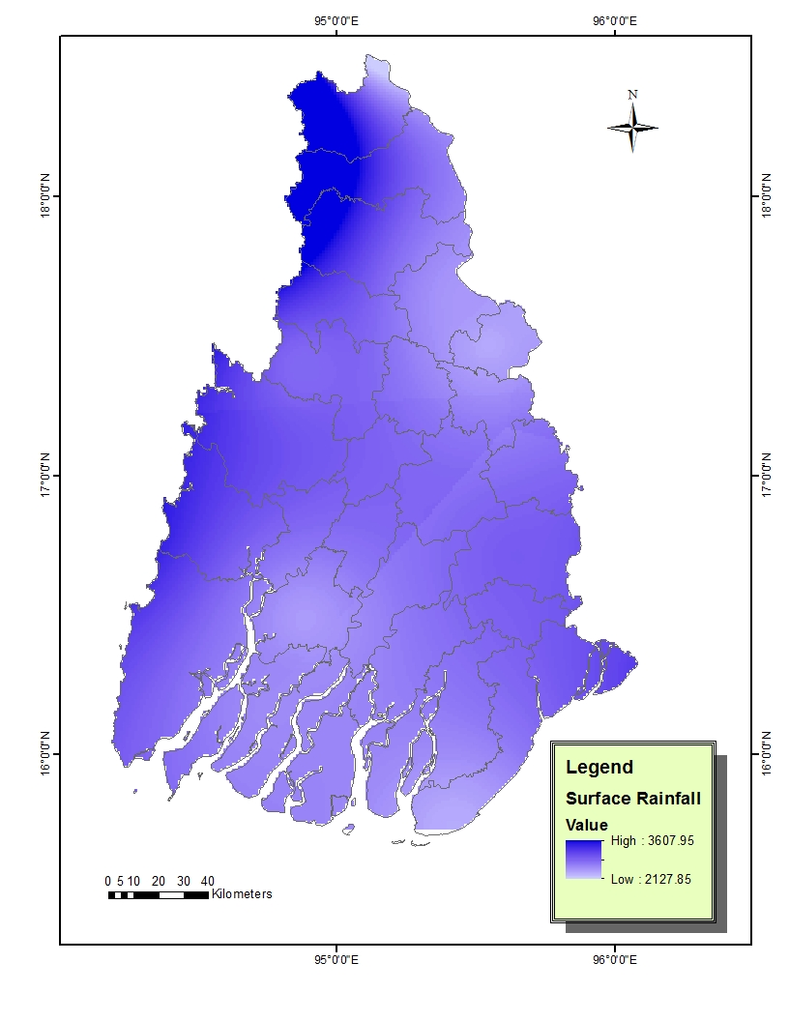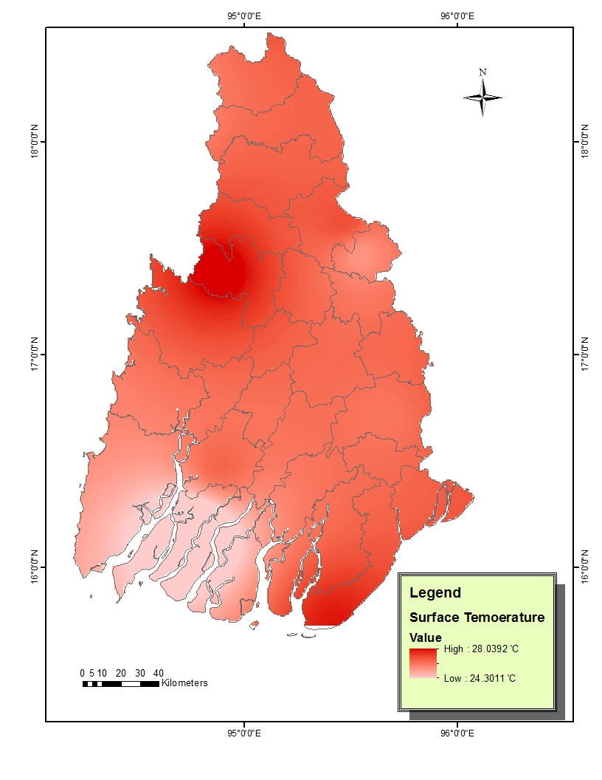
Figure 4 Temperature Situation of Ayeyarwady Region (Inverse Distance Weighted (IDW))
Source: Based on Table 1

Figure 3 Rainfall Situation of Ayeyarwady Region (Inverse Distance Weighted (IDW))

Source: Based on Table 1

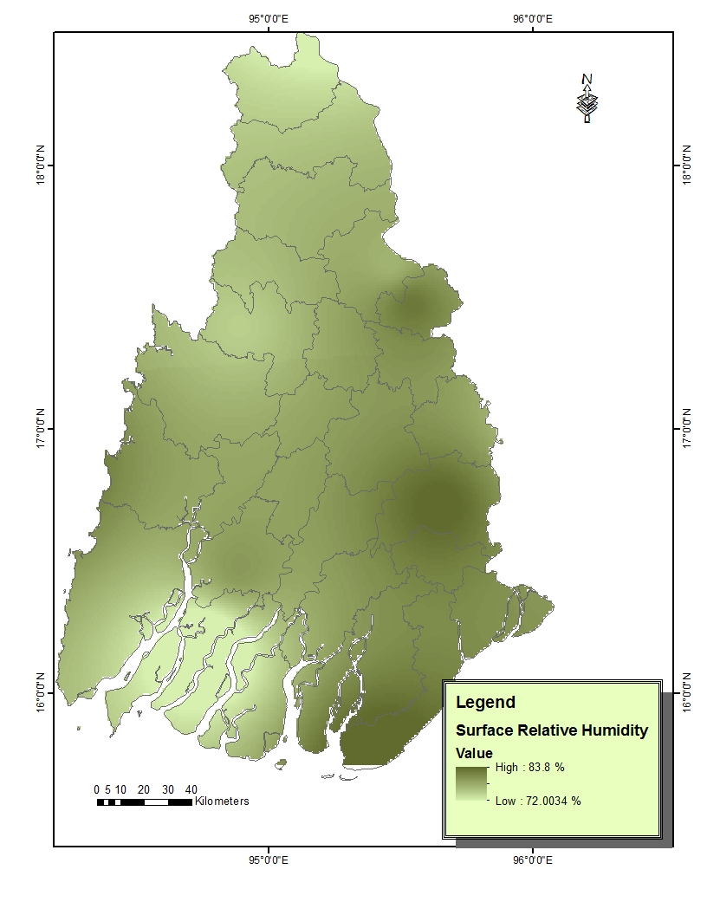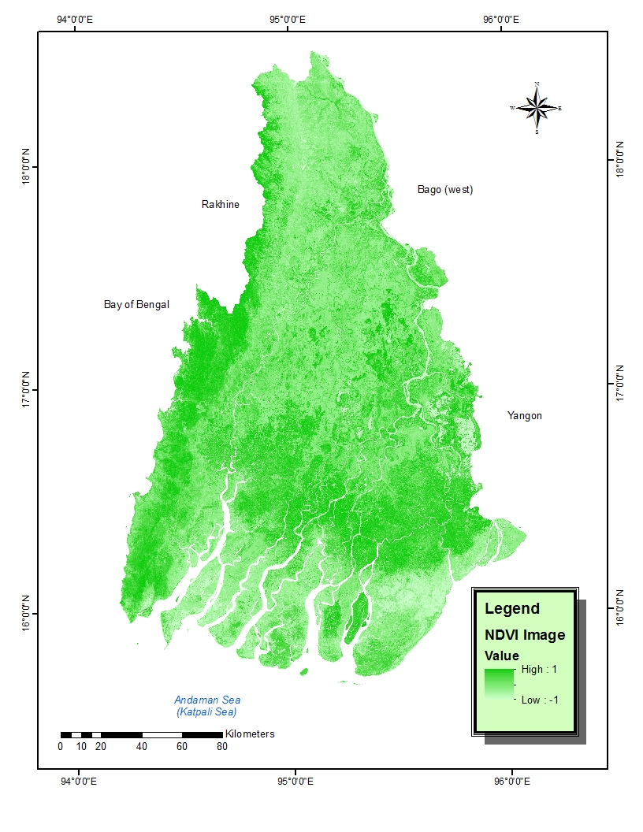

Figure5 Relative Humidity Situation of Ayeyarwady Region (Inverse Distance Weighted (IDW))
Source: Based on Table 1
Figure 6 NDVI image of Ayeyarwady Region Source: Landsat 8 ETM + 2013 image.

DEMOGRAPHIC CONDITIONS, MORBIDITY AND MORTALITY RATE

Population Density
The average population density of Ayeyarwady Region was 188 persons per square kilometre (487 persons per square mile) in 2013. Its population density was highest group of Ayeyarwady Region with 364 persons per square kilometre (944 persons per square mile) in 2013, mainly due to richness of cultivated land.
The increased population density is one of the factors for malaria transmission. Because, human, vector and climatic condition together cause the incidence of malaria morbidity. Population density at township level in Ayeyarwady Region varies from 48 to 364 persons per square kilometre (124 to 944 persons per square mile). Figure 7 represents population density of Ayeyarwady Region. Generally, the available data reveals that the rate of malaria incidence is low in areas with high population density, whereas the areas with moderate and low population density are high in malaria morbidity rate.
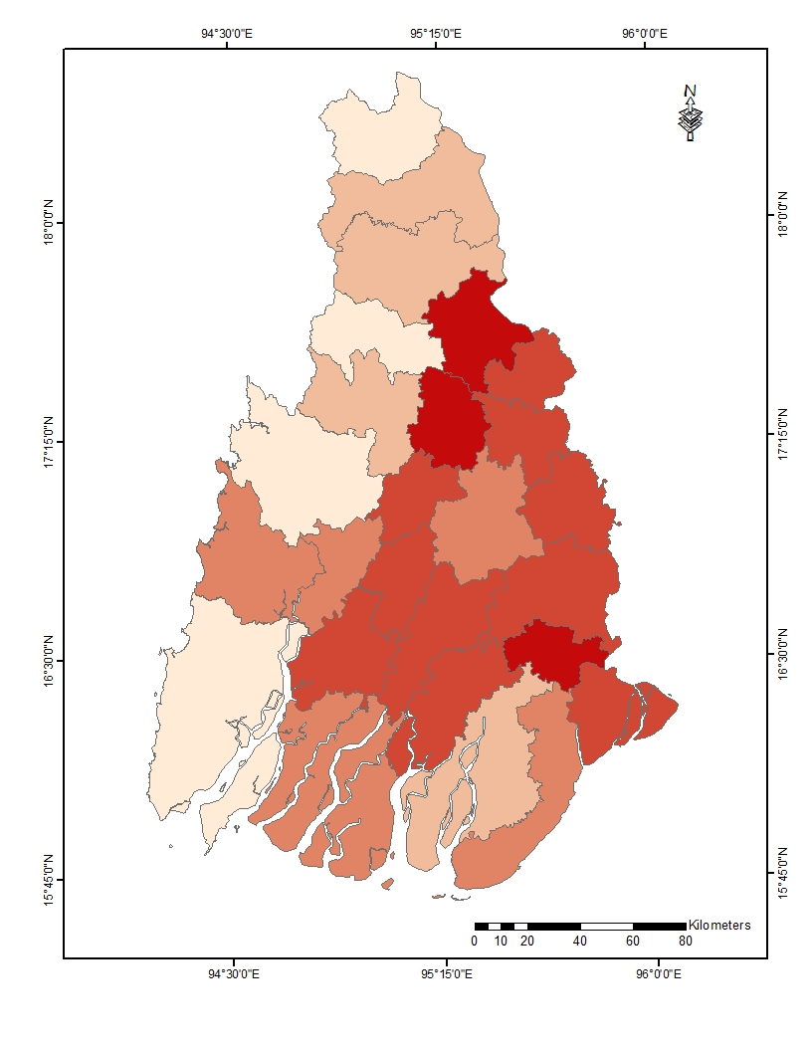
Figure 7 Population Density per square mile of Ayeyarwady Region, 2013
Source: Based on Table 1

Malaria Morbidity Rate on 1000 persons, 2011 to 2013
Morbidity rate of malaria at national level was 13 per 1000 persons. The township with morbidity rate higher than national level is Kyangin, Pathein, Ngapudaw and Thabaung and the remaining townships are less than the national level. The morbidity rate for the whole Ayeyarwady Region during the study period range from 0.13 to 42.65 per 1000 people. The townships with relatively higher rates 22.42 to 42.65 were Kyangin, Pathein, Ngapudaw and Thabaung in Ayeyarwady Region. Figure 8 and Table 1 show the morbidity rate on 1000 persons. Climatically, the townships with high temperature and relative humidity coincided with the area of high malaria morbidity Ayeyarwady Region.

Mortality Rate on 100,000 persons, 2011 to 2013
Malaria mortality rate per 100,000 persons at the national level was 4.7 persons. High malaria mortality rate than national level was observed in Kyangin, Pathein and Ngapudaw in Ayeyarwady Region.
The malaria mortality rate ranges between 0.03 and 14.22 per 100,000 persons. The townships with high mortality rates ranging from 0.3 to 2.3 are Kyangin, Pathein, Ngapudaw and Thabaung all located in the Western Ayeyarwady Region. In other township the rate ranged between 0.03 and 0.3. The townships with high malaria mortality rate coincide nearly with the area of relatively high rainfall and high relative humidity. Some townships (Kyangin, Pathein, Ngapudaw and Thabaung) in the Western Ayeyarwady Region experience high malaria mortality rate than others. Figure 9 and Table 1 show the mortality rate on 100,000 persons.
Therefore, treatment provided is in the preparatory phase. However, as the morbidity rate in the 8 township is rather high and thus the treatment level should be upgraded to intensive level.

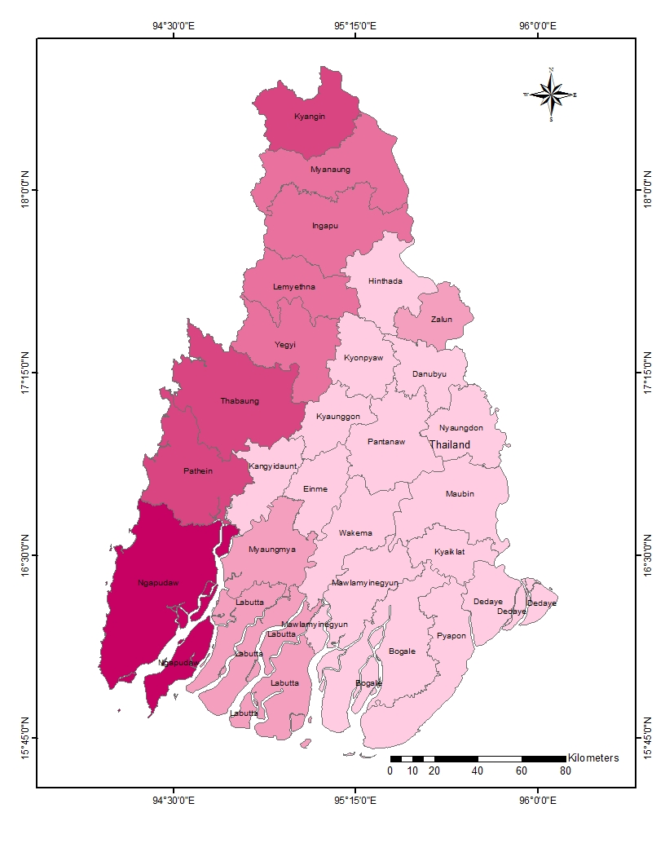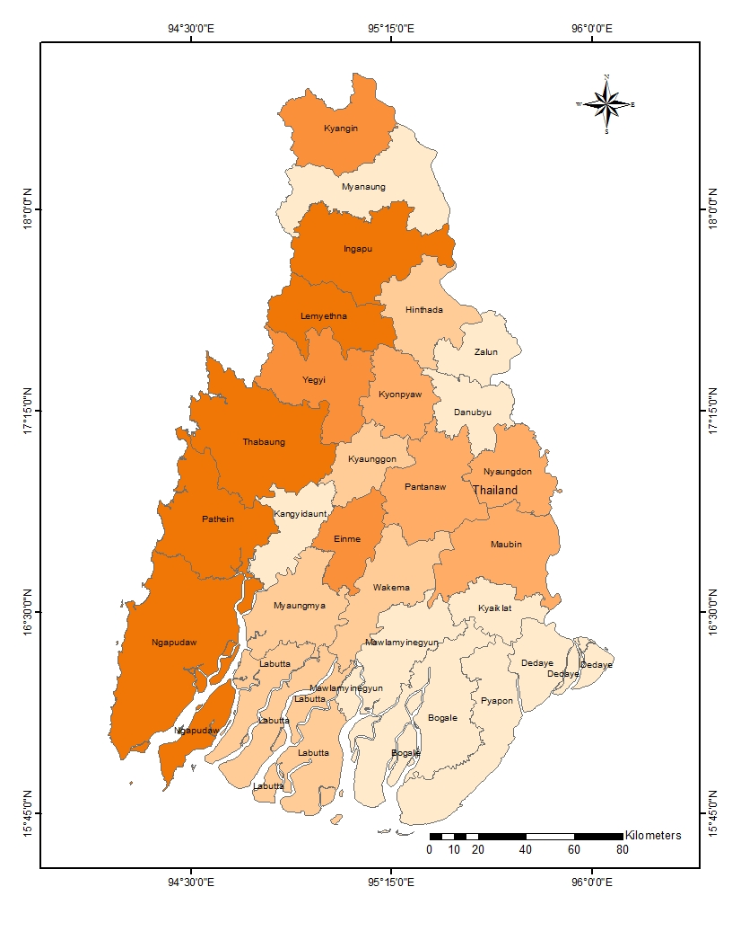
Figure 8 Distribution of Morbidity Rate in Study Area
Source: Based on Table 1
Figure 9 Distribution of Mortality Rate in Study Area
Source: Based on Table 1

ANALYSIS ON MALARIA INCIDENCE IN AYEYARWADY REGION
Analysis by Using Residual Method
Residual Method is employed to show clear comparison between the average morbidity and mortality rates for the period 2011-2013. The resultant figures can be differentiated as: (1) Normal group, (2) Above normal group
In the normal group, the mortality rate is at normal (average) level, whereas the rate is higher in the above normal group. The townships with above normal groups are Pathein, Ngapudaw and Ingapu. For the remaining 23 townships the mortality rate is normal. Therefore, treatment provided is in the preparatory phase. However, as the mortality rate in the 3 township is rather high and thus the treatment level should be upgraded to intensive level.

Analysis on Geographic and Social Conditions in Ayeyarwady Region
Multiple Linear Regressions
A linear regression model may have more than one independent variable. The following is a model with two independent variables:
For comparison, dependent and independent variables are shown in Table 1. Malaria morbidity rate is the dependent variable and NDVI value, Numbers of Health Care Centre, Temperature, Rainfall and Relative Humidity and Population Density are the independent variables. In comparing these two types of variables, Linear Regression Analysis (Stepwise Method) is employed. As a result, a linear regression model is the outcome.

This is a model in three dimensional spaces that can be visualized geometrically. Malaria morbidity rate is the dependent variable and Relative Humidity and population density are the independent variables. In this model, R² (Coefficient of Determination) is 0.67 revealing Relative Humidity and population density indicate almost 67 percent of the variability of malaria morbidity rate. The estimated model is;

Malaria Morbidity Index = 20.889 – 0.252RH – 0.004 Pop Density
R = Correlation Coefficients = 0.819, R square = Coefficient of Determination= 0.67
In this model, RH and population density are the basic predictors and thus are more suitable to use only in different places within Ayeyarwady Region. For regions other than Ayeyarwady Region, the model should be appropriately modified by using more relevant variables existing in the area concerned.

FINDINGS AND SUGGESTIONS

In accordance with the objective of WHO'S Roll Back Malaria Programme, malaria morbidity and mortality rates could have been reduced by about 50 percent within Ayeyarwady Region. The climatic conditions of the study area are favorable for the breeding and survival of mosquitoes that act as the main responsible vectors.
This study reveals that Kyangin, Pathein, Ngapudaw, Yegyi, Lemyetna, Ingapu, Myanaung and Thabaung are high in malaria morbidity and mortality rates. The townships having the physical and demographic condition favorable for malaria incidence nearly correspond with the morbidity and mortality rates of the respective townships.
In the areas with high morbidity and mortality rates, more intensive care should be carried out in prevention and treatment of the disease so as to be able to reduce the rates.
Preventive measures are indeed necessary, as it is better than cure. According to Residual Method, the townships that are above normal rates are Pathein, Ngapudaw and Ingapu. These townships are high in relative humidity percentage and NDVI value. By using different media, the Department of Health should provide more health education training and talks for the local inhabitants to gain knowledge in relation to malaria. Spraying insecticides and providing impregnated bed nets should also be carried out. Thus it is necessary to upgrade the education level of the poor rural inhabitants by any possible and suitable means.

CONCLUSION

Among the 26 townships of Ayeyarwady Region, the mortality rate is above normal in 3 townships and in the areas with high morbidity and mortality rates, more intensive care should be carried out in prevention and treatment of the disease so as to be able to reduce the rates.
In this paper the following estimate model has been constructed using Stepwise Regression Method and it can be used for the prediction of malaria morbidity in any area within Ayeyarwady Region. Should the prediction of malaria morbidity be made, it would be easy to arrange how to appropriately undertake in accord with the risk areas for prevention and treatment of malaria. In building for forecasting the morbidity rate, only six basic environmental factors that cause malaria have been considered.
If the above-mentioned findings and suggestions are focused to be carried out, the malaria morbidity rate of Ayeyarwady Region could be further reduced to the level set as the Millennium Development Goals (MDGs) in 2015.Because, malaria creates a huge problem not only to the patients and their families, but also to the remarkable extent, to the socio-economic development of the nation.

Table1 Dependent and Independent Variables of Ayeyarwady Region

No | Township Name | Rainfall (mm) | Temper-ature ˙C | Relative Humidity | NDVI  Index | Population Density | Numbers of  Health Centre | Morbidity Rates | Transformation  (Morbidity Rates)
1 | Pathein | 2663 | 26.5752 | 79.21 | 189.58 | 198 | 65 | 15.00 | 1.1761
2 | Kangyidaunt | 2543 | 26.7006 | 78.68 | 177.32 | 210 | 44 | 0.24 | -0.6198
3 | Kyaunggon | 2564 | 26.9019 | 78.72 | 140.45 | 250 | 45 | 0.74 | -0.1308
4 | Yegyi | 2564 | 27.6162 | 77.19 | 147.40 | 150 | 49 | 9.66 | 0.9850
5 | Kyonpyaw | 2502 | 26.8592 | 78.84 | 140.70 | 311 | 52 | 0.96 | -0.0177
6 | Thabaung | 2641 | 27.1959 | 77.59 | 187.23 | 72 | 44 | 13.20 | 1.1206
7 | Ngapudaw | 2564 | 25.8723 | 77.23 | 183.77 | 48 | 84 | 42.65 | 1.6299
8 | Hinthada | 2434 | 26.9005 | 78.55 | 136.93 | 364 | 64 | 0.92 | -0.0362
9 | Myanaung | 2768 | 26.7691 | 77.06 | 130.34 | 144 | 60 | 8.76 | 0.9425
10 | Kyangin | 2819 | 26.7439 | 75.67 | 170.35 | 85 | 28 | 22.42 | 1.3506
11 | Ingapu | 2675 | 26.8915 | 77.73 | 175.17 | 127 | 69 | 11.63 | 1.0656
12 | Lemyethna | 2625 | 27.2532 | 77.57 | 168.84 | 107 | 33 | 7.50 | 0.8751
13 | Zalun | 2385 | 26.4271 | 80.39 | 144.29 | 286 | 46 | 1.29 | 0.1106
14 | Myaungmya | 2731 | 26.5929 | 78.77 | 187.37 | 246 | 65 | 2.63 | 0.4200
15 | Wakema | 2503 | 26.6083 | 79.41 | 171.66 | 256 | 63 | 0.34 | -0.4685
16 | Eainemae | 2529 | 26.6825 | 78.97 | 179.98 | 266 | 45 | 0.80 | -0.0969
17 | Labutta | 2457 | 25.4094 | 75.45 | 115.99 | 202 | 90 | 2.03 | 0.3075
18 | Mawlamyinegyun | 2497 | 26.4919 | 79.06 | 176.91 | 278 | 88 | 0.51 | -0.2924
19 | Maubin | 2581 | 26.6793 | 81.49 | 147.83 | 244 | 88 | 0.14 | -0.8539
20 | Nyaungdon | 2538 | 26.7631 | 79.36 | 148.88 | 245 | 46 | 0.13 | -0.8861
21 | Danubyu | 2457 | 26.5941 | 79.69 | 150.16 | 252 | 43 | 0.19 | -0.7212
22 | Pantanaw | 2540 | 26.7280 | 79.76 | 163.42 | 199 | 57 | 0.33 | -0.4815
23 | Pyapon | 2471 | 27.1748 | 81.56 | 131.61 | 220 | 80 | 0.27 | -0.5686
24 | Kyaiklat | 2577 | 26.7045 | 81.09 | 183.84 | 330 | 45 | 0.17 | -0.7696
25 | Bogale | 2475 | 26.8403 | 80.35 | 145.64 | 173 | 62 | 0.35 | -0.4559
26 | Dedaye | 2610 | 26.8847 | 80.02 | 149.28 | 244 | 61 | 0.08 | -1.0969
 | Skewness | 0.71 | -1.13 | -0.29 | -0.18 | -0.35 | 0.44 | 2.71 | 0.39

REFERENCES

Dutta, S., 2006: Malaria Epidemiology on Jalpaiguri District Applying Remote Sensing & Geographic Information Systems”, Centre for Remote Sensing Applications, Dissertation Paper, University of North Bengal.

Khin New, 1973: “A Geographic Study of the Distribution of Malaria, Leprosy and Trachoma in Myanmar” M.A Thesis (Unpublished), Geography Department, University of Yangon (In Myanmar).

Malaria Research Centre, 1977-2002: A Profile of Malaria Research, Indian Council of Medical Research, Delhi-110054 INDIA

Ministry of Health, 2009: Health in Myanmar, Myanmar.

Tin Shwe, 1993: Malaria Disease, Research Scientist and Head Clinical Research Unit, Department of Medical Research, Yangon, Myanmar (In Myanmar).

REFERENCES FROM WEBSITES

http://www.searo.who.int/en/Section10/Section21/Section340_4024.htm (15/7/14)

