Assessment of Urban Temperature Spatial Distribution Based on Effective Indices Using Satellite Imagery and Ground Truth Data(A case Study Tehran city)

Mohsen Ahadnejad Reveshty¹ , Abdulhakim Rewaz²
Email:ahadnejad@znu.ac.ir
Email: rivaz1966@yahoo.com
^{1,2}University of Zanjan, University Blvd., 45371-38791, Zanjan, I. R. Iran,

KEY WORDS: Urban temperature, Landsat 8, Tehran, NDBI, Thermal image

ABSTRACT: The spatial distribution of urban temperature is a concept that demonstrates inequality of temperature on the city. This inequality caused by various factors such as land use and land cover type, form and geometry of buildings, building density and its spatial distribution, geographic position, green space as well as population density and energy consumption. Studies show that urban temperature spatial distribution a little considered in terms of urban planning and urban management. Because previous studies respectively about heat islands and temperature difference between urban and rural environments.
This paper has been tried to assessment the urban elements impacts on urban temperature spatial distribution. For this purpose, Landsat 8 images and other ground data such as urban land use and population density maps, also NDVI, NDBI and NBI indices has been used in this study.
The results of this study show that the temperature distribution pattern in Tehran were affected by land use and population density. So that in the west and southwest regions of Tehran due to nearby Mehrabad International Airport and industrial land use allocation as well as open and barren land with relatively higher temperature in compared to other urban areas.

Introduction
Population growth (natural increase and migration) and development of cities with physical and spatial variations are the main causes of climate change in the world, nowadays one of major problem in urban areas are increasing surface temperature due to changes in natural covers that it effect the natural vegetation has been removed and impervious surfaces, such as stone, asphalt, cement is replaced.(Malakpur and et al, 2010). This temperature difference and the unbalanced distribution of temperature in the city and surrounding areas resulting from various factors, such as land use, lack or shortage of urban green spaces, small ponds, colour and asphalt cover, congestion, fuel accumulation Cars، (Gourmelon,2003; Schubring&Weng2004).
Considering the increasing growth of urban settlements and physical development of the cities and also various functions of vegetation, studying its temporal spatial variations is an important component of urban and suburban environment (Archi and Niazi2010, 61). These differences are mainly due to the alteration of natural surfaces with highly reflective parking lots, concrete masses, asphalt roads etc resulting in the higher absorption of solar radiation, and a greater thermal capacity and conductivity, thereby affecting the thermal environment in cities(Lilly and et al,2009).
Land use is defined as "the arrangements, activities and inputs people undertake in a certain land cover type to produce, change or maintain it" (FAO/UNEP, 1999). Land use should be matched with land capability and at the same time it should respect the environment, and global climate systems (FAO/UNEP, 1996). Land use is converting over time and the most important driving force of land use changes is the human need. Human population is increasing and it causes transformation of natural ecosystems into human landscapes so that it due to the environment with different temperature. Human settlements and especially, large urban and industrial areas significantly modify their environment. Changing from permeable and moist land uses to impermeable and dry one with paving and building material can sharply affect energy budget and land surface temperature (Guo et al., 2012) as well as many other surface properties like the amount of evaporation, surface infiltration, runoff rate, drainage system, etc. It is therefore critical to have detailed information of temporal and spatial land use changes and its rate. Land surface temperature (LST) is temperature of the skin surface of land which can be derived from satellite information or direct measurements. LST provides an accurate measure for indicating energy exchange balance between the Earth and the atmosphere (Zhengming et al., 1989). LST shows a high spatial heterogeneity. The degree of LST is affected by land surface attributes, which are significantly influenced by elevation, slope and aspect which exert a direct control on the incoming solar radiation (Dubayah, 1990) Besides, topography is one of the factors that control the soil moisture distribution, thus exerting an additional influence on land surface temperature. Variation in LST also may be subject to seasonality, time of day, sea breeze, surface air temperature, humidity, wind speed, and land use (Wang et al., 2008; Keramitsoglou et al., 2011) Vegetation in urban areas is important as it can control environmental conditions and energy exchange by selective reflection and absorption of solar radiations (Guard et al., 1985: 137) and it can also be described as an effective factor on air pollution control and human health (Vagrophski and Heights 1997: 27).
In this paper, we will review some of the factors in the unbalanced temperature distribution Land surface temperature measurements, in conjunction with the physical properties of the surface play a significant role in environmental processes, can be provide useful information.

The study area
Tehran, is the capital of Iran and Tehran Province. With a population of around 8.3 million and surpassing 14 million in the wider metropolitan area, Tehran is Iran's largest city and urban area, and the largest city in Western Asia. Figure 1 shows the location of the study area.
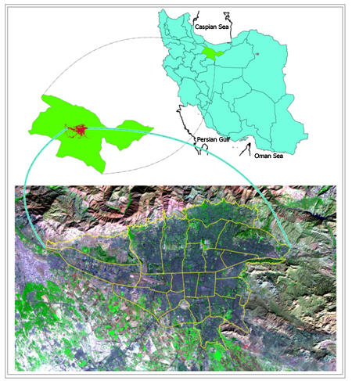
Figure1. Location of Case study Area in Iran

Materials and Methods
Materials
Development of remote sensing technology, which collects multi-spectral, multi-resolution and multi-temporal data spatial distribution of temperature can be analyzed with ease. Remote sensing and GIS is an effective tool in detecting urban land use and land cover change (Ehlers et al. 1990, Treitz et al. 1992, Harris and Ventura, 1995).
The data used in this paper from Landsat 8 included Operational Land Imager (OLI), and the Thermal Infrared Sensor (TIRS) that has been acquired at 15 August 2013. Also 1:2000 land use map and another thematic map has been used in this paper. Table 1 shows characteristic of data used in this paper.
Table1 : LANDSAT8 band used in this paper
Band Number | Spatial Resolution(m) | Spectral Resolution(µm)
Red(Band4) | 30 | 0.630-0.680
NIR(Band5) | 30 | 0.845-0.885
SWIR2(Band6) | 30 | 1.560-1.660
TIR1(Band10) | 100m up to 30m | 10.30-11.30
TIR2(Band11) | 100m up to 30m | 11.25-12.50

Methods
In this paper urban land use effect has been investigated on urban temperature distribution. for this propose LST has been extracted from Landsat8 thermal images that these process were discussed in following:
Land Surface Temperature(LST)
In this study, the surface temperature is calibrated from the DN (Digital Number) of Landsat 8 imagery, which represents the absolute radiation of land cover; the calibration is based on the NASA model. For each DN from Landsat8 imagery, The following equations are implemented in the evaluation process for Landsat 8 satellite (Eq. 1; Melesse, 2004; Chander and Mark- ham, 2003).
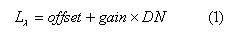
where offse,gain are user defined parameters, in this study gain(0.00033420) and offest(0.10) has been consider based on NASA model. we can estimate the absolute temperature of the land surface (T). This is expressed in Eq. 2 (Melesse, 2004; Mobasheri and Mousavi, 2004).
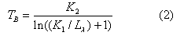
where, T is the effective at-satellite temperature in Kelvin; K1 (774.89) is the post calibration constant of spectral radiance in W/(m2 sr μm); K2 (1321.08) is the post-calibration constant of absolute temperature in temperature degrees (Kelvin);Lλ is the spectral radiance in W/(m2 sr μm).
After preparation land surface temperature(LST) maps with using 1:2000 urban land use map temperature distribution has been extracted for main land uses such as bare land, green space, urban services,....etc.

Results and Discussion
In this paper, with using Landsat8 satellite images and with using above methods the land surface temperature (LST) distribution has been excreted and then using Tehran 1:2000 land use map the temperature distribution were obtained for each of urban main land use that were discussed in following.

Bare land
This land use is one of urban land use that had high temperature that included 4737 hectares area. Most of spatial distribution of land use is related to district 22 that have very high temperature in comparing with another Tehran urban districts. The analysis of land surface temperature shows that minimum temperature in this land use were 28.5° C and maximum 45.90° C and mean temperature were 38.84° C. Also the analysis of temperature distribution histograms showing the maximum distribution of temperature is related to 39 to 41 ° C that districts 1,3 and 4 had minimum temperature in comparing with another districts. figure2 show the status of temperature distribution in bare land use in Tehran municipal districts.
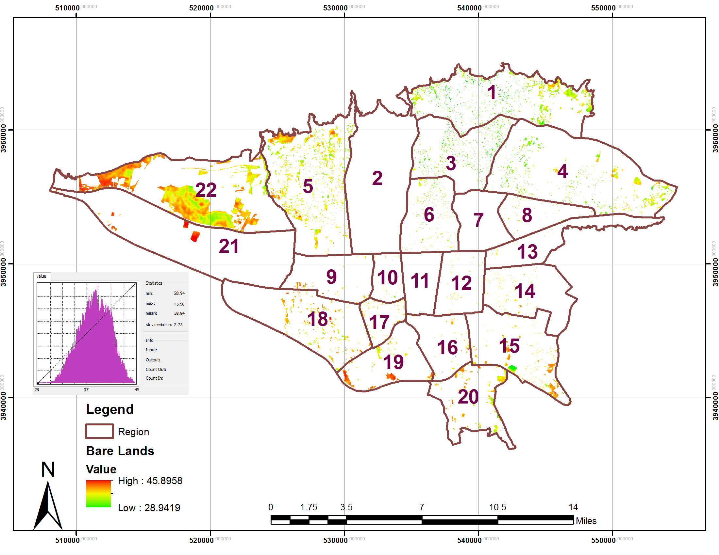
Figure 2. Map of temperature distribution in bare land in the Tehran municipal districts

Industrial Land Use
industrial land use is another urban land use that had high temperature in comparing with another urban land use due to manufacturing industries and fuel consumption in this regions. based on 1:2000 Tehran land use map this land use had 2639 hectares area that distributed mainly in districts 21,18,19 and 9. One of the main reasons for the high temperature distribution in these districts is related to high distribution of this land use with comparing to other districts. The analysis of land surface temperature shows that minimum temperature in this land use were 29.13° C and maximum 46.38° C and mean temperature were 40.36° C. Also the analysis of temperature distribution histograms showing the maximum distribution of temperature is related to 37 to 42 ° C. figure3 show the status of temperature distribution in industrial land use in Tehran municipal districts.
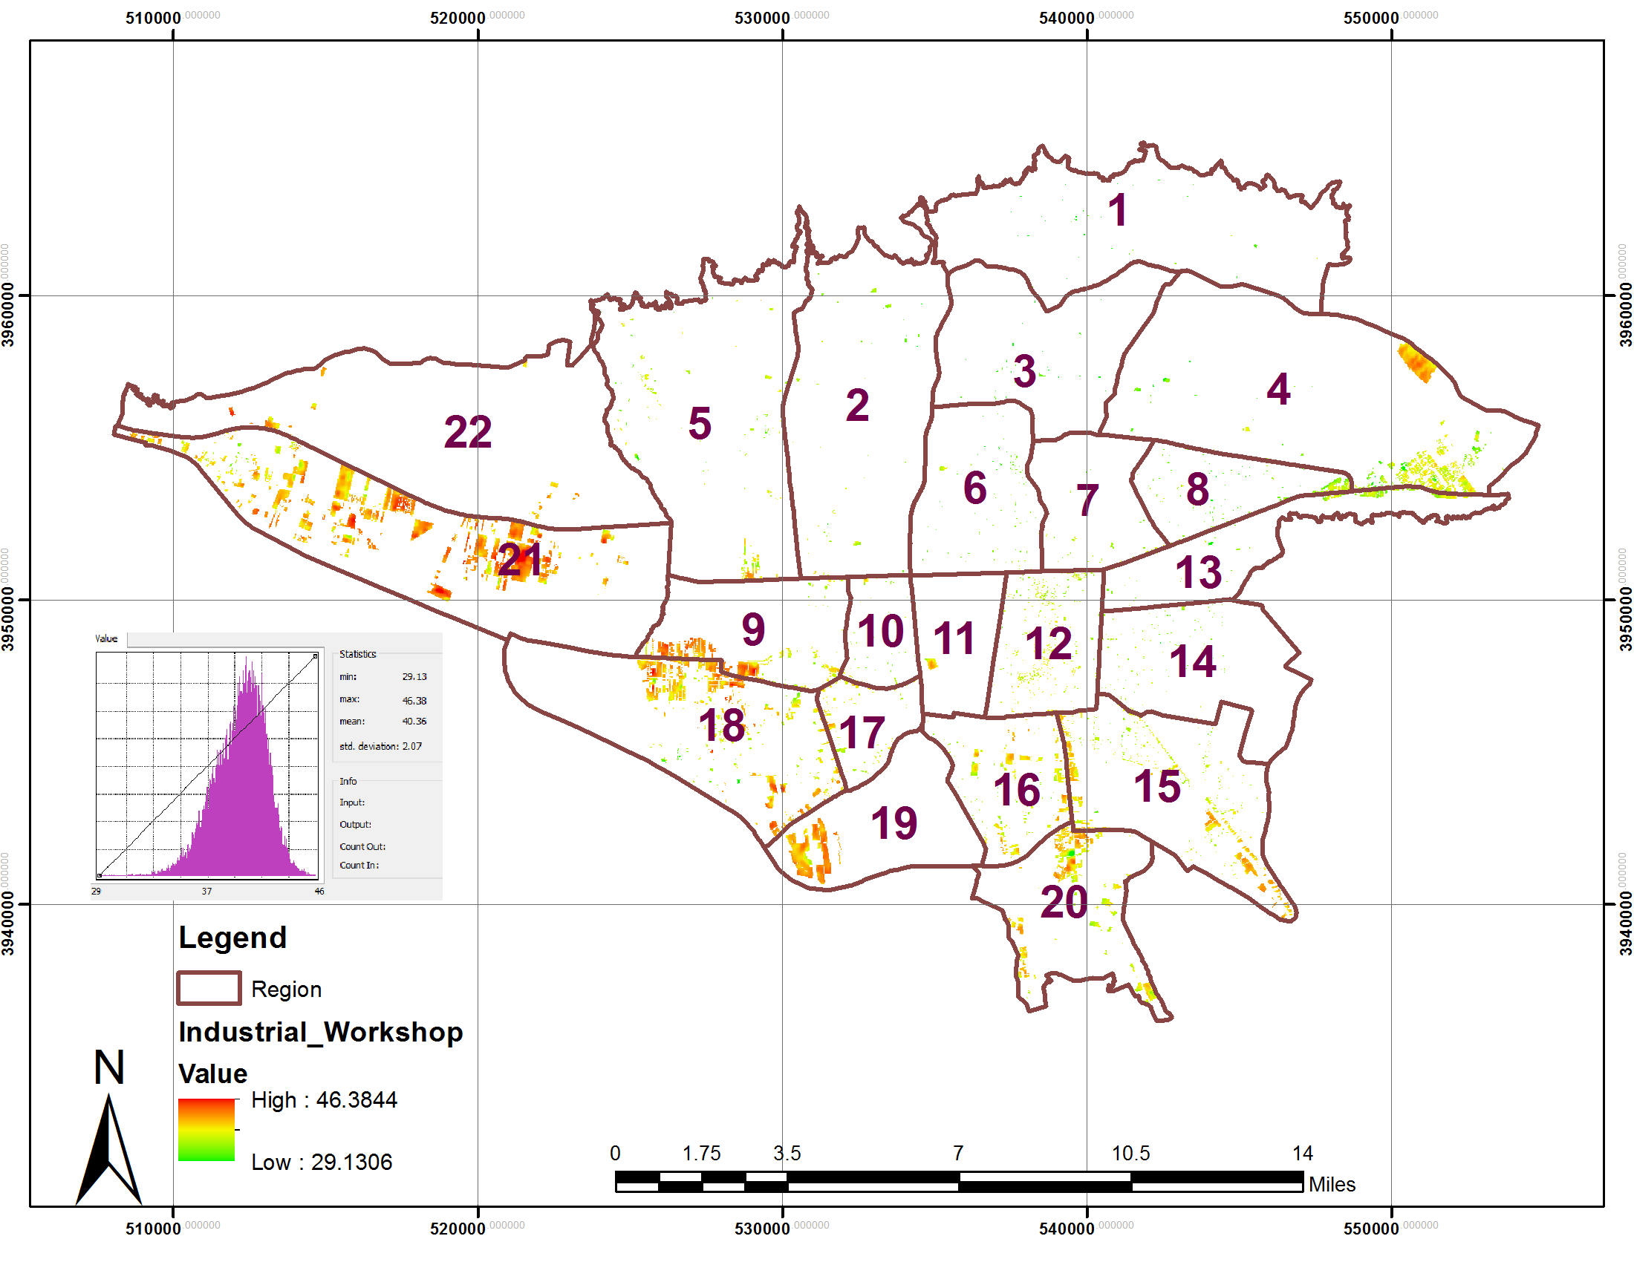
Figure 3. Map of temperature distribution in industrial land use in the Tehran municipal districts

Transportation and storage land use
transportation and storage land use is another urban land use that can be high temperature due to Concentration of pollutants such as Urban vehicles. based on 1:2000 Tehran land use map this land use had 2953 hectares area that distributed mainly in districts 9,2 and 6. The main reason of high distribution of this land use in district 9 is due to located Mehrabad International Airport in this district that had very high temperature even with comparing this land use in the another districts. The analysis of land surface temperature shows that minimum temperature in this land use were 30.85° C and maximum 49.24° C and mean temperature were 41.01° C. Also the analysis of temperature distribution histograms showing the maximum distribution of temperature is related to 37.5 to 44 ° C. figure4 show the status of temperature distribution in transportation and storage land use in Tehran municipal districts.
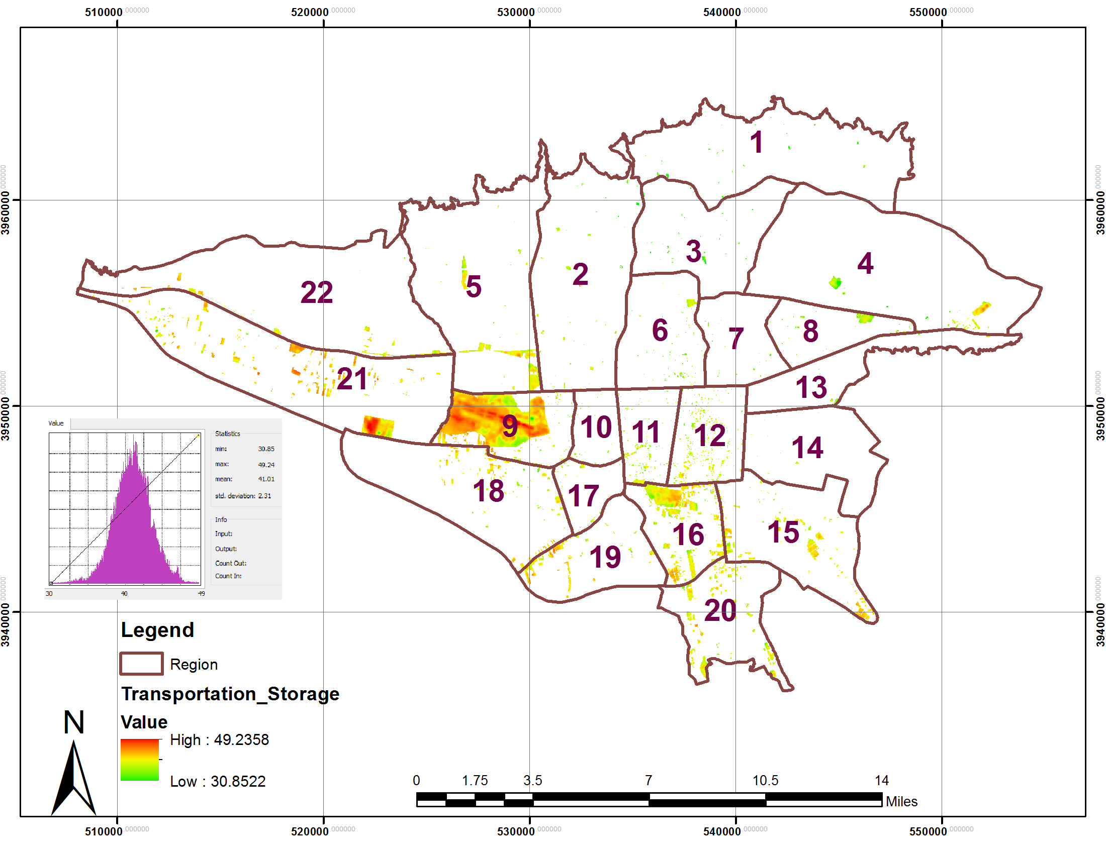
Figure 4. Map of temperature distribution in transportation and storage land use in the Tehran municipal districts
Urban Utilities Land use
the urban utilities land use are another urban land use that can be high distribution in comparing to other urban land use. base on 1:2000 Tehran land use map this land use had 5052 hectares area that distributed mainly in districts 22and 19. The analysis of land surface temperature shows that minimum temperature in this land use were 28.24° C and maximum 45.44° C and mean temperature were 37.47° C. Also the analysis of temperature distribution histograms showing the maximum distribution of temperature is related to 33 to 39 ° C. figure5 show the status of temperature distribution urban utilities land use in Tehran municipal districts.
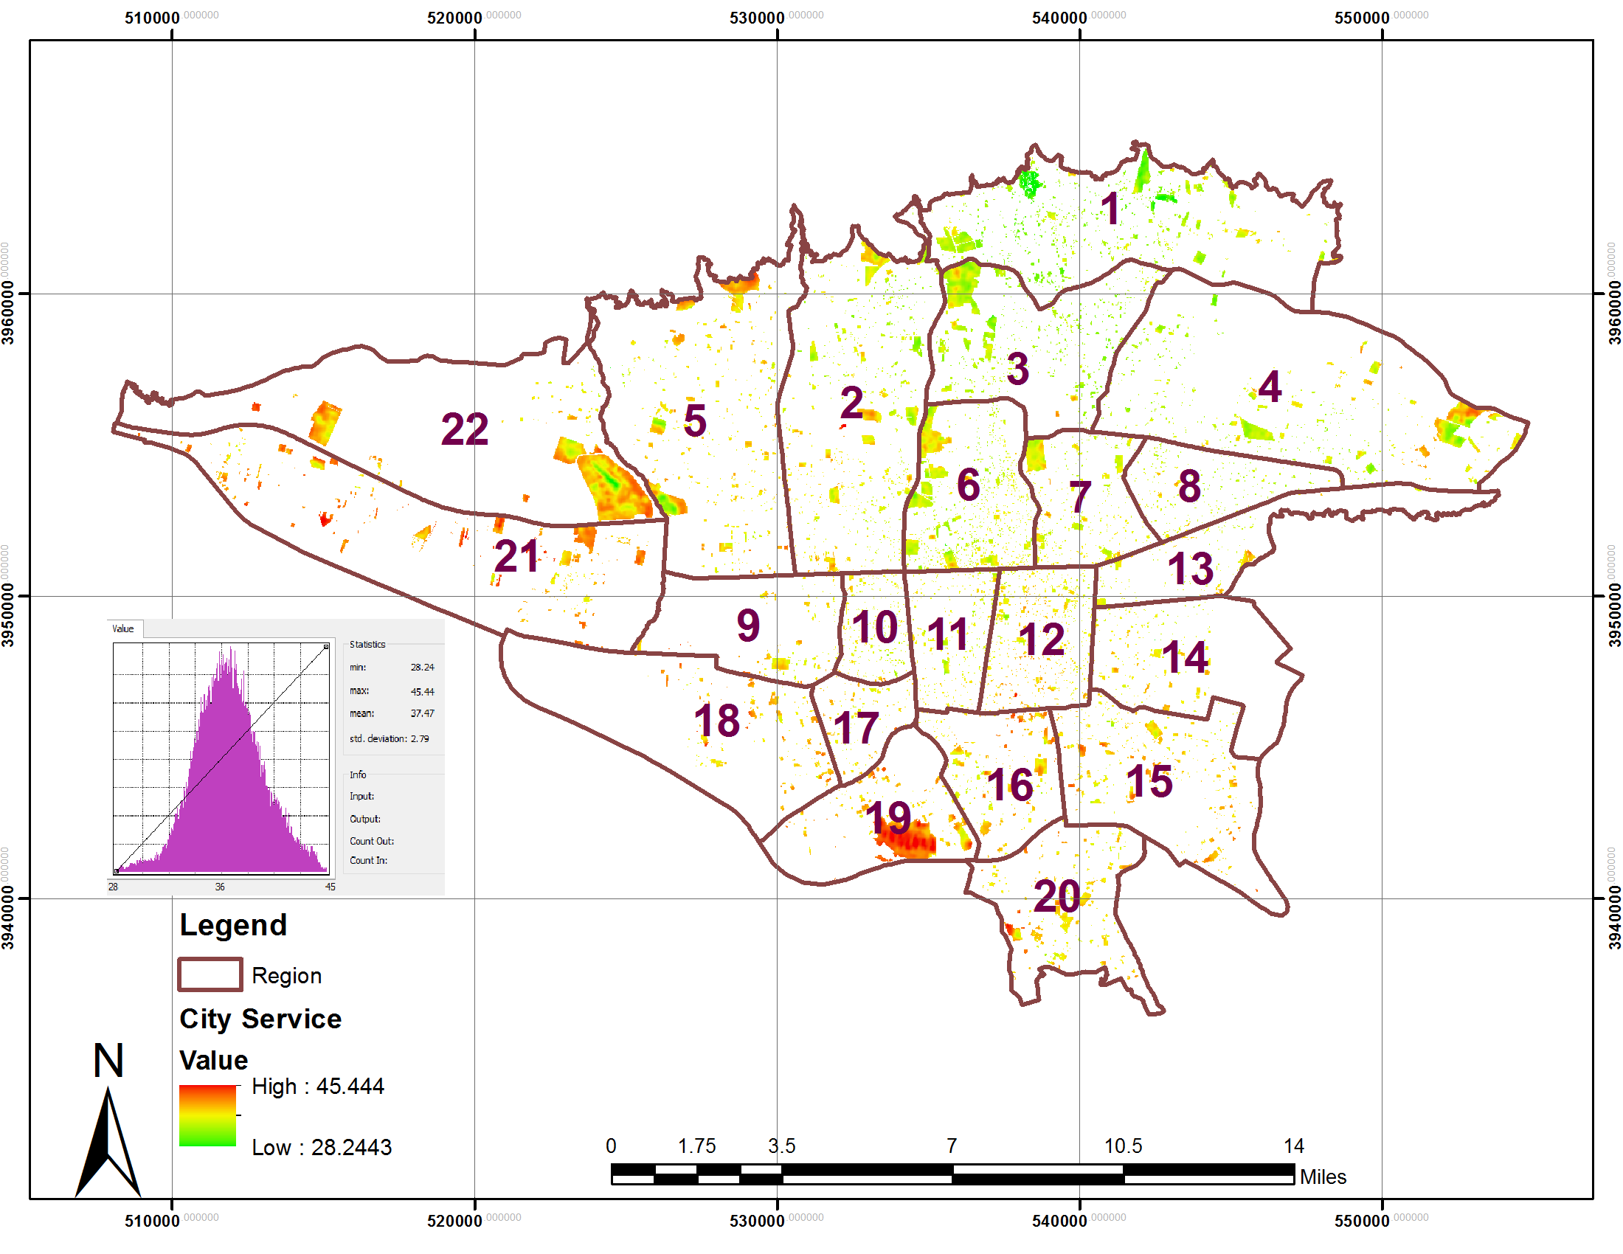
Figure 5. Map of temperature distribution in urban utilities land use in the Tehran municipal districts

Green Space land use
green space land use one of important urban land use that had equilibration temperatures in urban area and also plays a positive role in the urban ecology and environment. based on 1:2000 Tehran land use map this land use had 4911 hectares area that distributed mainly in districts 22,2,4 and 15. The analysis of land surface temperature shows that minimum temperature in this land use were 28.61° C and maximum 45.91° C and mean temperature were 37.72° C. Also the analysis of temperature distribution histograms showing the maximum distribution of temperature is related to 33 to 39 ° C. figure6 show the status of temperature distribution green space land use in Tehran municipal districts.
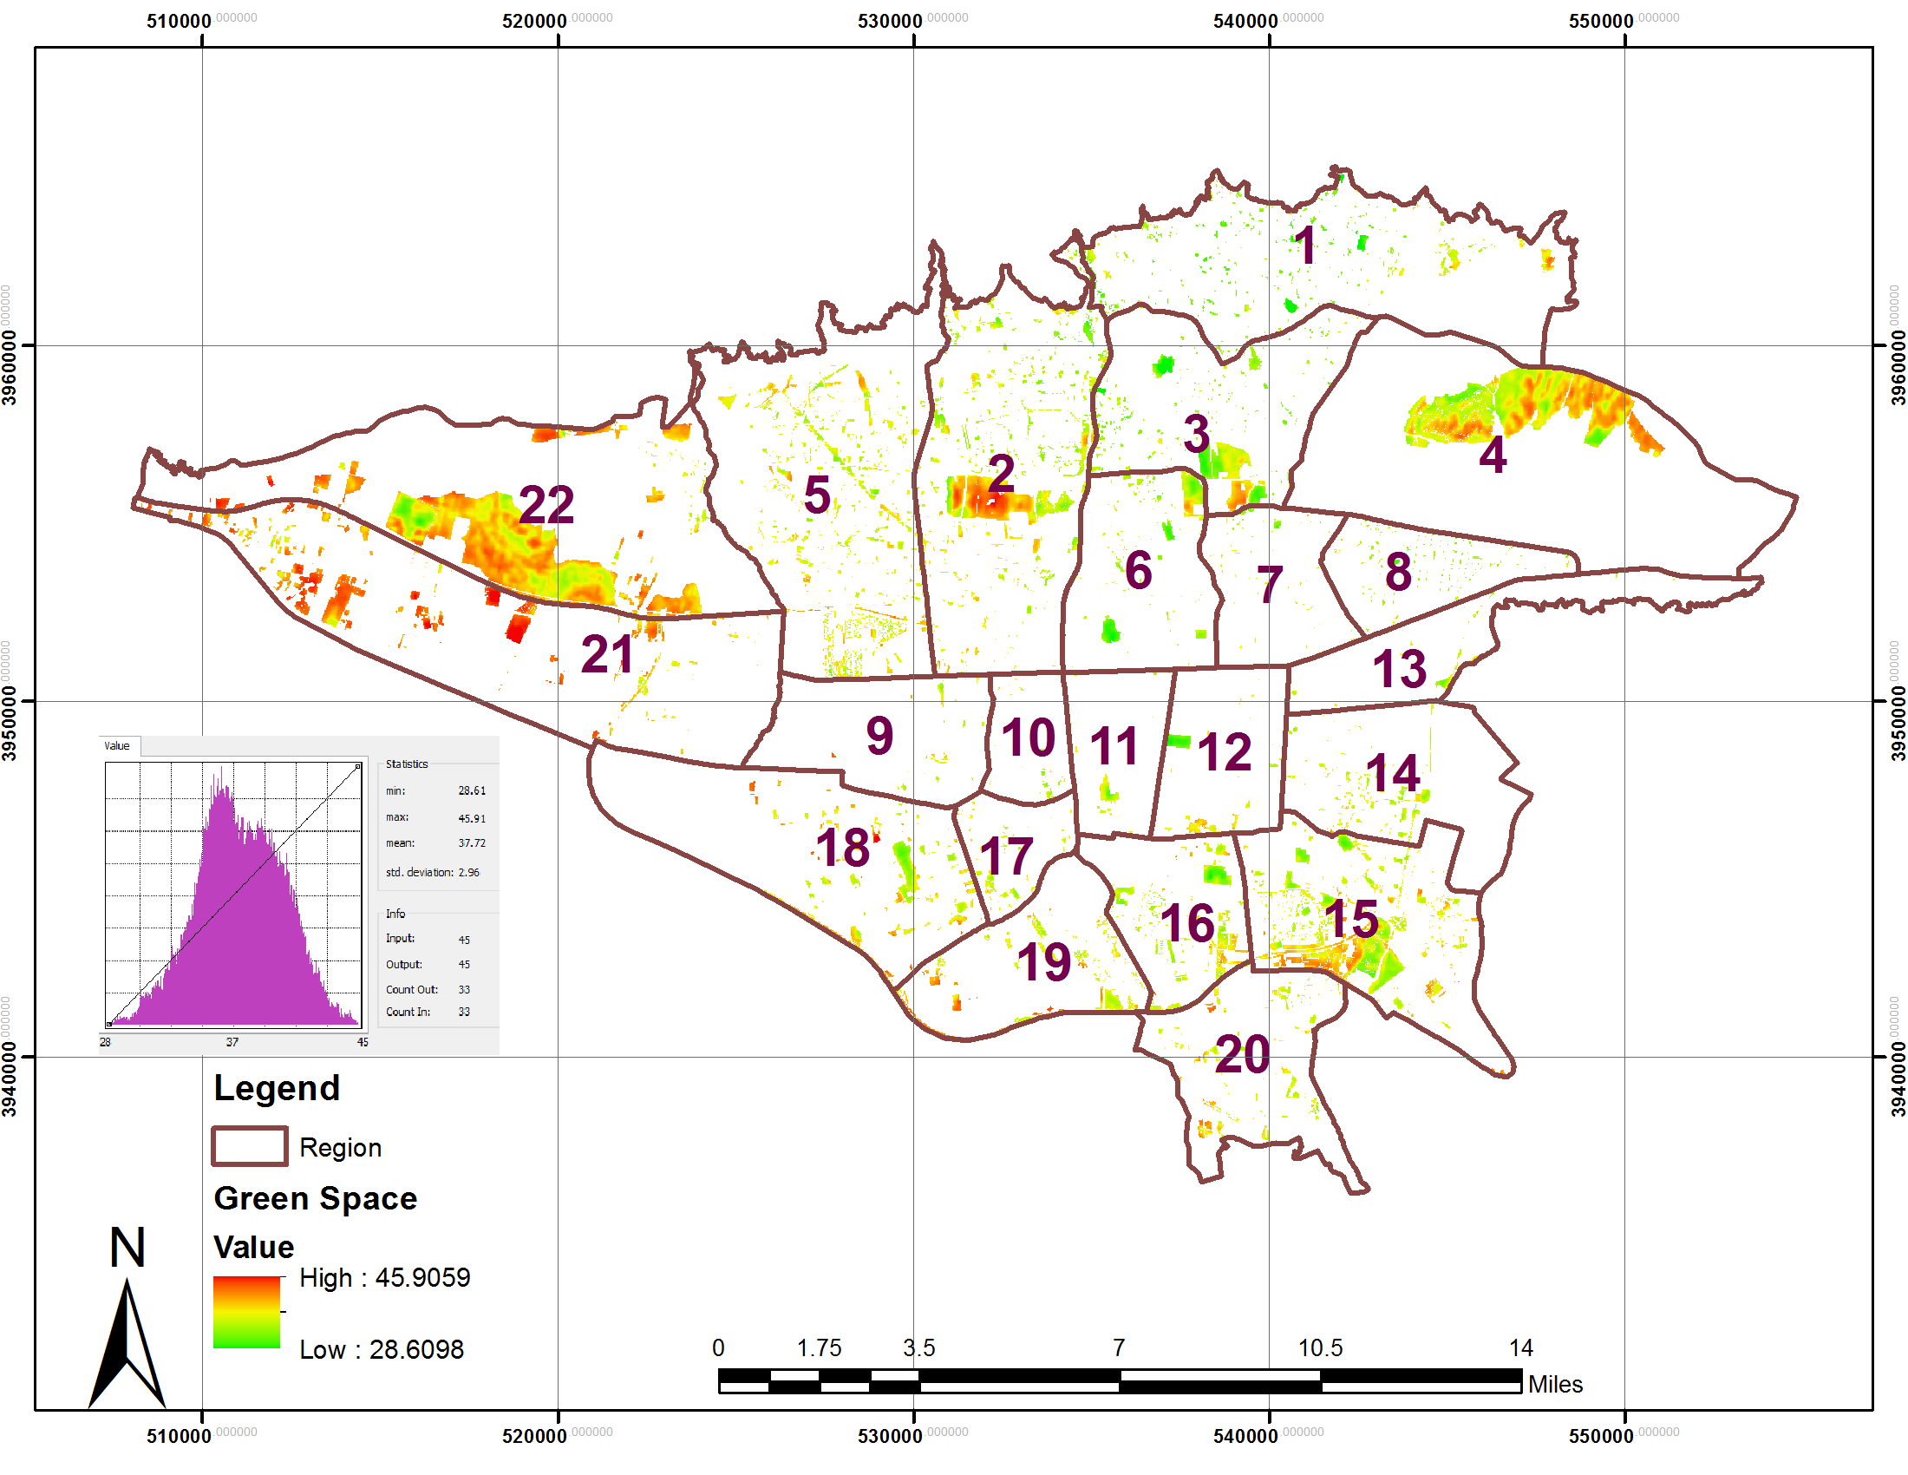
Figure 6. Map of temperature distribution in green space land use in the Tehran municipal districts
Commercial and administrative land use
Commercial and administrative land use are another urban land use that its temperature distribution investigated in this paper. based on 1:2000 Tehran land use map this land use had 4911 hectares area that distributed mainly in districts 21,12,6 and 4. The analysis of land surface temperature shows that minimum temperature in this land use were 27.23° C and maximum 47.68° C and mean temperature were 37.38° C. Also the analysis of temperature distribution histograms showing the maximum distribution of temperature is related to 35 to 38 ° C. figure7 show the status of temperature distribution Commercial and administrative land use in Tehran municipal districts.
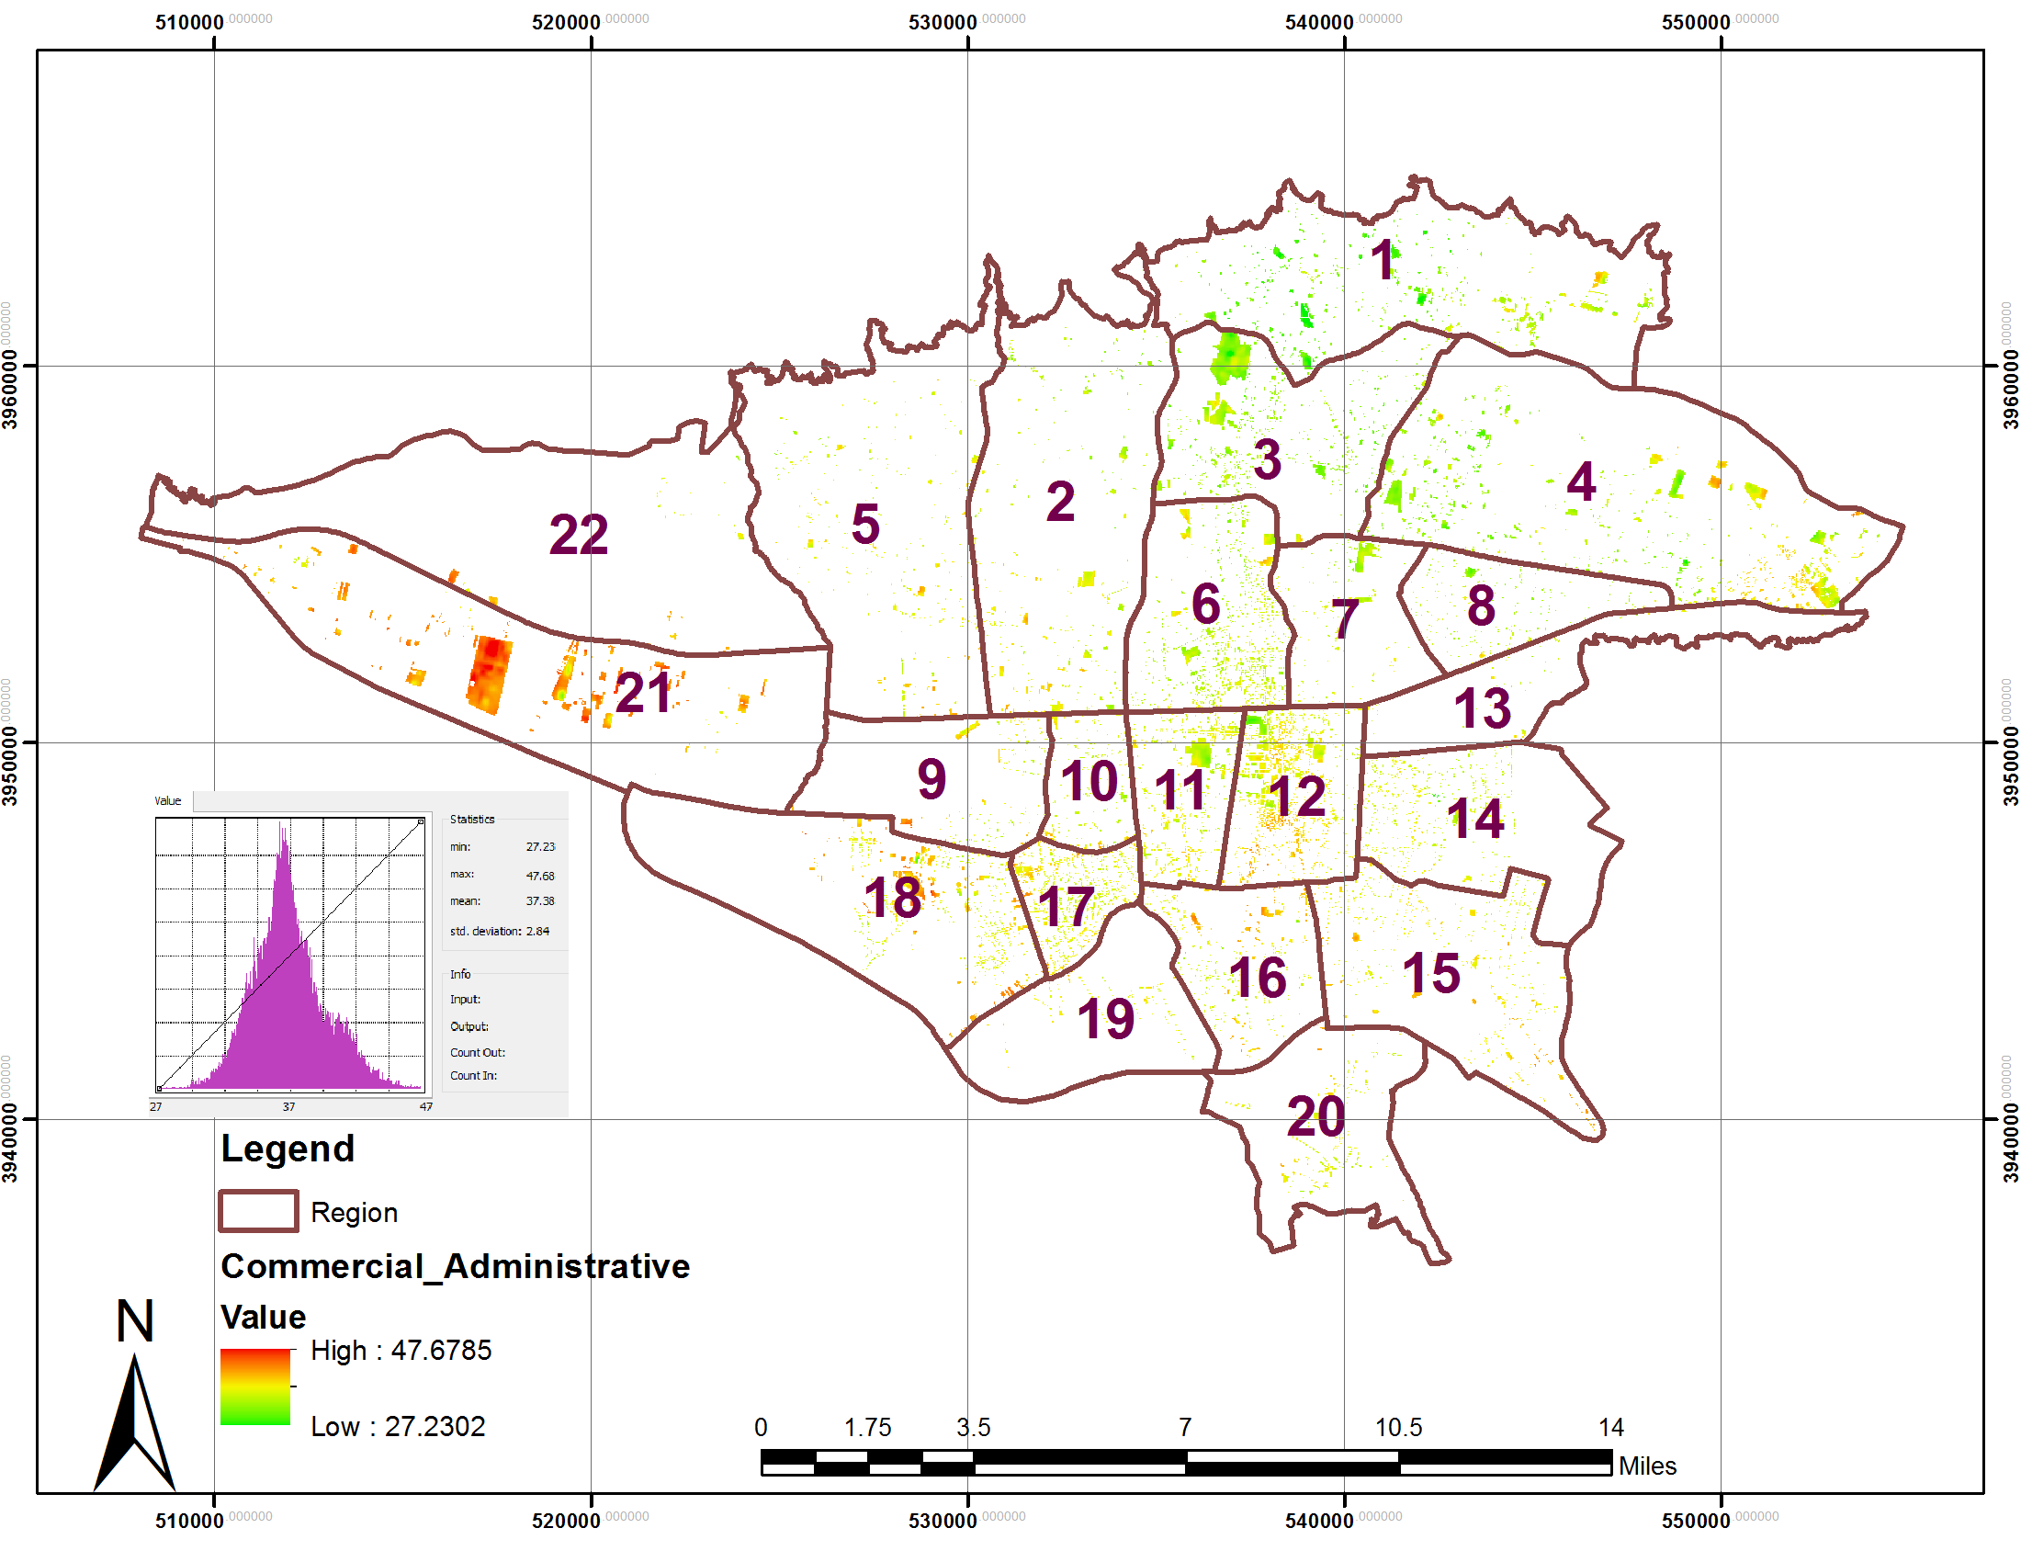
Figure 7. Map of temperature distribution in commercial and administrative land use in the Tehran municipal districts

Residential land use
Residential land use is one of major urban land use that had very high distributed in urban districts in comparing with another land use. This land use due to using air conditioners system in building had more balanced in temperature distribution. based on 1:2000 Tehran land use map this land use had 17701 hectares area. The analysis of land surface temperature shows that minimum temperature in this land use were 28.31° C and maximum 46.92° C and mean temperature were 36.14° C. according to results district 21 and 22 had very high temperature in comparing with other districts. the main reason for high temperature in this districts were a large percentage of industrial, transportation and barren lands in these areas. Also the analysis of temperature distribution histograms showing the maximum distribution of temperature is related to 33 to 37 ° C. figure8 show the status of temperature distribution Residential land use in Tehran municipal districts.
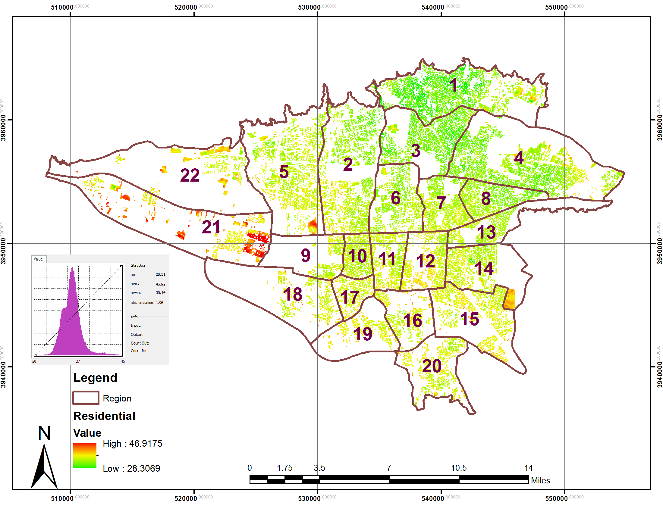
Figure 8. Map of temperature distribution in residential land use in the Tehran municipal districts
Conclusion
This study examined the effect of urban land use on urban temperature distribution in Tehran municipality districts, using Landsat8 satellite imagery and 1:2000 urban land use data .relationship between land use and temperature distribution has been assessment in this paper So that was identified during the study, the surface temperature of the transportation and Bayer crowded urban areas most used for industrial users more than other regions. Hence, it can be noted that the vegetation was important in reducing the surface temperature of Managers and city planners will in future planning To create an urban landscape in terms of quantity and in terms of distribution and growth, especially in the rapidly expanding Tehran, pay to special attention.

Reference
Archi, Saleh and Niazi, Yaghoob; 2010, comparing various techniques for monitoring land use change – vegetation using RS and GIS (Case study of Darre Shahr, Ilam province), magazine of the applying remote sensing and GIS in natural resource science, year 1, No. 1, winter 2010, pp 61 – 75.
Chee F Chan, Julia Lebedeva, José Otero, Gregory Richardson.2007, Urban Heat Islands: A Climate Change Adaptation Strategy For Montreal, Services des infrastructures, transport at environment of the City of
Montreal, NP 78.
Chen, Y.; Wang, J.; Li, X. (2002) A study on urban thermal field in summer based on satellite remote sensing. Remote Sens. Land Resour. 2002, 4, 55–59.
Dousset,B., F., Gourmelon .2003. Satellite multi-sensor data analysis of urban surface temperatures and land cover, ISPRS Journal of Photogrammetry and Remote Sensing, v. 58, p.43-54.
Fabrizi, R.; Bonafoni, S.; Biondi, R.2010, Satellite and ground-based sensors for the urban heat island analysis in the City of Rome. Remote Sens. 2, 1400–1415.
Haverter sara P. (2012),Adapting to Urban Heat: A Tool Kit for Local Governments, Harrison Institute for Public Law Georgetown Climate Center, NP 81.
Jiang, Z., A. Huete, J. Chen, Y. Chen, J. Li, G.Yan and X. Zhang. (2006). Analysis of NDVI and scaled difference vegetation index retrievals of vegetation fraction, Remote Sensing of Environment. 366-378.
J. Chen, P. Gong, C. He, R. Pu, P. Shi, Land use/cover change detection using improved change vector analysis, Photogrammetric Engineering & Remote Sensing, 69(4), pp. 369-379, 2003.
J. Voogt and T. R. Oke, “Effects of urban surface geometry on remotely-sensed surface temperature, ”Int. J. Remote Sens.19, 895–920 (1998).
Lilly Rose A, Monsingh D. Devadas.2009, “ANALYSIS OF LAND SURFACE TEMPERATUR AND LAND USE / LAND COVER TYPES USING REMOTE SENSING IMAGERY - A CASE IN CHENNAI CITY, INDIA”, *Sathyabama University, Chennai, India, **Anna University, Chennai, IndiaThe seventh International Conference on Urban Climate,29 June - 3 July, Yokohama, Japan.
Melesse, A.M.,2004, Spatiotemporal dynamics of land surface parameters in the Red river of the north basin. Physics and Chemistry of the Earth 29, 795-810.
Nazarian, Asghar; Zaieeian, Parviz; Jangi, Ali Akbar; 2007, studying the role of location and morphology in Tehran air quality using GIS and satellite data, Geographical researches, No. 61, pp 17 – 30.
Soberino,J.A. , and Raissouni,N.,(2000). Toward remote sensing methods for land cover dynamic monitoring: Application to Morocco, Int. Journal of Remote sensing,21, p. 353-366.
Tehran air pollution statistics book, environment organization, 2011.
Tehran meteorology statistics book, 2001, Tehran agriculture – meteorology research office, Tehran province meteorology general office.
Weng, Q., Lu, D., and Schubring, J., (2004). Estimation of land surface temperature- vegetation abundance relationship for urban heat island studies: Remote Sensing of Environment, 89, p.467-483.
Xu, H., X. Wang, and G. Xiao, 2000. A remote sensing and GIS integrated study on urbanization with its impact on arable lands: Fuqing City, Fujian Province, China, Land Degradation & Development, 11(4):301–314.
Y. Zha, Y.Gao, S. Ni, Use of normalized difference built-up index in automatically mapping urban areas from TM imagery. Int.J. Remote Sensing, 24(3), pp. 583-594, 2003.
Y. H. Kim and J. J. Baik, “Spatial and temporal structure of urban heat island in Seoul,” Am. Meteorol. Soc.44, 591–605 (2005).
Y. Zha, Y.Gao, S. Ni, Use of normalized difference built-up index in automatically mapping urban areas from TM imagery Int.J. Remote Sensing, 24(3), pp. 583-594, 2003.

