A New Integrated Sensor-Collected Intelligence Architecture Based on Satellite

Zhang Weiwei*，Zhang Qiuli，Zhang Qian，Cao guili，Yao Yigang
Beijing Institute of Space Mechanics & Electricity, Zhongguancun East road 99, Haidian District, Beijing, China, 100190
Email: wwlovelife@126.com

KEY WORDS：Information sharing, Information architecture, Multi-sensor intelligent integration, Computer management control strategy

ABSTRACT：With the rapid development of the aerospace technology, the number of sensors is dramatically increasing and the image resources which get from the remote sensing satellite are more and more. The number of images and signal intercepts are well beyond the capacity of the existing analyst community so there are huge backlogs for translators and image interpreters and much of the collected data are never reviewed. The broadband is the bottleneck of the data application. In order to increase the rate of the remote sensing data, a new integrated sensor-collected intelligence architecture based on satellite is proposed. In this architecture it mainly adopts to the multi-sensor intelligent integration, and the computer management control strategy is employed and the key element of this architecture is the separation of the data and its application. On the other hand, through the ubiquitous communications system and the strategy of the user interaction the effective information is acquired, and the amount of the transmitted data is dramatically decline. We get the data sharing network from the satellites to the ground. This strategy reduces not only the amount of the transmitted images, but the dependence on data transmitting technology, and it lays the foundation for the function expansion, the user increase and the information sharing. This strategy is convenient for the integrated service platform construction on which the data is accepted quickly, processed and applied based on remote sensing satellite, and conductive to the development and utilization of the overall service platform based on the satellite.

1 Introduction

With the rapid development of space remote sensing technology, the satellite-borne image resolution gets continuous improvement and the area of the remote sensing coverage is expanding, and the remote sensing data is dramatically increasing, so the storage and transmission of the data becomes the bottleneck of the data application^{[1]}. Taking the American commercial satellite GeoEye-1 for example, the satellite can round the Earth 12 or 13 circles every day, and it can collect the panchromatic images of 700,000 square kilometers and the multispectral color image of 350,000 square kilometers, the maximum ground resolution is 0.41m, and the amount of image data closes to 10TB, so it is a challenges to the distribution and transmission of the data^{[2]}.
Currently, for the restricted communication conditions, there is a big contradiction between the large amounts of data and low communication bandwidth, and the application of the remote sensing images is restricted, and it becomes a resistance of sharing the satellite remote sensing image and data.
For above reasons, this paper proposes the new satellite-based integrated sensor-collected intelligence architecture for establishing a shared services platform based on the overall satellite data. the following sections of this paper are organized as follows, in the next section the intelligent sensors are introduced, in third section we presents the integrated sensor-collected intelligence architecture, and then the difficulties and key technologies of the system are given, in the last this article conclusion is given.

2 Intelligent Integrated Sensors

2.1 Advantages of the intelligent integrated sensors

Currently, the existing communication analysis capabilities of the large number of satellite images and information can’t meet the demand, and the multi-source data fusion is applied into the effective information extraction, so the advantages of the intelligent integrated sensors are as follows:
a) It can be more effective and reasonable to achieve the best combination, and it can make the multi-source data fusion to achieve the best results.
b) The intelligence integrated sensors have the small size, light weight and full-featured to achieve the same effect.
c) It can improve the function of the target detection and recognition, and realize the multi-target tracking, the zooming of the interesting objectives.
d) It provides the possibility that can be compensated the lack of hardware features by the employing the software.

2.2 Working Mode of the Intelligent Integrated Sensors

The satellite-borne sensors include the visible light, infrared and multispectral, they can constitute different working mode depending on the characteristics of the various sensors and the mission tasks. Table 1 is the working mode of the intelligent integrated sensors.
Table 1 the working mode of the intelligent integrated sensor.
Working mode | characteristics | Working condition
Visible and Infrared | Visible: high resolution of the target  Infrared: the covert detection and work at night | All-day
Visible and Multispectral | The extraction of the target information | Daytime and all-day
Infrared and Multispectral | Target detection during day and night  The extraction of the target information | All-day
Visible, Infrared and Multispectral | All of above | All-day
Intelligent Integrated Sensors can be associated with the integration of multi-source data to complete the data fusion, in order to obtain accurate position estimates and the identity estimates, as well as the extraction of remote sensing image data for the valid information.

2.3 Introduction of the Intelligent Integrated Sensors

In this paper, the intelligent integrated optical sensor adopts the multi-array of the sensor array, such as the figure 1. The image system of the multi-array sensor array comprises the telecentric lens group, the multi-array sensor array and the control module of the sensor array. The telecentric lens includes at least three telecentric lenses, and each telecentric lens has one sensor array. One senor array can constitute several hundreds of smaller pixel detector (e.g. 5M detector element) with array arrangement. Each telecentric lenses can receive the image of the target area and the sensor array can acquire the image. The control module of the sensor array control the synchronous expose of the sensor array, meanwhile, the integration time of each sensor array can be adjusted so that the sensor array has the same integration time.
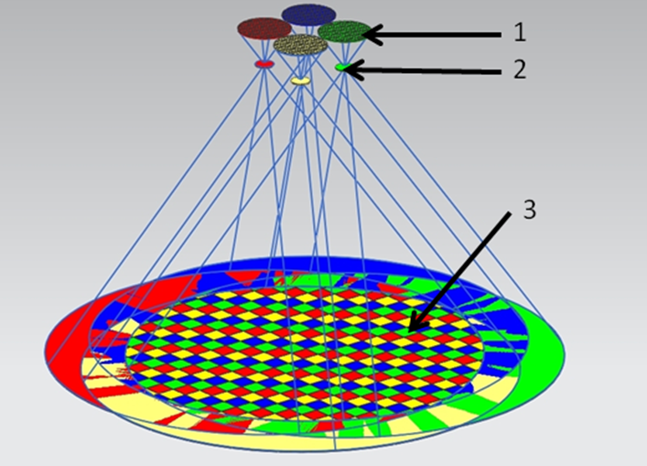
Fig.1 Multi-array sensor array
In fig.1 1 is the sensor array, 2 is the telecentric lens group and 3 is the image of the target aera
In order to extract the effective information of the remote sensing data, the multi-array sensor array is employed to meet the information demand of the users, and it can complete the basic image processing on satellite. If the users need the low-resolution global images, the image on the multi-array sensor array can be read by binning method. If you need the detailed investigation of the local area, the single array sensor image can be acquired.

3 Intelligence Architecture of the Integrated Sensor

3.1 Introduction Intelligence Architecture

Services are the core of the intelligence architecture of the integrated sensor which includes management layer, data layer, shared services layer and application layer. Image and data resources can be shared as a service for more users to provide various applications. The user of the application layer does not think about the complexity and the achieving processing of the image data, and the user demand is met by requesting the application layer. Meanwhile, for the service platform security of the data distribution is realized by controlling users’ access permission. Figure 2 shows the structure of the intelligence architecture of the Integrated Sensor.
Fig.2 the intelligence architecture
The function of each layer is as follows:
a) Management layer
The management layer has mainly two aspects: one is all kinds of data sharing policies, regulations and standards, which can manage various functions of the shared database. Other is that the management layer completes the effective management and control by the management control system of the optical remote sensing data on satellite, and the management requirement is from the data layer. By this way we can get the effective information, and reduce the waste of the resources.
b) Data layer
Data layer is mainly established to support the integration of remote sensing services platform, which includes acquirement of the remote sensing data, the construction and updating of the remote sensing database. Remote sensing data source is from the remote sensing image and data on satellite.
c) Shared Services Layer
Shared services layer of the remote sensing data was built on the basic of the data layer, which include the application service interfaces and resource directories. Shared services layer provides the service interfaces to the data application, the data descriptions, registration and distribution. Application layer can find the service on the shared services layer by binding the interface of the data service to call the data.
d) Application Layer
Application layer is mainly to support the application needs of various industries and other public service, such as land, agriculture, real estate, water, environment and transportation, emergency, public service and so on. Application layer can be based on the needs of various industries to distribute the visiting permission, call the data interface of the shared services platform, then you can access to relevant information.

3.2 The Foundation of the Intelligence Architecture

The intelligence architecture is based on the integrated sensors and it’s management control system, which include the image generation, image acquisition and processing, the image application^{[3-5]}. To accomplish this task, you must have a real-time image processing system with robustness, and during the process, the image processing system has the interactive operation with the ground user system, and this needs the high-capacity channel to ensure the upload of the users’ instruction and the downlink of image data. The whole image process system includes hardware and software.

3.2.1 The Image Processing System on Satellite

The image processing system on satellite is the key to the Integrated Sensor-Collected intelligence architecture, the parallel fiber optic transmission module is employed on the image acquisition between the image processing system and intelligent integrated sensors on satellite. The image processing system is comprised of the n individual and parallel processor modules, and the number of the processor modules is determined by the characteristics of optical load. Figure 3 shows the processor module.
Fig.3 the Satellite-borne Sensor Processing Module

The every processing module of the image processing system on satellite is the same hardware, and each processing module is shown in fig.4 and it can process the certain pixel of the optical sensor number and acquire the individual image, the n images can mosaic the whole image. Each processing module includes two FPGA, dual-core computer, image compression equipment, fiber optic converters and data storage hard disk. The model and preference of the hardware can be chosen by the performance parameters of the optical image system on satellite. Many image processing operations can be completed in a single FPGA, the whole processing system has a powerful processing capabilities based on system requirements. The parallel processing of the image is completed in the FPGA, and the computer accomplishes the logic control. The image processing system on satellite can compress the image and transmit it, and the compressed image and the original data are stored, and this system can control the optical sensing spatial resolution and frame rate of the sensor to meet the needs of the different users.

Fig.4 the Satellite-borne Processing System

3.2.2 Ground User Interactive Display System

Ground user interactive display system can display the image from the satellite on the touching screen. The operator can scan the image for the selection or arbitrary scaling according to needs of the users, in this process, the purpose of the operator will be transmitted to the image processing system on satellite, and the image processing system will compress the image on satellite and transmit it to the ground according to the operator’s purpose, this whole process is the interactive operation between the image processing system on satellite and ground user interactive display system. The touching screen of ground user interactive display system is shown in fig.5.

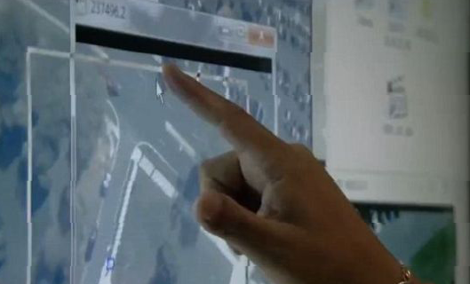
Fig.5 The touching screen of ground user interactive display system
The user can develop the function of the further application and the multi-user interface, such as the interface to the Google Earth. In addition, this system can be exploited for the user different needs to meet the needs of the user in order to build the architecture sharing data and the application database.

4 Difficulties and Key Technologies

The difficulties and key technologies of the integrated sensor-collected intelligence architecture are as follows:
a) Mutli-sensor/camera integration
In order to improve the efficient extraction of remote sensing information, the multi-source data fusion is used and it needs to multiple cameras multi-optical sensors integrated, so this brings the challenges of multi-sensor alignment, time unity, position determination and the imaging sutures and so on.
b) Data processing capability
The multi-sensor integration has the higher pixel, up to gigapixel, so it needs the super data processing capabilities. One is related to the processing image and data techniques, such as improving signal to noise ratio, the data identification, decreasing of the data collection and so on. On the other hand, the intelligent integrated sensor is comprised of the large multi-sensors, so you can use each individual sensor data, and the exploitation of the image application has the great potential, thus this require the powerful image processing capabilities.
c) High-speed communication and information transmission
The ultra-high speed data processor fiber optical channel network is required when the data from the sensors to the image processing system, how to allocate the data transmission is the difficulty of the system design. In addition, the functions of the data processing, network utilization and the user search depend on the reliable communication system, which must support the high-bandwidth mobile data, in order to ensure the synchronization of the user data.
d) Marking metadata
Data must have the characteristics of the visibility, the availability when the data is needed. In order to distinguish the message information data and non-information message, the original data and the processing data, we must give the mark to the data for finding timely the appropriate data. Due to the huge amount of data exploitation is carried out, so how to mark the data and improve the efficiency of the system is one of the key technologies of the system.
e) The exploitation of the large data and information
The integrated sensor-collected intelligence architecture needs the feedback of the user to optimize the processing of data, decrease the complexity of the system hardware and the effective extraction of the information. Therefore, how to develop a real-time feedback can acquire the user purpose in order to the exploitation of the data, this is one of the difficulties of the system.
(6) Powerful computers and network management
The integrated sensor-collected intelligence architecture established the data-sharing network from the satellite to the ground. The users can exploit the different functions, which need to extract the effective information and manage the data classification, so it must have the powerful computer and network management to support the intelligence architecture.

5 Conclusions

In this paper an integrated sensor-collected intelligence architecture based on satellite is proposed to build a sharing data net, and the architecture is comprised of the multi-array sensor array, the image processing system and the ground user interactive display system, in order to solve the bottleneck of the satellite data transmission and the invalid information redundancy problem. This architecture not only improve the utilization of the satellite data, reducing the amount of the remote sensing image transmission, but also can develop a series of remote sensing image application and the network service platform according to the users’ purpose, and this lay a foundation to the satellite data sharing.

6 References

[1] Ding Hailing, Lin Baojun, Research on Simulation System for High-speed Real-time Remote Sensing Image Compression, computer simulation, 2006, Vol.23, No.5, p42-44
[2] Chen Long, Wang Yong, Wang Yan, Xu Jinping, Design and Implementation of Transmission System for High-speed Remote Sensing Image Compression, computer engineering & Software, , 2012, Vol.33, No.1, p5-11
[3]Brain Leininger, Jonathan Edwards, John Antoniades, David Chester, Dan Haas, Eric Liu, Mark Stevens, Charlie Gershfield, Mike Braun, James D. Targove, Steve Wein, Paul Brewer, Donald G. Madden ,Khurram Hassan Shafigue.Autonomous real-time ground ubiquitous surveillance imaging system(ARGIS-IS)[J]. Proc. Of SPIE, 2008,6981(69810H-1):http://www.darpa.mil,2011
[4]Wide-area aerial surveillance systems. Persistent Surveillance systems, http://www.persistentsurveillance.com.
[5]Report of the joint defense science board intelligence science board task force on integrating sensor-collected intelligence[R] Office of the Under Secretary of Defense for Acquisition, Technology, and Logistics Washington, D.C.20301-3140:3-18.

