THE EVALUATION OF LAND TO AGRICULTURE IN BANGGAI REGENCY

Bambang Riadi, Wiwin Ambarwulan
Spatial Information Agency (BIG), Jalan Raya Jakarta Bogor KM 46 Cibinong Bogor INDONESIA
Email : briadi_jasinfo@yahoo.com ; bambang.riadi@big.go.id ; w_ambarwulan@yahoo.com

ABSTRACT
Business food crops over the years remained progression, it is supported by government programs namely through intensification program aimed at encouraging farmers to do agricultural enterprises by using seeds, fertilization, irrigation and pest control as well as a good way to farm. Besides the intensification of efforts on extensification programmes are also carried out through the expansion of agricultural areas. The success of the production of food crops in addition to the intensification and extensification is also largely determined by a State seasons occurred during growing season is concerned. Land resource potential and direction of commodities is the basic information that is required in the planning of agriculture in an area. Information needs to be equipped with the formulation of technology resource management more specific land among others in applying techniques of soil conservation, soil fertility management and management of organic material.

This research developed a concept of potential agriculture site selection base on land system and current physical land information. Moreover, satellite image interpretation was used to obtain land physical data. These data then integrated with land use and land system data using a Geographic Information System tool to perform spatial analysis in order to obtain a potential farmland classification. This analysis result in three types of potential agricultural land namely wetland rice agriculture, dry land agriculture, and annual crops agriculture. This results show provisional information which has potential use for land zonation. Accordingly, the results can be used as input for further development of feasibility study for defining agricultural zone and crops types. The potential farmland class show that land area potential for developing wetland rice agricultural amounted for 88 thousand hectares (9.16% of the total area) and dry land agricultural amounted for 133 thousand hectares (13.76 % of the total area). Total area of Banggai Regency area 967.270 ha.

Land in this category has great physical limitations, so that maintenance at the level of management should be implemented. This kind of spatial information is actually has important role in supporting national food security.

Keywords: agricultural land, land use zoning, potential, marginal land, development land

INTRUDUCTION

Background
The activities of the mapping of the potential of land resources inventory focused on the land and modeling spatial to examine the potential of land every unit land to be analyzed
The acquisition of this land unit was approached by using satellite image interpretation process to lose aspects of geomorphology/landform as a representation of the natural processes that exist in a region with a combination of processing using GIS to overlay process instruments with other coverage (Nurwadjedi dan Poniman, 2009).
The mapping of potential land is an early stage as input directives the spatial, later after the mapping of any potential, the availability of land continued with study of the capabilities of every unit of the land.
Recommendations for the provision of Land for the development of potential map of farmland land coverage includes information : the suitability of rice agricultural land, dry land agricultural land suitability, suitability of land plants annual, and the road network as well as the availability of infrastructure.
Spatial information above is then used as the basis for development of the region into the future taking into account aspects of land development in the agricultural sector for the purpose of strengthening food security independently (Suwarno, dkk., 2010).
Spatial information is also could be implemented through a system of information based spatial to the need for the socialization for outsiders to the development of the integrated.
Analysis of the suitability of the Land is a land evaluation activities in order to be able to describe the level of suitability/conformity a plot of land for a specific use (Hardjowigeno, Widiatmaka, 2007).
The conformity assessment of land for certain plants adapted to the environmental conditions and the likelihood of such plants is required by residents as foodstuffs or commodities which have high economic value.
When a land less potential to a particular use, so evaluation land useful for users to be known parapet what the matter for the use of the land so as to be done business repair a parapet in accordance with the terrain.
The evaluation of land suitability in fact relates to an evaluation for a specific use, such as for cultivating rice, corn, etc. (Sitorus, 1985).
Conformity land can be assessed to the current state ( or actual ), the present or after held improvement ( improvement or potential ), more specifically conformity the land viewed from the physical properties of the environment, which is composed of climate, the land, topography, hydrological, and or drainage according to an undertaking peasantry or a particular commodity productive (Djaenudin et al., 2003).
Banggai regency a region consisting of the use of the wetlands, fields, plant coconuts, palm oil plantations, forest, settlements, shrub, similar forests, dense forest, the forest industry plants, mixed forests, grasslands, bush, reed and embankment.
The area of dense forest dominates the Banggai regency and are generally located in the central part of the county. While the plantations, rice fields and settlements are generally located on the beachfront in Banggai regency.
The characteristics of land use in the analysis of the suitability of the Land obtained from existing maps are already available. These land characteristics Data such as the name of the land (USDA, 1987), climatic conditions, the type of land, land use, slope, slope class a class altitude places, erosion hazard, danger of flooding and geological conditions
The making of maps conformity land for a crop food wet land, dry land and plant plantation ideally is availability of data chemical properties of land ( basa, pH, C-org, KTK ), the physical properties of land ( drainage, texture ) that can be obtained from the field survey. But in this research data that is available map land scale of 1: 250,000.
Therefore, a class of conformity that is produced on a study this to the level of the order. Thematic existing data is the name of land (USDA, 1987 ), the climate condition, the form of land type the use of land, a class of the slope, a class of the height of the place, the dangers of erosion, danger of flooding and the condition of geology. In relation to this, to know type use land physically most appropriate and economically rewarding. This analysis will also useful later on, so as to be done attempts to improve system rice farming business. For that the research activity this study evaluation conformity land for Banggai regency with intent find area corresponding to the crops and plantation next would increase economic.

Purpose and objective
The intention of this research is to map the potential land with the use of remote sensing technology and geographic information systems, digital spatial database obtained so that the potential of the land Regeny of Banggai
As for the goal of knowing the potential of the land in the entire land area of the particular spatial Regency of Banggai; presented in a spatial database that can be used as input in spatial planning. The use of land potential data as the first step in optimization land for achieving balance of exploitable natural resources for the achievement of the management of natural resources sustainable.

The benefits of
Research is expected to give positive impact government benefits for Banggai Regency. Data spatial conformity, in the form of land availability, land and directive input area development is optimal for spatial planning.
The results of this research are expected to provide a view for the decision maker Banggai Regency Government to embark on a land area of development orientation, not only on the aspects of the original revenue increased value for the area, but more on the value of the wider region of resilience, given the complexity of the matter and form of the management of the area.

METHOD

The methodology of the analysis of the suitability of land for food crops (wetlands and dry land) and plantation crops are using geographic information systems (GIS) and the checking of the field. Broadly speaking, the stage of implementation of the activity is divided into stages of preparation, analysis and drafting stage map.
Stage includes activities preparation data topography, map secondary thematic map data and data tabuler study area.Processing the end was a generalization of special map data sheets Banggai regency.
Of thematic slope and maps altitude place arranged a map topographical maps made from layer of the contour and a high point. Stage of the proceedings the mapping of thematic with a method of TIN ( irregular triangular network ), according to data from the contours of next made DEM ( digital elevation of models ).Of DEM will later made a map of the height of the place and map slope. Flow chart of process research is presented in Figure 1.

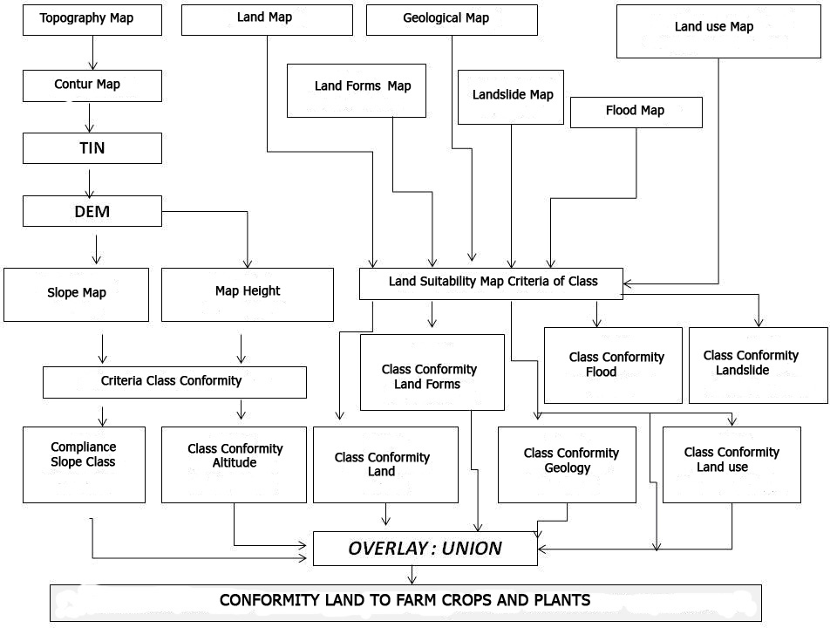
Figure.1. Flowchart Preparation Of Land Suitability Map

Thematic basis, the formulation of the map should be conducted by provision and preparation of thematic data supporting having a reference system equal to the needs of modeling spatial the end. A map thematic basis of what is meant is the map of thematic single outcome derived directly from the process of extracting data (Riadi,B.2013).

Thematic map base used in this research consisting of :
- Map of land cover, land cover data extraction of the topography map.
- Map the intensity of rainfall, the extrapolation method using the mapping isohiet data from each measuring rainfall stations available. For the purposes of modeling the spatial detail of the suitability of the farmland needed rainfall intensity data are detailed.
- Map of the slopes, the result of the extraction of the data DEM (digital elevation model).
- Map of Geomorphology, produced through the process of interpretation of geomorphology at the DEM data produces a representation of the region with accentuating the relief aspect.
Map of soil Spring detail, where the existing soil map unit has a content attribute (information) that is fairly complete with the requirements analysis for the classification of agricultural land suitability. In this study a new ground mapping is not done, but using a reference map of RePProt (soil type Map) Bakosurtanal production and soil type Map production of BBSDLP (Hall of a large Resources of agricultural lands). This information is then entered in the database of the land as the main material for the process of modeling the spatial arrangement of agricultural land suitability map.

Spatial Modeling
Spatial modeling is at the core of this research, which was carried out gradually with the adoption of a number of different methods of each of the stages. The first stage, spatial modeling to generate data of potential agricultural land from the existing classification. This stage is a spatial operation of thematic data base which is then overlay using the GIS (Campbell, 1996). Spatial analysis at this stage is based on the scoring system.
The second phase, the acquisition of land, availability of data by using a method of matching analysis between land potential data with the status of the area. The final stage of this research is data acquisition agriculutral zone between matching event analysis of the data available farmland with existing current condition. For a more detailed analysis of the directive, the development of the agricultural zone will be more detail on the level of sub district using data available (ESRI, 1997a)

Analysis of conformity land
Analysis of the suitability of the land in the Regency of Banggai done with attention to the elements of land resources. The element used for this activity is the slope map, vegetation cover, landscape diversity and stability of the land. Landscape diversity and slope factor obtained from a Digital Elevation Model of the analysis results (DEM), whereas vegetation cover obtained from Landsat imagery and topographic maps (ESRI, 1997b).
Then proceed with the analysis of the suitability of the land for agriculture. The elements used in land suitability analysis is the map slope, land cover, land forms, the stability of the soil and rainfall. Giving a score for each element and overlay will produce a map of land suitability based on criteria is used. As for the minimum space requirements are intended to control the growth of the village which is based on the concept of sustainable development. Land suitability analysis results provide referrals for zoning the forest and a buffer area of productive agricultural area (ESRI, 1997c).
The analysis of the process of producing thematic maps needed presence in the form of a map in print, the process data layout to produce a thematic map prints with themes : A map of conformity land for a crop of rice, food a food crop dry land and the map of conformity land for a crop an estate. Description of the maps presented in the explanatory report of the task force as a part of the map.

RESULTS AND DISCUSSION

Analysis evaluation conformity land in this activity give the outer covering of three result analysis conformity derivable based on data systems land and verification matching event analysis methods with other parameters slope, namely land, and climate (ESRI, 1997c).
In geo-morphology, study area is dominated by rocks volcano and karst. Topography region relatively flat until wavy and hilly. Having regard side geo- morphology, topography, geological and land forms, in general land at the study can be expressed as not having constraint signifying for commercial operation agriculture food and plantation especially in the area along the coast. Consideration of the suitability of the land would then determine the constraints to development. With the fact that bio-physical conditions, land suitability analysis based on characteristics of the land will be heavy on analysis of this point.

Conformity land the rice plant
Food crops of rice fields in the area of study is the land of rice fields that are found in the West Toili district , Moilong district, South Batui district and Batui district. Those district are rice barn in Regency of Banggai. The Total area of wetlands or rice fields is 14.924,66 Ha (BPS, 2012).
Results of the analysis, the appropriate land for food crops on wetlands (existing conditions) covering an area of 88,592.13 Ha (9,16%) of Banggai. The region is not suitable for food crops on wetlands covering an area of 878,677.87 Ha (90,84%), and Figure. 2. The development of appropriate land located in the vicinity of rice paddy fields in existing as well as on several other locations i.e. in district of Bualemo, district of Simpang Raya, district of Bunta and district of Nuhon.

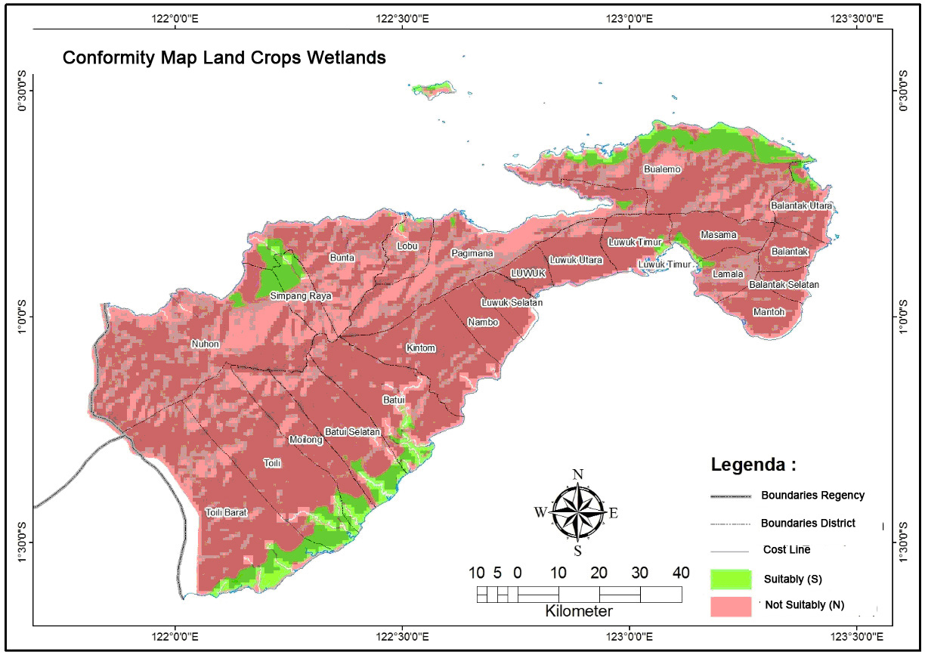
Figure.2. Conformity map land crops wetlands

If the development of food crops on Wetlands Area is directed at other uses (APL), Spatial analysis based on the physical in overlay with a map of forest area obtained land that is appropriate for the use of a food plant of wetlands having space 78.267,68 ha ( 8,09 % )

Conformity food crop land dry land
Land resources in Indonesia is largely a dry land that has the potential for agricultural purposes. Potential dry land was different between one area to other regions, hanging from factor topography / form region, geology and soil conditions, climate (temperature, precipitation, wind and shines), the state of water resources and socio-economic circumstances of society (Syam, etl., 2012). There is also potential difference caused the need for the selection of the type of farmer and the kinds of technology that fits with the potential of the dry land (Suriadi, 2010).

Dry land is defined as land that is in a State of nature have the condition, among others:
- sensitive to erosion, especially when soil is tilted or not covered with vegetation
- the land is low fertility level
- water is the limiting factor and usually depends on the rainfall
- top soil dan sub soil has a very low humidity

Information obtained from an analysis of data on the research indicated that opportunities utilization of agriculture dry land to Banggai regency is still likely. The availability of ample land at this point has not yet been optimized as investment opportunities for local governments, So that it will change the condition of the land sleep into land which can give high economic value.
Criteria for the evaluation of land suitability of rice paddy fields and dry land farming in principle almost the same. Parameter that distinguish the criteria for both of them was a class drainage. Evaluation of conformity of land for rice is seeking a class of drainage hampered on class most appropriate ( S1 ) and somewhat hampered on class reasonable facsimile ( S2 ) and appropriate marginally ( S3 ). Other parameters are the same for both types of land suitability. Commodities that could be developed as a dry land crops such as sweet potato, cassava, corn, vegetable, and fruit group. The implementation of plants dry land not only being able to provide local food, but certainly impact on improving the community economic agents this sector.
In a study, conformity land crops dry land found throughout regency of Banggai. A food crop dry land planted are rice field. Corn, of the manioc, sweet potato, peanut, green beans and soybean.
Results of the analysis of the information of land that is suitable for food crops on dry land 133.110,14 ha (13,76% ). So the area is not suitable for food crops on dry land 834.159,86 ha (86,24%). Location suitability of dry land are generally found on dry land, existing location and direction of development in the area surrounding the existing dry land. Districts that do not have the padi fields are West Toili, Moilong, Bunta, Nuhon and Luwuk. Map the suitability of land for food crops dry land are presented in Figure 3. Based on a map of conformity land for a crop known that the dry land, almost all regions are generally appropriate for dry land is on lowland almost in all districts except district Pagimana, district Balantak, district of South Balantak, district Masama.

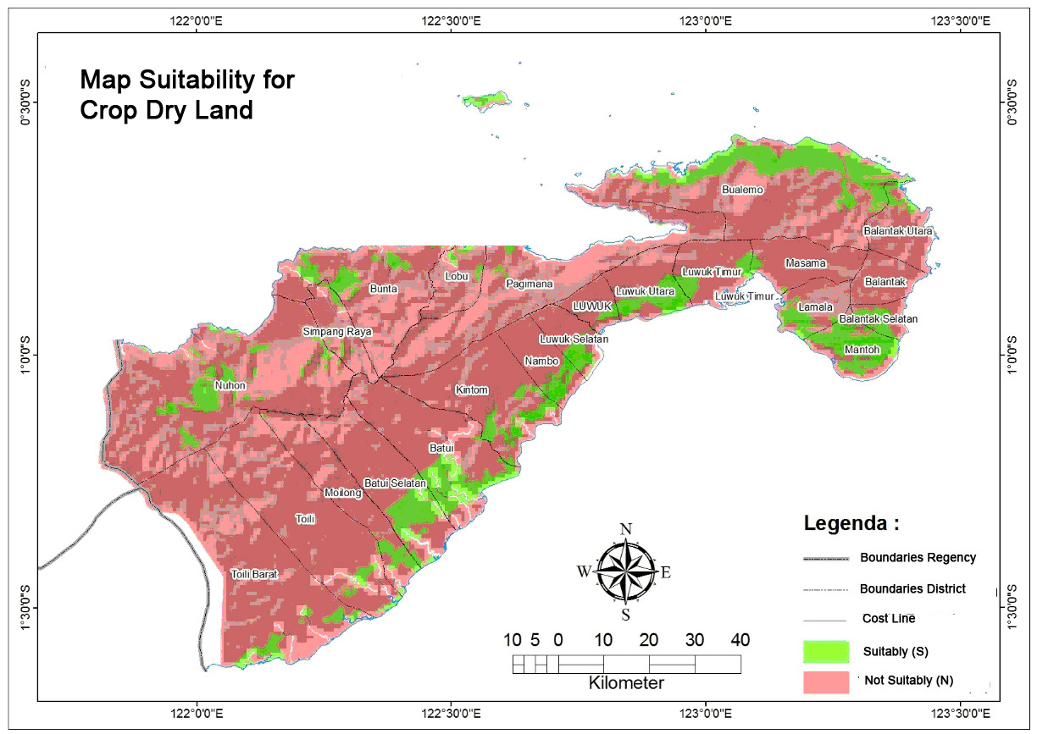
Figure.3. Map Suitability for Crop Dry Land

Agricultural sector development dry land can be implemented as the availability ' s human resources and resource other supporting are enough many in this region, product market food crops dry land be allocated to local needs. While for the next development, the region is very possible due to the supporting infrastructure for marketing is not difficult.

The Suitability Of Land For Plantation Crops
An annual plant is a type of plant that can produce more than one year. The implementation of the most readily from the agricultural sector an annual plant is an estate like coffee, cocoa, rubber trees, palm oil as well as some product spices as vanilla and cloves. Of the criteria used as a reference seemed that the terms of land that is appropriate to the development of an annual plant higher quality in comparison with the criteria set on the evaluation of the other.
The leading commodity crop plantations in the Regency of Banggai was coconut commodity, The leading commodity crop plantations in the regency of Banggai commodity is coconut, oil palm, cocoa and rubber trees. In 2012 the number of coconut production 2.788 tons of planting acreage area of 61.729 ha, palm oil production reaches a wide area with tons of 7.072 planting 17.519 ha, cocoa production area 1.373 tons with extensive planting 44.805 ha (BPS,2012).
Plantation commodities plants constituting plant trading quite strategic because be the source of foreign exchange in agriculture. Area of study, there is potential for a variety of crops and plantations can be obtained in some places. According to data from the Directorate of the Ministry of agriculture Plantations Jakarta (2007), in Banggai Regency, there were, among others : cocoa. Commodities cocoa grown on 17.314 hectares of land with production capacity reaching 6.418 tons.
Based on analysis obtained land that is appropriate to an annual plant / plantation area of 198.713,13 ha (20,54 %). The region is not suitable for annual crops/plantations is 768.556,87 ha (79,46%) of the area. Map the suitability of land for annual crops/plantations are presented in Figure 4.

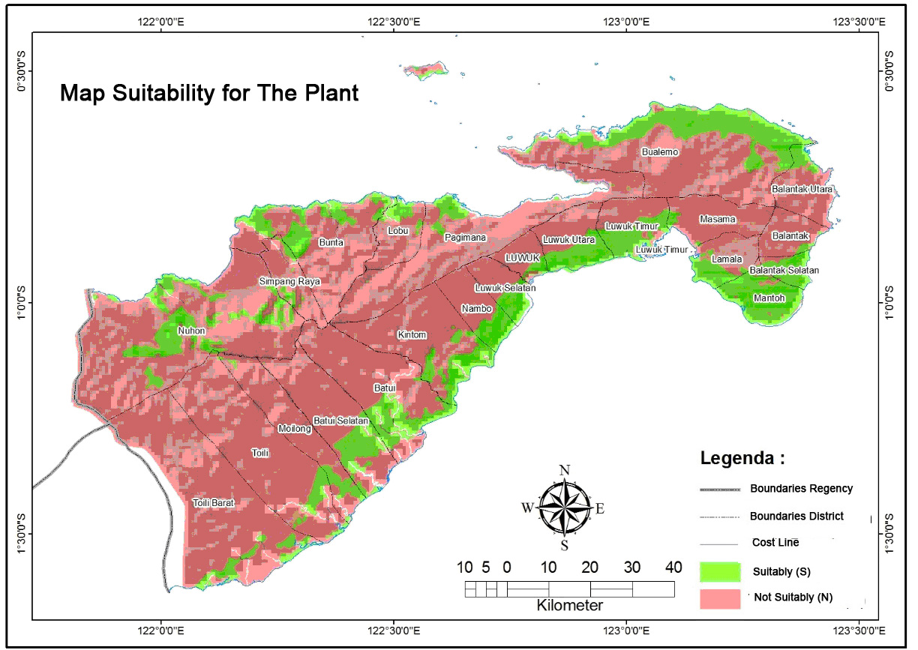

Figure.4. Map Suitability for The Plant

The development of the flagship commodities need to be adapted to the topography of the region. The topography of the Banggai Regency has a tilt that varies, areas with a slope of 0% u 2% covers 12,52% of area potential highly utilized for the business activities of agriculture wetlands and settlements. On slope 2% u 15 % cover of area 13,47 % of the potential be used for various types of agriculture businesses, but the necessary soil and water conservation efforts. Slope 15 % u 40 % cover area 37,26 %, slope is quite cartilages and is unfit for cultivation plants, plant chosen at once serves as conservation. The slope of more than 40 % cover an area 36,75 % very potential affected by erosion, and the only viable be used for preserved forest area
On the average a region that is appropriate to plant an estate is very low which is under 15 %. It is because regency Banggai dominated by forests that cannot be used for development areal agriculture. The determination of the criteria determining the areal extents is appropriate or not appropriate for crop plantations. The rate of conformity land is also very determined by data thematic that exist and depth information data. The core of the analysis is the availability of land suitability map land that comes with physical data of land and soil chemical data.
The development of annual crops can be directed at the commodity which has a high economic value. By looking at the condition of the climatology of the region, most likely the development of annual crop sectors can be realized. The limiting factor of development of annual crops in this region is physically actually isn't too big, but more on the factors of cost and technology, where the business sectors of agriculture of annual plant in general used for intermediate periods ranging from 10 years under 25 years old.

CONCLUSION

Evaluation of conformity land is a model that has long developed in Indonesia. This evaluation is based on an analysis of farm land system mapping approach to eliminating the physical characters of the land. Research on the evaluation of the suitability of the Banggai regency land potential is an effort of local government in an effort to achieve food security as well as the early stages of searching for a solution to optimize the development potential of the region.
Mapping using GIS technology is able to speed up analysis in this evaluation process. The existence and quality of the initial data as input in the mapping of spatial modelling, as a major factor for the quality of the data produced. Data relating to the physical parameters compiler of land evaluation conformity Banggai regency still not enough so some parameters that included in drafting spatial model yet is really hot data.
After doing the process of spatial modelling of land suitability evaluation results classification is at the stage of review, scale ideal analysis requires uniformity of spatial data scale mapping and related information generated. Results of the study of land suitability evaluation can be used as initial input for the planning of land use, spatial direction, and policy development in the agricultural sector. To increase the benefits suggested soon follow up on the results of this research by conducting an analysis of the evaluation of the data verified with field data acquisition for the cutting edge. Subsequent activities can use remote sensing imagery data instruments to provide physical access to information a better land, precision, and accuracy.
The research activity evaluation of conformity land if it is conducted with complete data will produce good information for the decision makers in local government, As well as investment in provision of data spatial information that can be used for the purposes of a more extensive.

Acknowledgments
Thanks conveyed to the Central Sulawesi Provincial Government which has funded activities in research studies on the potential of natural resources. A thank you to Dr. Dewayani that has given the opportunity join the research team in Central Sulawesi.

Reference
Riadi, B (2013). Agricultural Area Land Evaluation of Maritime Islands to Support Food Security. Majalah Ilmiah Globe. No. Akreditas: 529/AU1/P2MI-LIPI/04/2013 Vol.15(1), 23-29.
Syam, Darmawan dan Banuwa, Ningsih. (2012). The Utilization Of Satellite Imagery In Identifying Changes In Land Closure. Majalah Ilmiah Globe. No. Akreditas: 253/Akred-LIPI/P2MBI/05/2010. Vol. 14(2), 146 -156.
Widiatmaka, Ardiansyah dan Ambarwulan, W. (2012). Changes of Organic Carbon Soil Reserves in the context of land use change. Majalah Ilmiah Globe. No. Akreditas: 253/Akred-LIPI/P2MBI/05/2010. Vol. 14(2), 170-177.
Suwarno, Y., Munajati, SL., Khifni, M. dan Fitriyanto, AC. (2010). The design of its spatial model food security a remote island. Majalah Ilmiah Globe. No. Akreditas: 253/Akred-LIPI/P2MBI/05/2010. Vol.12(1), 37-47.
Suriadi. (2010). Climate change and food security in West Java province. Majalah Ilmiah Globe No. Akreditas: 253/Akred-LIPI/P2MBI/05/2010 Vol.12(1), 48-55.
Nurwadjedi dan A. Poniman. (2009). The utilization of image data alos for mapping rice-fields. Jurnal Ilmiah Geomatika. No. Akreditas: 128/Akred-LIPI/P2MBI/06/2008. Vol.15(1), 36-45.
Central Bureau Of Statistics, Banggai Regency (BPS), 2010. Banggai regency in the rate of
(Kabupaten Banggai dalam Angka 2010).
Central Bureau Of Statistics, Banggai Regency (BPS), 2011. Banggai regency in the rate of
(Kabupaten Banggai dalam Angka 2011).
Central Bureau Of Statistics, Banggai Regency (BPS), 2012. Banggai regency in the rate of
(Kabupaten Banggai dalam Angka 2012).
Djaenudin. D, H. Marwan, H. Subagjo, A. Hidayat. 2003. Technical Evaluation Of Land For
Agricultural Commodities. Agricultural Research and development agency of the Ministry of agriculture
(Badan Litbang Pertanian Departemen Pertanian). Bogor.
Hardjowigeno, S., Widiatmaka.. 2007. The evaluation of Land Suitability and land use Planning.
Gajah Mada University Press, Yogyakarta)
Agricultural Research and development agency of the Ministry of agriculture, 2003. Technical Evaluation of
land for agricultural commodities. Jakarta.USDA. 1983. National Soil Handbook. SCS-USDA,
Washington, DC
Djaenudin, Marwah, Subagyo, Mulyani dan Suharta. (2000). Criteria For The Suitability Of Land For Agricultural . Puslittanak. Bogor.
Burrough, McDonnell. (1998). Principals of Geographical Information Systems. Oxford University Press.
Campbell. (1996). Introduction to Remote Sensing. Second Edition. The Guilford Press.
ESRI. (1997a). ArcView 3D Analyst. Environmental Systems Research Institute, Inc. Redlands. USA.
ESRI. (1997b). ArcView Image Analysis. Environmental Systems Research Institute, Inc. Redlands. USA.
ESRI. (1997c). ArcView Spatial Analyst. Environmental Systems Research Institute, Inc. Redlands. USA.

