EMULATING THE HABITAT OF DIFFERENT TREE SPECIES AT LOW–MEDIUM ELEVATION BY MACHINE LEARNING

Chin-Jou Hsu (1), Bao-Hua Shao(2), Nan-Chang Lo(3)Kai-Yi Huang(4)

¹Dept. of Forestry, Chung-Hsing University, 145 Xingda Road, Taichung 402, China Taipei
²Nan-Tou Division Office, Forest Bureau, Council of Agriculture, 456 Shihguan Rd., NanTou 542
³Experimental Forest Management Office, Chung-Hsing University, 145 Xingda Rd., Taichung 402
⁴Dept. of Forestry, Chung-Hsing University, 145 Xingda Road, Taichung 402
Email: 1023037bear@gmail.com; baobao357@gmail.com; njl@nchu.edu.tw; kyhuang@dragon.nchu.edu.tw

KEY WORDS: species distribution model (SDM), decision tree (DT), random forest (RF), terrain position (TP), ecological amplitude (EA)

ABSTRACT: Numerous studies have applied a geospatial information system (GIS) coupled with machine learning algorithms to build species distribution model (SDM) for simulating the habitat of rare plant species with narrower ecological amplitude (EA) on a specific characteristic (e.g. elevation), but seldom for species with broader EA since simulating the latter is generally more difficult than the former. This study selected Randaishan cinnamon (Randaishan cinnamon, RC) and Rhododendron formosanum (Formosan rhododendrons, FR) as targets with different EAs for comparison. Moreover, data for terrain-related variables (e.g. slope) were used in this study since data for them can be easily acquired by remote sensing. DEMs of three grid sizes (5, 20, and 40 m) were used to derive these variables, including elevation, slope, aspect, terrain position (TP), surface curvature (SC), profile curvature (PRC), and plan curvature (PLC). The SDMs were generated using discriminant analysis (DA), decision tree (DT), random forest (RF), and support vector machine (SVM) that were developed using the machine learning module (scikit-learn) written in Python programming language. Both values of the Kappa coefficient of agreement and Matthews correlation coefficient (MCC) for RF are the best, DT is the second, and SVM and DA are the worst among them. Regardless of which algorithm being used, the accuracies of FR models are at least 10% greater than those of RC models. Of more importance, not only it is more efficient to simulate steno-species (i.e. FR) than eury-species (i.e. RC), but also the predictive ability of the former is superior to that of the latter. FR species has much stronger adaptability to poor circumstances with thin, infertile, and acidic soils than RC species does. Furthermore, it has been found that the TP (i.e. slope position from ridge or peak to valley) plays a vital role, followed by elevation, and other variables vary with the resolution and algorithm. DEMs and their derived terrain-related variables can improve the accuracy of SDM substantially as the spatial resolution raises from 40m to 5m, and there are more variable combinations to achieve the highest accuracy.

INTRODUCTION
Species distribution model (SDM), i.e. used for predicting ecological patterns and processes, has always been a part of ecology, but it became a necessary in the latter half of the 20th century. Technological innovations over the last few decades, especially in the fields of remote sensing (RS), geospatial information system (GIS), and global navigation satellite system (GNSS) coupled with machine learning greatly enhanced researchers' capacity to describe the patterns in nature accurately over broader spatial scales and at a greater level of detail than ever before. However, the 3S (GIS, GNSS, RS) system combined with statistical model analysis is often used to simulate the habitat distribution of rare plant or animal species (Gross et al., 2002; Bourg et al., 2005), but seldom to build SDMs for tree species with a broader ecological amplitude (EA) since simulating the latter is generally more difficult than the former. Therefore, this study selected Randaishan cinnamon Miq. (Randaishan cinnamon, RC) and Rhododendron formosanum (Formosan rhododendrons, FR) as targets with different EAs for comparison.

Ecology has entered a world of big data, and is confronting the attendant opportunities and challenges (Farley et al. 2018). Nowadays, advances in machine learning algorithms have enhanced the ability to handle big data, while effectively combining RS and GIS tools can more accurately describe spatial patterns and guide field surveys (Engler et al., 2004). The variables derived from SDMs of three grid sizes (5, 20, and 40 m) results in a huge amount of data. In order to consider the possibility of all variable combinations, the research attempted to use data mining approach in a semi-automation way and develop SDMs based on machine learning methods such as discriminant analysis (DA), decision tree (DT), random forest (RF), and support vector machine (SVM).

STUDY AREA AND TARGET SPECIES

  - Study Area
The entire study area is situated in Huisun Experimental Forest Station (HEFS) (Figure 1) which is one of the experimental forest in the Chung-Hsing University. The location is about the northeast corner of Nantou County, with latitude 24°2’ - 24°7´ N and longitude 121°0’ - 121°8’ E. Elevations range from 450 to 2,419 m above mean sea level, mean annual precipitation is around 3,317 m, and mean annual temperatures range from 15.0 to 24.2 °C. It comprises five watersheds, and the climate of HEFS is inland Region of Humid subtropical climate. The environment where are about 1,100 species of plantshas high species richness and it is a representative forest in central of Taiwan. This study adopted a rectangular area covering the entire irregularly shaped of HEFS, with a total area of approximately 18,164.3 ha. The analysis and simulation were performed based on it.

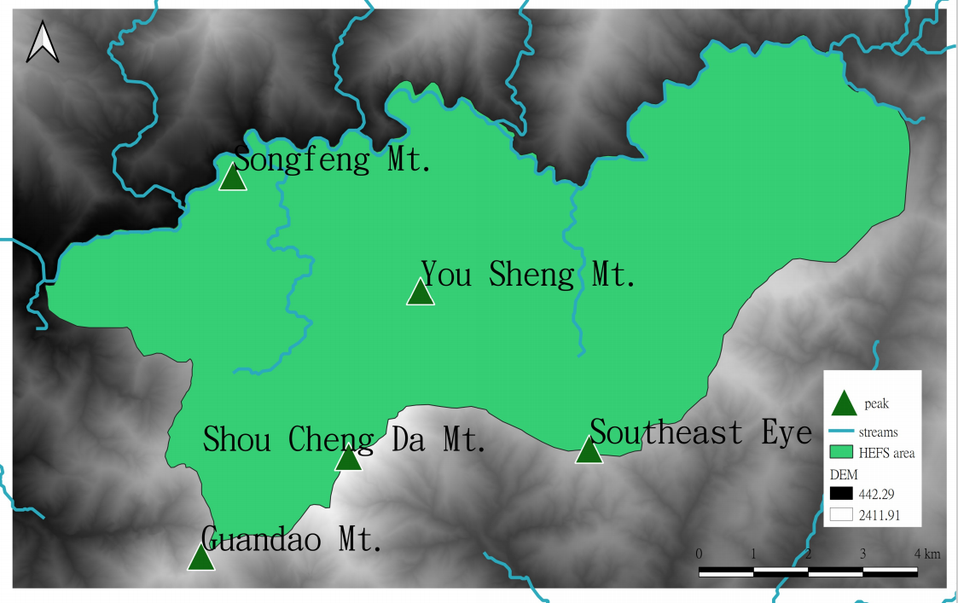
Figure 1. Map for Huisun Experimental Forest Station

Target Tree Species

2.2.1 Randaishan cinnamon (Randaishan cinnamon, RC)
RC tree is an evergreen broad-leaved tree species and widely distributed in central and southern Taiwan. It is a dominant species in the study area; the tree species and other characteristic vegetation species comprise the forest type of RC. It is shade-resistant and prefers deep shade and humid areas. Hence, it usually occurs at terrain position from midslope with deeper shade all the way down to valley bottom.

2.2.2 Rhododendron formosanum (Formosan rhododendrons, FR)
FR tree grow in the upper boundary of broad-leaved forests at an elevation of 600–2,500 m. It grows mostly on steep slopes or ridges and usually forming a large area of pure forest on flat mountain tips or ridges with enough exposure to sunlight. Moreover, they can grow in harsh places such as thin soil with low pH value. In HEFS, they are usually found on a broad ridge or flat mountain top (Lo, 2010).

METETIALS AND MATHODS

  - The Target and Background Sampling
Data for the target species were collected by GPS with 5m extendable antenna and laser range finder. There were 140 RC tree samples and 181 RF tree samples collected from the shrunken study area, respectively. Since several samples belong to the same pixel, after the data integration, different samples were sequentially retained. In addition, all of the background samples were randomly selected by ArcGIS software packages and the number of these samples is five times more than that of the target species samples.

  - Topographic Variable
Almost all the variable layers in this study are derived from DEM by utilizing ArcGIS software packages and DEM is produced by LiDAR. These layers include elevation, slope, aspect, terrain position (TP), surface curvature (SC), profile curvature (PRC), and plan curvature (PLC). In addition, the important variable layers TP were calculated by the python script developed in the study.

3.3.1 Terrain position (TP)
TP affects the degree of soil moisture, dryness and wetness. The corresponding formula is shown in equation 1.

……..….. (1)

where PV = Euclidean distance from point P to the nearest valley line;
PR = Euclidean distance from point P to the nearest ridgeline

In the above formula, P is a certain verification point (grid), and P_{ij} is the relative position ratio of row j in thecolumn.

Before calculating TP, the researcher needed to depict the ridgeline and valley linelayers manually. Considering that there may bedifferent effectiveness for building models with ridge and valley of different complexity, the researcher drew ridgelines and valley lines as detailed as possible. And they were divided such complexity into three levels as shown in figure2. After drawing ridgelines, the next step is to overlay the ridgeline and valley lines from simple to complex which formed three combinations of ridgeline and valley lines. Notice that three combinations of ridgelinesand valley lines were generated; therefore, there are threetypes of TP (TP1, TP2, and TP3) layers to be considered.
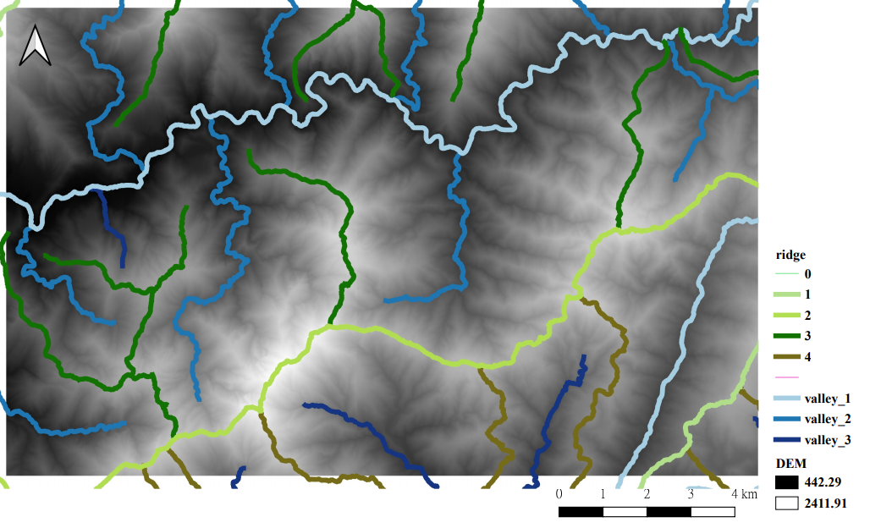
Figure 2.The ridgeline and valley line of different levels

  - Model Development

3.3.1 Discriminant analysis (DA)
This is a technique for dividing groups. Samples of known categories are selected in advance to have a classification effect. Use grouping variable as a response variable (y in the following formula), and multiple quantitative discriminant variables as explanatory variables (xi in the following formula) to establish a discriminant function. The formula is as follows:

y = b₀ + b₁x₁ + b₂x₂ + … + b_{i}x_{i} + … + b_{n}x_{n} ……..….. (2)

y is the discriminant score, xi is the discriminant variable, and bi is the discriminant coefficient or weight. The new observations are appropriately classified using the discriminant function (Li, 2018). This study uses the programming language Python, a linear discriminant generated by automatic iteration.

3.3.2 Decision Tree (DT)
Decision tree (DT) is a technology with classification and prediction functions in the field of data mining. Establishing appropriate classification rules by analysing known raw data and make a single interpretation variable function to construct a binary decision tree. Similar regions are called nodes. In each step of fitting a classification tree, optimization is performed to select a node, a predictor, and a critical value or a set of codes that will result in the most uniform base-level subset of the data, such as the Gini coefficient (Breiman et al., 1984). This criterion can set the best tree as a compromise between the goodness of fit of the training data and the tree size. When the classification data is complete, the final region is called the end node. The end nodes distribute the final results based on the group membership of most observations (Breimanet al., 1984; De’ath and Fabricius, 2000).

3.3.3 Random Forest (RF)
RF is ensemble classifier. By creating multiple decision trees to generate predictions, the final classification decision method is the voting decision of the classification results calculated by the generated trees (Breiman, 2001). The advantage of RF is that it has a high prediction accuracy, a good tolerance for outliers and noise, and it is not easy to over-fit. (Belgiu and Drăguţ, 2016). RF was achieved by implementing the machine learning package scikit-learn in python.

3.3.4 Support Vector Machine (SVM)
SVM is a supervised learning method that uses the principle of statistical risk minimization to estimate a classified hyperplane. The basic method is to construct a linear separating hyperplane, and the linear mode is to implement a nonlinear separation range. This hyperplane is obtained by maximizing the distance between Positive class and Negative class. SVM is a linear model but it also could deal with non-linear problems by using the kernel trick (Cristianini and Shawe-Taylor, 2000). The study tested linear and nonlinear SVM by implementing the machine learning package scikit-learn in python.

3.3.5 Model Validation
The study took split-sample validation approach to split the whole dataset into training subset and test subset with the ratio of 3/7, and evaluated the corresponding performance with aids of Cohen’s Kappa and Matthews correlation coefficient (MCC).

RESULTS AND DISCUSSION

  - Descriptive Statistics
According to the descriptive statistics of topographic variables (Table 1), the samples of FR are distributed in the altitude range of 1,037m to 2,077m, and it is mostly distributed with ridges above 1,000 m, which is consistent with the data of the traditional HEFS survey (1,000–2,200 m). The RC are distributed in the altitude range of 1,076m to 2,082m, which is higher than the general natural distribution range of 500m to 2,000m. This may be due to the choice of sampling survey. The average slope of RC is about 22.3 degrees, and the result is gentler than the average slope of the whole region of 39.1 degrees, indicating that RC prefers to grow on gentle slopes that are not easy to lose water at higher altitudes and are relatively humid. The average slope of FR is 24.8 degrees, which is also lower than the background samples and this species mostly grows on steep slopes or wide flat ridges. According to the statistics of TP, RCs tend to grow from medium to low terrain position along the slope. Also, from the statistics of PRC, at medium TP it usually occurs in gullies or depressions with negative PRC values, and at low TP, it occurs in low-lying land area or valleys since it may be shade-tolerant or even prefer to grow in sun-shading areas with sufficient soil moisture and nutrients. The average slope position of FR is 0.68. This result shows that it is consistent with the position of the slope of the FR growing on the middle slope and near the mountain edge as indicated by traditional plant ecology.

Table 1. Descriptive statistics of topographic variables
Background samples
 | elevation(m) | aspect |  | slope (°) |  | SC |  | PRC |  | PLC |  | TP1 |  | TP2 |  | TP3
Mean | 1302 | 5 |  | 39 |  | -1 |  | -1 |  | 0 |  | 0.44 |  | 0.49 |  | 0.11
SD | 378 | 2 |  | 13 |  | 15 |  | 8 |  | 9 |  | 0.31 |  | 0.29 |  | 0.09
min | 473 | 1 |  | 1 |  | -118 |  | -62 |  | -40 |  | 0.00 |  | 0.00 |  | 0.00
max | 2374 | 8 |  | 72 |  | 79 |  | 40 |  | 82 |  | 1.00 |  | 1.00 |  | 1.00
Target samples (FR)
 | elevation(m) |  | aspect |  | slope (°) |  | SC |  | PRC |  | PLC |  | TP1 |  | TP2 |  | TP3
Mean | 1733 |  | 3 |  | 25 |  | 4 |  | 1 |  | -3 |  | 0.67 |  | 0.89 |  | 0.31
SD | 298 |  | 2 |  | 12 |  | 8 |  | 5 |  | 5 |  | 0.30 |  | 0.23 |  | 0.32
min | 1037 |  | 1 |  | 2 |  | -23 |  | -20 |  | -19 |  | 0.32 |  | 0.18 |  | 0.02
max | 2076 |  | 8 |  | 55 |  | 34 |  | 16 |  | 11 |  | 1.00 |  | 1.00 |  | 1.00
Target samples (RC)
 | elevation(m) |  | aspect |  | slope (°) |  | SC |  | PRC |  | PLC |  | TP1 |  | TP2 |  | TP3
Mean | 1630 |  | 3 |  | 2 |  | 2 |  | 1 |  | -1 |  | 0.76 |  | 0.84 |  | 0.30
SD | 252 |  | 3 |  | 11 |  | 6 |  | 4 |  | 3 |  | 0.29 |  | 0.24 |  | 0.29
min | 1076 |  | 1 |  | 3 |  | -8 |  | -8 |  | -15 |  | 0.21 |  | 0.09 |  | 0.05
max | 2082 |  | 8 |  | 46 |  | 26 |  | 12 |  | 6 |  | 1.00 |  | 1.00 |  | 1.00

  - Topographic Variables
In the study, program coding with Python scripts, we are achievable to exhaust all possible combinations of variables, thereafter singling out automatically the best suitable variable combinations in terms of various assessing indices. There are 9 parameters tested in this research, and the table 2＆3 shows that the variable combination of both species must include TP. It affects the degree of soil moisture, dryness and wetness. At low TP, it occurs in low-lying land or valleys because it may be shade-resistant, or even prefer to growing on fertile soils with rich moisture. Moreover, each model prefers different kind of TP. This indicates that different tree species and models tend to add different combinations of ridges and valleys. In particular, in FR, all algorithmic variable combinations include slope, and the possible reason is that she grows on steep slopes or ridges.

Table2. Topographic variables Usability in FR

 | kappa |  |  |  | mcc
 | DA | SVM | DT | RF | DA | SVM | DT | RF
elevation |  | Ⅴ | Ⅴ | Ⅴ |  | Ⅴ | Ⅴ | Ⅴ
aspect | Ⅴ | Ⅴ | Ⅴ |  | Ⅴ | Ⅴ | Ⅴ | Ⅴ
slope | Ⅴ | Ⅴ | Ⅴ | Ⅴ | Ⅴ | Ⅴ | Ⅴ | Ⅴ
SC | Ⅴ | Ⅴ |  |  | Ⅴ |  |  | Ⅴ
PLC |  | Ⅴ |  |  |  |  |  | Ⅴ
PRC |  | Ⅴ
TP1 | Ⅴ | Ⅴ | Ⅴ | Ⅴ |  | Ⅴ | Ⅴ | Ⅴ
TP2 | Ⅴ | Ⅴ | Ⅴ | Ⅴ | Ⅴ | Ⅴ | Ⅴ | Ⅴ
TP3 | Ⅴ |  |  | Ⅴ | Ⅴ |  |  | Ⅴ

Table3. Topographic variables Usability in RC
 | kappa |  |  |  | mcc
 | DA | SVM | DT | RF | DA | SVM | DT | RF
elevation | Ⅴ | Ⅴ |  | Ⅴ | Ⅴ | Ⅴ |  | Ⅴ
aspect | Ⅴ | Ⅴ |  | Ⅴ | Ⅴ | Ⅴ |  | Ⅴ
slope | Ⅴ | Ⅴ |  |  | Ⅴ | Ⅴ |  | Ⅴ
SC
PLC | Ⅴ |  |  | Ⅴ | Ⅴ | Ⅴ
PRC | Ⅴ | Ⅴ |  | Ⅴ | Ⅴ | Ⅴ |  | Ⅴ
TP1 | Ⅴ | Ⅴ | Ⅴ | Ⅴ | Ⅴ |  | Ⅴ | Ⅴ
TP2 | Ⅴ | Ⅴ | Ⅴ | Ⅴ | Ⅴ | Ⅴ | Ⅴ | Ⅴ
TP3 | Ⅴ | Ⅴ | Ⅴ | Ⅴ | Ⅴ | Ⅴ | Ⅴ | Ⅴ

  - Ecological Amplitude
As shown in Table 4 and Table 5, it indicated that the accuracies of most FR models are at least 10% greater than those of RC models at the resolution of 5m. It can be inferred from the above that the difficulty of simulation prediction is related to the EA of the species. Not only it is more efficient to simulate steno-species (FR) than eury-species (RC), but also the predictive ability of the former is superior to that of the latter. From the viewpoint of ecological adaptability to poor circumstances, FR species has much stronger adaptability to environment with thin, infertile, and acidic soils than RC species does. Considering the inter-species competition, the former owing to its slow growth rate cannot compete with the latter in fertile environment.

Table4. The performance of the models from FR
Grid | MCC |  |  |  | Kappa
Grid | DA | SVM | DT | RF | DA | SVM | DT | RF
5m | 0.63 | 0.76 | 0.83 | 0.89 | 0.63 | 0.76 | 0.83 | 0.88
20m | 0.56 | 0.63 | 0.79 | 0.85 | 0.54 | 0.59 | 0.79 | 0.85
40m | 0.55 | 0.48 | 0.69 | 0.83 | 0.54 | 0.38 | 0.65 | 0.83

Table 5. The performance of the models from RC
Grid | MCC |  |  |  | Kappa
Grid | DA | SVM | DT | RF | DA | SVM | DT | RF
5m | 0.66 | 0.66 | 0.71 | 0.72 | 0.65 | 0.64 | 0.70 | 0.71
20m | 0.59 | 0.15 | 0.74 | 0.75 | 0.55 | 0.09 | 0.74 | 0.74
40m | 0.61 | 0.67 | 0.67 | 0.67 | 0.56 | 0.66 | 0.66 | 0.65

  - DEM Resolution
Regardless of whether it is RC or FR, the performance of their SDMs can be improved substantially as the spatial resolution of DEM and those terrain-related variables raises from 40m to 5m. This result responded to those in previous studies (Lo, 2010). Furthermore, KAPPA and MCC will be improved as the spatial resolution of DEM becomes thinner, among them this phenomenon is more obvious in FR. This indicates that the sensitivity of the target species to changes in resolution can reflect the characteristics of growth.

  - Models
When comparing the different models in Table 4 and Table 5, the performance of the FR model is generally better than RC. Especially in the RF models, the value of MCC and KAPPA are both as high as 0.8 or more. Overall, the predictive accuracies of RF and DT are good enough while the others strikingly differ, which show that RF and DT are the best and most suitable for SDM problems among shallow machine learning algorithms.

5. CONCLUSIONS
The difficulty of building SDM for simulating the habitat of speciesis closely related to the ecological characteristics of each species. The study illustrated a broad comparative exploration of species ecological characteristics with different organisms and processes responding to their environments, and the ways that these responses vary geographically. FR grow in the upper boundary of broad-leaved forests and the soil layer is harsh and thin with low pH value. In contrast, RC is eury-species withbroader EA, which increases the difficulty of simulation. Hence, the overall modeling accuracies of FR species were higher than those of RC species and ecological characteristics of species affected predictive performance of models.

For the model performance, the study also discusses data quality and model selection. For simulation prediction, high-resolution DEM does have a better simulation effect for tree species at low to medium altitudes, especially in DT and RF, which have better model performance.

On the other hand, this research attempts to explore those predictive variables that are important or even key variables for the target species. We ran through all the variable combinations through a self-written program, selected the better-performing combinations, and evaluated the importance of the variables. The results indicated that whether FR or RC, the importance of TP can be seen in the same class. According to the statistics of TP and elevation, the sites where tree species grow can be estimated. More importantly, TP affects the local climate (e.g. sunshine) and the degree of soil moisture and RCs usually occur from medium to low TP, RC species may be shade-resistant or even prefer to growing on fertile soils with rich moisture at lower TP.

Future studies will develop terrain-related variables as the surrogates of causal factors that includerainfall, humidity, soil moisture and thickness, sunlight, and others. The raster data of these variables will be calibrated by combining on-site measurements of these causal factors with different remotely sensed data and spatially extrapolated over a large area using sophisticated machine learning algorithms, such as Convolutional Neural Networks (CNN) and deep learning. These studies will also apply above-mentioned algorithmsand improve the resolution of layers to perform species distribution modelling so that the accuracy and reliability of SDMs can be greatly improved.

REFERENCES
Belgiu, M., and Drăguţ, L., 2016. Random forest in remote sensing: A review of applications and future directions. ISPRS Journal of Photogrammetry and Remote Sensing, 114, pp. 24-31.

Bourg, N.A., McShea, W.J., and Gill, D.E., 2005. Putting a Cart before the Search: Successful Habitat Prediction for a Rare Forest Herb. Ecology, 86 (10), pp. 2793-2804.

Breiman, L., Friedman, J.H., Olshen, R.A., and Stone, C.J., 2017. Classification and regression trees, Classification and Regression Trees.

Breiman, L., Friedman, J.H., Olshen, R.A., and Stone, C.J., 1984. Classification and regression trees. Wadsworth &amp; Brooks/Cole Advanced Books &amp; Software.

Cristianini, N., and Shawe-Taylor, J., 2000. An Introduction to Support Vector Machines and Other Kernel-based Learning Methods. Cambridge University Press, Cambridge.

De’ath, G., and Fabricius, K.E., 2000. Classification and Regression Trees: A Powerful yet Simple Technique for Ecological Data Analysis. Ecology, 81 (11), pp. 3178-3192.

Engler, R., Guisan, A., and Rechsteiner, L., 2004. An improved approach for predicting the distribution of rare and endangered species from occurrence and pseudo-absence data. Journal of Applied Ecology, 41 (2), pp. 263-274.

Farley, S.S., Dawson, A., Goring, S.J., and Williams, J.W., 2018. Situating Ecology as a Big-Data Science: Current Advances, Challenges, and Solutions. BioScience, 68 (8), pp. 563-576.

Gross, J.E., Kneeland, M.C., Reed, D.F., and Reich, R.M., 2002. Gis-Based Habitat Models for Mountain Goats. Journal of Mammalogy, 83 (1), pp. 218-228.

Lin Z.Y., 2018 Multivariate Analysis: Operation and Application of SPSS. Wisdom culture. pp. 489-530.

Lo, N.C., 2010. Modeling and Mapping Forest Tree Potential Habitat Using 3S Coupled With Multivariate Statistics, Forestry. National Chung-Hsing University.

