Analyzing the relationship between urban vegetation and land surface temperature in Raipur City, India

Subhanil Guha (1), Himanshu Govil (1), Monika (1), Mahesh Kumar Tripathi (1),
Arjun Pratap Shahi (1), Gaurav Mishra (1)

¹Department of Applied Geology, National Institute of Technology Raipur-
492010, Chhattisgarh, India
Email: subhanilguha@gmail.com; himgeo@gmail.com; geniousmonika11@gmail.com; tripathi.mahesh1@gmail.com;arjunpratapshahi@gmail.com;
mshgaurav04@gmail.com;

Abstract: Urban vegetation and land surface temperature (LST) are recently considered as significant determinants for estimating urban environmental health. Recently, urban greeneries are gradually being declined with the increase of impervious surfaces and dry bare lands. Consequently, LST of the urban area is constantly increased. In this study, the spatiotemporal changes in LST and green vegetation inside Raipur City of India were estimated from different Landsat satellite sensors. More specifically, the relationships of LST and normalized difference vegetation index (NDVI) were produced at three different dates of winter season (16-JAN-1998, 14-JAN-2009, and 23-JAN-2018). A weak negative regression of LST-NDVI was observed for the whole of the Raipur City. This LST-NDVI regression became stronger in the area with urban vegetation inside the city.

Keywords: Urban vegetation, Regression, Landsat, Land surface temperature (LST), normalized difference vegetation index (NDVI).
- Introduction
This Landsat thermal infrared (TIR) bands are frequently used by the scientists and researchers in geographical and environmental application [1-7]. Land surface temperature (LST) and urban heat islands (UHI) analysis recently becomes a popular research field that are entirely based on TIR data [8-11]. There are several relevant numerical LST retrieval methods were developed. Normalized difference vegetation index (NDVI) is very recognized spectral index in remote sensing application domain, and it is closely related to LST as well as UHI effect [15-24]. Generally, NDVI presents a negative regression with LST but the intensity of this relationship is varied spatially and temporally [25-27]. NDVI is widely used for identifying urban vegetation which may be considered as one of the major parameters in LST variation [28-30]. The prime objectives of the research were: (1) to determine NDVI-LST relationship for three different time period in the winter season and (2) to show the role of urban vegetation in the variation of LST.
- Materials and methods
Raipur city, capital of Chhattisgarh State and a modern technological city in India was chosen for the present study [29-32]. The latitudinal and longitudinal extent of Raipur city is from 21º11'22"N-21º20'02"N and from 81º32'20"E-81º41'50"E (Fig. 1). The city has an elevation of around 300 m. It comes under the tropical savannah (Aw) type of climate. Winter months (December-January) remain cool and dry. A moderate rate of land conversion has been taken place in Raipur in the recent years.
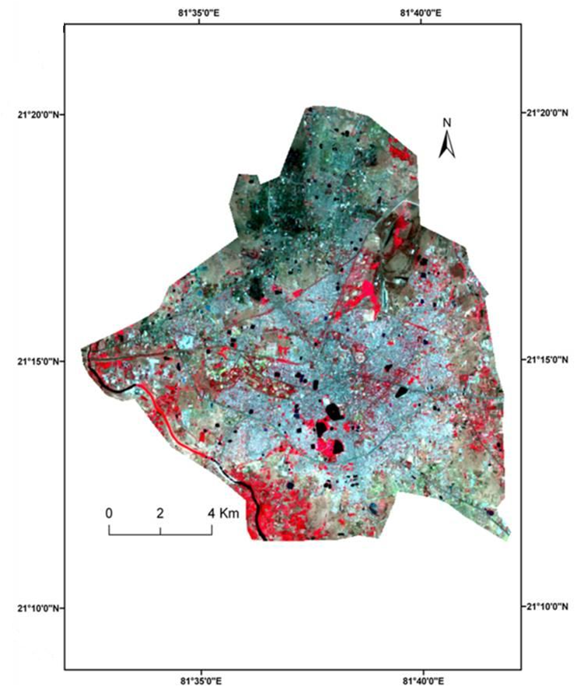
- Location of the study area
Landsat sensors are one of the popular remote sensed data used in deriving LST and NDVI. It records reflected or emitted energy from Earth surface features in different wavelengths of electromagnetic spectrum (EMS). The EMS forms of radiated energy from Gamma rays to Radio waves. Landsat data records blue, green, red, near-infrared, mid-infrared, and thermal infrared wavelength regions digitally and this information are captured, processed, and stored in a data archive. Table 1 presents the spectral information of Landsat data.
Table 1. Band specification of Landsat 5 TM and Landsat 8 OLI & TIRS data
Landsat 5 TM | Landsat 8 OLI & TIRS | Landsat 5 TM | Landsat 8 OLI & TIRS
Bands | Wavelength (µm) | Bands | Wavelength (µm)
Band1-Blue (30m) | 0.45-0.52 | Band1-Ultra Blue (30m) | 0.435-0.451
Band2-Green (30m) | 0.52-0.60 | Band2-Blue (30m) | 0.452-0.512
Band3-Red (30m) | 0.63-0.69 | Band3-Green (30m) | 0.533-0.590
Band4-NIR (30m) | 0.76-0.90 | Band4-Red (30m) | 0.636-0.673
Band5-SWIR1 (30m) | 1.55-1.75 | Band5-NIR (30m) | 0.851-0.879
Band6-TIR (120m) | 10.40-12.50 | Band6-SWIR1 (30m) | 1.566-1.651
Band7-SWIR2 (30m) | 2.08-2.35 | Band7-SWIR2 (30m) | 2.107-2.294
 |  | Band8-Pan (15m) | 0.503-0.676
 |  | Band9-Cirrus (30m) | 1.363-1.384
 |  | Band10-TIR1 (100m) | 10.60-11.19
 |  | Band11-TIR2 (100m) | 11.50-12.51
Cloud-free Landsat 5 data of 16 January 1998, 14 January 2009, and Landsat 8 data of 23 January 2018 (Table 2) were used for the entire study. United States Geological Survey (USGS) provides the Landsat datasets freely downloadable. Winter images were selected to reduce the impact of humidity in the image. The entire study can also be performed in monsoon, pre-monsoon, and post-monsoon seasons to validate the research outcome. Urban vegetation of the study area was significantly determined using supervised classification and suitable NDVI threshold values.
Table 2. Specification of used Landsat datasets
Multidate Landsat data | Sun Elevation (º) | Sun Azimuth (º) | Cloud Cover (%) | Earth-Sun Distance (AU) | Time
Landsat5 (16.01.1998) | 37.06 | 141.49 | 0.00 | 0.98 | 14:31:37
Landsat5 (14.01.2009) | 38.25 | 144.11 | 0.00 | 0.98 | 14:41:09
Landsat8 (23.01.2018) | 41.35 | 145.81 | 0.14 | 0.98 | 14:56:05
AU= Astronomical Unit
- LST retrieval process
The LST was estimated from the thermal infrared (TIR) bands of Landsat data (band 6 in Landsat 5 and band 10 of Landsat 8) of Raipur city from the algorithms which are given below (Artis & Carnahan, 1982):
Where, = the effective wavelength; = Boltzmann constant (1.38x10-23 J/K); = Plank’s constant (6.626x10-34 Js); = the velocity of light in a vacuum (2.998x10-8 m/sec); = emissivity.
Where, = the brightness temperature (K); and = calibration constants. = 607.76, = 1260.56 (for Landsat 5 TM); = 774.89 and = 1321.08 (for Landsat 8 OLI & TIRS); = the spectral radiance (Wm-2sr-1mm-1).
- Results and analysis
- Spatial distribution of NDVI and LST
The spatial distribution maps of NDVI and LST were shown in different time periods (Fig. 2-4). Fig. 2 represented the NDVI and LST values for 1998 satellite image. LST values ranged between 17.68ºC and 9.20ºC (Table 3). North-west and south-east parts of the study area indicated high LST values where NDVI values were lesser. Fig. 3 showed The NDVI and LST values for 2009 image. The maximum and minimum LST values were 23.01ºC and 11.14ºC. LST and NDVI values of 2018 image were represented by Fig. 4. It was clear from the figures that high LST values were found in those places where NDVI values are lesser.
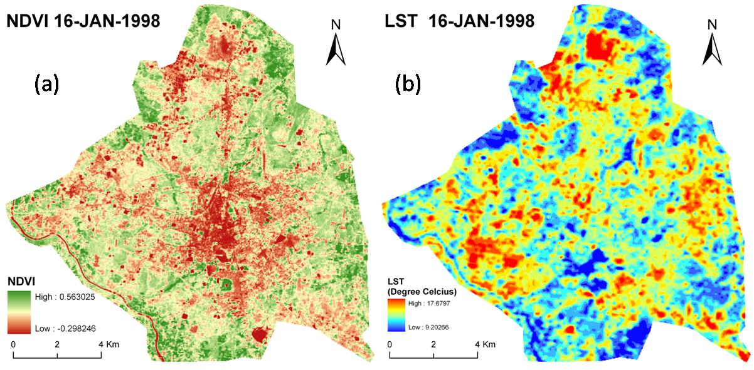
- (a) NDVI and (b) LST Map for 16-JAN-1998
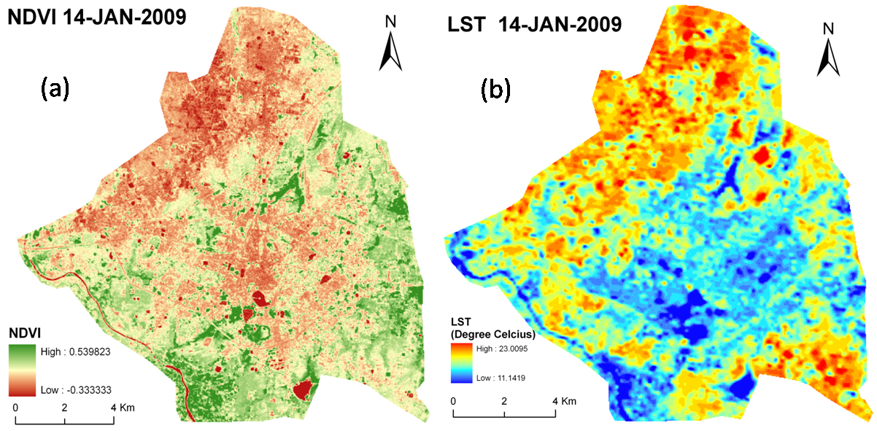
- (a) NDVI and (b) LST Map for 14-JAN-2009
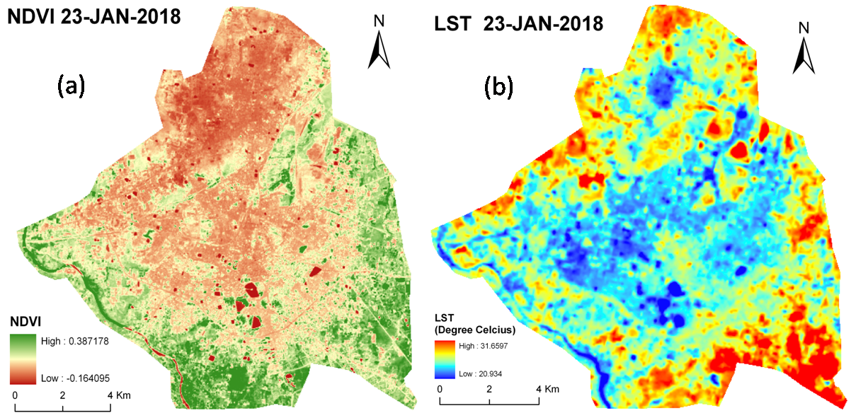
- (a) NDVI and (b) LST Map for 23-JAN-2018
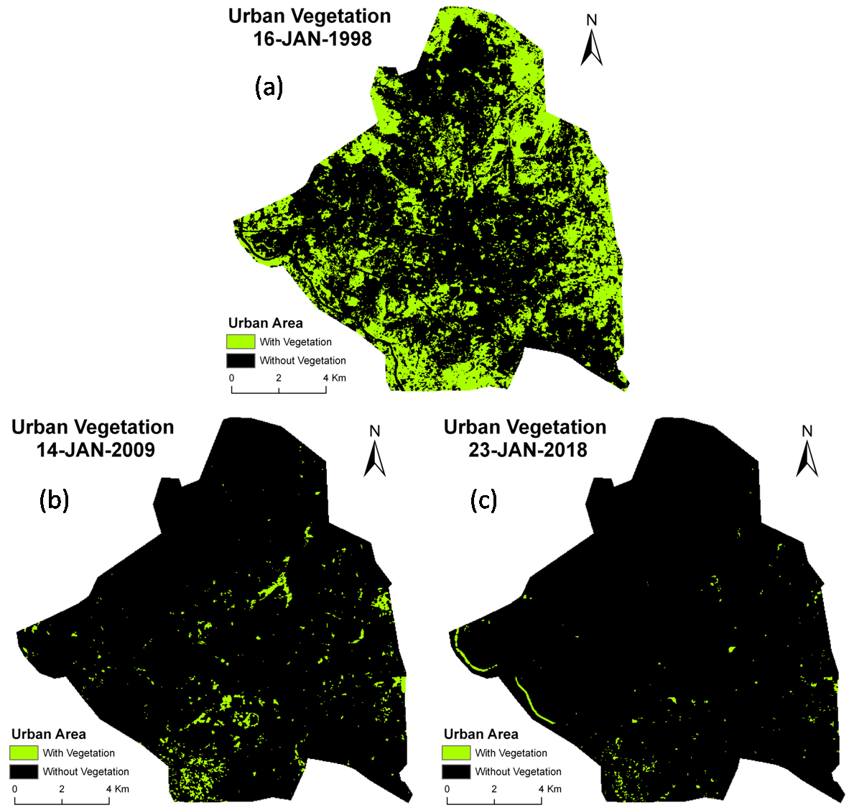
- Urban Vegetation Map of Raipur City: (a) 16-JAN-1998; (b) 14-JAN-2009; (c) 23-JAN-2018
Special focus of the study was given on the continuous monitoring of urban vegetation. These urban vegetation zones remain cool and favourable for human settlement. TABLE IV revealed and compared the LST values for whole of Raipur city and for the area with urban vegetation within the Raipur city. The urban vegetation zones were reduced with time (Fig. 5). This land conversion was taken placed mainly due to excessive pressure of urbanization.
Date | LST  (Min) |  | LST  (Max) |  | LST  (Mean) |  | LST  (Standard deviation)
Date | W.C. | U.V. | W.C. | U.V. | W.C. | U.V. | W.C. | U.V.
16-JAN-1998 | 9.20 | 10.18 | 17.68 | 16.31 | 13.65 | 13.31 | 1.01 | 0.92
14-JAN-2009 | 11.14 | 12.10 | 23.01 | 19.03 | 17.15 | 15.00 | 1.64 | 1.11
23-JAN-2018 | 20.93 | 21.48 | 31.66 | 27.49 | 25.26 | 24.23 | 1.36 | 0.99
Table 3. Varation of LST (ºC) for the whole city (W.C.) and for the area with urban vegetation (U.V.)

LST-NDVI relationship
Generally, LST builds a negative regression with NDVI. TABLE III showed the correlation coefficient of LST with NDVI for the whole of Raipur city and for the area with urban vegetation. The LST-NDVI regressions were weak negative for the whole Raipur city. In the area with urban vegetation, these regressions became stronger (Table 4). The changing pattern of the LST-NDVI relationships was mainly produced because of the complex nature of landscape.
Table 4. Correlation coefficient values of LST-NDVI
Date | Whole Raipur city | Area with urban vegetation
16-JAN-1998 | -0.23209 | -0.41405
14-JAN-2009 | -0.25628 | -0.40606
23-JAN-2018 | -0.25468 | -0.41022
- Conclusion
In the present study, Landsat satellite sensors were used for determining the impact of urban vegetation in generating LST in Raipur city, India and to interpret the temporal variation of LST-NDVI relationship. The LST-NDVI relationships remained negative for all the three winter images of different dates. This negative relationship became stronger within the area of urban vegetation.
Some research works can be incorporated in the later studies. Seasonal correlation between NDVI-LST can be analyzed to get more reliability in LST estimation. In addition to that, any new mathematical model can also be applied to notice the LST-NDVI relationship.
Acknowledgement
Authors are thankful to United States Geological Survey (USGS).
References
- Bendib A, Dridi H, Kalla MI (2017) Contribution of Landsat 8 data for the estimation of land surface temperature in Batna city, Eastern Algeria. Geocarto Int, 32(5): 503-513. http://dx.doi.org/10.1080/10106049.2016.1156167.
- Guha S, Govil H (2019) Evaluation of ASTER TIR data-based lithological indices in Malanjkhand Copper Mines of Madhya Pradesh, India. Appl Earth Sci 129(1): 3-8. https://doi.org/10.1080/25726838.2019.1684018
- Weng Q (2001) A remote sensing-GIS evaluation of urban expansion and its impact on surface temperature in Zhujiang Delta, China. Int J Remote Sens, 22 (10): 1999–2014.
- Govil H, Guha S, Diwan P, Gill N, Dey A (2020) Evaluation of ASTER TIR Data-Based Lithological Indices in Parts of Madhya Pradesh and Chhattisgarh State, India. In: Sharma N., Chakrabarti A., Balas V. (eds) Data Management, Analytics and Innovation. Advances in Intelligent Systems and Computing, vol 1042. Springer, Singapore, pp. 161-169. https://doi.org/10.1007/978-981-32-9949-8_12
- Guha S, Govil H, Tripathi M, Besoya M (2018) Identification of rocks and their quartz content in Amarkantak, India using ASTER TIR data. The International Archives of the Photogrammetry, Remote Sensing and Spatial Information Sciences, Volume XLII-5, 2018 ISPRS TC V Mid-term Symposium “Geospatial Technology – Pixel to People”, 20–23 November 2018, Dehradun, India. https://doi.org/10.5194/isprs-archives-XLII-5-255-2018.
- Guha S, Govil H, Tripathi M, Besoya M (2018) Evaluating Crosta technique for alteration mineral mapping in Malanjkhand copper mines, India. The International Archives of the Photogrammetry, Remote Sensing and Spatial Information Sciences, Volume XLII-5, 2018 ISPRS TC V Mid-term Symposium “Geospatial Technology – Pixel to People”, 20–23 November 2018, Dehradun, India. https://doi.org/10.5194/isprs-archives-XLII-5-251-2018.
- Guha S, Govil H, Gill N, Dey A (2020) Analysing the Capability of NCI Technique in Change Detection Using High-and Medium-Resolution Multispectral Data. Geoecology of Landscape Dynamics, Springer, Singapore, 133-147. https://doi.org/10.1007/978-981-15-2097-6_10
- Weng Q, Yang S (2004) Managing the adverse thermal effects of urban development in a densely populated Chinese city. J Environ Manage, 70 (2): 145–156.
- Chen XC, Zhao HM, Li PX, Yin ZY (2006) Remote sensing image-based analysis of the relationship between urban heat island and land use/cover changes. Remote Sens Environ, 104 (2): 133–146.
- Chen Y, Wang J, Li X (2002) A study on urban thermal ﬁeld in summer based on satellite remote sensing. Remote Sens Land Manage Plann,4: 55–59.
- Zhang Z, He G, Wang M, Long T, Wang G, Zhang X, Jiao W (2016) Towards an operational method for land surface temperature retrieval from Landsat 8 data. Remote Sens Lett, 7 (3): 279–288. http://dx.doi.org/10.1080/2150704X.2015.1130877.
- Qin Z, Karnieli A, Berliner P (2001) A mono-window algorithm for retrieving land surface temperature from Landsat TM data and its application to the Israel–Egypt border region. Int J Remote Sens, 22 (18): 3719–3746.
- Munoz JC, Cristóba J, Sobrino JA, Soria G, Ninyerola M, Pons X (2009) Revision of the single-channel algorithm for land surface temperature retrieval from Landsat thermal-infrared data. Photogram Eng Remote Sens, 47 (1): 339–349.
- Munoz JC, Sobrino JA (2003) A generalized single channel method for retrieving land surface temperature from remote sensing data. J Geophys Res, 108. http://dx.doi.org/10. 1029/2003JD003480.
- Tucker CJ (1979) Red and photographic infrared linear combinations for monitoring vegetation. Remote Sens Environ, 8: 127– 150.
- Govil H, Guha S, Dey A, Gill N (2019) Seasonal evaluation of downscaled land surface temperature: A case study in a humid tropical city. Heliyon 5(6): e01923. https://doi.org/ 10.1016/j.heliyon.2019.e01923
- Govil H, Guha S, Diwan P, Gill N, Dey A (2020) Analyzing Linear Relationships of LST with NDVI and MNDISI Using Various Resolution Levels of Landsat 8 OLI/TIRS Data. In: Sharma N., Chakrabarti A., Balas V. (eds) Data Management, Analytics and Innovation. Advances in Intelligent Systems and Computing, vol 1042. Springer, Singapore, pp. 171-184. https://doi.org/10.1007/978-981-32-9949-8_13
- Guha S (2016) Capability of NDVI technique in detecting mangrove vegetation. Int J Adv Biol Res 6(2): 253-258.
- Guha S, Govil H (2020) An assessment on the relationship between land surface temperature and normalized difference vegetation index. Environ Dev Sustain https://doi.org/10.1007/s10668-020-00657-6
- Guha S, Govil H, Dey A, Gill N (2018) Analytical study of land surface temperature with NDVI and NDBI using Landsat 8 OLI/TIRS data in Florence and Naples city, Italy. Eur J Remote Sens 51(1): 667-678. https://doi:10.1080/22797254.2018.1474494
- Guha S, Govil H, Dey A, Gill N (2020) A case study on the relationship between land surface temperature and land surface indices in Raipur City, India. Geogr Tidsskr https://doi.org/10.1080/00167223.2020.1752272
- Guha S, Govil H, Diwan P (2019) Analytical study of seasonal variability in land surface temperature with normalized difference vegetation index, normalized difference water index, normalized difference built-up index, and normalized multiband drought index. J Appl Remote Sens 13(2): 024518. https://doi.org/1010.1117/1.JRS.13.024518
- Deilami K, Kamruzzaman M (2017) Modelling the urban heat island effect of smart growth policy scenarios in Brisbane. Land Use Policy, 64: 38–55.
- Ma Q, Wu J, He C (2016) A hierarchical analysis of the relationship between urban impervious surfaces and land surface temperatures: spatial scale dependence, temporal variations, and bioclimatic modulation. Landsc Ecol, 31: 1139–1153. http://dx.doi.org/10.1007/s10980-016-0356-z.
- Guha S, Govil H, Diwan P (2020) Monitoring LST-NDVI Relationship Using Premonsoon Landsat Datasets. Adv Meteorol 2020: 4539684. https://doi.org/10.1155/2020/4539684
- Guha S, Govil H (2020) Land surface temperature and normalized difference vegetation index relationship: a seasonal study on a tropical city. SN Applied Sciences. 2: 1661(2020). https://doi.org/10.1007/s42452-020-03458-8
- Guha S, Govil H (2020) Seasonal impact on the relationship between land surface temperature and normalized difference vegetation index in an urban landscape. Geocarto Int. https://doi.org/ 10.1080/10106049.2020.1815867
- Tran DX, Pla F, Carmona PL, Myint SW, Caetano M, Kieua PV (2017) Characterizing the relationship between land use land cover change and land surface temperature. ISPRS J Photogram Remote Sens, 124: 119–132. http://dx.doi.org/10.1016/j.isprsjprs.2017.01.001.
- Guha S, Govil H, Gill N, Dey A (2020) Analytical study on the relationship between land surface temperature and land use/land cover indices. Ann GIS 26(2): 201-216. https://doi.org/10.1080/19475683.2020.1754291
- Guha S, Govil H, Mukherjee S (2017) Dynamic analysis and ecological evaluation of urban heat islands in Raipur city, India. J Appl Remote Sens 11(3): 036020. https://doi:10.1117/1.JRS.11.036020
- Guha S, Govil H, Besoya M (2020) An investigation on seasonal variability between LST and NDWI in an urban environment using Landsat satellite data. Geomat Nat Haz Risk 11(1): 1319-1345. https://doi.org/10.1080/19475705.2020.1789762
- Guha S, Govil H, Gill N, Dey A (2020) A long-term seasonal analysis on the relationship between LST and NDBI using Landsat data. Quatern Int. https://doi.org/10.1016/j.quaint.2020.06.041
- Artis DA, Carnahan WH (1982) Survey of emissivity variability in thermography of urban areas. Remote Sens Environ, 12(4): 313–329.

