DELINEATIONS OF THE MALAY PUBLIC REALM IN THE HISTORICAL KUALA KANGSAR

Illyani Ibrahim (1), Puteri Shireen Jahn Kassim (2), Alias Abdullah (1)

¹ Department of Urban and Regional Planning, Kulliyyah of Architecture and Environmental Design, International Islamic University Malaysia, Gombak, Selangor, Malaysia
Email: illyani_i@iium.edu.my, alias@iium.edu.my
¹ Department of Applied Arts and Design, Kulliyyah of Architecture and Environmental Design, International Islamic University Malaysia, Gombak, Selangor, Malaysia
Email: puterishr@iium.edu.my

KEYWORDS: distance, GIS, historical, walkability, Perak Sultanate

ABSTRACT: Perak Sultanate is the response to the fall of the Melaka Malay Sultanate. The beauty of Perak Sultanate with the others is that they have different capitals based on the ruling Sultanate's request. This research aims to compare the urban between the pre-colonial, post-colonial, and after mobilisation of the Sultanate of Perak's royal town. The objective of this paper is to analyse the Malay public realm in the pre-colonial, post-colonial and after mobilisation in the particular royal town. The method uses interviews from the inhabitants in the study areas and content analysis from text documentation for Geographical Information System (GIS) mapping. The analysis will be divided into the three phases of Perak royal architecture; i) pre-colonial; early Perak Sultanate, from 1550 to 1800; ii) post-colonial, after the appointment of British Residence, 1874 to 1929; iii) after mobilisation, 1930 and above. The main findings show that there are changes of palaces in a different timeline as time goes by. The pre-colonial also shows the close intimacy of the public realm in the Kuala Kangsar area; the distance is no longer an important element in royal town as the mobilisation era took an important role.

HISTORICAL BACKGROUND

Perak has been faced through ups and downs from the political context. Achiness, Dutch and British have been involved in Perak, especially in the tin monopoly. Acheh has conquered Perak in the late 1570s and for the next hundred years. As Acheh continued to harass Perak, Sultan Mansur Shah was disappeared during Friday prayers at Masjid Kota Lama Kanan. Soon after that, his family was captive to Acheh. As there is no Sultan left, the pembesar requested the Sultan of Perak from the ruler of Acheh, and he sent the younger son of Sultan Mansur Shah I to become Perak's third Sultanate, Sultan Ahmad Tajuddin Shah. In 1740, there is internal dissension between two rulers of Perak, Raja Muhammad, and Sultan Muzaffar. Sultan Muhammad controlled Lower Perak up to Pachat while Sultan Muzaffar ruling from Kuala Kangsar over Upper Perak. The attack of Bugis in 1745 recognised Raja Muhammad as the Sultan. In the case of Perak, the Bugis interfered with the political system ranked below the Raja Muda. Fig. 1 shows the Perak dynasty.
The arrival of Dutch in Perak started in 1641, and they attempted to control the tin trade in the 17th century. The Dutch tried to monopolise the tin-ore trading in Perak by using several Sultanate's influences but failed. In 1651, the people of Perak destroyed the Dutch plant, and the Dutch tried to renew the agreement and seek compensation for the loss of their plant. However, the Perak government launched a surprising attack on the Dutch. In 1670, Kota Belanda was built on Pangkor Island, and they tried to agree and negotiate for another treaty and failed again.
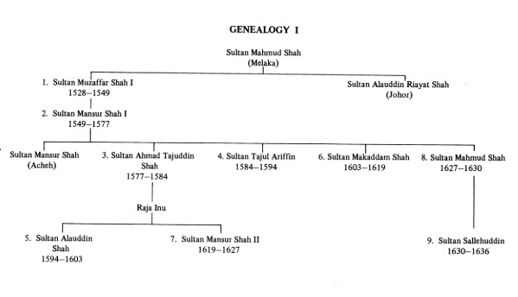
Figure 1: Perak dynasty (Kim, 2015)

In 1818, Siam asked Kedah to invade Perak. In the mid-1820s, Britain, Dutch and Siam established a treaty of influence in South-East Asia. Thus in 1926, the British started to protect Perak in 1826 due to a lack of security. One of the problems in controlling the mines, as the Chinese immigrants, had formed a rival clan group allied with Malay chides and local gangsters. A continuous fight between local gangster groups Gee Hin and Hai San around Kelian Puah and Kelian Baharu and continued to the other states. Several wars occurred from 1861 to 1862 and 1871 to 1974.
Another one is the power struggle in the Perak royal court. Sultan Ali died in 1871, and the next line should be Raja Abdullah. However, he is not present during the burial of the Sultan; thus, Raja Ismail becomes the next Sultan of Perak. Raja Abdullah was not happy with the decision and asked help from the British to become his proxies. Thus, the Pangkor Treaty was signed between the British and the Sultan of Perak. One of the conditions was that the Sultan should accept a British Resident with administrative powers. Thus, Sultan Abdullah becomes a Perak Sultanate with the help of the British. This shows that the British succeeded in the mine's monopoly and indirectly had dropped the Malay Sultanate's power that only focuses as the head of Islam and the Malay customs only. The decision of administration and economy are totally given to the Resident.

- PUBLIC REALM IN URBAN DESIGN

Understanding the public realm in urban design from public streets, market places, social walkways, and meeting places. There are two types of studies related to this research, called as pre-industrial and post-colonial. The pre-colonial is an Un-self-conscious approach created by people who do not think as designers, but the urbanism has affected the urban environment. This type of design is based upon the intuition that is not clearly stated. The city is structured based on the cultures and their way of life. The layout was mainly based on ritual and cosmological symbols referred to as religious, civic landmarks, and beliefs. The post-colonial were more complex and dynamic, and it is responded to ecological choice, land ownership structures, and growth of road and urban infrastructure.

This analysis will be divided into the three phases of Perak royal architecture; i) pre-colonial; early Perak Sultanate, from 1550 to 1850; ii) post-colonial, after the appointment of British Residence, 1874 to 1929; iii) after mobilisation, 1930 and above. The pre-colonial era, focusing on the early timber and timber craftsmanship, that includes Istana Sri Sayong, or Istana Lembah. In the post-colonial phase, selected after the Pangkor Treaty 1874, we choose a timeline between 1874 and 1929. The last one is after mobilisation, the 1930s, and the above—method used for this study using pictorial, content analysis, and interviews. Fig. 2 shows the relocation of the capital of Kuala Kangsar from the 1500s to the 1900s.

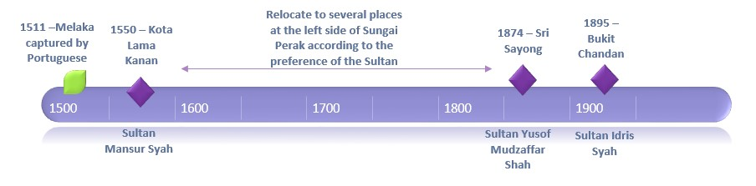
Figure 2: The relocation of the capital of Kuala Kangsar

- STUDY AREA

After Melaka's ruptured in 1511, Sultan Mahmud Syah I had run away to Kampar, Sumatera. His prince, Sultan Alauddin Riayat Shah II established the Sultanate of Johor, while Sultan Muzaffar Syah was invited to rule Perak, and he was the first sultan of Perak. He died in 1549 and was buried in Tanah Abang, the same place he arrived from Klang approximately 21 years ago. The second Perak Sultanate is Raja Mansor (1549 – 1577) had made Kota Lama Kanan near to Kuala Kangsar as the place of his capital. However, Acheh had attacked Perak in 1573, and Sultan Mansor and his family were arrested and brought to Acheh. The rest of the Sultan had found other places for his city centre.
The 27th Perak Sultanate, Sultan Yusof Mudzaffar Shah established his capital further upstream, at Sayong, not far from Kuala Kangsar. At the end of the 20th century, Sultan Idris moved the palace from Sayong to Bukit Chandan on the west bank of the Perak River due to the palace's location in Sayong are close to the river, and it was used to flood many times. The relocation of the new capital has followed the advice of Orang Suci, who existed as a long-bearded man and white robe.
The study area is selected in the royal town of Perak Sultanate. The location of the Perak Sultanate is different according to the preference of the Sultan. Thus, the researcher selected these three study areas in Kota Lama Kanan, Sayong, and Bukit Chandan, actually not far from each other. Sultan Mansor Shah, the 2nd Perak Sultanate, established his capital in Kota Lama Kanan. Sultan Yusof Mudzaffar Shah is the 27th Perak Sultanate, established his capital at Sayong. At the end of the 20th century, Sultan Idris moved the palace from Sayong to Bukit Chandan on the Perak River's west bank. Fig. 3 shows the map of the study areas in three different places; Kg Kota Lama Kanan, Sayong, and Bukit Chandan.

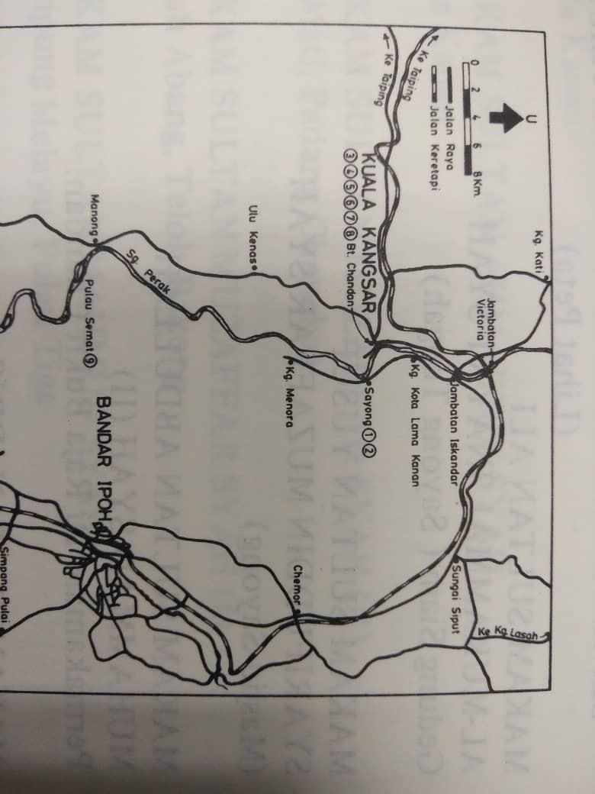
Figure 3: The study area in Kg Kota Lama Kanan, Sayong and Bukit Chandan
(Source: Halim, 1981).

- METHODOLOGY

The pre-colonial study was done based on the local communities' interviews and content analysis from documented materials. The most reliable evidence for the Historical of Perak consists of local and a few travellers' accounts. Content analysis was done by analysing the settlement form of the study area back in the 1800s. In this case, pre-colonial sources, several interviews were conducted with the locals. For the post-colonial study, several references were used as the main sources, such as McNair in 1878, Isabella Bird in 1884, who travelled to Malay Peninsular in 1884, and Swettenham in 1893. Fieldwork was also conducted in Kota Lama Kanan, Sayong and Bukit Chandan, Kuala Kangsar, and Perak. The researchers have mapped all of the historical features that existed in Kota Lama, Sayong, and Bukit Chandan. The similarity and differences between both analyses will be described in the analysis section. Figure 4 shows the methodology of this research.

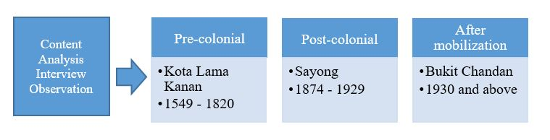
Figure 4: The methodology adopted for this research

- THE ROYAL TOWN OF KUALA KANGSAR

This study focuses on three (3) different timeline, which is, according to pre-colonial, post-colonial, and after mobilisation. The pre-colonial is to understand the urban design of the royal town before the colonial period, from 1549 to 1820. The post-colonial period is when the coming of colonial 1847 to 1929, while the last one is after mobilisation, the 1930s and above.

  - Pre-colonial of Perak (1549 to 1594) – Kota Lama Kanan

Kota Lama Kanan is located at the upper stream of the Sungai Perak. It was reigned by Sultan Mansur Shah (1549 – 1577), the 2nd Perak Sultanate, the son of Sultan Muzaffar Shah from Melaka in 1511, after the arrival of Portuguese to Melaka. Sultan Mansur Shah was appointed as the second Sultan of Perak. He established his capital at further upstream at Kota Lama Kanan, about 1.5 km from Kuala Kangsar. Previously, the name of the place of Kota Lama Kanan was called Kampung Kandang. As he was the grandson of Sultan Mahmud Syah, he could be steeped in the old Melaka traditions, including his capital arrangement. Understand the characteristic of the royal town of Kota Lama Kanan will also indirectly define Melaka's character.
The name was changed to Kota Lama Kanan as Sultan Mansur Shah left it. A story claimed that Sultan Mansur Shah was gone without a trace during Friday prayer. However, the sultan was defeated by the Achehnese army, and the Sultan and his family were captured and taken to Acheh, where he eventually died. According to local reports, it was believed that an old fort was still existed to protect a palace belonging to Sultan Mansur Shah 1, which was built inside the walls, and it was built to defend his highness and his subjects against the Achehnese army(Aziz & Abdullah, 2011).

  - Post-colonial of Perak (1874 to 1929) - Sayong

The Sayong palace is located at the riverside of Sungai Perak, directly opposite the sand shelf in Sungai Perak. During this time, Istana Sri Sayong was the one built by Sultan Yusof Shah. They prefer to protect the royal paces by selecting areas that they able to detect the enemy from afar; thus, this is the reason they place the palace just next to the river.

…The Malay village is located at the riverside with the river flowing, with the palms and other fruit trees is exceeding picturesque. The houses are placed here and there according to the taste and convenience of the owner. There are so many houses that a double row occupies the riverbank, a line of communication exists between them that does not deserve the title of road, for the Malay never thinks of constructing anything of this kind, but leaves to Dame Nature. In this case, the houses are built, and as the people walk to and from the path comes of itself."
(McNair, 1878)

Malay built their villages near to the river. Each village consists of houses clustered under the fruit trees. Each kampong will have approximately 44 houses. The Malay houses were a wooden building, and the floor was raised high above the ground. The house was on wooden piles, and the kitchen and piles separated from the main building were connected with it by a platform. The dwelling stood a few feet back from the river, and, as its owner was a man of means, the structure was of some size, the floor and walls of stout planks and a strong palisade enclosed the surrounding yard (Swettenham, 1895). Four main races in Kuala Kangsar, Chinese and Keling, and Malay fisherman. The houses are built for the most part on piles; at high water, the sea washes under them, and the means of intercommunication are wooden staging from house to house (Swettenham, 1895). Each village had several mosques. In each village, they have a properly constituted mosque for them to pray and gathered. The mosque is all conical buildings of wood and attap raised on wooden pillars, and to visit masjid, there is a small road, using foot, from the kampongs (Bird, 1884). The masjid was located close to the river. It is placed near the river due to convenience; their main transportation is the river, and the ablution is performed in the river. Fig. 5 shows the general view of the Malay village at the river bank.

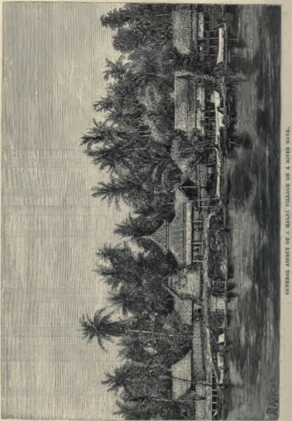
Figure 5: Malay village on a riverbank (Bird, 1884)

The market was at the town in Kuala Kangsar. The market was located along the road. Trading in Kuala Kangsar was mostly done by the Chinese, with a few Klings among them, and they have a row of shops (Bird, 1884). Fig. 6 shows the general view of the Malay village at the river bank.

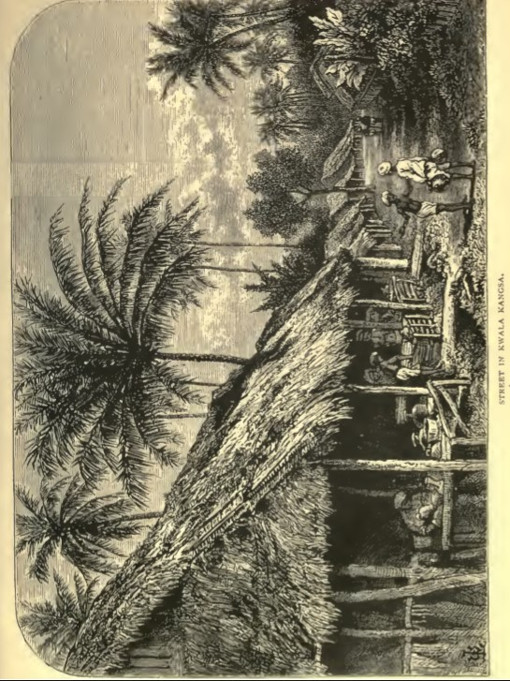
Figure 6: Streets of markets in Kuala Kangsar (Bird, 1884).

  - After mobilisation (1930 and above) – Istana Iskandariah

As the palace of Sri Sayong was usually flooded, then a palace was built on the hill close to the Batang Hari, then it called Bukit Chandan. Previously, Istana Negara was built in 1895, but Istana Iskandariah replaced it in the same location in 1933. Besides, Istana Lembah was built in 1926 as a temporary residence because Istana Iskandariah was still under construction to replace the Istana Negara.
The settlements had emerged along the river in Kuala Kangsar. After mobilisation, the road segments are actively built due to the actively tin mining. Thus, the settlement started to build along the roads at both Sayong and Bukit Chandan areas. As the modernisation has arrived, many buildings were built, especially in commercial areas. The characteristic of royal town in Bukit Chandan are found, particularly at the entrance of Kuala Kangsar.

- PUBLIC REALM CHARACTERISTIC OF TRADITIONAL ROYAL TOWN

This analysis focuses on several places such as Kampung Kota Lama Kanan, Kampung Sayong, and Bukit Chandan, and the similarities and differences between these eras are determined. This analysis will depict the public realm characteristics of the pure royal town.

  - Kampung Kota Kanan Lama

During the reign of Sultan Mansur Syah, the royal town was located at Kampung Kandang. Sultan Mansur Shah suddenly disappeared during Friday prayer. After his missing, the town was called Kota Lama Kanan. These buildings are closed to the river located at the back of the mosque (masjid) entrance. The palace, surrounded with the kota tanah yang bersilang and covered with a tapered bamboo has been left uninhabited.


Figure 7: The map of Kota Kanan Lama during pre-colonial

The pre-colonial map (Fig. 7) shows that the location of Masjid Kota Lama Kanan, open spaces, and the palace of Sultan Mansur Syah. The palace was closed to the mosque at 20 meters below the walkability distance, less than 400 meters. The 20 meters distance is much closed; thus, this showing the closeness of the Islamic religion with the Sultanate. The masjid
was located close to the river. It is placed nearby the river due to convenience; their main transportation is the river, and the ablution is performed in the river. The market was located in front of the masjid, and next to the padang. This shows that masjid was a center of public activities, as surrounded by the market and Padang. This study can be said that the urban pattern and architecture of Kuala Kangsar is a legacy from the Melaka urban area during the Glory day. However, in 1594, the capital was changed to Bota Kanan, Parit, according to the respective Sultan's preferences during that particular period.
The current masjid is the new one built in 1916, and it was built on the site of the old masjid since 1578. The old masjid was burned down by the British during the Perak War from 1875 to 1876. The makam was located in front of the Mosque. The historical evidence existed since Kota Lama Kanan were the palace, masjid, and the makam.

  - Sayong

Sri Sayong, is the name of the palace located in Sayong. This area is selected to present the post-colonial analysis (1874 – 1929), whereby Sayong was a capital since 1887 during the reign of Sultan Sharifuddin Muzaffar Shah until Sultan Idris Mursyidul Adzam Shah, who responsible of relocating the palace from Sayong to Bukit Chandan due to the areas were frequently flood due to the lowland factor. The mapping of Sayong is defined from the content analysis done by the three travelers who wrote on their experience in meeting Sultan Idris and Sultan Abdullah in Kuala Kangsar. There is the market and mosque information in the reviews, but no location has been stated in the explanation. The houses are located close to the river. The reviews show that each village can have 40 houses, and most of them are located beside the river. Houses also surround the mosque. In terms of setting and configuration, the palace would be surrounded by the Sayong village and the floating market where the island is located opposite the palace.
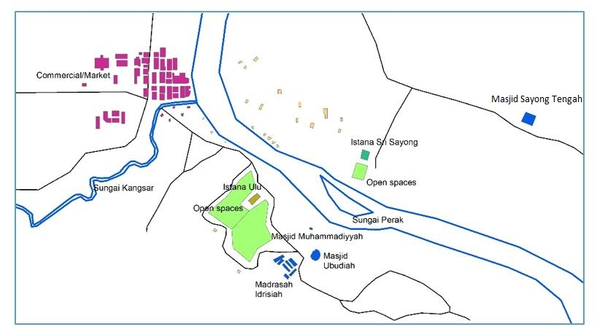
Figure 8: The map of Kuala Kangsar during the post-colonial era

The post-colonial map (Fig. 8) includes the relocation process from Sayong to Bukit Chandan. The interview was conducted and has helped us to understand the social space during those days. During the reign of Sultan Yusuf in 1886, the residence is still at Istana Sri Sayong. The meeting was conducted at the padang of Istana Sri Sayong, opposite to the Perak River. The masjid is located at Masjid Sayong Tengah, 900 meter from the palace. The market is located at Kuala Kangsar town, 1.2 km from the palace. This information has concluded that the entire town even bigger than during the earlier time, which is during the reign of Sultan Mansur Shah.

During the reign of Sultan Idris Shah, he relocates Istana Sri Sayong to Istana Negara at 1895. Probably Masjid Muhamadiyyah used as worship purposes as it was there since 1888. Only after 1914, Masjid Ubudiah was built, and the distance of Istana Ulu to Masjid Ubudiah is 400 meters away, which is also at the walkability distance. Masjid Ubudiah was surrounded to open spaces or padang, as the areas to meeting with the people (rakyat). During those days, Sultan Idris Shah was frequently prepared a feast to have a gathering with the rakyat. According to many historical images, many transportation systems on the land are still using elephants.
Istana ulu - 1903

  - Bukit Chandan

Further analysis has focused on the timeline from the 1930s and above because the Malay Peninsular mobilisation has started.
The previous palace, called Istana Sri Sayong, was relocated to Bukit Chandan, and it took place in 1895. The palace was called Istana Negara. During these days, the meeting usually takes place at Masjid Ubudiah. The urban form shows a linear connection from the residential northeast of Istana Iskandariah towards Istana Ulu. The map shows that Masjid Ubudiah becomes a linkage between the royal palace and the settlements. Makam is an important element to the Masjid Ubudiah, and this makam has placed many Perak royal. The makam is located close to the mosque so that the burials can be performed immediately. The commercial areas (market) are located further away from these areas.
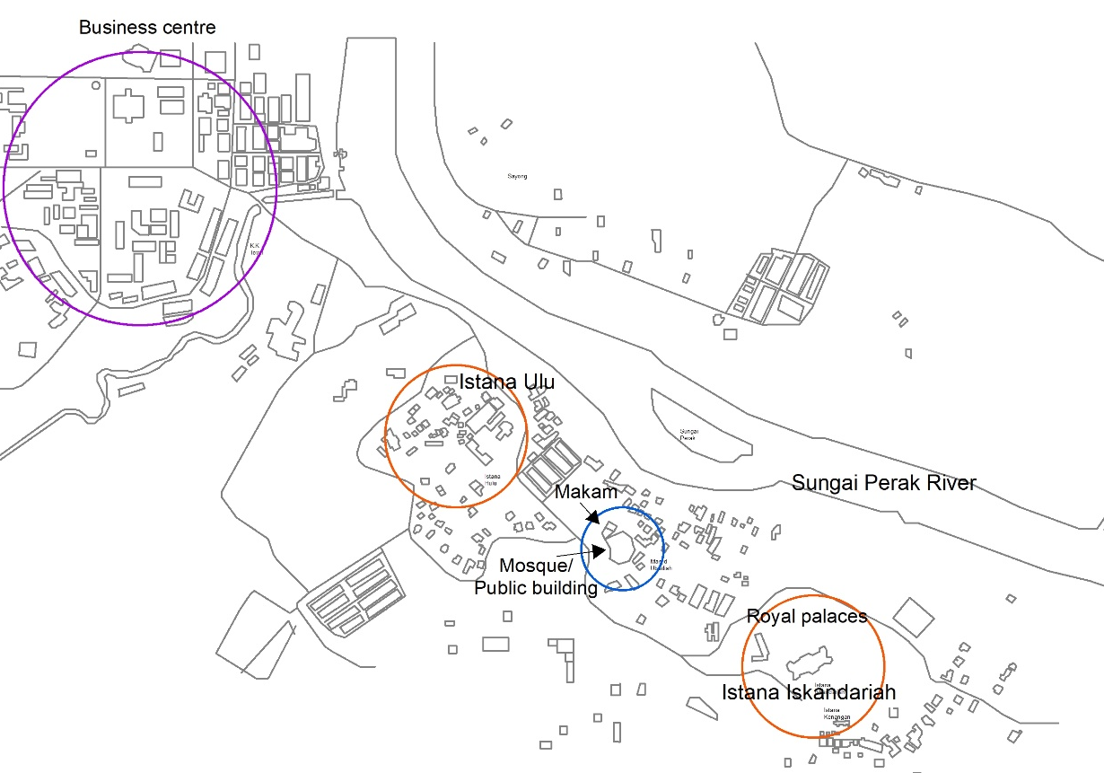
Figure 9: The map of Kuala Kangsar after mobilisation

Fig. 9 shows the map of Kuala Kangsar after mobilisation. The previous palace, Istana Ulu, was converted into a museum, and Istana Iskandariah was built on the hill of Bukit Chandan. Istana Iskandariah and Masjid Ubudiah is 500 meters, which is more than the walkability standard.

- RESULT AND FINDING

Table 1 below shows the distance between the palace and the mosque, padang, settlement and market. The palace is also located close to the masjid, showing the importance of Islam by the royal. During the past, the royal used to walk to places by foot; thus, this is why the mosque is close to the river. This study suggested that there is evidence of mosques built in Perak, and it was built using timber and traditional structure during the pre-colonial era.

Table 1 shows the palace and the distance to the mosque
From Palace | To mosque | To padang | To settlement | To market | Year
Kota Lama Kanan | 60 meter | 30 meter | 220 meter | 20 meter | 1549
Istana Sri Sayong | 600 meter | 30 meter | 500 meter | 1.2 km | 1887
Istana Iskandariah | 400 meter | 400 meter | 500 meter | 1.8 km | 1933

Kota Lama Kanan is one the example of the pre-colonial era. The mosque, padang, settlement, and market distance were 60, 30, 220, and 20 meters. This result shows that the Malay historical royal city does obey the 400-meter walkability distance in the urban design principle. The palace functioned as an administration and defence centre, and thus the mosque and padang were closed to the palace for a gathering of the rakyat. It can be concluded that the end of the urban form of Malay is the archetype form in Melaka, that we can find from Kota Lama Kanan. These features are located along the river, but the mosque is directly located near the river. The reason for placing mosque near the river is to monitor any invasion from the enemy, as during those days, Kota Lama Kanan was attacked by multiple enemy from Acheh and Siam. In fact, around the 1800s, during the British invasion, iron cannon can be seen in front of the mosque. Thus, it is also confirmed that Mosque was a defence centre during those days. Thus, Kota Lama Kanan is a Melaka model, but it has ruptured the Malay pure identity into the current pattern because of colonialism. This can be said that the urban pattern and architecture of the character of Kuala Kangsar is a legacy from Melaka urban area during the Glory day.

The post-colonial analysis (Sri Sayong) shows that the distances from palace to all physical features are more dispersed than the earlier one. For example, the location of Sri Sayong to the mosque was 10 times far from the earlier one in Kota Lama Kanan. The distance from palace to the settlement in Sri Sayong is also twice compared with Kota Lama Kanan, the same for the market, which was located farther up to Kuala Kangsar commercial area.

The further analysis, after mobilisation, which is after 1930. The palace location is at Istana Iskandariah, Bukit Chandan. The palace's distance to mosque is 400 meter and to padang (located around Masjid Ubudiah) is also 400 meter. According to the interview, the royal's place to meet the people is at Masjid Ubudiah. The distance from the palace to the settlement and market is 500 meter and 1.8 km, respectively. This analysis shows that after mobilisation, the location was more dispersed than previously. The 'intimacy' and 'walkability' are lesser due to the mobilisation era that has shortened the time.

- CONCLUSION

This study successfully analyses on the public realm in the pre-colonial, post-colonial, and after mobilisation. The pre-colonial shows there are intimacy of public realm in the Kuala Kangsar area. The distance is no longer an important element in royal town as the mobilisation era has shortened travel time.

Acknowledgement

Thank you for this research group for an extensive discussion regarding the subject of this paper. Thanks to the International Islamic University of Malaysia and the Ministry of Higher Education (MOHE) for the research grant "Trans-Disciplinary Research Grant Scheme (TRGS16-03-002-00002). Thank you also goes to the locals in Kuala Kangsar for their extensive historical information during the interview. The authors also would like to sincerely thank all referees for their suggestions to improve the manuscript.

References

Aziz, K. A., & Abdullah, F. Z. (2011). Cultural Heritage Tourism Development in Kota Lama Kanan, Kuala Kangsar, Perak. Universiti Tun Abdul Razak E-Journal, 7(2), 1–10.
Bird, I. L. (1884). The Golden Chersonese and the way Thither. New York G. P. Putnam’s Sons.
Halim, N. A. (1981). Tempat-tempat Bersejarah Perak. Jabatan Muzium, Kuala Lumpur.
Kim, K. K. (2015). Malaysian Branch of the Royal Asiatic Society, 59(1), 1–26.
McNair, M. F. (1878). Perak and the Malays. Charles Dickens and Evans, Crystal Palace Press.
Swettenham, F. A. (1893). About Perak. Singapore Straits Times Press.
Swettenham, F. A. (1895). Malay Sketches. Ballantyne Hanson & Co.

