MINIATURIZED RADAR DETECTION
TECHNOLOGY FOR SPACE TARGET BASED
ON MICROSATELLITE

Yuhua Guo(1)(2)*, Zhenghuan Xia(1)(2),Tao Zhang(1)(2), Zhilong Zhao(1)(2), Dunge Liu(1)(2),
Yao Zhang(1)(2), Huifeng Shi(1)(2),Fuzhan Yue(1)(2)

¹State Key Laboratory of Space-Ground Integrated Information Technology, Beijing, 100095,China
²Beijing Institute of Satellite Information Engineering, Beijing,100095, China
Email: yuhuaguo321@163.com X

KEY WORDS: Space Objective, Miniaturized Phased Array Radar, Target Search and Tracking, Microsatellite

ABSTRACT: In this paper, a miniaturized phased array radar technology based on the concomitant satellite is proposed. By comparing the performance of different band radars in searching and fine tracking of large-scale space targets, considering the factors of searching and tracking, system complexity and power consumption, finally C band is selected as the working band of radar. In this paper, the design of miniaturized phased array radar system, the signal processing method of target search and tracking, and the error analysis of ranging and angle measurement are described in detail. The simulation results show that the miniaturized phased array radar can search for 40º × 40º three-dimensional space targets in the range of 25km, achieve the ranging accuracy of 0.4m and the angle measurement accuracy of 0.03º, and meet the needs of large-scale search and tracking of space targets.

INTRODUCTION

  - Sheets for Papers and Typing

With the development of space technology, there are more and more space debris and invalid spacecraft, which threaten the space security of high-value satellites (Junkai Qi,2013, Jianfeng Y,etc.,2015a). Therefore, it is necessary to detect space targets. At present, the space target detection is basically two ways: Ground-based detection and space-based detection. Because most of the ground-based detection stations are located in China, the detection points and detection airspace are limited. It is impossible to detect space debris in all time, all airspace. However, space-based observation is not limited by airspace, which can realize the detection and tracking of space
targets in the whole airspace (Shaomin L.,2009).
Space-based space debris detection is a method to detect space debris by using the detection equipment on the space-based platform including satellites, spaceships and space stations, and the main detection equipment includes optical telescope, microwave radar and laser radar. Optical detection has certain requirements for light conditions. In addition, optical measurement can only measure angle, which will increase the difficulty of positioning due to the limitation of high-precision ranging. Because of its large size and high power consumption, the onboard radar is more suitable for carrying on large satellite platform. Laser radar has the characteristics of high positioning accuracy and strong anti-jamming, but the technology of space high-power laser signal generation and reception is not mature at present, and it is only used for the detection of close space targets in space-based detection(Jing Li,2016,Zizheng G.,2014,Chunbo L.,etc.,2012a). When space-based radar is used to detect space debris, special observation satellites can be used, or satellites, spaceships and space stations that are responsible for other tasks can be carried, or small satellite networks can be used to distribute multiple satellites in the whole orbit layer that is expected to be observed. At present, the main radars for space-based observation of space debris in the world are: the United States on board the international space station for surveillance orbit radar of channel debris. Microwave radar on the small satellite group of French Centre for space research. Millimeter-wave phased-array radar in Russia and space debris observation radar in Canada(Zeying T.,2015b,Yanbin L.,2012b). The research of space-based radar detection began in 2000 in China, and the idea of space multi-beam measurement radar was put forward. Although the research work of space-based radar detection has been several decades, due to the limitation of radar detection
ability, the on orbit measurement system needs to be further studied.
In this paper, a miniaturized phased array radar technology based on the concomitant satellite is proposed for the full-time detection and tracking of the surrounding space target of high value spacecraft. This paper presents the performance of different band radars in searching and tracking large-scale space targets. Considering the factors of searching and tracking, system complexity and power consumption, finally C band is selected as the working band of radar. The design of miniaturized phased array radar system, the signal processing method of target search and tracking,
and the error analysis of ranging and angle measurement are described in detail.

RADAR SYSTEM DESIGN

  - Selection and Analysis of Working Band

The phased array radar carried by the microsatellites needs to simultaneously meet the needs of a wide range of space target search and fine tracking and other tasks. According to the radar equation under the search mode, the search performance depends on the power aperture product of the radar. Figure 1 shows the SNR and RCS relationship curve with the power aperture product of 4Wm2, the search distance within 1.5s of 25km, and the spatial coverage of 40 ° × 40 °. The SNR of X, C and S band radars is almost the same. According to the radar equation under the target tracking mode, the tracking performance depends on the power aperture gain product of the radar. Figure 2 shows the relationship curve between the SNR and the RCS of tracking three targets at the same
Figure 1. Relationship curve between SNR and RCS in large-scale search mode
Figure 2. Relationship curve between SNR and RCS in target tracking mode

time and the target tracking frame rate of 10Hz. It can be seen that the X-band and C-band can meet
the tracking SNR requirements of targets with an RCS of more than 0.5m² (about 20dB).
For X-band and C-band phased array antennas with the same aperture, the number of X-band antenna elements is more than that of C-band phased array antenna. In order to meet the same flexible beam scanning ability in spatial search, X-band phased array radar has more TR components and more complex structure, while C-band phased array radar has less TR components and lower loss, which is easier to meet the design requirements of lightweight and low cost. Considering the factors of large-scale search, precise target tracking, system complexity and cost,
C-band is selected as the working band of miniature phased array radar.

Radar System Design

The composition of phased array radar based on microsatellites proposed in this paper is shown in Figure 3, mainly including C-band phased array antenna and electronic system. The C-band phased array antenna consists of 100 antenna elements and 25 TR modules. Each TR module contains 2 × 2 sub-arrays antenna. The peak power of the transmitted signal of each TR module is 10W, and the signal duty cycle is less than 10%. Phased array antenna can scan and cover 40 °× 40 ° spatial range to achieve large-scale space target search. Electronic system mainly includes signal transmitter, IF receiver, RF circuit, clock management unit, FPGA and signal processing unit, etc. FPGA is mainly used to control the time sequence of the system, such as signal generation, echo receiving, echo data storage, etc. Signal processing unit is mainly used to detect and estimate the spatial targets. The
system parameters of phased array radar are shown in Table 1.
Figure 3 Phased array radar system
Table 1 Main parameters of Radar
Parameters | Value
Doppler central frequency |  | 5.3GHz
Bandwidth  Peak power  Pulse width  Antenna aperture  Antenna gain  Antenna 3dB beam width  Scanning scope  Search time  Target tracking frame frequency  Pulse repetition frequency  Sampling frequency  Quantization bits  Number of FFT  Detection scope  Processing delay |  | 20~150MHz  250W  1~40μs  38cm×38cm  >26dB  7o  40o×40o  1s  1~10Hz  1~10KHz  100~450MHz  12-bit  64  0.25~25Km  <0.5s

Radar operation mode

The phased array radar can achieve a wide range of space target search and detection by means of electric scanning. According to the antenna beam width and search airspace, the phased array antenna scans six beams in the azimuth and pitch directions respectively. Because the total search time is 1s, the dwell time of each beam is about 27.8ms, as shown in Figure 4. After the target is searched, the beam is adjusted to track the target for a long time. In order to meet the requirement of 10Hz tracking frame frequency, compared with the search mode, the coherent accumulation time is100ms, and the SNR will be increased by 5.5dB. For multiple targets, in order to ensure the SNR requirements, it is necessary to reduce the tracking frame frequency of each target appropriately. For example, tracking three targets at the same time, the tracking frame rate of each target is about 3.3Hz. In addition, in order to minimize the detection blind area and reduce the mutual interference between signals, the time-frequency orthogonal transceiver mode of small time bandwidth product and time bandwidth product is adopted, and time sequence is shown in Fig.5.

Figure 4. Target search mode
Figure 5. The target search time sequence

SIGNAL PROCESSING

In order to detect and track space targets in the neighborhood of high-value spacecraft, the steps to be taken include target detection, target measurement and target tracking. When the target is detected, the range analysis is carried out first, and then the CFAR target detection is carried out through the range compression processing of the target echo and the short-time FFT in the azimuth direction. When the target is detected, the beam is adjusted to track the target for a long time. Firstly, the beam scanning is carried out, then the sum and difference beam processing is carried out, and then the sum difference amplitude look-up table is used to find the target position. When the position of the target is found, the target is tracked. In the tracking process, range compression, azimuth short-time FFT, CFAR detection are carried out, and finally trajectory correlation processing is carried out. The signal processing module flowchart is as shown in Figure 6.
Figure 6. Flowchart of signal processing module

EXPERIMENTAL SIMULATION

In this section, the range and angle measurement errors of C-band radar are simulated and analyzed. Firstly, the ranging accuracy is analyzed, and then the angle measurement accuracy is analyzed. Suppose the geometry of the satellite and target is as shown in the Figure 7. The coordinates of the satellite are (0,0,0), and the position of the target relative to the satellite is (1.5e4,1.8e4,1.5e4). The relative flight speed of the target is assumed to be 10m/s.
Figure7. The geometric relationship between the satellite and the target

Range accuracy

First of all, we detect the close range (70m-1000m) target, and the simulation parameters are shown in Table 2. Firstly, the raw signal echo (Figure 8) is compressed in range direction, and the result is shown in Figure 9.Then the azimuth short-time Fourier transform is performed, as shown in Figure 10. In order to analyzing the signal-to-noise ratio of the point target, the distance and azimuth cuts of the point target are shown in Figure 11. As can be seen from Figure 11, the signal-to-noise ratio can reach more than 15dB. We conducted 500 tests on the target, and the root mean square error was less than 0.3m, which met the requirements of the accuracy (Figure 12).

Next we consider the ranging accuracy of far distance targets (20km~30km). The simulation parameters are shown in Table 3. Taking the detection target distance of 23km as an example, the result of the azimuth short-time Fourier transform is carried out as shown in the Figure 13. Then the range and azimuth cut of the point target are shown in the Figure14. It can be seen from the range and azimuth cut of the point target that the SNR can reach more than 10dB. After 500 tests on the target, the root mean square error is less than 0.4m, which meets the requirements of the accuracy (Figure 15).
Table 2 Simulation parameters
Parameters | Value
Sampling frequency |  | 400MHz
Chirp bandwidth  Velocity  Pulse duration  SNR  Number of FFT  Simulation times  Pulse Repetition Frequency |  | 120MHz  10m/s  40μs  15~20dB  64  500  1000Hz

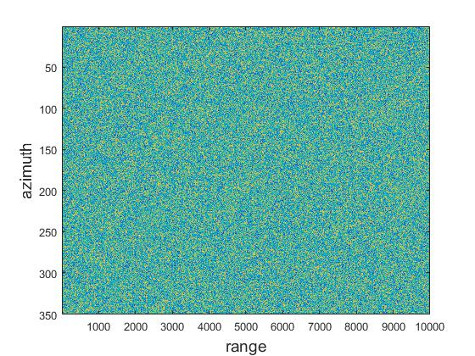
Figure 8. Raw signal generation
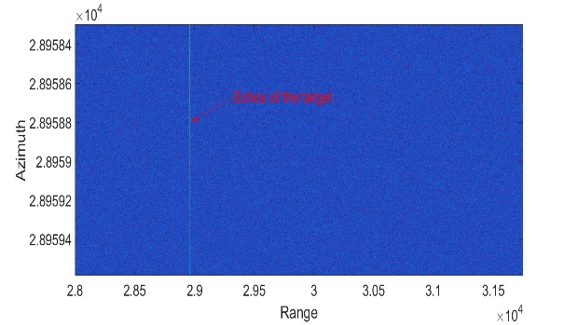
Figure 9. Range compressed data
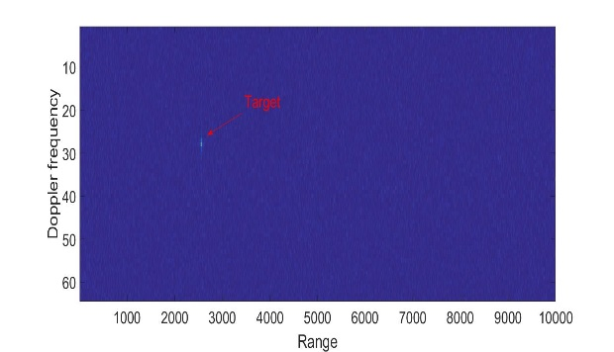
Figure 10. Azimuth FFT
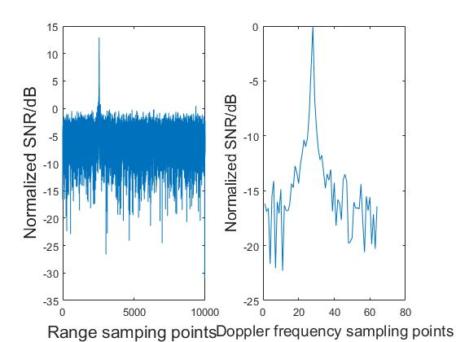
Figure 11. Range and azimuth cut of point target

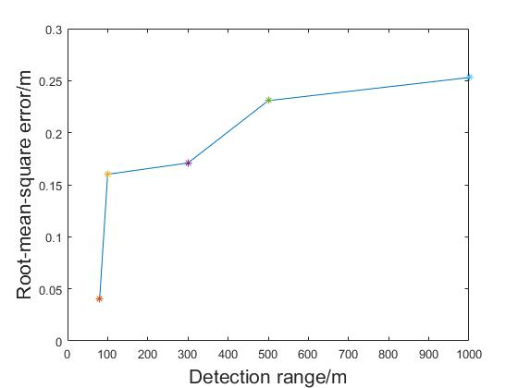
Figure 12. Root-mean-square error
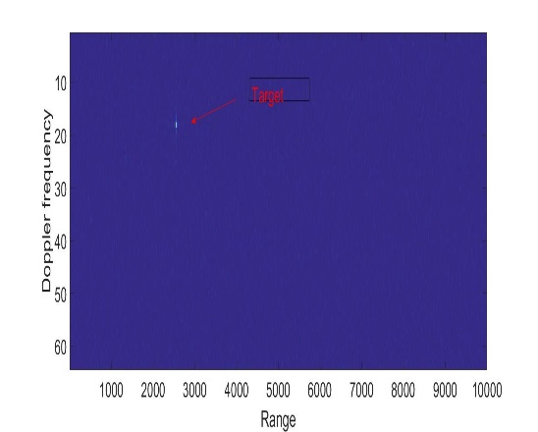
Figure 13. Azimuth FFT
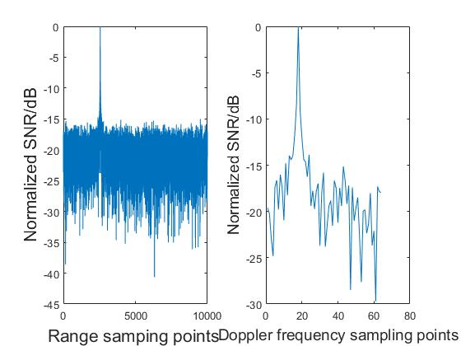
Figure14. Range and azimuth cut of point target
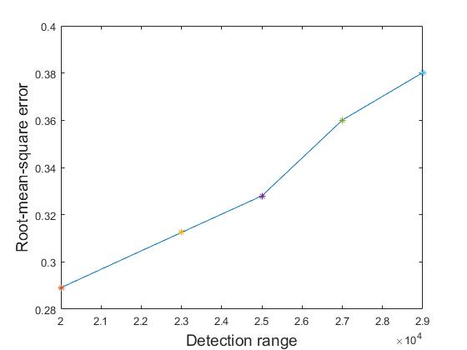
Figure 15. Root-mean-square error
Table 3 Simulation parameters
Parameters | Value
Sampling frequency |  | 400MHz
Chirp bandwidth  Velocity  Pulse duration  SNR  Number of FFT  Simulation times  Pulse Repetition Frequency |  | 120MHz  10m/s  40μs  10~13dB  64  500  350Hz

Angle measurement accuracy

After the target is searched, the beam is adjusted to track the target for a long time. The simulation parameters shown in Table 4.

Assuming that the scanning beam pattern is shown in Figure16, the beam width is 4.3 ° and the scanning interval is 4 ° with a total of 15 beams covering the 60 ° range. The sum of the differences of each beam obtained by calculation is shown in Figure 17. It can be seen from the Figure 17 that the difference sum ratio is an approximately linear monotone function in the corresponding interval.

Using the above beam pattern and the simulation parameters shown in Table 4, the angle measurement simulation of five point targets with a distance of 15 km and an azimuth of -27 °, - 15 °, 0 °, 13 ° and 25 ° is carried out for 500 times. The range compression signals of the five targets are shown in Figure18. The simulation results of angle measurement of five targets are shown in Table 5, and the root mean square error is less than 0.031 °.
Table 4 Angle measurement simulation parameters
Parameters | Value
Sampling rate |  | 400MHz
Signal bandwidth  Detection range  Target moment azimuth angle  Azimuth sampling interval  SNR  Simulation times |  | 50MHz  15km  -27°,-15°,0°,13o,25o  0.02°  5~15 dB  500

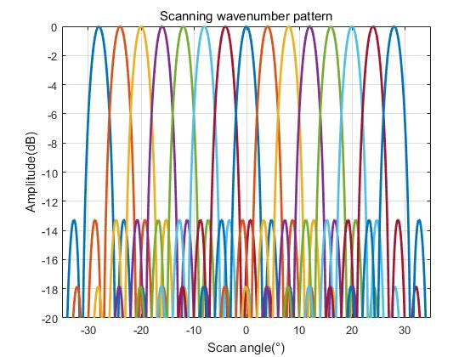
Figure16. Scanning wavenumber pattern
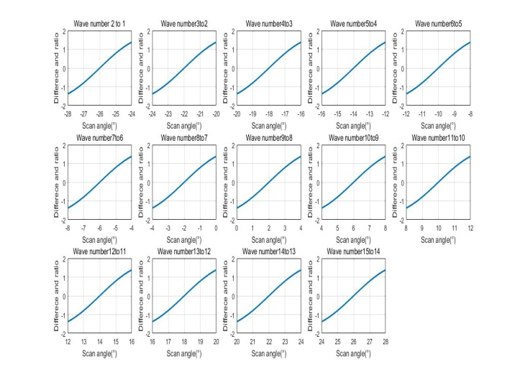
Figure 17 Difference and ratio of wave numbers
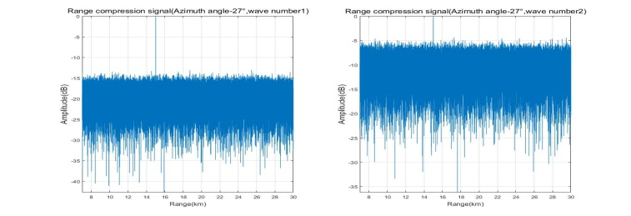
(a)

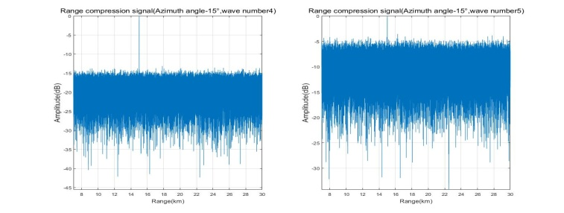
(b)
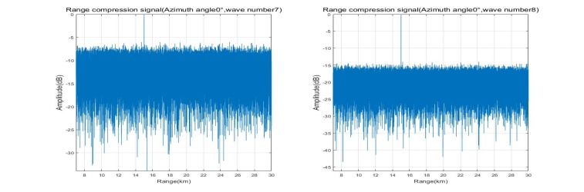
(c)
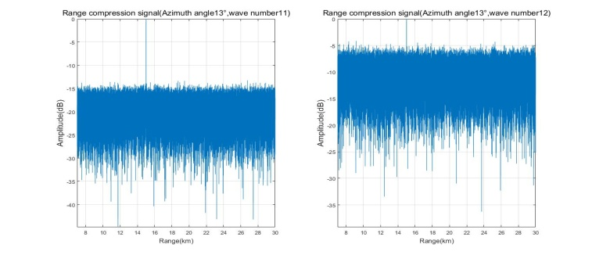
(d)
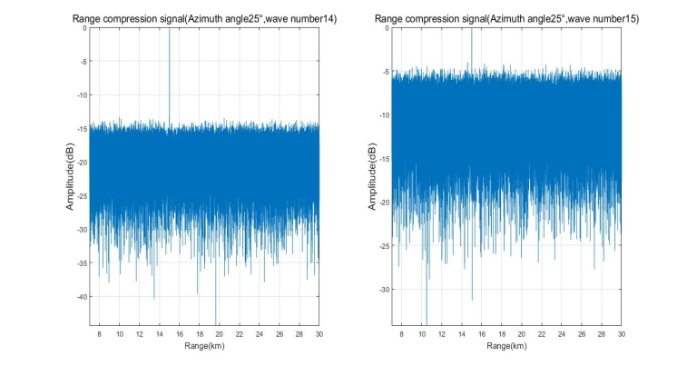
(e)
Fig. 18 Range compression signal of five targets

CONCLUSION

In order to meet the needs of space target detection and application, this paper proposes a miniaturized phased array radar detection and measurement technology based on concomitant satellite. This paper analyzes the performance of different band radars for large-scale spatial target search and measurement tracking, finally C band is selected as the working band of radar. The design of miniaturized phased array radar system, time-sharing receiving and transmitting time sequence of far and near targets, signal processing methods of target search and measurement are described in detail. Simulation analysis shows that the miniaturized phased array radar can search and measure three-dimensional space targets of 40o × 40o in the range of 25km, achieve ranging accuracy of 0.4m and angle measurement accuracy of 0.03o, and meet the large range of space targets surrounding search and tracking application requirements, to provide a supplementary way for ground detection means.
Table 5 Simulation results of angle measurement for five targets
Target real  angle | Average measured  angle | Root mean square  error
-27o  -15o  0o  13o  25o | -26.9970o  -14.9952o  -0.0311o  12.9929o  24.9973o | 0.0226o  0.0227o  0.0302o  0.0236o  0.0231o

ACKNOWLEDGEMENTS

This research is supported by Innovation Funds of Equipment Pre-Research (No. JZX7Y20190253040601, No. JZX7Y2019 0253036001), CASC Scientific and Technological Innovative Research and Design Projects (No. (503)Y-Y-Y-FZLDTX-20).

REFERENCES

Junkai Qi.,2013. A new large field of view and small distortion optical system.the 26th National Symposium on Space research, Hainan, China, pp, 57-75.

Jianfeng Y., Zhi L., Huaifeng L., et al.,2015a. Concept for Space Based Continuous Millimeter wave Radar for Space Debris Detection, Space International, 433(1), pp. 70-75.

Shaomin L., Wei N., Xin M., et al.,2009. Research on Space Target Exploration Technology, National defense technology, 30(3), pp. 6-13.

Jing L.,2016. Study on space highspeed target detection by spaceborne random noise radar'. PhD thesis, Nanjing University of Science &Technology.

Zizheng G., Kunbo Xu., Yongqiang M., et al.,2014.The space debris environment and the active debris removal techniques', Spacecraft Environment Engineering, 31(2), pp. 129-135.

Chunbo L., Shaobo Z., Xiang’e H., 2012a. Detection of space debris of centimeters in size via spaceborne ladar ', Infrared and Laser Engineering, 41(5), pp. 1244-1248.

Zeying T., Xianfeng H., Zongbao C.,2015b. Development status and enlightenment of foreign space—based space surveillance systems', Aerospace Electronic Warfare, 31(2), pp. 24-30 .

Yanbin L., Lizhong J., Yong H.,2012a. Development research on space-based target detection and surveillance system', Guidance & Fuze, 33(3), pp. 50-60.

