ASSESSING VEGETATION DAMAGE CAUSED BY EXTREME COLD WEATHER IN THE SOUTH OF CHINA USING REMOTE SENSING

Na Li (1)(2), Yong Yang (1)(2), Yunpeng Wang(1)

¹ University of Chinese Academy of Sciences, 19 Yuquan Road, Shijingshan District, Beijing, 10049, China
² State Key Laboratory of Organic Geochemistry, Guangzhou Institute of Geochemistry, 511 Kehua Road, Tianhe District, Guangzhou, 510640, China
Email: wangyp@gig.ac.cn

KEY WORDS: Remote sensing; cold weather; vegetation; NDVI

ABSTRACT: Extreme cold weather hit the Southern area of China in early 2008, causing heavy damage to vegetation. Evaluating the damage to vegetation in this area is a long-term task for the local governments. In this paper, we assessed the vegetation destruction in the Southern area of China, including Guangdong, Guangxi, Hunan, Fujian and Jiangxi provinces using remote sensing data. Firstly, we extracted damaged vegetation information by using remote sensing image classification technology, in combining with Digital Elevation Data (DEM) and spatial analysis method. Secondly, the damaged vegetation was recognized in the classified MODIS data after the cold events. Our results show that the areas of damaged vegetation reach 83056 km², including 43912 km² for Hunan Province, 19859km² for Jiangxi Province, 10490km² for Guangxi Province, 5961km² for Guangdong Province, and 2832km² for Fujian Province, respectively. The damaged vegetation is mainly distributed in the area with an average elevation of 590 m, and most of it is distributed on the gentle slope area (5-25°, 73.4%) and the northern slope region (0-90° and 270-360°, 59%). Mixed forests, woody savannas and evergreen needle-leaf forest are the most damaged vegetation types, accounting for 85% of whole damaged vegetation. This study demonstrated the applicability of remote sensing technology for evaluation vegetation damages by extreme cold weather in subtropical area.

- INTRODUCTION

In winter, the central and southeast regions of China often suffer from wind, rain, snow and freezing weather as a result of strong cold wave (Liu, 1995). In particular, from 10th January to early February, 2008, the atmospheric circulation was abnormal due to the intersection influence of southwest warm moist airflow and strong cold air in the east of Lake Baikal (Wu, 2010). Some parts of China, especially most parts of the southern area, encountered four large-scale rain and snow weather successively, causing a rare large-scale and extreme cold disaster of snow storm and frozen rain. Tewnty provinces including Guangdong, Fujian, Guangxi, Hunan, and Jiangxi witnessed the extreme cold weather, which seriously affected ecology, agriculture, transportation and communication facilities. Rapid and accurate assessment of the vegetation damage caused by the extreme cold weather is significant for the protection and restoration of ecological environment in the disaster-stricken area.
As an advanced earth observation technology, remote sensing has advantages of continuous coverage monitoring and rapid mapping in space. It has become one of the significant means of environment and disaster monitoring and evaluation (Zhao, 2013). MODIS (Moderate Resolution Imaging Spectroradiometer) is a medium resolution imaging spectrometer carried on EOS series satellites. It has 36 discrete spectral bands and a wide spectral range, ranging from 0.4 m (visible light) to 14.4 m (thermal infrared) (Michael, 1999). MODIS has shown advantages in macroscopic earth observation with high temporal resolution, which provides a new tool for large-scale vegetation damage assessment after the extreme cold weather.

- STUDY AREA AND DATA

The study area of this paper is Guangdong, Guangxi, Hunan, Fujian and Jiangxi provinces in the south area of China, which all belong to the subtropical monsoon climate zone. The total study area is about 919,100 square kilometers and the longitude and latitude ranges of the study area are from 104.49°E to 120.72°E and from 20.22°N to 30.12°N, respectively.
MODIS data used in this paper are MODIS L1B radiation correction data provided by LAADS (Level land Anllosphere Archived Distribution System), and land cover data products provided by LPDAAC (Land Processes Distributed Active Archive Center). Global 90 m SRTM DEM data were used before the extreme cold weather on 27th January, 2007 and on 2nd March, 2008, respectively. Non-remote sensing data include surface meteorological data and radiation data, which are both monthly observation data from ground stations in 2007 and 2008.

- DATA PROCESSING

  - MODIS Pre-processing

MODIS L1B data provided by LAADS were not physically calibrated. MODIS is a passive oscillating scanning detector, causing a bow-tie effect (Richard, 2004). Therefore, the Georeference MODIS tool in ENVI 4.3 is used for geometric rectification of MODIS LIB data and removal of bow-tie effect (Guo, 2004). The FLAASH atmospheric correction model in ENVI software is also applied to eliminate the radiation distortion and obtain the real radiation information of ground objects.

  - Vegetation Information Extraction

    - Vegetation Index Calculation

Vegetation index, also known as spectral vegetation index, refers to various values of vegetation with certain indicative significance that are composed of linear and nonlinear combination of multispectral data obtained by remote sensing sensors. NDVI (Normalized Difference Vegetation Index) has been widely used in vegetation monitoring research and plant phenology research using remote sensing images (Huete, 2002). It is one of the most efficient indicators to assess plant growth status and vegetation spatial distribution density. NDVI is more sensitive to the changes of soil background, which greatly enhances the detection sensitivity of vegetation coverage. NDVI is also regarded to be linearly related to the vegetation distribution density, which can be calculated by following equation:

$\text{NDVI}=(\text{NIR}−R)/(\text{NIR}+R)$ (1)

Here, NIR is the near infrared reflectance, corresponding to the reflectance of the first band (620-670nm) in MODIS data; R is the red band reflectance, corresponding to the reflectance of the second band (841-876nm) of MODIS.
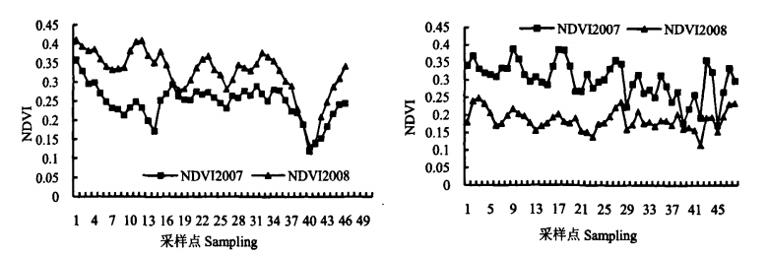
Figure 1 A NDVI Section of the Healthy Vegetation (Left) and Damaged Vegetation (Right) in March 2008 and January 2007 in Guangdong Province

Taking Guangdong Province as an example, the normal vegetation sample points (left of Figure 1) and typical damaged vegetation sample points (right of Figure 1) are selected from the MODIS Image in March 2008 through visual interpretation in combination with other reference materials (Yang, 2009). NDVI value of the sample points was calculated respectively. The NDVI value of the damaged vegetation is obviously different from that of the normal vegetation.
It can be seen from Figure 1 (left) that the change trend of NDVI in March 2008 is basically the same as that in January 2007, as well as the peak and valley values of NDVI are consistent. In general, the dynamic range of NDVI value in March 2008 is greater and the biomass information is richer compared with the NDVI value in January 2007. It shows that the vegetation growth in March is more vigorous than that in January under normal circumstances.
The overall change trend of damaged vegetation NDVI value in two years in Figure 1 (right) is basically the same, and peak-valley variation is relatively consistent. However, the NDVI value of the vegetation in March 2008 is generally lower than that in January 2007, which is opposite to that of normal vegetation in two years. The comparison results in Figure 1 show that the vegetation is seriously damaged and the vegetation biomass is greatly declined in this area.

    - Information Extraction of Damaged Vegetation

Unsupervised classification is the process of searching and defining natural similar spectra and groups in multispectral images (Zhao, 2004). ISODATA (Iterative Self-Organizing Data Analysis Technique) is one of the most commonly-used unsupervised classification methods. In this paper, ISODATA and the maximum likelihood ratio classification methods are firstly used to classify the MODIS remote sensing images of the study area. Subsequently, the unsupervised classified images are used as prior knowledge, and the training area is selected as the basis for supervised classification. The appropriate training area is selected as a sample combined with visual interpretation.
In this study, ENVI software is used for remote sensing image processing and classification. Through repeated adjustment of classification parameters and comparative analysis of other land cover auxiliary data, the land cover of five provinces in the south area of China is divided into water body, normal vegetation, damaged vegetation, crops as well as architecture and others (Figure 2).
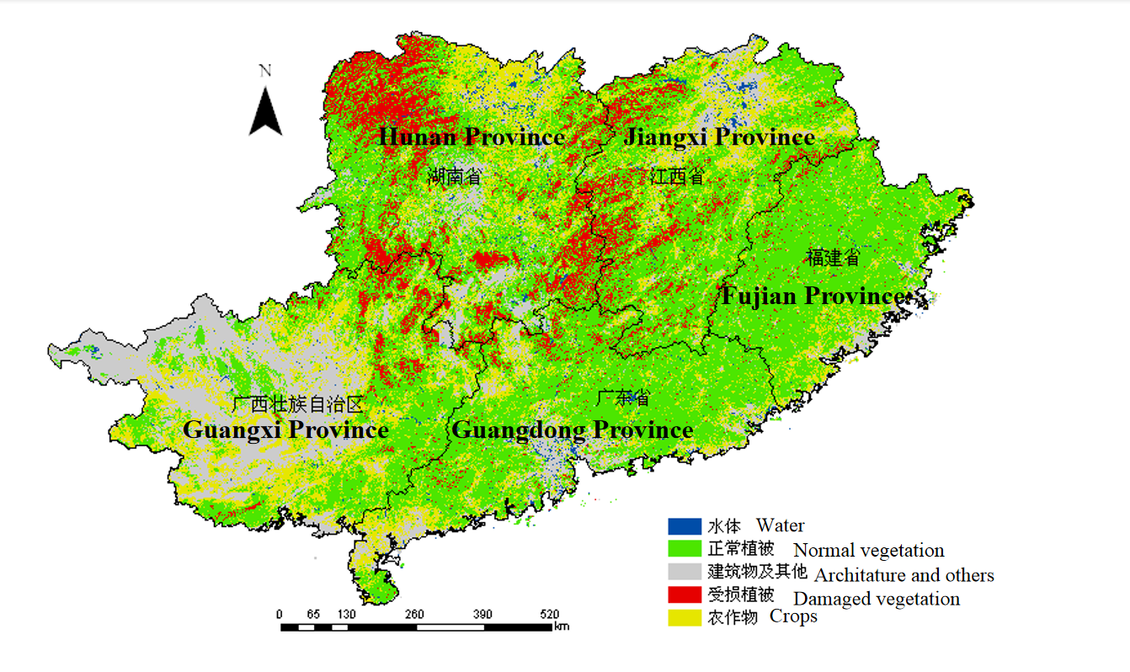

Figure 2 Land Cover Map Showing Damaged Vegetation of Five Provinces in the South of China

The total damaged vegetation area in five provinces in the south of China is estimated about 83056.06km², including 43912.06km² in Hunan Province, 19859.63km² in Jiangxi Province, 10490.75km² in Guangxi Province, 5961km² in Guangdong Province, and 2832.65km² in Fujian Province, respectively. The vegetation damage area in Hunan Province is the largest among five provinces, accounting for 52.9% of the total damaged vegetation area. As is shown in Figure 2, the damaged vegetation is mainly distributed in Nanling area (at the border of Guangxi, Hunan, Guangdong and Jiangxi provinces), Zhangjiajie area (in Northwest Hunan Province), as well as Jinggangshan area (in Jiangxi Province).

    - Damage of Different Vegetation Types

The damage information of different vegetation types in five provinces in the southern area of China is obtained through overlay analysis of damaged vegetation distribution and 1 km IGBP land cover data. Different types of vegetation suffered varying degrees of destruction caused by the extreme cold disaster. The most seriously damaged are mixed forest, tropical woody savanna and evergreen coniferous forest, which account for 85% of the total vegetation damage area.

- LANDSCAPE IMPACTS ON VEGETATION DAMAGE

The distribution of vegetation is related to elevation, slope, aspect and other topographic factors (Yang, 2009). In this paper, the correlation between terrain factors and vegetation damage was analyzed based on the non-supervised classification of damaged vegetation data (as discussed previously) and SRTM DEM data.

  - Elevation

The vertical distribution zone of vegetation is formulated due to the varieties of water and heat factors at different altitudes (Wu, 2017). We extracted elevation information of damaged vegetation (Figure 3) after overlaying with SRTM 90 DEM data. The average elevation of damaged vegetation is calculated as 590 m. According to the results of field investigation in northern Guangdong, the damaged vegetation is mainly distributed more than 400m above sea level, accounting for 70% of the total damaged vegetation area in the five provinces in southern area of China. The damaged vegetation is mainly distributed in mountainous areas with high altitude, complex terrain and low temperature.
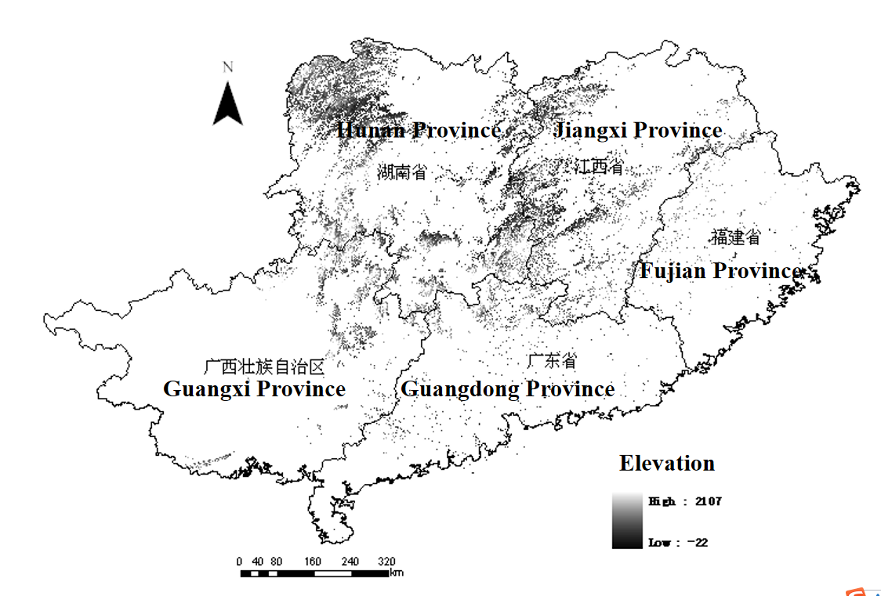
Figure 3 Elevation Distribution Map of Damaged Vegetation of Five Provinces in the South of China

  - Slope

Slope not only affects the composition of parent material, organic matter, thickness, moisture, pH and other basic soil properties, but also determines the surface energy receiving from solar radiation. Slope is a key factor affecting the spatial distribution and damage extent of vegetation. In this study, the spatial analysis module provided by ArcInfo was used to output the slope map of the study area by combining with SRTM 90m DEM data. Subsequently, the slope distribution of the damaged vegetation in the five provinces in south of China was obtained by overlay analysis of the damaged vegetation and the slope data.
It is easier to form freezing rain on steep slope at high altitude with low temperature. Therefore, the vegetation in these areas is more vulnerable to freezing weather and mechanical damage. However, because the vegetation coverage area on steep slope is generally less than that in gentle slope, the damaged vegetation area of gentle slope is more serious in general. As shown in the left of Figure 4, 74.3% of the total vegetation damaged area is in the gentle slope area with a gradient of 5°-25°.

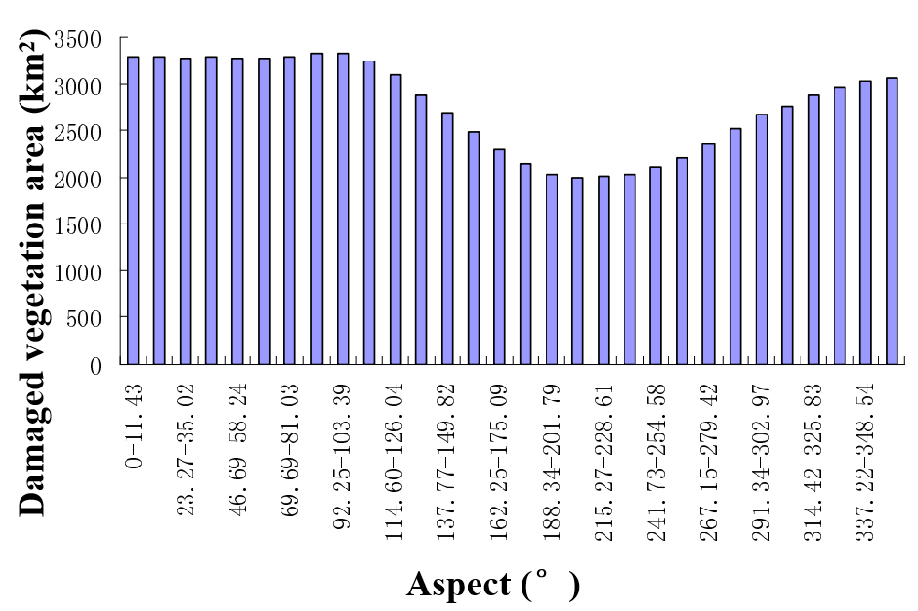
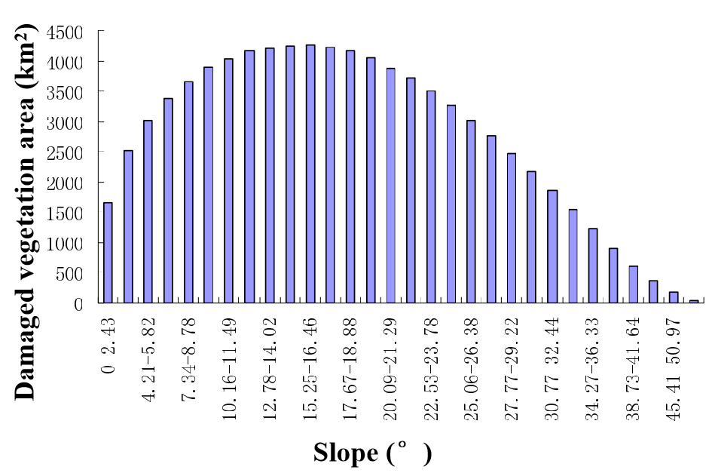
Figure 4 Slope (left) and Aspect (right) Distribution Map of Damaged Vegetation of Five Provinces in the South of China

  - Aspect

Aspect determines the amount and dynamic of solar radiation and surface water on the slope surface, which affects the distribution of different types of vegetation, especially in the shady slope and sunny slope. In order to simplify the comparison of the damaged vegetation aspect , the aspect is simply divided into northern slope region (0-90°, 270-360°) and southern slope region (90-270°). The northern slope region is more likely to snow and freeze for a long time due to the different sunlight exposure and intensity between the northern slope and the southern one. As is shown in the right of Figure 4, the damaged area of the north slope is estimated about 48525km², accounting for 59% of the total vegetation damage area in the five provinces in the southern area of China.

- DISCUSSION AND CONCLUSION

In this paper, the distribution of damaged vegetation after the extreme cold weather in 2008 was obtained by unsupervised classification of MODIS data. Result shows that the extreme cold weather caused extensive damage to vegetation in five provinces of southern China. The NDVI value of damaged vegetation in March was far less than that in January, 2008. The total areas of damaged vegetation reach 83056 km². By combining with DEM data, it shows that the vegetation damage is found related to the elevation, slope, aspect and other terrain factors. The average elevation of vegetation damage is about 590 m, and the vegetation damage deteriorates on Northern slope region and gentle slope area less than 15°.
MODIS data has an edge on high time resolution and multi-spectrum, which is proven to be an effective technical means for monitoring large-scale cold weather disaster. However, error exists in the process of unsupervised classification due to mixed pixels in the medium resolution image. Different unsupervised classification algorithms also affect the accuracy of pixel classification. Additionally, limited meteorological monitoring stations affect the spatial fitting accuracy, which also causes errors of mapping. Future research should focus on modified classification algorithms and the combination of high-resolution data such as SPOT and Landsat TM data to increase monitoring precision.

ACKNOWLEDGEMENT

This study was supported by the China NSFC (U1901215) and China 863 Program (2006AA06A306).

Reference:
Guo G.M., 2004. Geometric Calibration of MODIS Data. Remote Sensing Information, (3), pp.26-28.
Huete, A., Miura, T., Rodriguez, E.P., Gao X., Ferreira L.G., 2002. Overview of the radiometric and biophysical performance of the MODIS vegetation indices. Remote Sensing of Environment, 83, pp.195-213.
Liu X.N., Sun A.J., Zhang S.Y., 1995. Study of climate features for cold wave in South China. Journal of Catastrophology, 10(2), pp.58-63.
Michael, D., 1999. A Guide to NASA's Earth Science Enterprise and the Earth Observing System. In: Eos Reference Hand book.
Richard L.M., Brent A.M., 2004. Using MODIS Terra 250m imagery to map concentrations of total suspended matter in coastal waters. Remote Sensing of Environment, 93(1-2), pp.259-266.
Yang Y., 2009. Assessing Vegetation damage from cold disaster in Guangdong using MODIS data. Ecological Science, 28(6), pp.543-547.
Wu H.y., Du Y.D., 2010.Climatic Characteristics of Cold Waves in South China in the Period 1961-2008. Advances in Climate Change Research, , pp.192-197.
Wu Z.J., He G.J., Huang S.L., Wang M.M., Lin J.T., 2017. Terrain effects assessment on remotely sensed fractional vegetation cover in hilly area of southern China. Journal of Remote Sensing, 21(1),pp. 159-167.
Zhao C.X., 2004. Comparative Study of Supervised and Unsupervised Classification in Remote Sensing Image. Journal of Henan University ( Natural Science), 34(3), pp.90-93.
Zhao, Y.S., 2013. Principles and methods of remote sensing application analysis. Beijing, pp.3-16.

