Research on cloud detection Algorithm based on GF-5/DPC data
Wei Lesi (1), Husi Letu* (1), Huazhe Shang (1)

¹ State Key Laboratory of Remote Sensing Science, Aerospace Information Research Institute, Chinese Academy of Science, 20 Datun road, Chaoyang District, Beijing 100101, China;
Email: 20174014016@mails.imnu.edu.cn ; husiletu@radi.ac.cn*; shanghz@radi.ac.cn

KEY WORDS: Atmospheric remote sensing；Cloud detection；Apparent pressure；Multi-angular polarization；GF-5／DPC
ABSTRACT: The Directional Polarimetric Camera (DPC) carried by the GaoFen-5 (GF-5) satellite can continuously observe the earth in multiple bands, multiple angles and high spatial resolution. This data is useful for investigating cloud distribution and cloud – radiation – climate interactions. This paper uses the French multi-angle polarization load POLDER (Polarization and Directionality of the Earth’s Reflectance) cloud detection algorithm as a reference, and combines DPC multi-band reflectivity, polarization reflectivity, apparent pressure and other information to develop a cloud detection algorithm for DPC measurement. The algorithm is mainly divided into three parts: First, the threshold method is used to detect cloud pixels, and the apparent pressure is introduced to further restrict the conditions of clouds (such as cirrus, stratocumulus, etc.) at different heights, and then use the 865nm band polarization reflectance to identifies the sun glare area reflected by the sea surface, and corrects the sun glare interference when the reflectance threshold is used to identify cloud pixels. In order to verify the accuracy of the algorithm, this study verified the cloud pixel coincidence of MODIS's MOD06 cloud mask product and the cloud detection algorithm results on October 1, 2018. The results showed that the cloud pixel and clear pixel coincidence of the cloud detection results in this study and MOD06 cloud mask product was 78% and 70% respectively. It can be seen from visual interpretation that the cloud detection results in this study are closer to the real cloud distribution, while the observation time of MOD06 cloud mask product is slightly different from that of DPC, resulting in poor consistency with the cloud distribution of DPC RGB composite. Above results indicate that cloud detection algorithm proposed in this study can provide important data support for subsequent DPC research on cloud parameters, water vapor, and aerosols.

Introduction
Clouds cover 50% to 70% of the earth's surface area and are one of the important factors affecting the atmospheric radiation budget and climate change (Ma et al., 2018). Due to the multiple scattering characteristics of clouds to solar radiation and the spatial complexity of the cloud itself, it is difficult to obtain cloud observation data with high spatial and temporal resolution on a global scale from ground station points and aircraft observations (Letu et al., 2015). Since the birth of satellite sensors, large-scale acquisition of cloud physical characteristic parameters has become possible. Satellite remote sensing inversion technology is one of the most effective methods to study cloud microphysical characteristics and spatial and temporal variation distribution by using the electromagnetic wave information observed by the satellite to estimate the optical and physical characteristics of target objects (Li et al., 2014; Li et al., 2019, Letu et al., 2020). On the other hand, cloud detection is the basis for the retrieval of atmospheric parameters such as cloud characteristic parameters, aerosols, and water vapor (Mason 2002). These atmospheric parameters can be used in the estimation of the surface energy budget and the assessment of climate effects, and can also be combined with high the cloud products and aerosol products produced by the data of satellite No. 5 serve for the study of the interaction between clouds and aerosols in polluted areas in my country (Sun et al., 2018).
Since the development of passive remote sensing satellite cloud detection methods, predecessors have established a large number of mature cloud detection algorithms, such as threshold method, pattern method, statistical method and comprehensive method; among them, the most widely used method is threshold method (Saunders et al., 1988). Compared with traditional optical remote sensing methods, polarization detection has higher sensitivity to clouds and aerosols (Zheng et al., 2018). For the cloud detection of polarization sensors, Buriez (1997) first developed POLDER by combining polarization information with a threshold method. Cloud detection algorithm. The algorithm is divided into five parts. First, the atmospheric absorption of the oxygen A zone is used to express the apparent pressure, combined with a certain threshold to distinguish between high-level cirrus clouds and stratocumulus clouds near the ground; then use the reflectivity difference detection of ground objects Cloud, ground or sea surface; then detect the obvious difference between cirrus clouds and cloudless conditions under 443nm polarization reflectivity; then detect medium and low clouds within a specific scattering angle range through 865nm polarization reflectivity; finally use visible light and near-infrared reflection Rate ratio is the detection of living land vegetation on the sea surface. Combining the above detections, the values ​​that exceed a certain range of the threshold are classified as "cloud" or "clear" respectively. This method is simple and practical. However, due to the deviation of the instrument's field of view from the actual cloud distribution, misjudgment occurs in pixels with small optical thickness such as broken clouds.
In order to provide an effective cloud detection algorithm for DPC, this paper develops a DPC cloud detection algorithm based on the POLDER cloud detection algorithm, which uses information such as apparent pressure, multi-band reflectivity, polarization reflectivity, and near-infrared band reflectivity to enter the cloud and The clear sky detection threshold is selected, and the multi-angle information of the polarization detector and the sampling analysis of multiple regions are used to determine the threshold, and a cloud detection algorithm suitable for DPC loads is given.

- Data and Methods
2.1. DPC Data
On May 9, 2018, the Gaofen-5 satellite was successfully launched at the Taiyuan Satellite Launch Center. It filled the gap in the polarization data of the global atmosphere and ocean since POLDER-3 ended the observation mission. It is China’s ability to achieve high spectral resolution. An important symbol of earth observation capability. DPC uses 512×512 effective pixels in the 544×512 pixels of a charge-coupled device (CCD) array to achieve earth observation with a field of view of 1850 km and a spatial resolution of 3.3 km. The flight perimeter covering global observations is 2 days. DPC has 3 polarization bands (center wavelengths are 490 nm, 670 nm, and 865 nm) and 5 non-polarization bands (center wavelengths are 443 nm, 565 nm, 763 nm, 765 nm and 910 nm). The polarizer and filter of the DPC are mounted on the same wheel, and the spectral polarization measurement results are obtained through the rapid rotation of the wheel. At the same time, each time the wheel rotates at a fixed angle, the measurement results of different wavebands can be continuously obtained. Among them, the observation of the 490nm, 670nm and 865nm channels can also obtain the polarization observation value, which can be directly converted into Stokes parameters (I, Q and U) (Li et al., 2018).

2.2 MODIS Data
Moderate-resolution Imaging Spectroradiometer (MODIS) is a large-scale space remote sensing probe developed by NASA. It is equipped with Terra launched in 1999 and Aqua satellite launched in 2002. MODIS has 36 spectral bands, covering visible light to thermal infrared bands, among which the spatial resolution of bands 1-2 is 250m, the resolution of bands 3-7 is 500m, and the resolution of other bands is 1000m. Every 1 to 2 days, it can provide dynamic observation data on a global scale, including global cloud cover changes, earth energy radiation changes, ocean land and low altitude changes. This article uses MODIS' atmospheric secondary standard product MOD06, which includes cloud characteristic products, including cloud cover, cloud mask, cloud phase state, cloud microphysical parameters, cloud top parameters, etc. The spatial resolution of the product's own geographic coordinate information is 5km, and the spatial resolution of the cloud mask product is 1km and 5km. In order to match the 3km spatial resolution data of the DPC data, Scaling up the 5km data of MOD06 in this study. (Steve et al., 2010).

2.3. Cloud Detection Algorithm
In this research, the cloud detection algorithm is based on the POLDER cloud detection algorithm and combines the multi-channel and multi-angle characteristics of DPC to develop a cloud detection algorithm suitable for DPC. This algorithm is based on a series of single-pixel inspections. First, the high-level cirrus clouds and the mid-bottom stratocumulus clouds are identified based on the apparent pressure; then the multi-band reflectance is used to identify the clouds over the ocean and land; through NDVI and near Infrared band reflectivity is used to identify clear sky areas on the ocean and land; then the solar flare area over the ocean is used to identify clear sky areas using polarization reflectivity; finally, the unclassified pixels are re-detected using multi-angle information.
Compared with the POLDER cloud detection algorithm, the cloud detection algorithm in this paper redesigns the detection process and detection threshold considering the characteristics of each band of DPC data. And the polarization information overcomes the defect that the POLDER cloud detection algorithm cannot effectively detect cloud pixels in the solar flare area. The specific flow of the algorithm will be described in detail below. Figure 1 is the flow chart of the algorithm:
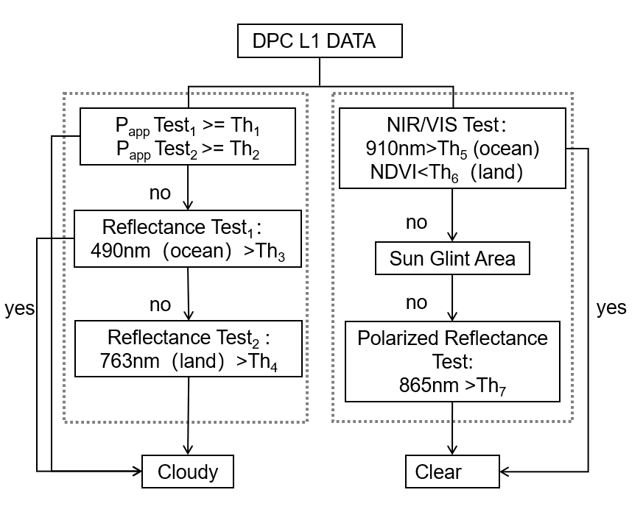
Fig. 1. Flow chart of Cloud detection method for DPC

- Results
In order to test the feasibility of the algorithm, applied the cloud detection algorithm to the data of some parts of the world of DPC on October 1 and compared it with the MODIS cloud detection products at the same time. In this test, two regions were selected, namely Pacific and American continent regions. Since the Pacific region in October is in the Pacific typhoon season, the Pacific typhoon season is a period of tropical cyclones in the Pacific waters (including the South China Sea) north of the equator and west of the international date line. Although national weather stations do not specify the duration of the typhoon season, most tropical cyclones in the Northwest Pacific usually form between May and December. Therefore, there are a large number of typhoons over the Pacific at this time, and there are also different degrees of fragmented clouds around the typhoon. Therefore, choosing this area can effectively detect the accuracy of cloud detection; while the northern part of South America is located near the equator, and updraft prevails throughout the year. Moreover, the northeast trade wind and the southeast trade wind can blow water vapor from the Atlantic Ocean to land. The air in the northern part of South America is full of water vapor, the air rises and the temperature decreases, and the water vapor condenses clouds to form rain. Therefore, the high cloud cover in northern South America can also test the accuracy of this research algorithm. In Fig. 2. (d), two typhoons can be clearly seen due to the typhoon season in the Pacific, and there are many broken clouds on the edge of the typhoon and the ocean. Similarly, the central part of the South American continent in Fig. 2. (a) is very much covered. And covered with broken clouds. Comparing the DPC cloud detection results in Fig. 2. (b) and (e) with Fig. 2. (c) and (f) MYD06 cloud products, it is found that the cloud and clear sky areas detected by the cloud detection algorithm in this paper are very consistent with the visual interpretation results. degree. Then used the confusion matrix to calculate the two cloud detection results. As shown in Fig.3, can see that the MYD06 cloud mask and the algorithm results in the cloud pixel and clear sky pixel detection by the higher Consistency, the proportions obtained by the confusion matrix are 70% and 78% respectively.
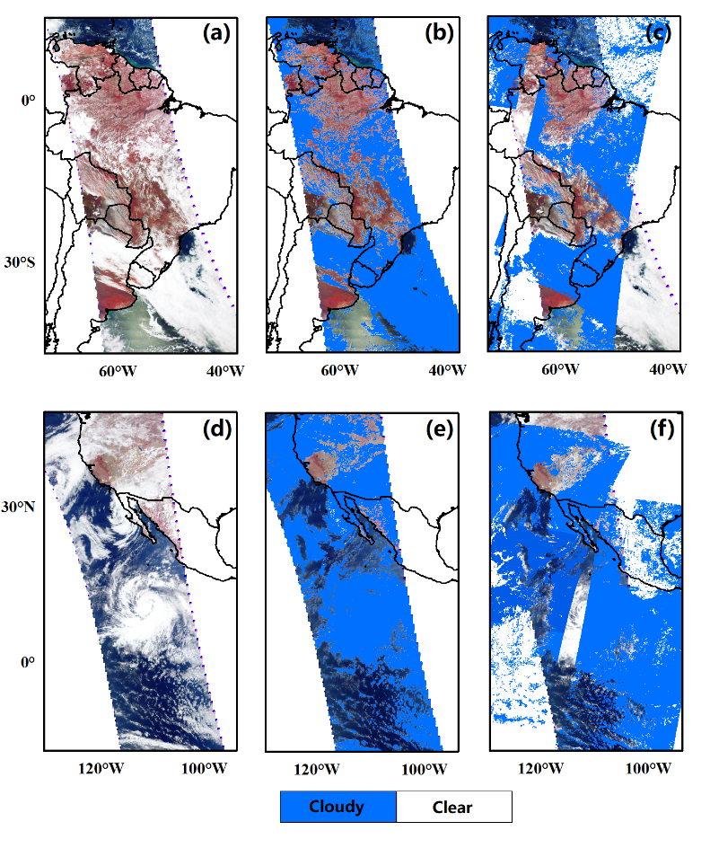
Fig. 2. (a) DPC RGB Composite of the South America on October 01, 2018 (UTC:15:33~16:16) ;(d) DPC RGB Composite of the Pacific Ocean on October 01, 2018 (UTC:20:27~21:13) ;(b)and(e) Cloud detection result of DPC; (c)and(f) Cloud Mask of MOD06;
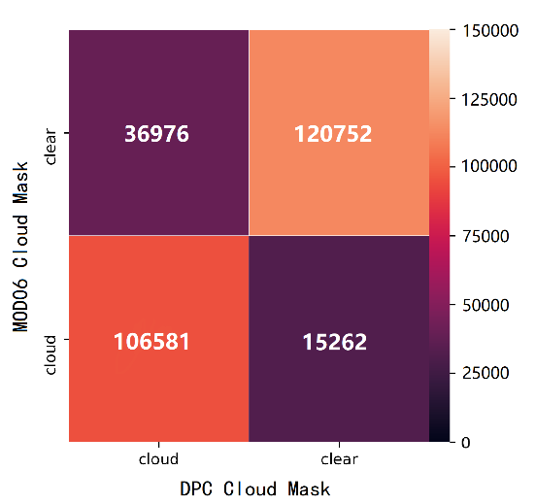
Fig. 3. Confounding matrix for MOD06 cloud mask and DPC cloud detection results

- Conclusion
In this study, a cloud detection algorithm based on threshold method was established by using the data of gaofen-5 DPC atmospheric Multi-angle polarimetric detector. The research mainly did the following work and drew corresponding conclusions:
(1) Apparent pressure similar to POLDER cloud detection algorithm is selected as the first detection of cloud detection, and the reflectivity and polarization reflectivity of cloud pixels and clear sky pixels are statistically analyzed, and multiple threshold retrieval cloud detection algorithms are constructed. According to the difference of cloud level, reflectivity of cloud, ocean and land, the optimal combination of threshold is explored one by one, so as to ensure the accuracy of cloud detection to the maximum extent.
(2) The cloud detection results of this study are given in the form of cloud masks, and each pixel will identify its category: cloud, clear sky. The cloud detection result obtained by using the algorithm on the data of October 01, 2018 is compared with the MOD06 cloud mask at the same time. From the results, it can be seen that the cloud detection result of this algorithm MOO06 cloud mask has a higher degree of agreement.

Reference
Buriez, J C, C Vanbauce, F Parol, P Goloub, M Herman, B Bonnel, Y Fouquart, P Couvert, & G Seze. (1997). Cloud detection and derivation of cloud properties from POLDER. International Journal of Remote Sensing 18 (13):2785-813.
Letu, H, Bao, Y H, Xu, J, Qing, S & Bao, G. (2015). Radiative properties of cirrus clouds based on hexagonal and spherical ice crystals models. Spectroscopy and Spectral Analysis, 35(5): 1165–1168
Letu, H, Shi, J C, Li, M, Wang, T X, Shang, H Z, Li, Y H, Ji, D B, Wen, J G, Yang, K, Chen, L F. (2020). A review of the estimation of downward surface shortwave radiation based on satellite data: methods, progress and problems. Science China (Earth Sciences), v.63(06), 26-41.
Li, X H, Shen, H F, Zhang L P, Zhang, H Y, Yuan, Q Q, and Yang, G. (2014). Recovering Quantitative Remote Sensing Products Contaminated by Thick Clouds and Shadows Using Multitemporal Dictionary Learning. IEEE Transactions on Geoence Remote Sensing, 52 (11):7086-98.
Li, X H, Wang, L Y, Cheng, Q, Wu, P H, Gan, W X, and Fang, L N. 2019. Cloud removal in remote sensing images using nonnegative matrix factorization and error correction. ISPRS Journal of Photogrammetry Remote Sensing, 148: 103-113
Run Ma, Husi L T, Shang H Z, A N R, He J, Han X, Wang Z M .(2018). Estimation of downward surface shortwave radiation from Himawari-8 atmospheric products. Journal of Remote Sensing, 23(05):924-934
Mason, B J. 2002. "The role of clouds in the radiative balance of the atmosphere and their effects on climate." Contemporary Physics, 43 (1):1-11.
Steve Ackerman, Richard, F, Kathleen, S, Liu, Y H, Liam G, Bryan, B and Paul, Ml . 2010. Discriminating clear-sky from cloud with MODIS algorithm theoretical basis document (MOD35). Version 6.1.
Saunders, R W, and K T Kriebel. 1988. An improved method for detecting clear sky and cloudy radiances from AVHRR data. International Journal of Remote Sensing, 9 (1):123-50.
Shang, H Z, L T Husi, T Y Nakajima, Z M Wang, R Ma, T X Wang, Y H Lei, D b Ji, S S Li, & J C Shi. 2018. Diurnal cycle and seasonal variation of cloud cover over the Tibetan Plateau as determined from Himawari-8 new-generation geostationary satellite data. Scientific Reports,8(1):1105.
Sun, Y Z, Jinag, G W, Li, Y R, Yang, Y, Dai, M S, He, J, Ye, Q, Cao, Q, Dong, C Z, Zhao, S H and Wang, W H. 2018. GF-5 Satellite: Overview and Application Prospects. Spacecraft Recovery & Remote Sensing, 39(3): 1-13
Winker, D., Hostetler, C., Vaughan, M., and Omar, A. 2006. CALIOP algorithm theoretical basis document. Part 1: CALIOP instrument, and algorithms overview Release 2.0 available at[http://www-calipso.larc.nasa.gov/resources/pdfs/PC-SCI-202.Part1_v2-Overview.pdf] .

