IDENTIFYING CHARACTERISTICS OF HISTORICAL FORTS IN MALAY PENINSULAR

Illyani Ibrahim* (1), Puteri Shireen Jahn Kassim (2), Nor Zalina Harun (3), Alias Abdullah (1), Noranisa Roslee (1)

¹ Department of Urban and Regional Planning, Kulliyyah of Architecture and Environmental Design, International Islamic University Malaysia, Gombak, Selangor, Malaysia
Email: illyani_i@iium.edu.my, alias@iium.edu.my, noranisa@gmail.com
¹ Department of Applied Arts and Design, Kulliyyah of Architecture and Environmental Design, International Islamic University Malaysia, Gombak, Selangor, Malaysia
Email: puterishr@iium.edu.my
³Institute of the Malay World and Civilisation (ATMA), Universiti Kebangsaan Malaysia,
43600 Bangi, Selangor Darul Ehsan, Malaysia.
Email: nzalina@ukm.edu.my

KEYWORDS: culture, history; GIS mapping, Malay Peninsula; urban form; physical elements

Abstract: This study focuses on the nature and characteristics of the forts in old Malay cities. This study's objectives are; i) to analyse the characteristics of historical forts, and ii) to compare the characteristics of forts in the historical Malay Peninsula. Content analysis was performed for the secondary data gathered from previous works and documentations. Six drawings of old forts were designed based on the previous excavation works. The matrix analysis indicated the following characteristics of the forts among the forts are: i) located on the top of the hill and facing the river/sea, ii) forts has a wall that plays a role as a boundary that separated from the other areas, iii) these forts located close to the river/sea, iv) the form of the forts either square or rectangle, v) the structure of the forts usually using natural elements.

INTRODUCTION

In the local context, it is difficult to study history as not much information available. The Chinese voyager wrote the earliest documented text from several writers, Ma Huan, during the Melaka Sultanate rule. Another prominent writer from Westerner, Tome Pires, had produced a book called The Suma Oriental, right after 1511, during the conquered of Portuguese in Melaka. Only after 1612, the local author came up, namely as Tun Sri Lanang. In the Malay narratives, most of the events are described in the classic poem, and at most, the works refer to the culture of the past or arts that belong to a historical tradition. Some of the sentences were written based on the oral story from the people who lived in a particular village. Forts are one of the evidence that shows the events that happened in historical times.
Forts are important elements of such a city that also including buildings in the urban form elements. Peninsular Malaysia has numerous forts that need to be preserved as a legacy from the traditional culture. The uniqueness of this historical forts is deserved to be preserved. Thus, documenting local forts is an important effort to be done. The content should be based on international standards; however, it will also be limited to such forts. Thus, it can be valuable to implement legal protection, preservation matters, and adaptive re-use in the future (Rinandi, Suryaningsih, & Heritage, 2015).

It should be stressed that the forts in Western and Chinese are different from the forts studied in the local context. The traces from historical Western, Chinese, and India can still be seen until now, but this is not what we saw in the study area. Forts of the local areas mostly shown from the fortification structure and tombs of the Sultanate can be found in the nearby locations. Some of the forts have vanished, and some of them leave some remains. This is due to several explanations; most of the forts were built using bamboo, wood, and nipah, it is easily lost and damaged as time goes by. For those forts built using stones and bricks, there are remaining forts, although some of them were abandoned.
There were many forts discovered that could be classified as traditional forts and city walls, which were built both during the Islam era and even in the colonial era. To remain consistent as far as possible, it has been decided to simplify the classification of forts. In the study area, the forts are classified into three fort classification; i) pre-colonial era), ii) post-colonial. The pre-colonial era is the fort that was built before the arrival of the colonial. The post-colonial is the fort that has been influenced by the Western nation.
Fort in the local study is only concentrated in the place where the ruler stays. This is also true in Indonesia, such as Fort Takimpo and Fort Badia at Bau-bau Island, South-East Sulawesi (Rinandi, Suryaningsih, & Heritage, 2015). These forts were built by the Indonesian and built-in their fight against colonialism during the colonial era. However, some parts abroad have a walled city, whereas the walled areas include the entire city. An example is a walled city built in 11 Century, named by Walled City of Lahore during the rule of Mahmud Al-Ghazni during the medieval era, and it was made by mud.
In the Malay Peninsula context, the forts play an important role as the main city as a focal point of administration and rulers' residence. It can be fully fort, partially fort, or no fort with a natural fort. The fully fort are the forts that surrounded the whole area. Partially fort is the fort with an area of partly with wall and partly surrounded by natural elements. No fort are the walls entirely from the natural elements. Natural elements can be formed by the undulation of topography or the trees.
To remain consistent, this research will be conducted based on the forts built by the local context, from 1500 to 1800s. Hence, this study's objective is twofold; i) to analyse the characteristics of forts in the historical Malay Peninsula, from documented literature and image of the forts, and ii) to categorized the forts according to its characteristics.

RESEARCH METHODOLOGY

Relevant secondary sources were reviewed in addition to published historical books and articles. The qualitative methods used in this research consisted of (i) library research of old history books, (ii) document analysis, and iii) image of the forts. It is worth noting; however, that comprehensive works in past studies are scarcely available. The CAD drawing was done on these six forts, according to Nasir's image (1990). These drawings are done to compare the differences in the total area of each fort. Fig. 1 shows the flow of the process done in this study.
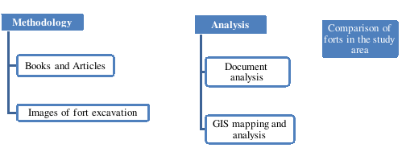
Figure 1: The flow of the process done in the study

- STUDY AREA

The study area is covered according to the layout map of the forts around the Malay Peninsula. Only six (6) remaining forts examined in this study lack information about the rest of the forts. Figure 1 shows the location of the forts. It can be seen that the forts are located along the east of Peninsular Malaysia.

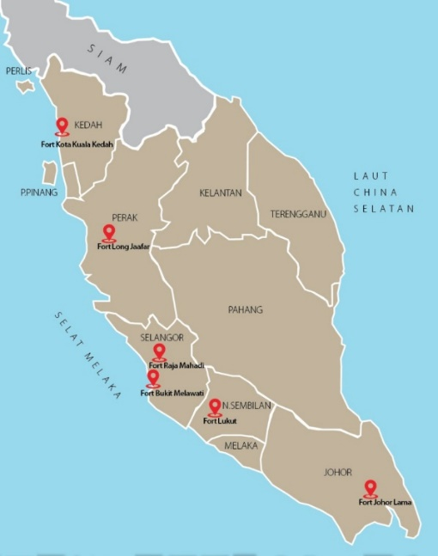
Figure 2: The location of forts in Peninsular Malaysia

HISTORICAL CONTEXT OF FORTS IN MALAY PENINSULA

All of the ancient cities in the Malay Peninsula locate significant buildings for defense purposes. Fort is one of the important elements of urban form. Sejarah Melayu narrates that Megat Iskandar Shah built a palace with a fort on top of St. Paul Hills. As he embraced Islam in 1414, another significant mosque called Masjid Jamek was built close to the palace. Fort of Melaka was guarded by armed warriors, comprised of the administrative, palatial, mosque, sentry towers, and royal residences complexes.
As evidenced by Nasir (1990), eighty-seven forts were built in the Malay Peninsula. However, some of the forts are untraceable due to a lack of documentation. Archaeological evidence has revealed that fort is one of the important elements in a city. Analysis of Melaka events showed that the fort's construction was essential because it served as an administration and defense center. Until today, Fort Ngah Ibrahim in Perak, Fort Long Jaafar in Perak, and Fort Malawati in Kuala Selangor remain visible. All of these forts were located next to the river. The forts in Johor, Pahang (Jeran, 1992; Shellabear, 1977), Perlis, and Kedah also served as administrative centers for the ruler. However, Selangor's fort was established as the ruler (Shellabear, 1977) and a defense center (Jeran, 1992).
Although many forts were listed as above, not many forts left its remains. This paper attempts to discuss the historical forts according to the timeline from the 1500 century to 1900 century. These forts are Fort Batu Johor Lama, Fort Kuala Kedah, Fort Melawati, Fort Long Jaafar, and Fort Lukut. The timeline of these forts is shown below;

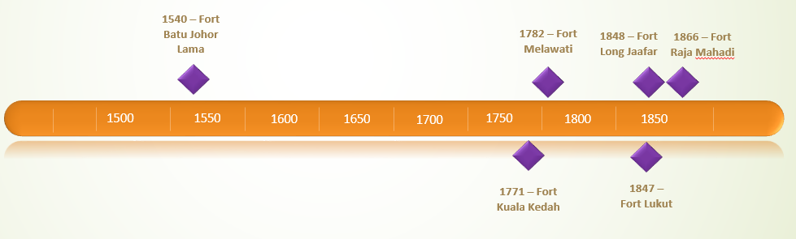
Figure 2: Timeline of the forts in the Malay Peninsula

According to Fig. 2, Fort Batu Johor Lama was the earliest fort that we still can see its traces. The influence of the construction knowledge from the Malay Sultanate in Melaka can be inherited in this fort. In further, Fort Kuala Kedah existed a decade earlier than that Fort Malawati, Kuala Selangor. The built year of Fort Lukut, Negeri Sembilan, and Fort Long Jaafar in Perak was almost the same. Then, Fort Raja Mahadi was built in 1866 in Klang. The figure shows that there is a big gap between fort Batu Johor Lama and Fort Kuala Kedah. Further analysis will answer the first objective, which is to analyse the characteristics of forts in the historical Malay Peninsula.

- Fort Batu Johor Lama
After the fall of the Malay Sultanate of Melaka in 1511, Johor became the administrative and defense center. There are twelve forts altogether in Johor, most of which are located near to the river. Fort Johor Lama, built by Sultan Alauddin Riayat Syah II (1528–1564), was a rectangle-shaped building enveloped by soil-covered stones (Nasir, 1990; Razak, 1998). This fort is also located just next to the river, built for a strategic, defensive purpose on a major trade route. This was the first fort that was built from a solid stone buckle (Nasir, 1990). The area of this fort is 961.54-meter square. The fort's total length is estimated at approximately 1012.7 meters, and the average width is between 2 meters to 4 meters, and on the outside of this city wall, there is a trench for defense purposes (Asyaari Muhamad, 2009).

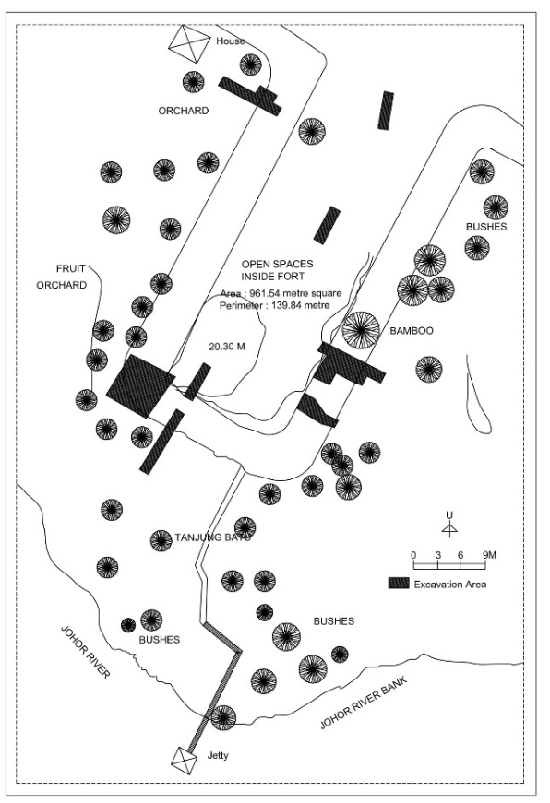
Figure 2: Fort Batu Johor Lama
(Source: Abdul Halim Nasir, 1990; constructed: Author, 2020).

- Fort Kuala Kedah
The fort is built at the left bank of a river and on a swamp area. Due to its location on a swamp area, the embankment is done inside the fort, making it situated on higher ground. It is located by the left bank of Sungai Kedah, reflecting the river's importance as a trade and transportation route. A canal is found outside of the fort that is also known as Alor Melaka.
The fort's shape is squared-oval as the walls of the fort are not similar at each side. The walls are made of high-quality bricks, red bricks paved by a cement-like substance possibly made from chalk or seashells or corals that have been cooked and mixed with an adhesive. Kota Kuala Kedah walls are designed for stronger defense as it contains a space for soldiers to guard the fort in between two walls of 7.65 meters, and the base is filled with soils of 1.50 meters high (Nasir, 1990). The fort also has corners for guarding the fort and a bridge located at the grand entrance in which it can be moved and controlled from the inside of the fort. The cannons are positioned towards Sungai Kedah and Selat Melaka as both are significant as one of the enemy attacks' access. This evidence suggests that the forts were built using bricks combined with cement and limestones. The traces of guardhouses, kitchen, assembly hall, storage for weaponry, and musolla can also be seen.

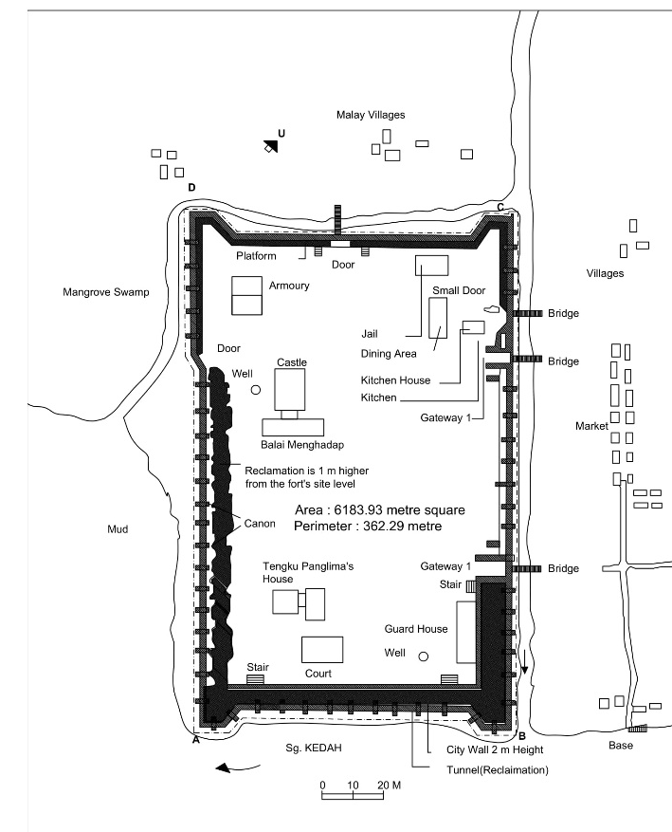

Figure 2: Fort Kuala Kedah
(Source: Abdul Halim Nasir, 1990; constructed: Author, 2020).

- Kota Long Jaafar
Fort Long Jaafar was built using bricks in Bukit Gantang, Perak. This fort was constructed using bricks and soil mixed with stone and arrange appropriately (Nasir, 1990). It was found that the whole complex covers five main areas; defense area, water retention area and garden, cemetery area mainly for relatives and workers at that time, and relocation area for the Japanese army camp and railway station (Yunus, Yunus, Omar, & Ismail, 2009).

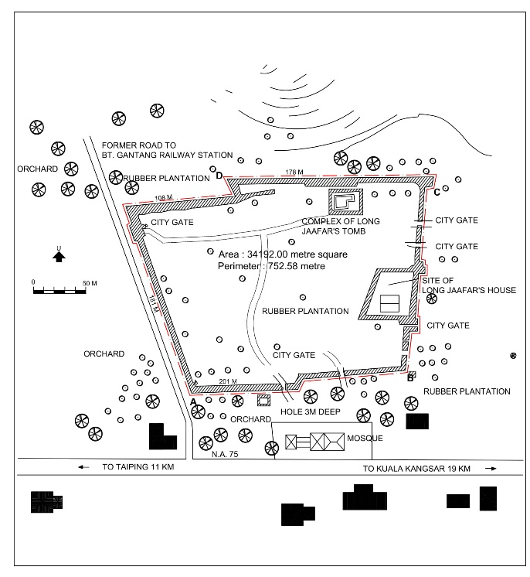
Figure 3: Sketch showing Fort Long Jaafar. The existence of the external and the internal wall
(Source: Abdul Halim Nasir, 1990; constructed: Author, 2020).

This fort has external (white double lines) and internal (shaded double lines) wall. Based on vegetation found growing within the internal walls, and from interviews with local villagers, Long Jaafar's house is believed to be situated within this fortified internal wall (Yunus et al., 2009). The area of Kota Long Jaafar is 34,192-meter square.

- Fort Malawati, Selangor
Fort Malawati is in a square shape and was made of soil and solid stacks. The fort's measurement is 74 m x 30 m, and the walls are embanked with soils of 2-meter-high from the inside of the fort. The area of this fort is 23442-meter square. This fort is located at the hilltop and facing the Kelang River. A grand entrance at the East of the fort and a paved road with gravels heading towards the Kuala Selangor town's foothill. It is very close to the main road that links to the town. This fort was also equipped with cannon that was placed at the walls.
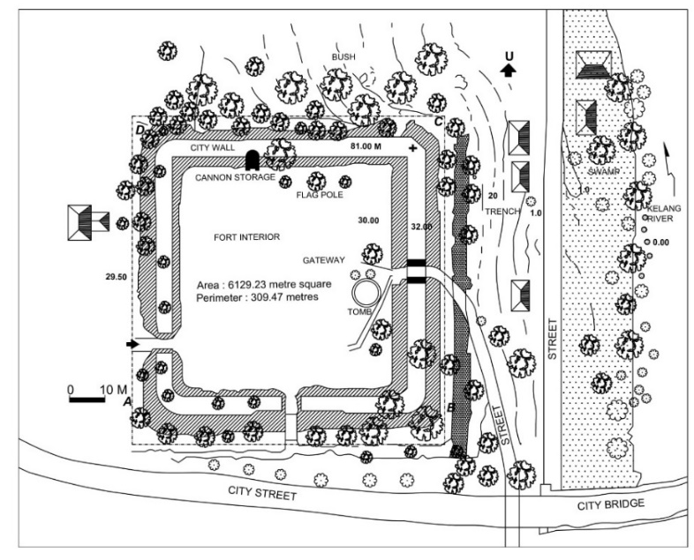
Figure 5: Fort Malawati, Kuala Selangor
(Source: Abdul Halim Nasir, 1990; constructed: Author, 2020).

- Fort Lukut
In Negeri Sembilan, Fort Lukut was located in the middle of a roadway from Seremban to Port Dickson. The fort was located on top of the hill of Bukit Gajah Mati with a view towards the sea, close to Sungai Lukut. The area of this fort is 18250-meter square. Fort Lukut was the only fort owned by a Malay, Raja Jumaat ibn Raja Jaafar (1847), in the nineteenth century for a tin ore trades (Nasir, 1990). At that time, tin mining was an important economic activity in Negeri Sembilan, and Fort Lukut was made a necessity for tin ore trading. To construct the fort, gravels were stacked and arranged on layers of earth walls. Each wall of the rectangular fort was measured at a different height. The fort had two grand entrances and a smaller entrance, which was located on the Eastern wall of the fort (Nasir, 1990). Fort Lukut also served as the ruler's residence and was described as a large building that had three water ponds made of bricks (Nasir, 1990). The ponds served to store drinking water collected from the river by the hill.

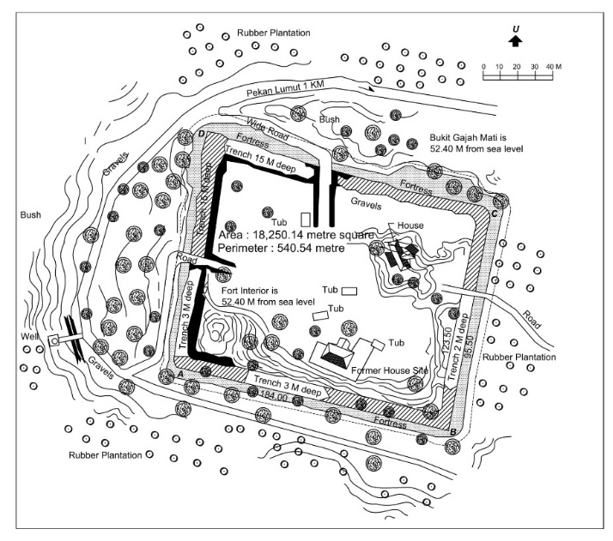
Figure 6: Fort Lukut, Perak
(Source: Abdul Halim Nasir, 1990; constructed: Author, 2020).

- Fort Raja Mahadi, Kelang
A fort is located Fort Raja Mahadi is located on the hilltop at the right bank of Sungai Kelang. It was built with a grand entrance and storage at the Northside built-in 1876. This fort built using soil stacks earth wall of 1.8 meters in height surrounding the 81 square meters (9.5 m x 9.5 m) rectangular fort (Nasir, 1990). Fort Raja Mahadi is 6129.23-meter square. A trench was installed with bamboo and woods traps at the surrounding the walls, to complicate enemy attack. Trenches were also installed with traps of bamboos and woods and equipped with cannons placed at the fort's platform.

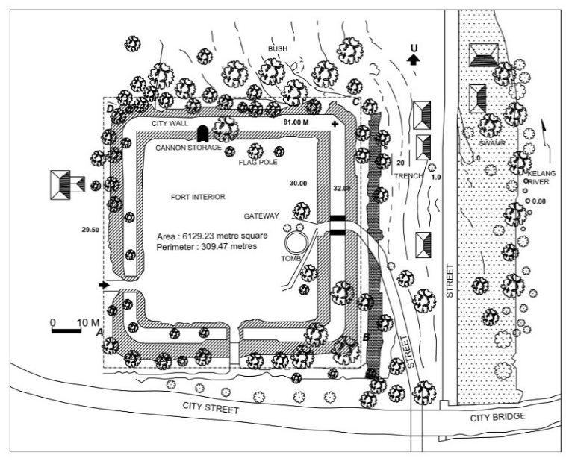
Figure 6: Fort Raja Mahadi, Kelang
(Source: Abdul Halim Nasir, 1990; constructed: Author, 2020).

- MATRIX ANALYSIS OF FORTS IN MALAY CITIES

The matrix below (Table 1) shows the matrix analysis of the studied forts showing the forts' characteristics in Malay cities. The analysis includes year built, location, a form of the forts, structure, the features surrounding the forts, and the fort itself. Six forts are examined as below;

Table 1 shows the matrix analysis on the forts in Malay cities
Types | Fort | Fort categories | Shape | Structure | Surrounded by | Year
Colonial designed fort | Fort Long Jaafar | Fully fort | Rectangle-shaped | Bricks | N.A | 1848
 | Fort Lukut | Fully fort | Square shaped | Gravel stacked | NA | 1847
 | Fort Raja Mahadi | Fully fort | Square shaped | Soil stacked | Woods, bamboos | 1866
Malay fort | Fort Kuala Kedah | Partially fort | Rectangle-shaped | Base – Soil  Wall - Bricks | Cannons | 1771
 | Fort Malawati | Fully fort | Square shaped | Soil stacked | Cannons | 1782
 | Fort Batu Johor Lama | Partially fort | Square shaped | Soil stacked | Trenches | 1540
N. A. not available

This section will answer the second objective, which is to compare the traditional Malay forts. Several similarities are found between these forts. Firstly, all of these forts have a wall that plays a role as a boundary separated from the other areas. The town's main heart was the fort, which was generally located at the highest point of the settlement, or on the hill. The fort was an area that functioned as a place for people to gather and discuss important matters. Open spaces or alun-alun are also important features in forts. Such space distribution can increase the chance of meeting for any events or activities.
Generally, these forts were used for defensive purposes and characterized by its position on a high hill. It was also noticeable that these forts also function as an administration and residential center. The cannons placed surrounding the walls show that security is an important element in the Malay city. Other than cannon, the defense tools include bamboo or woods, and these are located around the forts. So far, Kota Long Jaafar is the largest fort by comparing with all six analysed fort, while Fort Kuala Kedah is the smallest.
It can be seen that the earlier architecture of Malay forts was straightforward with square-shaped forts and surrounded by trenches. The Malay fort construction used soil stacked. The architecture of designed colonial forts built after the 1800s shows that they were influenced by Western building design. These forts are located at the river's side for strategically positioned to become the heart of the village/town. The fort was close to the river because rivers were the main transportation means. It was easy for them to security control the water traffic. Many forts were used as a defense center in all states, and security was important to guard attacks from enemies. All of the activities, such as trades, tax, and battles, occurred in the river areas.
The table (Table 1) also shows that the material used for each fort is different, as they were built from a different era, from 1550 until the 1800s. The earlier fort (Fort Batu Johor Lama) was built using a solid stone buckle, and after two centuries, the forts (Fort Long Jaafar) were built using arranged bricks. Kota Raja Mahadi is similar to the other Malay forts as the walls are made of embanked soils. Below is the summary of historical Malay Forts in Peninsular Malaysia.

Historical Malay Forts

Form and function
1. The fort as an administration and residence of the royal
2. Material: can be built bricks or soil
2. Defence from natural resources
3. A role as a centre or landmark of the village/town

Land Use Spaces
1. Open space
2. Located on the hilly area
3. Shape: Rectangle and square
4. Near to Coastal or River area
5. Defence as important criteria

Figure 7: Summary of the historical Malay Peninsular Forts

- CONCLUSION

This study shows that there are two types of forts; fully fort and partially fort. The conclusions drawn from this study on the fort in the Malay Peninsula are; i) located on the top of the hill and facing the river/sea, ii) all of these forts has a wall that plays a role as a boundary that separated from the other areas, iii) these forts located close to the river/sea, iv) the form of the forts either square or rectangle, v) Malay consider natural elements to be forts or natural security.

ACKNOWLEDGEMENT

This work was supported by the Grant awarded by Ministry of Education Malaysia, Transdisciplinary Research Grant Scheme (TRGS) No. TRGS/1/2016/UIAM/01/5/1. Thank you also goes to International Islamic University Malaysia.

References

Asyaari Muhamad. (2009). Penyelidikan Arkeologi di Johor dari Sudut Pandangan Warisan vs Pembangunan. International Journal of the Malay World and Civilisation, 27(2), 199–227.
Jeran, K. (1992). Hikayat Pahang. Kuala Lumpur. Fajar Bakti.
Morris, A. E. J. (1994). History of Urban Form Before the Industrial Revolutions. Pearson Education Limited.
Nasir, A. H. (1990). Kota-kota Melayu. Percetakan Dewan Bahasa dan Pustaka.
Razak, K. A. (1998). Peninggalan sejarah di pesisiran Sungai Johor. Johor Bahru. Yayasan Warisan Johor.
Rinandi, N., Suryaningsih, F., & Heritage, I. (2015). Inventory of forts in Indonesia. In ISPRS Annals of the Photogrammetry, Remote Sensing and Spatial Information Sciences, Volume II-5/W3, 2015 25th International CIPA Symposium 2015, 31 August – 04 September 2015, Taipei, Taiwan INVENTORY (Vol. II, pp. 263–270). http://doi.org/10.5194/isprsannals-II-5-W3-263-2015
Shellabear, W. (1977). Sejarah Melayu (3rd ed.). Penerbit Fajar Bakti Sdn Bhd.Adil.
Yunus, R. H. M., Yunus, S. H. M., Omar, Y., & Ismail, A. H. (2009). A Heritage Study On Kota Long Jaafar Rodzyah H. M. Yunus, Shamsury Ab. Karim, Yacob Omar, Abdul Halim Ismail. Journal Design and Built Environment, 2.

