Urban Expansion Analysis of GBA Based on Multi-source Nighttime Light Remote Sensing Images
Tielan Huang (1), Feini Huang (1), Jing Luo (1)(2)

¹ Guangdong Polytechnic of Industry and Commerce, 963 Guangzhou Avenue North, Tianhe District, Guangzhou,510510, China
² Jiaying University, Meisong Road, Meizhou, 514015, China
Email: 707549941@qq.com; 1073550908@qq.com; 945809721qq.com

ABSTRACT: In this paper, the DSMP/OLS nighttime light (NTL) images from 1992 to 2012 and the “LJ-01” NTL images in 2018 are used to extract urban built-up areas of Guangdong-Hong Kong-Macao greater bay area (GBA), by applying dynamic threshold method. On this basis, in order to reveal the spatial pattern and urban expansion process of each city in GBA, a number of indicators are used, including average light brightness, growth rate of average light brightness, urban built-up area, growth rate of urban built-up area , urban center of gravity coordinates, and offset distance of urban center of gravity. Finally, analyzes the main driving factors of urban expansion in GBA combined with the national economic statistics. The results show that: (1)From 1992 to 2018, the urban scale of GBA increased significantly. It forms an inverted "U" shaped urban agglomeration, with Guangzhou, Shenzhen and Hong Kong as the center, expanding outward in a radial manner. (2)Taking the Pearl River Estuary as the boundary, the development level of eastern cities is significantly higher than that of western cities. The development level of core cities such as Guangzhou, Shenzhen and Hong Kong was significantly higher than that of peripheral cities such as Jiangmen, Zhaoqing and Huizhou.(3)From 1992 to 2018, the expansion speed of the built-up area in GBA increases from small to large, and then decreases gradually. 2002-2007 was the fastest period of urban expansion. (4)From 1992 to 2018, there are three types of urban center of gravity migration: the center of gravity of periphery cities continued to move to the center of GBA; the center of gravity of central cities moved to the junction of neighboring cities; the center of gravity of special administrative cities is moving towards the ocean. Most cities have "vibration" in their directions of urban gravity movement. (5)Population growth, economic development, improvement of traffic conditions and favorable policies are the main driving forces of urban expansion.

KEYWORDS: Guangdong-Hong Kong-Macao greater bay area(GBA), urban expansion, nighttime light(NTL), DMSP/ OLS, LJ-01

1.INTRODUCTION
Nighttime light(NTL) data are closely related to human activities and spatial distribution of construction land, so they are an effective data source for extracting construction land[1]. DMSP/OLS and NPP-VIRS are two kinds of NTL data with highest attention in academic circles, and have been widely used in construction land identification[2]. However, the spatial resolution of these two kinds of NTL data is low, so the accuracy of the construction land identification results is not high [3]. The NTL satellite data of luojia-1 (LJ-01) launched by China in 2018 is far better than DMSP / OLS and NPP-VIIRS NTL data in terms of spatial resolution and spectral resolution, and is a more ideal NTL data source for identifying construction land [4]. At present, there are few studies on the application of LJ-01 to urban construction land identification and urban expansion analysis. Zhang analyzed the urban spatial morphology of Guangdong-Hong Kong-Macao greater bay area (GBA)based on the night light remote sensing image of LJ-01 NTL data[5]. Liu extracted the construction land in Wuhan City based on the LJ-01 NTL data[6]. Li Fei carried out a comparative study on the accuracy of built-up area extraction from LJ-01 and NPP -VIIRS NTL data [7].
In this paper, the DSMP/OLS nighttime light (NTL) images from 1992 to 2012 and the “LJ-01” NTL images in 2018 are used to extract urban built-up areas of GBA, by applying dynamic threshold method. On this basis, in order to reveal the spatial pattern and urban expansion process of each city in GBA, a number of indicators are used, including the total light brightness, average light brightness, growth rate of average light brightness, urban built-up area, growth rate of urban built-up area , urban center of gravity coordinates, offset distance of urban center of gravity , and migration velocity of urban center of gravity. Finally, analyzes the main driving factors of urban expansion in GBA combined with the national economic statistics.
2.STUDY AREA AND DATA SOURCE
2.1 Study area
The study area is GBA, which consists of Hong Kong and Macao, and nine cities in Guangdong Province, namely Guangzhou, Shenzhen, Zhuhai, Foshan, Huizhou, Dongguan, Zhongshan, Jiangmen and Zhaoqing. The total area is 56000 square kilometers, and the total population has reached 70 million by the end of 2018. It is one of the regions with the highest degree of openness and the strongest economic vitality in China.
2.2 Data Source
The administrative division data of GBA are from the website of the Ministry of natural resources of China, with a scale of 1:750000. Landsat5 TM, Landsat7 ETM + and Landsat 8 OLI_TIRS data from 1992 to 2018 of GBA comes from the website of geospatial data cloud, with a resolution of 30 m. DMSP / OLS NTL data for 1992-2012 are from the National Geographic Information Center website(https://www.ngdc.noaa.gov), the spatial resolution is about 1km, and the range of pixel brightness DN is 0-63. The LJ-01 NTL data in 2018 are from Hubei data and application network, with a spatial resolution of 130 m. The economic statistics of the cities in GBA from 1992 to 2018, including urban built-up area, GDP, population and other information, from the statistical yearbook of China and each cities.
3.METHOD
3.1 Data Preprocessing
The administrative division data of GBA were vectorized and projected into WGS-84 . The of Landsat series data were combined, mosaic and clipped. The DMSP / OLS NTL data was first clipped using administrative division data of GBA. Then, according to the method proposed by Lu[1], saturation correction and mutual correction (formula 1), intra annual fusion and inter annual correction were carried out successively. The correction formula was 1, 2 and 3. Finally they were re-sampled to 30 m. The LJ-01NTL data were firstly projected to WGS-84, and then geometric correction were carried out based on landsat8 image in 2012. Then, the corrected images were mosaic together, and clipped by administrative division data of GBA. Finally, the radiation correction(formula 4) of LJ-01 NTL data were carried out, and be re-sampled to 30 m. The statistical economic data are sorted into statistical tables according to administrative division and data type.
$\text{DNcorrrct}=a×{\text{DN}}^{{}_{2}}+b×\text{DN}+c$ （1）
DN is the brightness value before correction, a, b, c are regression coefficients, and DNcorrect is the corrected DN value.
n = 1992, 1993, 1994 ,……, 2012; DN _{(n-1, i)}, DN _{(n, i)} and DN _{(n + 1, i)} are the DN values of pixel i in n-1, n, n + 1 years.
${L=\text{DN}}^{3/2}⋅{\text{10}}^{\text{-10}}$ (2)
L is the radiance value after absolute radiometric correction, the unit is w / (M 2 · SR · μ m), and DN is the gray value of the image.
3.2 Extraction of Urban Built-Up Area
(1) Urban Built-Up Area Extraction from DMSP / OLS Data
According to the "hierarchical threshold method" proposed by Yang[9], for each year, based on the statistical data of urban built-up areas, 11 cities in GBA were gradually divided into four sets with similar NTL threshold values. Then, the optimal threshold value of each set was used to extract the corresponding built-up areas, and finally the urban built-up areas of the whole GBA were combined. The main steps of this method are as follows:
Firstly, according to the dichotomy method, the optimal threshold Dt of AiBj was determined, and the urban build-up area of each administrative unit in the set is calculated:
$D_{k}=\sum_{D_{x}=D_{t}}^{D_{\text{max}}}{f(D_{x})}$ (3)
k is the number of the administrative unit, Dx is a certain DN value from Dt to Dmax, and f (Dx) is the total area of urban build-up pixel with DN value Dx in administrative unit k.
Then, compare the difference E(Dt) between the urban build-up area Dk and the urban build-up area Sk in statistical data of each administrative unit in AiBj set, and classify the administrative units. Dk was extracted by the potential threshold Dt.
$E(D_{t})=D_{k}−S_{k}$ (4)
If E (Dt) <0, the administrative units were composed of set A_{i+1}B_{2j-1}, Dmax =Dt, Otherwise if E (Dt)≥0, the administrative units were composed to set A_{i+}1B_{2j}, Dmin =Dt.
Finally, set i=i+1, transferred to step 1, recalculated the potential thresholds of each set and compared them according to formula (6), until all E (Dt) values in the set are satisfied. And the best threshold for set A_{i}B_{j} is the optimal threshold of each administrative unit.
(2) Extraction of Urban Built-Up Area from LJ-01 NTL Data
The urban built-up area extraction of LJ-01 NTL Data was carried out according to the "city index method" proposed by Zhang[5]. Firstly, the NDVI index calculated by Landsat data was used to adjust the NTL value, and the vegetation adjusted urban NTL index (VANUI) was obtained. Then, the VANUI data of different years were clipped according to the administrative unit. Based on the statistical data of urban built-up area, different optimal thresholds of VANUI were selected for each city to extract the built-up area. Finally, the urban built-up areas of the whole GBA were combined.
The formula of VANUI is as follows:
$I_{\text{VANUI}}=(1−I_{\text{NDVI}})L_{\text{NOR}}$(7)
$I_{\text{VANUI}}$ is the VANUI index value, $I_{\text{NDVI}}$ is the normalized vegetation index value to reflect the vegetation signal, $L_{\text{NOR}}$is the normalized night light radiance
3.3 Calculation of Urban Spatial Expansion Index
According to the method of Wan[10], the change of urban spatial pattern was analyzed by calculating nighttime light index and urban expansion index.
3.3.1 Calculation of nighttime light index
(1) Average light intensity
${\text{DN}}_{\text{mean}}=\sum_{{\text{DN}}_{i}={\text{DN}}_{\text{min}}}^{{\text{DN}}_{\text{max}}}{({\text{DN}}_{i}×n_{i})}N_{j}$ (8)
DN_{mean}、DN_{min}、DN_{max} are the average, minimum and maximum values of light brightness; n_{i} is the number of pixels with DN_{i}; N_{j} is the total number of pixels.
(2)Growth rate of average light intensity
$R_{{\text{DN}}_{m}}=({\text{DN}}_{{\text{mean}}_{m}}−{\text{DN}}_{{\text{mean}}_{n}})/(m−n)$ (9)
R_{DN_m} represents the growth rate of average light brightness; DN_{mean_m} and DN_{mean_n} represents the average light brightness of years m and n.
3.3.2Calculation of urban expansion index
(1) Urban Center of Gravity
The gravity center of the city can reflect the relative position of the urban spatial distribution in the two-dimensional space. The formula is:
$\begin{aligned}X={\left(\sum_{i=1}^{n}{X_{i}×C_{i}}\right)}/{\sum_{i=1}^{n}{C_{i}}} \\ Y={\left(\sum_{i=1}^{n}{Y_{i}}×C_{i}\right)}/{\sum_{i=1}^{n}{C_{i}}}\end{aligned}$ (10)
x and y are the longitude and latitude coordinates of the center of gravity coordinates,X_{i} and Y_{i} are the coordinates of the ith pixel, C_{i} is the attribute value of pixel i, in this paper it is DN value, n is the total number of pixels in the region.
(2) Offset Distance of Gravity Center
The center of gravity offset distance L is the moving distance of the urban center of gravity of the next year compared with that of the previous year, as formula 11:
$L=\sqrt{{\left(X_{j}−X_{k}\right)}^{2}+{\left(Y_{j}−Y_{k}\right)}^{2}}$ （11）
X_{j} and X_{k} represent the X coordinate values of the two points, and Y_{j} and Y_{k} represent the Y coordinate values of the two points respectively.
4.RESULT AND DISCUSSION
4.1 NTL Brightness Change in GBA
The average NTL brightness and growth rate of GBA from 1992 to 2012 (not included in the statistics due to different data types) are shown in Figure 1. As can be seen from the figure, the average NTL brightness of each city in GBA is quite different. In 1992, Hong Kong, Macao and Shenzhen had the largest average NTL intensity, reaching 37.23, while Zhaoqing, Huizhou and Jiangmen had the lowest average NTL intensity of 3.22. In 2012, Dongguan, Shenzhen and Zhongshan were the three cities with the largest average NTL intensity, reaching 51.38, while Zhaoqing, Huizhou and Jiangmen were still the smallest, accounting for only 10.31. The average light brightness ratio in 1992 was 27.35 vs. 15.14, and that in 2012 was 41.24 vs. 29.76. From 1992 to 2012, the average NTL intensity of most cities in GBA showed a significant growth trend, from 19.25 to 33.93, with an average growth rate of 71.78%. Dongguan, Zhongshan and Foshan are the three fastest growing cities, accounting for 127.13%, while Hong Kong, Zhaoqing and Macao are the three cities with the slowest growth, accounting for only 22.02%. In terms of regional distribution, the average NTL brightness of the four cities in the east of the Pearl River estuary was significantly higher than that of the seven cities in the West.
4.2 Changes of Urban Built-Up Areas in GBA
The urban agglomeration of GBA has basically formed an inverted "U" shaped urban spatial development pattern around the Pearl River Estuary, with Guangzhou, Shenzhen and Hong Kong as the centers(Fig.2). The cities in the district are rapidly connected by expressways and expand outward in a radial manner.
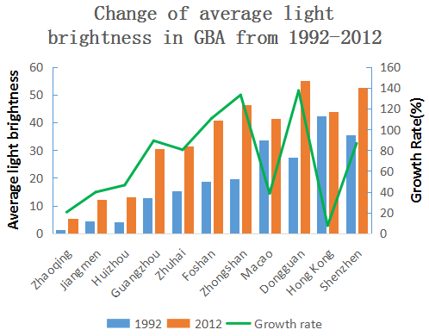 | 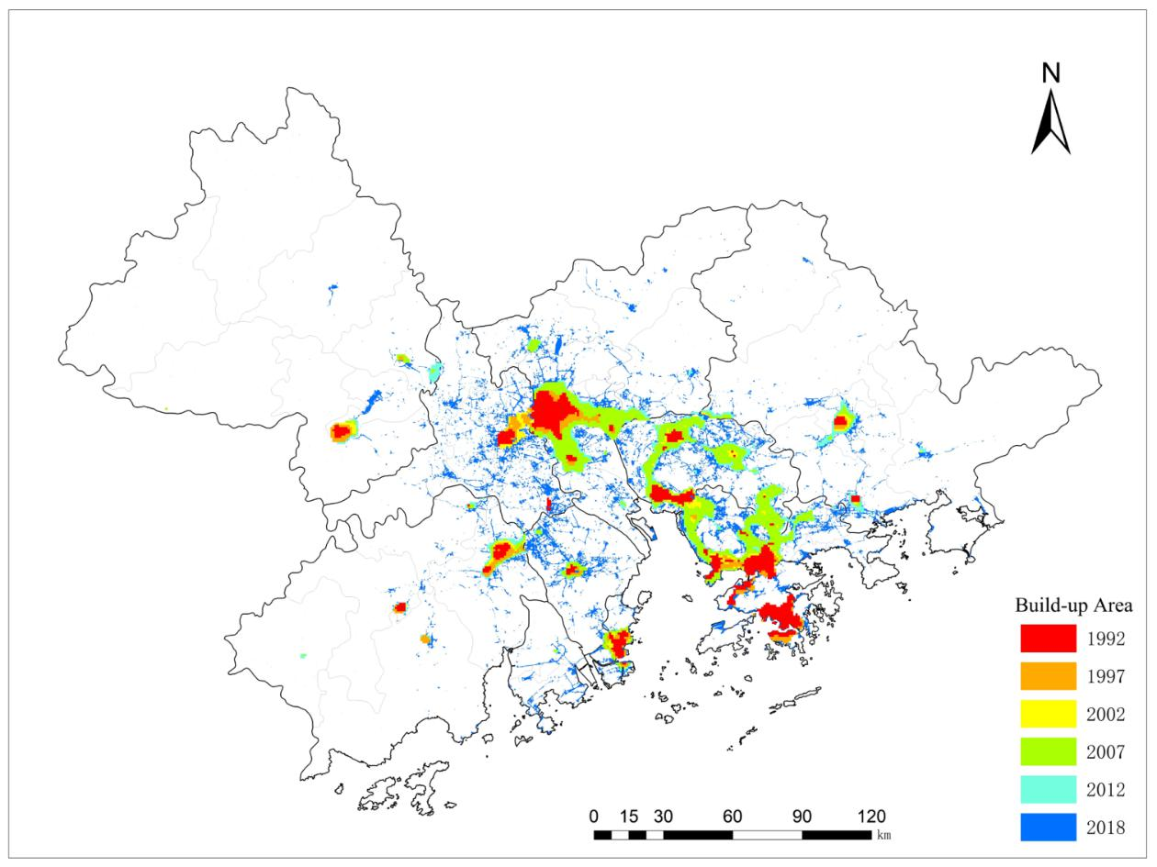
Fig.1 Change of average light brightness in GBA from 1992 to 2012 | Fig.2 Changes of urban spatial pattern in GBA from 1992 to 2018
In 1992-2018 years, the built-up area of the city of GBA grew steadily. The built-up area of Guangzhou, Dongguan and Shenzhen is much larger than other cities, while the built-up area of Macao is the smallest(Fig.3). Shenzhen, Huizhou and Zhongshan are the three cities with the largest growth proportion of built-up area, with 1121%, 944% and 742% , while Hong Kong has the least proportion, with only 54%. The growth rate of urban built-up area has changed from a small range to a large increase, and then to a small increase. The annual average growth rate of the total built-up area of 11 cities in GBA is as follow: 10.54% in 1992-1997, 5.8% in 1997-2002, 19.92% in 2002-2007, 4.62% in 2007-2012 and 3.21% in 2012-2018, and 2002-2017 is the period with the largest average annual growth rate(Fig.4).
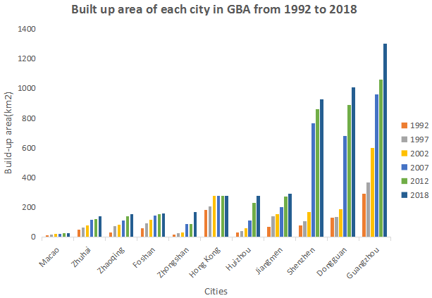 | 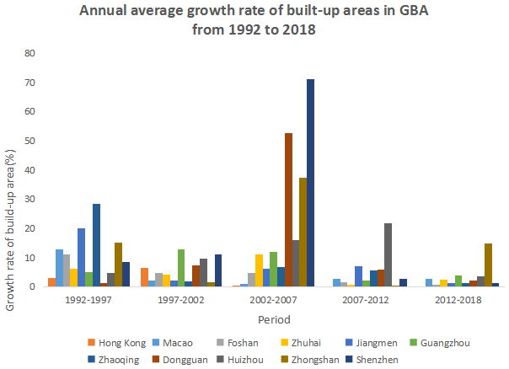
Fig.3 Built-up area of each city in GBA from 1992-2018 | Fig.4 Annual average growth rate of built-up area of each city in GBA from 1992-2018
4.3 Migration of urban center of gravity in GBA
From 1992 to 2018, there are three types of urban center of gravity migration(Fig.5): the center of gravity of Zhaoqing, Jiangmen and Huizhou continued to move to the center of GBA; the center of gravity of Guangzhou, Shenzhen, Dongguan, Foshan, Zhuhai and Zhongshan moved to the junction of neighboring cities; the center of gravity of Hong Kong and Macao is moving towards the ocean. The direction and trend of urban gravity movement in Zhaoqing, Jiangmen, Hongkong and Macao remained unchanged. Other cities have "vibration" in their directions of urban gravity movement. For example, the gravity centers of Guangzhou and Shenzhen first move to the northeast and then to the southwest.
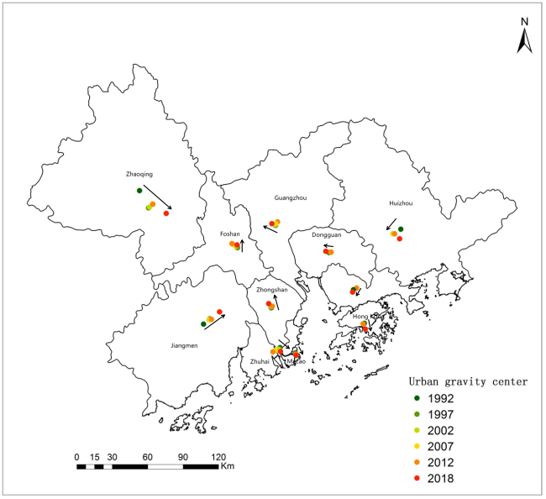
Fig.5 Migration of city gravity center in GBA from 1992-2018
The statistical chart of the center of gravity deviation distance of cities in GBA is shown in figures 6 and 7. From 1992 to 2018, the city with the smallest average deviation distance of the urban center of gravity in GBA is Macao, which is only 235.49 m every 5 years(m/5y). The second is Hong Kong, Dongguan and Zhongshan, which is about 1000 m/5y. Zhaoqing is the largest, with a migration distance of 10922.40 m/5y. Jiangmen and Huizhou are also larger, more than 4000 m/5y. In terms of time, the minimum average deviation distance of urban center of gravity is 850.04 m in 2007-2012, and the largest is 8713.04 meters in 2012-2018. The 1997-2002 and 2002-2007 were relatively stable, averaging about 1000 m. From the spatial pattern of urban center of gravity deviation, Hong Kong, Macao, Dongguan and other cities developed earlier and more stably, and the degree of urban gravity center deviation was not large. Zhaoqing, Jiangmen, Huizhou and other cities developed relatively late, with rapid urban development speed and large gravity center deviation.
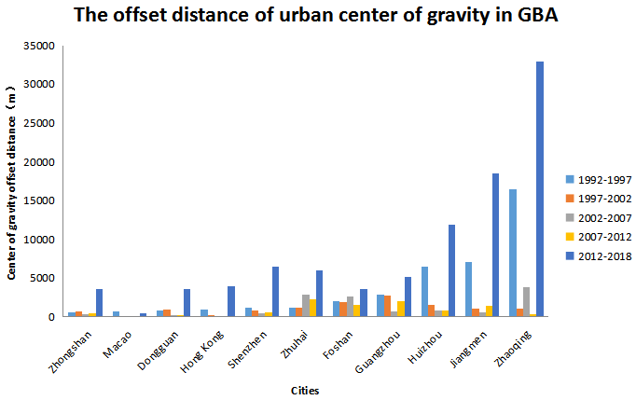 | 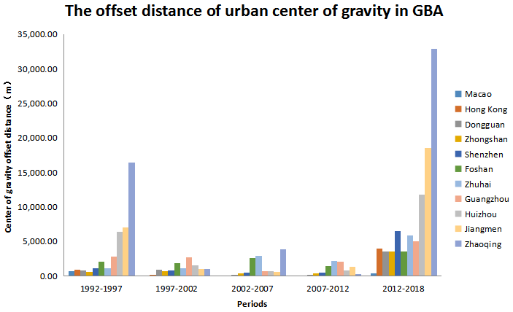
Fig.6 Center of gravity offset distance of cities in GBA (by cities) | Fig.7 Center of gravity offset distance of cities in GBA (by periods)
4.4 Analysis on driving forces of urban spatial pattern change in GBA
（1）Population density
Urban population is the initial and important driving force of urban built-up area. In 1992, the average population density of GBA was 2863.82 person / km², and reached 4151.36 person / km² in 2008, with an average annual growth rate of 1.67%. Through SPSS software, this paper analyzes the correlation between urban population and urban built-up area in GBA from 1992 to 2018. It was found a strong correlation between urban population and built-up area, and the correlation coefficient is 0.985
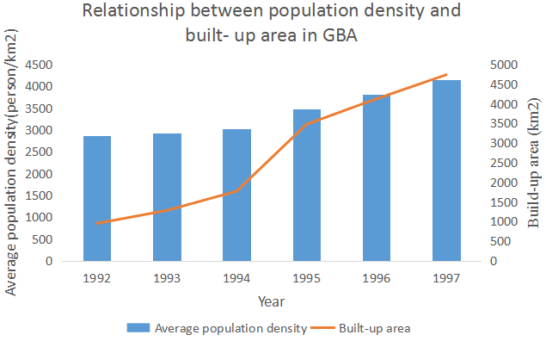.
Fig.8 Relationship between population density and built up area of GBA in 1992-2018
(2) Economical Development
The spatial expansion of urban built-up area is the internal demand and external performance of urban economic development. The rate of urban spatial expansion will change with the economic fluctuation. With the rapid growth of urban economy, the expansion of urban built-up area presents the form of spatial expansion in horizontal direction. Taking Guangzhou city with higher development cities and Huizhou City with lower development cities as examples, this paper analyzes the correlation between economic development data and urban built-up area from 1992 to 2018 by SPSS software. It was found that GDP, primary industry output value, secondary industry output value and third industry output value have strong correlation with built-up area, and the correlation coefficients are 0.931, 0.967, 0.969 and 0.907.
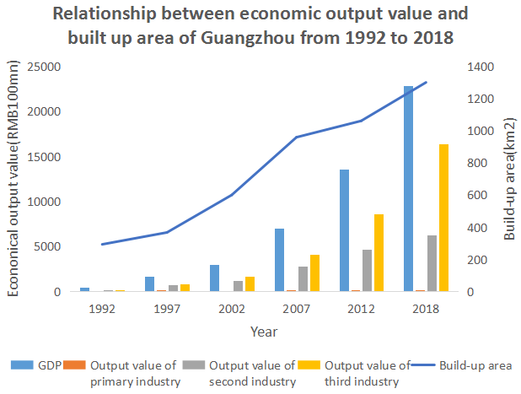 | 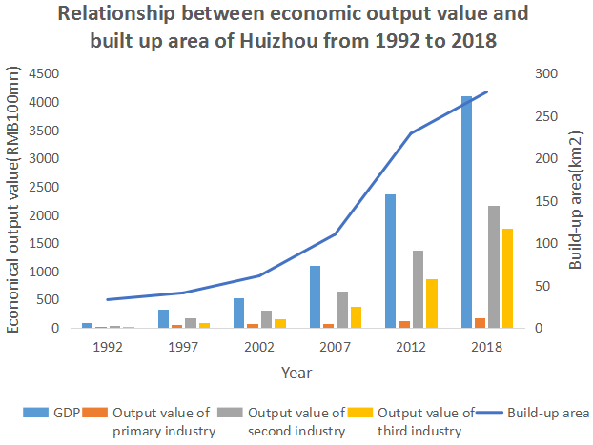
Fig.9 Relationship of economic output value and built-up area of Guangzhou from 1992 to 2018 | Fig.10 Relationship of economic output value and built-up area of Huizhou from 1992 to 2018
(3) Traffic factors
The development of transportation network is the most direct reason for expansion of urban built-up areas and the change of spatial pattern, which has a directional role. Taking Shenzhen as an example, from 1992 to 2018, the built-up areas were basically distributed around the main traffic network(Fig.10,11).
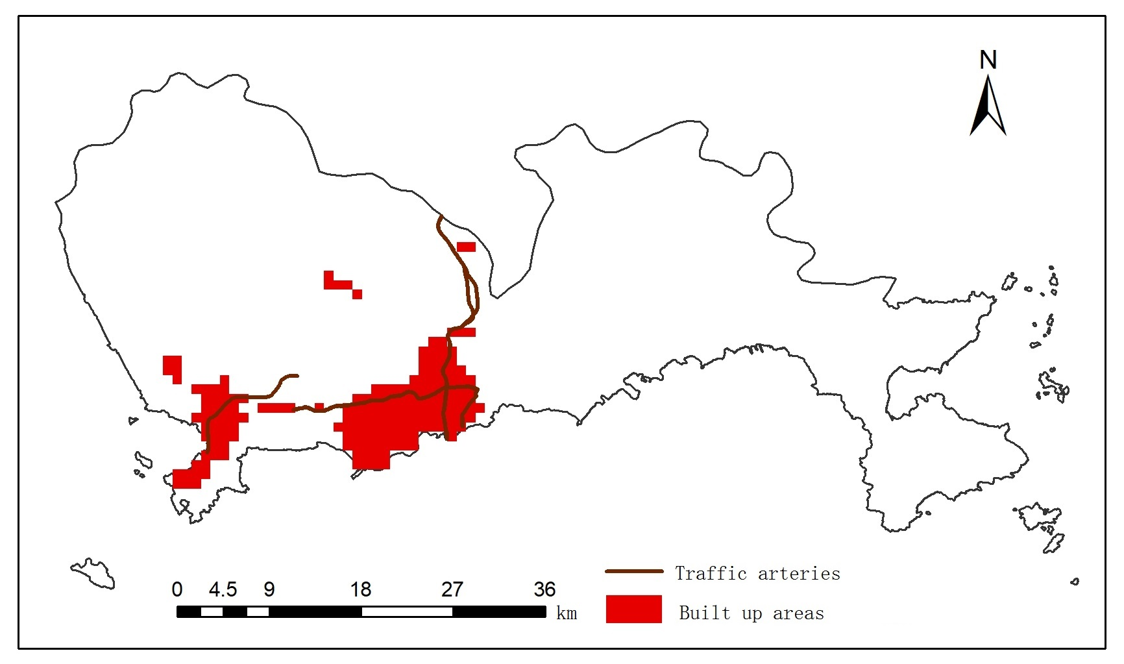 | 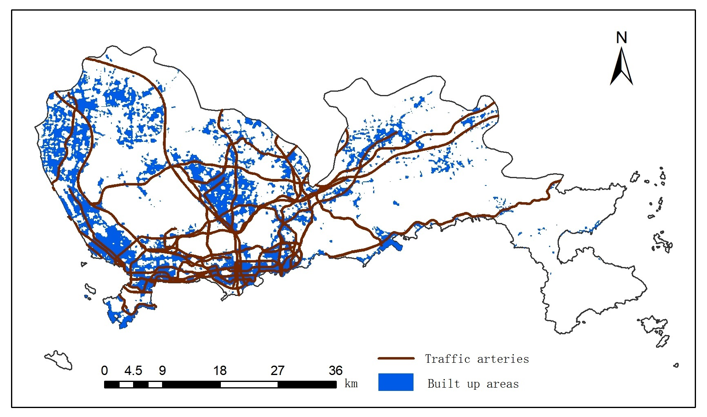
Fig.10 Relationship between traffic network and urban built-up area in Shenzhen in 1992 | Fig.11 Relationship between traffic network and urban built-up area in Shenzhen in 2018
(4) Policy factors
The regional development strategy issued by the national and local governments plays a guiding role in the development of cities. Guangdong Province proposed the construction of "Pearl River Delta economic zone" in 1994, Chinese government issued the outline of reform and development planning of the Pearl River Delta region in 2003 and tthe outline of development planning of GBA in 2019. These policies have promoted the rapid economic development of Guangdong, Hong Kong and Macao Bay area, and led to a sharp increase in the scale of urban construction land.
5.CONCLUSION
According to the research of this paper, the following conclusions are obtained：
(1)From 1992 to 2018, the urban scale of GBA increased significantly. It forms an inverted "U" shaped urban agglomeration, with Guangzhou, Shenzhen and Hong Kong as the center, expanding outward in a radial manner.
(2)Taking the Pearl River Estuary as the boundary, the development level of eastern 4 cities is significantly higher than that of western 7 cities. The development level of core cities such as Guangzhou, Shenzhen and Hong Kong was significantly higher than that of peripheral cities such as Jiangmen, Zhaoqing and Huizhou.
(3)From 1992 to 2018, the expansion speed of the built-up area in GBA increases from small to large, and then decreases gradually. 2002-2007 was the fastest period of urban expansion.
(4)From 1992 to 2018, there are three types of urban center of gravity migration: the center of gravity of periphery cities continued to move to the center of GBA; the center of gravity of central cities moved to the junction of neighboring cities; the center of gravity of special administrative cities is moving towards the ocean. Most cities have "vibration" in their directions of urban gravity movement.
(5)Population growth, economic development, improvement of traffic conditions and favorable policies are the main driving forces of urban expansion.
ACKNOWLEDGEMENT
Science and technology innovation project of university students in Guangdong Province (pdjh2020b0928) and Scientific research project of Guangdong Polytechnic of Industry and Commerce in 2019 (2019-zk-04) are acknowledged for financial supports.
REFERENCES
[1] Deng L Y, Shen Z F, Ke Y M. Built-up area extraction and urban expansion analysis based on remote sensing images[J]. Journal of Geo-information Science, 2018,20(7): 996-1003.
[2] Jia T, Chen K, Wang J Y. Characterizing the growth patterns of 45 major metropolitans in mainland China using DMSP/OLS data[J]. Remote Sensing, 2017,9(6):571-587.
[3] Yang H, Meng N, Wang J, et al. Spatial-temporal morphology simulation of Beijing- Tianjin- Hebei urban agglomeration thermal environment based on support vector machine[J]. Journal of Geo- information Science, 2019,21(2):190-200.
[4]Zhong L, Liu X S. Analysis on application potential of new night light data of Luojia No.1 [J]. Surveying and mapping bulletin, 2019 (7): 132-137.
[5] Zhang Y X, Li X, S Y, et al. Analysis of urban spatial morphology of GBA based on noctilucent remote sensing image of LJ-01.
[6] Liu Q Y, Zhan Q M, Li J S, et al. Application of night light image of LJ-01 in construction land extraction: a case study of Wuhan City [J / OL]. Journal of Wuhan University (Information Science Edition): 1-18 [2020-09-06] https://doi.org/10.13203/j.whugis20190376.
[7] Li F, Yan Q W, Zou Y J, et al. Study on improving the accuracy of nighttime lighting data extraction from built-up areas by POI: a case study of luojia-01 satellite and NPP / viirs data [J / OL]. Journal of Wuhan University (Information Science): 1-14 [2020-09-06] https://doi.org/10.13203/j.whugis20190266.
[8] Lu X, Li J, Duan P, et al. Correction of DMSP / OLS night light image in China [J]. Surveying and mapping bulletin, 2019 (7): 127-131
[9] Yang Y, He C Y, Zhao Y Y, et al. Study on hierarchical threshold method for extracting urban land use information using DMSP / OLS stable night light data [J]. Chinese Journal of image graphics, 2011, 16 (4): 666-673
[10] Wan Y, Chen Y H, Li J. Analysis of urban spatial pattern and dynamic expansion of Henan Province Based on DMSP / OLS Data [J]. Geography and geographic information science, 2019,35 (01): 89-94 + 2.

